Contents:

* Short about web application.
* Database.
* Web Application.

# Short about web application.

This is a single page web application made with NodeJS in WebStorm. WebStrorm is a good IDE for working with JavaScript web applications. It was fairly easy to setup the node and configuring a new project in WebStrorm. We use express that is equivalent to MVC in JS.

The view part of the project uses jade and the database used is MongoDB.

# Database

The database we used is MongoDB. It is a nosql database that is known for working very well in synergy with NodeJS.

The database is running separately from IDE on the 27017 port. We use console window to start the database. We can also use mongo to view the content from our database:

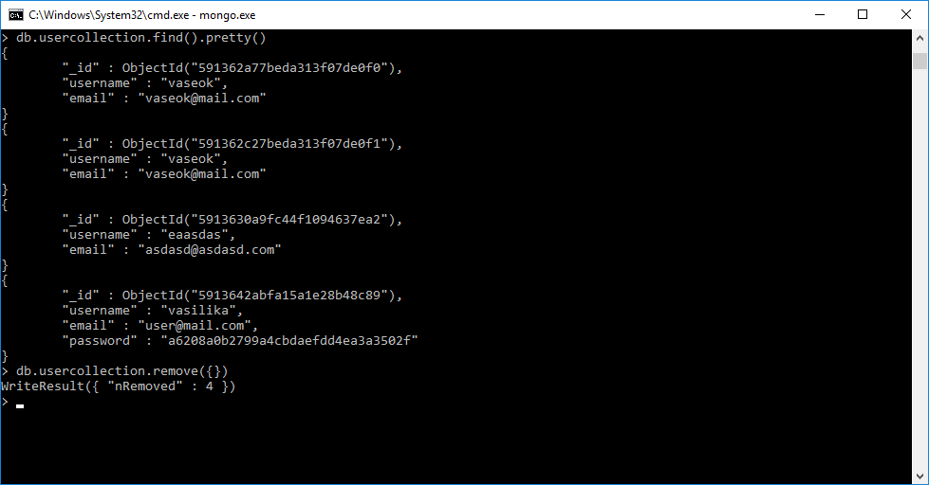

# Web Application

Our web application has a starting point that initializes all of our features like connection to database, express, the controls, listening port. That file is named **app.js** .

After that we have a folder routes where all of our controls are located. Controls are linked from our app.js.

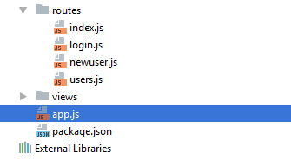

We don’t have a model because in our case we don’t require one.

All of our pages are:

* Index.
* Users.
* Newuser.
* Login.

**Index** contains three links to other pages.

**Users** contains a list of users that are currently registered. The data for the list is taken directly from the database.

**Newuser** contains a POST from where you can input the username, email and password and submit button. After pressing submit button username, email and md5 encrypted password are written into the database.

**Login** contains three fields where you can type your username and password and press submit. After pressing submit button we initialize a search in the database by the username field checking if the encrypted password is equal to input md5 password. If yes we output to the user that the login was a success.

# Conclusion

It is pretty hard to start making web applications if you don’t know the javascript and the parts related to connection between client side and server side. If I had more time I would make probably a fully functional web application, however I don’t have this luxury now. Web is pretty interesting topic by itself because it is different from programming on a device.