Report

Logic Programming and Artificial Intelligence

Laboratory work #2

Done by FAF-151 student: Calancea D.

Verified by : Lazu V.

Chişinău 2018

Laboratory work #2

# *Natural language processing*

# Task:

Elaborate a program that would analyze three sentences by the model presented below:

prep n

Pron part adj adv prep

n v art adj n

prep adv adj

# Implementation:

config([],State):-final(State).

config([Word|Rest],State):-

word(Word,Cat),

arc(State,Cat,State1),

config(Rest,State1).

recognize(String):-

initial(State),

config(String,State).

initial(1).

final(8).

arc(1,n,2).

arc(2,prep,1).

arc(1,pron,2).

arc(2,v,3).

arc(3,part,6).

arc(3,art,4).

arc(4,adj,5).

arc(5,n,8).

arc(6,adj,5).

arc(6,prep,9).

arc(9,n,10).

arc(10,prep,10).

arc(10,adv,8).

arc(4,adv,7).

arc(7,adj,5).

word(de,prep).

word(retea,n).

word(exemplu,n).

word(este,v).

word(dat,part).

word(prin,prep).

word(automatul,n).

word(de,prep).

word(mai,prep).

word(jos,adv).

word(mike,n).

word(car,n).

word(like,v).

word(likes,v).

word(ana,n).

word(city,n).

word(swim,v).

word(well,adj).

word(a,art).

word(banana,n).

word(eating,part).

word(swimming,part).

word(good,adj).

word(playing,part).

word(games,n).

word(tasty,adj).

word(quick,adj).

word(has,v).

word(a,art).

word(the,art).

word(rich,adj).

word(culture,n).

word(english,n).

word(is,v).

word(most,adv).

word(widespread,adj).

word(language,n).

word(i,pron).

word(enjoy,v).

word(learning,part).

word(new,adj).

word(things,n).

# Screens:

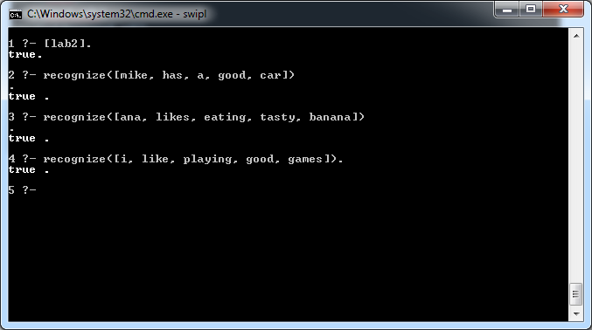

# Conclusion:

During this laboratory work I’ve learned how to make a natural processing language program in Prolog. Natural language processing is pretty important when writing smart text editors that help people avoiding grammar mistakes. Prolog very friendly in this area, and it’s an easy task for the programmer to write such a program.