Report

Logic Programming and Artificial Intelligence

Laboratory work #3

Done by FAF-151 student: Calancea D.

Verified by : Lazu V.

Chişinău 2018

Laboratory work #3

# Topic:

Expert systems. Study the principle of work of Artificial Intelligenge Systems.

# Task:

Elaborate a program that would represent real-world situations. Test and analyze the work of the system.

# Implementation:

go :- hypothesize(Car),

write('I guess that the car is: '),

write(Car),

nl,

undo,!.

/* hypotheses to be tested */

hypothesize(nissan) :- nissan, !.

hypothesize(mazda) :- mazda, !.

hypothesize(honda) :- honda, !.

hypothesize(chrysler) :- chrysler, !.

hypothesize(ford) :- ford, !.

hypothesize(chevrolet) :- chevrolet, !.

hypothesize(fiat) :- fiat, !.

hypothesize(ferrari) :- ferrari, !.

hypothesize(lamborghini) :- lamborghini, !.

hypothesize(volvo) :- volvo, !.

hypothesize(koenigsegg) :- koenigsegg, !.

hypothesize(bmw) :- bmw, !.

hypothesize(audi) :- audi, !.

hypothesize(mercedes) :- mercedes, !.

hypothesize(unknown).

nissan :- asian, verify(one_model_is_nicknamed_godzilla).

mazda :- asian, verify(has_winged_logo).

honda :- asian, verify(uses_vtec_engines).

chrysler :- american, verify(has_5star_logo).

ford :- american, verify(first_used_assembly_lines).

chevrolet :- american, verify(has_a_Corvette_model).

fiat :- italian, verify(produces_relatively_cheap_cars).

ferrari :- italian, verify(has_a_horse_logo).

lamborghini :- italian, verify(has_a_bull_logo).

volvo :- swedish, verify(produces_cars_as_well_as_trucks).

koenigsegg :- swedish, verify(produces_hypercars).

bmw :- german, verify(uses_inline6_engines).

mercedes :- german, verify(contains_name_of_a_woman).

audi :- german, verify(four_circles_logo).

/* classification rules */

european :- verify(is_an_european_manufacturer).

asian :- verify(is_an_asian_manufacturer).

american :- verify(is_an_american_manufacturer).

german :- european, verify(is_german).

swedish :- european, verify(is_swedish).

italian :- european, verify(is_italian).

/* how to ask questions */

ask(Question) :- write('Does the car have the following attribute: '), write(Question), write('? '),

read(Response), nl,

( (Response == yes ; Response == y) ->

assert(yes(Question)) ;

assert(no(Question)), fail).

:- dynamic yes/1,no/1.

/* How to verify something */

verify(S) :-

(yes(S) -> true ;

(no(S) -> fail ;

ask(S))).

/* undo all yes_no assertions */

undo :- retract(yes(_)),fail.

undo :- retract(no(_)),fail.

undo.

# Screens:

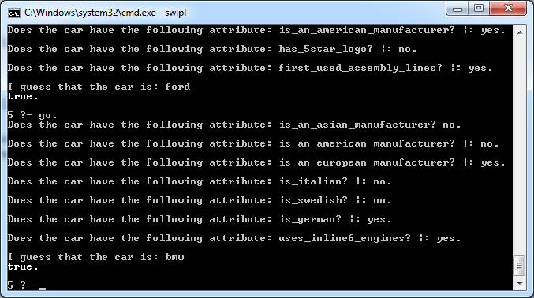

# Conclusion:

During this laboratory work I’ve learnt how to build a simple expert system. Expert systems are useful for finding the solution while interacting with the user when the data is insufficient. Expert systems help people to find the solution by providing useful hints.