# Application Testing

## Testing the Server with 1000 Requests

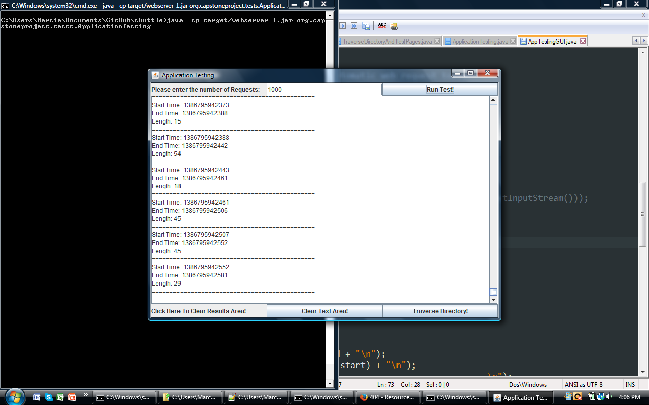

I just finished running the ApplicationTesting Program. To run to the program, I started the Shuttle webserver, and used the windows command line to navigate to the top-level directory (named shuttle). I then used the command :

**Java –cp target/webserver-1.jar org.capstoneproject.tests.ApplicationTesting**

I entered 1000 as the number of requests to generate and send to the shuttle webserver, and timed the run using the stopwatch on my smartphone. It took about 33.67 seconds for the test to complete. However, it is worthy of note that the running time seems to vary greatly. A couple of days ago, the average running time was a 1 minute and 15 seconds.

## Directory Traversal Testing

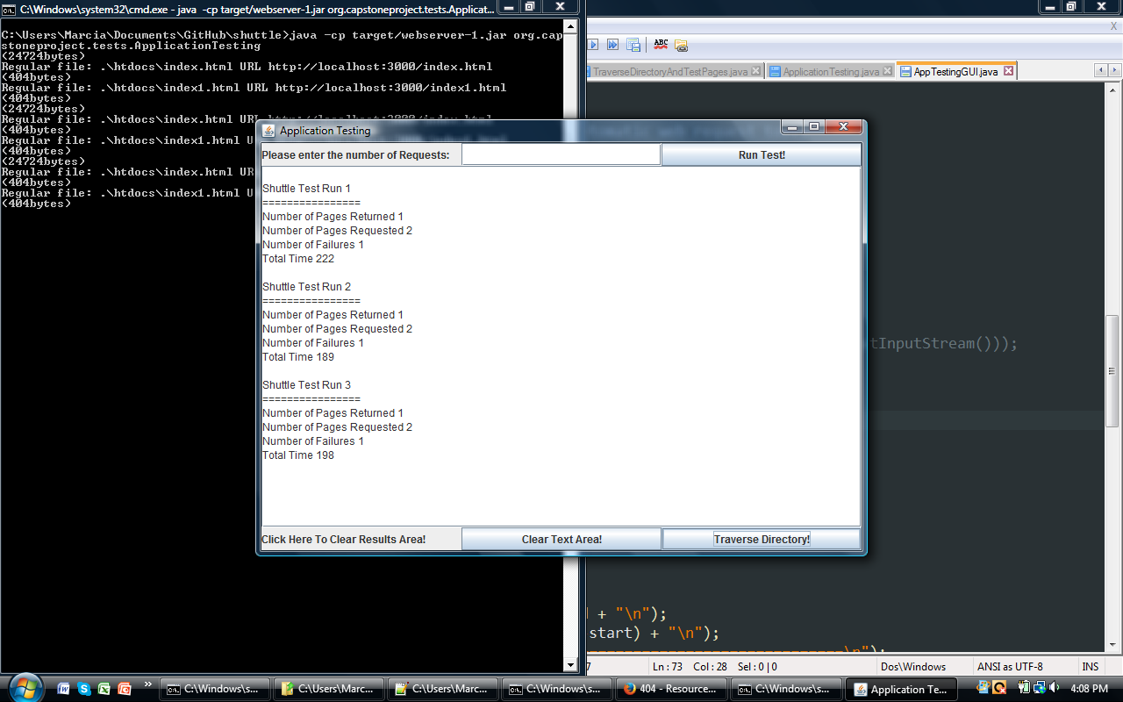

Clicking on the Traverse Directory button at the bottom of the screen will cause the ApplicationTesting program to perform a directory traversal of the default webroot. During the directory traversal, it generates a GET http request for every web page (.html) encountered and records statistics. The total time for each test run is in milliseconds.