**Databases Laboratory Work Nr 1**

**Title: Installation and Configuration of MS SQL**

**Prerequisites:** Docker, Azure Data Studio, MS SQL, zsh(or other shells)

**Objectives:** Install Database, restore AdventureWorks2017.bak and

configure login/roles.

**Tasks:**

Practical Tasks:

1) Install docker, MS SQL, Azure Data Studio.

2) Configure MS SQL and Azure Data Studio.

3) Create 3 logins (via query) and link them to database users.

Alter their roles (datawriter and datareader roles).

**Implementation**:

I am working with manjaro (archlinux) so i have somewhat harder process of installation. I decided to install ms sql through docker as container. I am doing it through pacman :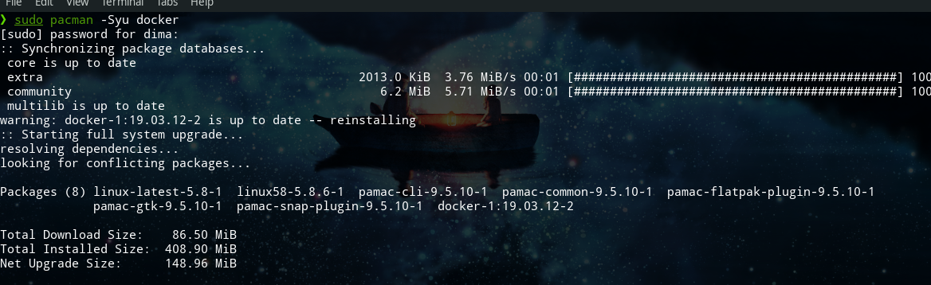

After we can write systemctl start/enable docker.service to start.

Now we can install ms sql 2017 on our ubuntu through docker and run it as container. We also can make so that ms sql will re start after every system reboot.

[https://hub.docker.com/_/microsoft-mssql-server.](https://hub.docker.com/_/microsoft-mssql-server)

As database Manager i installed Azure Data Studio.

2)Now we can enter into ms sql cmd as SA and configure our password and login. After we enter through Azure Studio

Manager and fill the required fields to connect to our database.

We have to add backup files to docker container. Firstly,

we find where our container is located (example: sudo docker in spect mssql), then to relocate backup file we will do this:



Now, Azure Data Studio can see it. Simply click on backup file in restore menu and new database will appear.

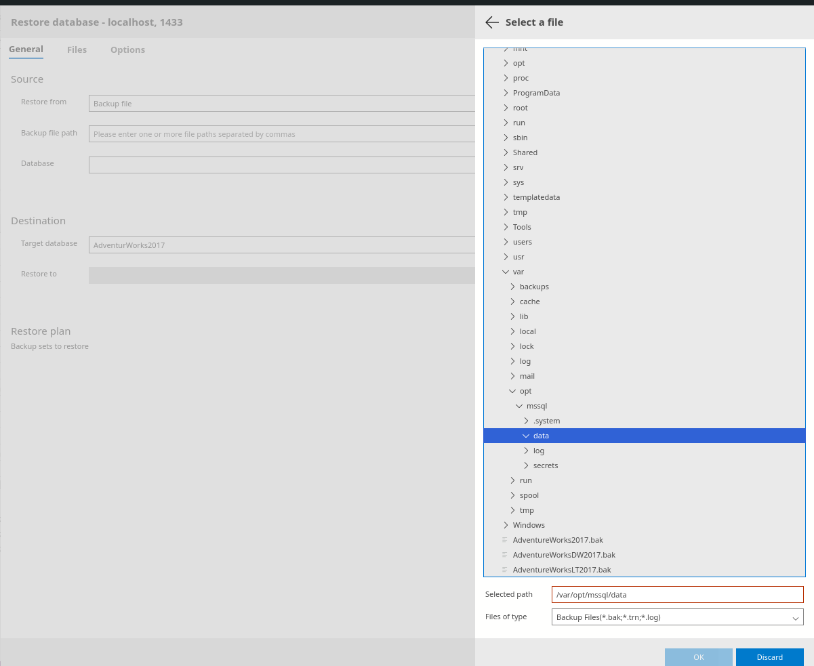

3) Finally, we can work with queries and add other users to our databases. Some examples of how to achieve this:

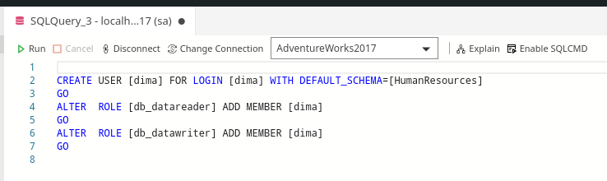

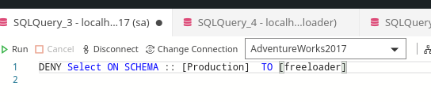

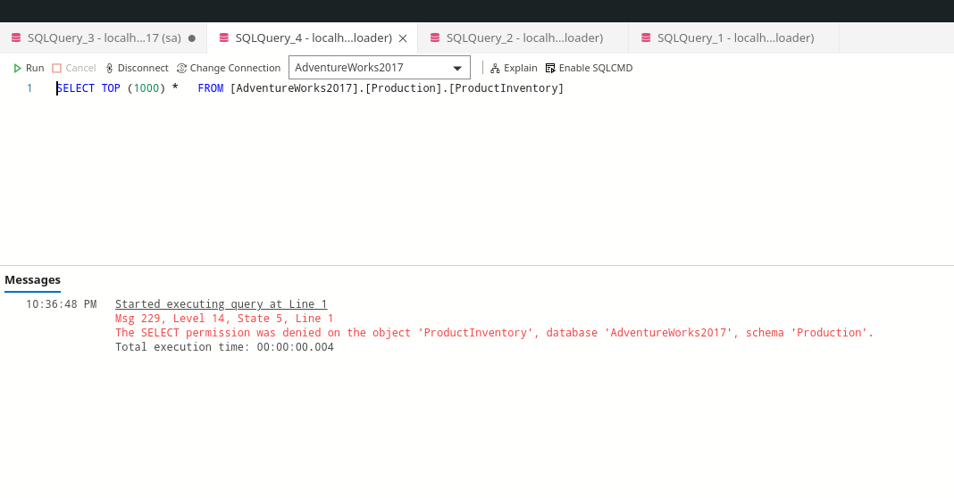

(It works!)

**Conclusion**: To summarize now we can install, configure and also write simple queries for MS SQL on linux. It is really simple to manage permissions and roles with powerful functionality of MS SQL. We also know more about Server Roles, Logins and User system.

Made by : Cambur Dumitru

Group : FAF-191