**Databases Laboratory Work Nr 3**

Creating and Modificating Tables

**Prerequisites:** MS SQL, SSMS/Azure Data Studio/e.t.c.

**Objectives:** To create a table and modify it.

**Tasks:**

1) Answer the question:



2)Answer the question:

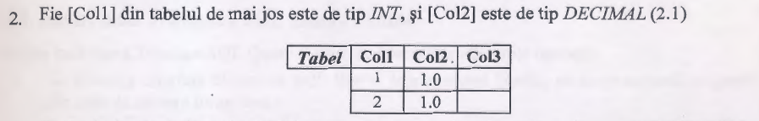

3)Create database university with tables groups, disciplines.

4)Insert the given data.

**Implementation** :

1)Decimal(4, 1) - four free spaces, one of them goint for float. So, answers are:  
 a)16.2

b)116,2

2) Answer is: Col3 - data type on the out is decimal.

1.0

2.0

3) I wrote a query to create a database named university (it’s configurations are similar to previous work configuration)

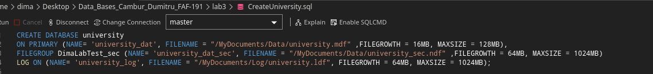

4)I wrote another query to:

1) Create Tables

2) Insert Into it Values

3) Select and show it’s values.

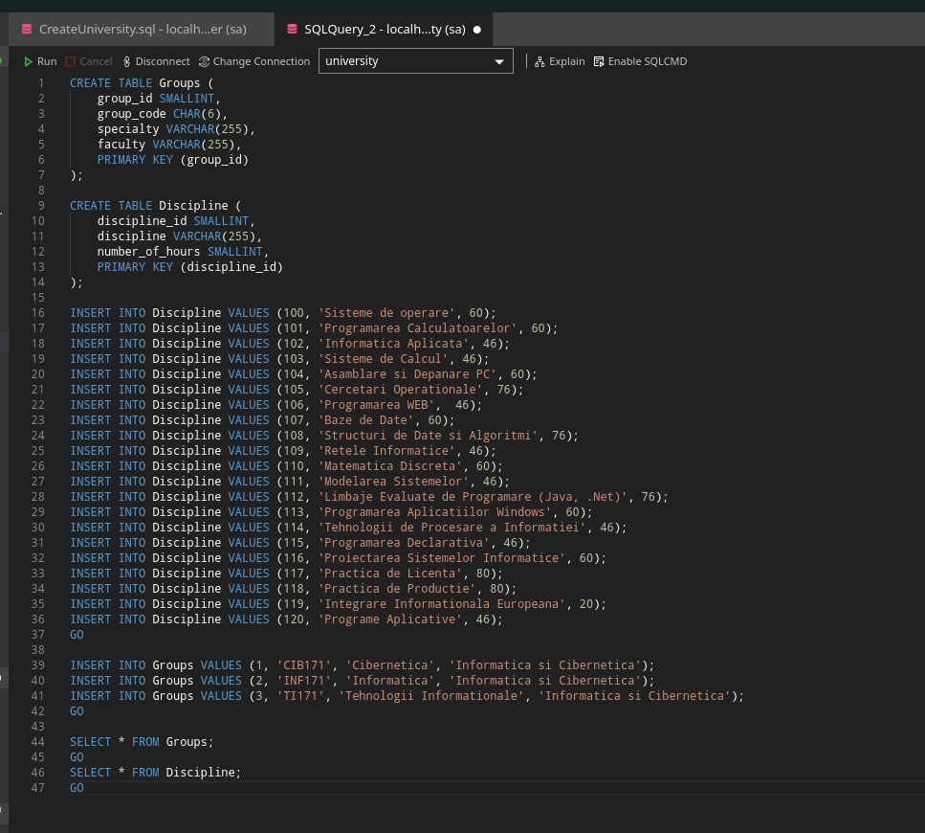

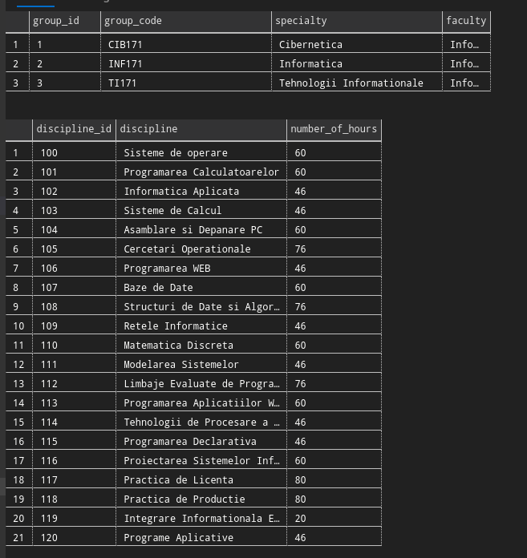

**Conclusion**: After doing this laboratory work i learnt how to work with tables, how to Select values and Insert values into them. I also know about many different data types