**Databases Laboratory Work Nr 4**

SELECT Queries

**Prerequisites:** MS SQL, SSMS/Azure Data Studio/e.t.c.

**Objectives:** To create a table and do different queries depending on task.

**Tasks:**

1: 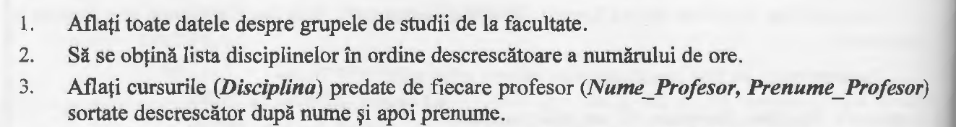

2: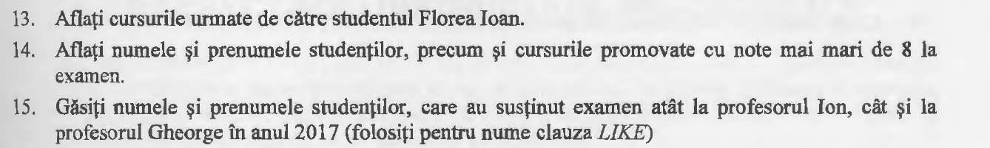

3:

**Implementation** :

1: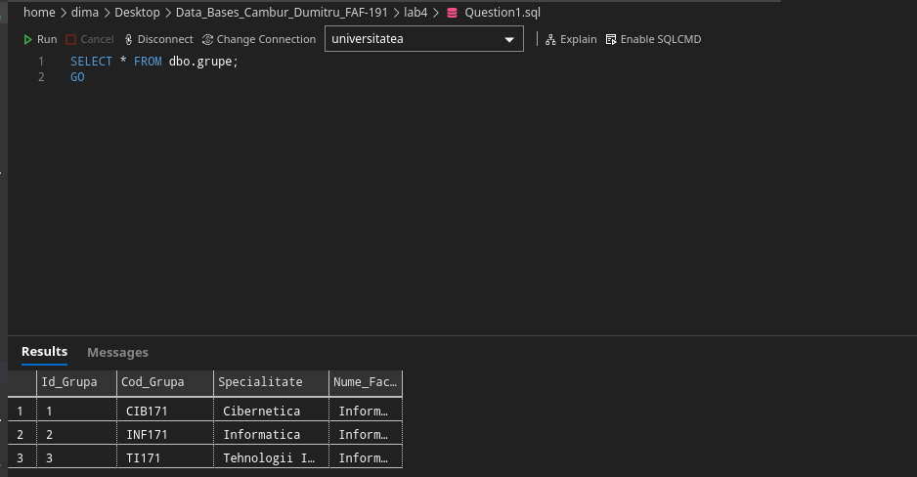

2: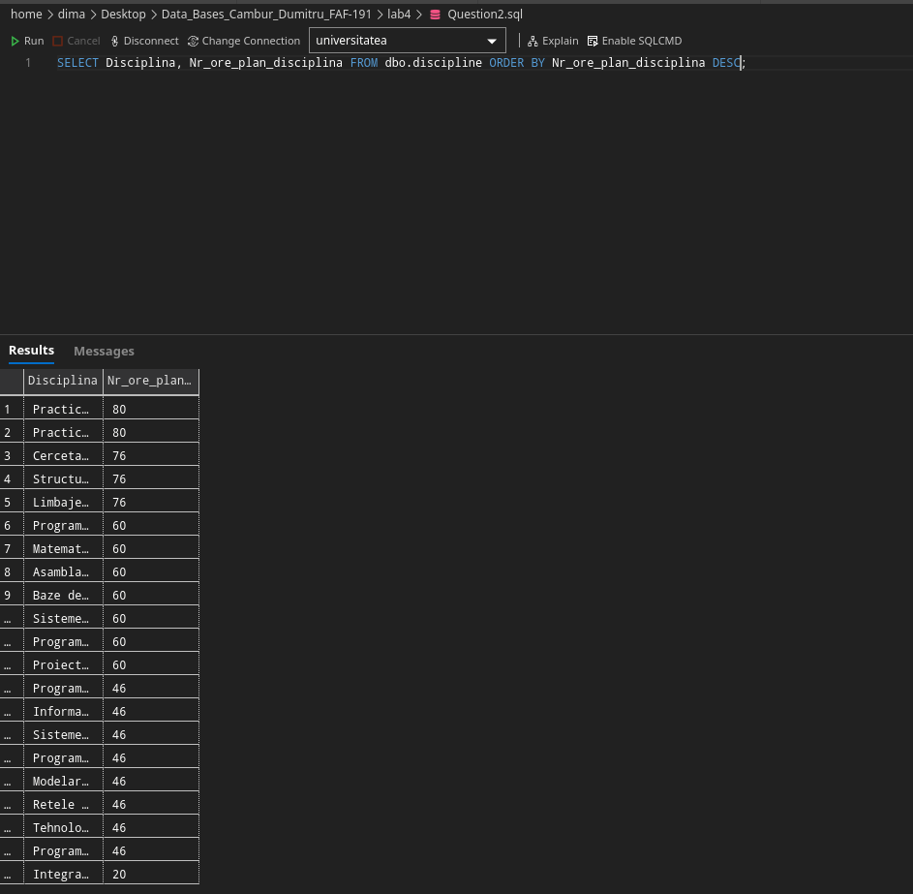

3: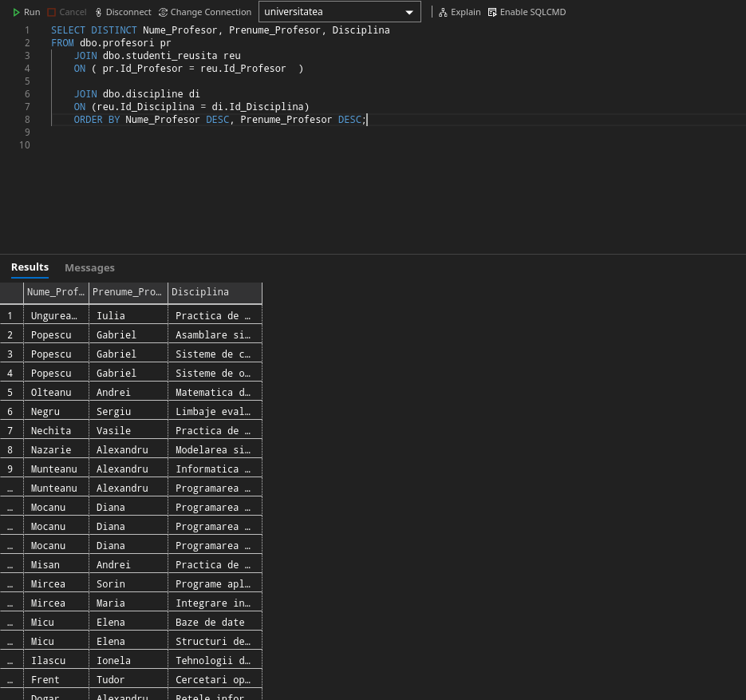

13: 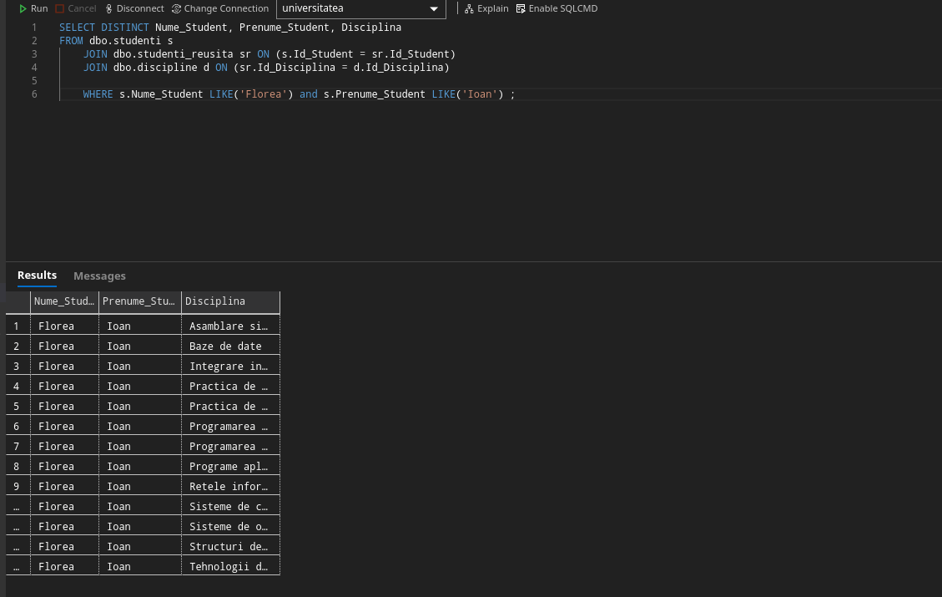

14: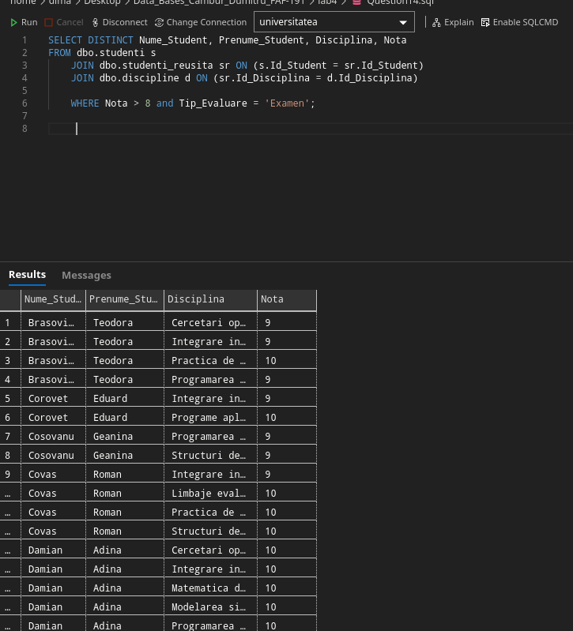

15: 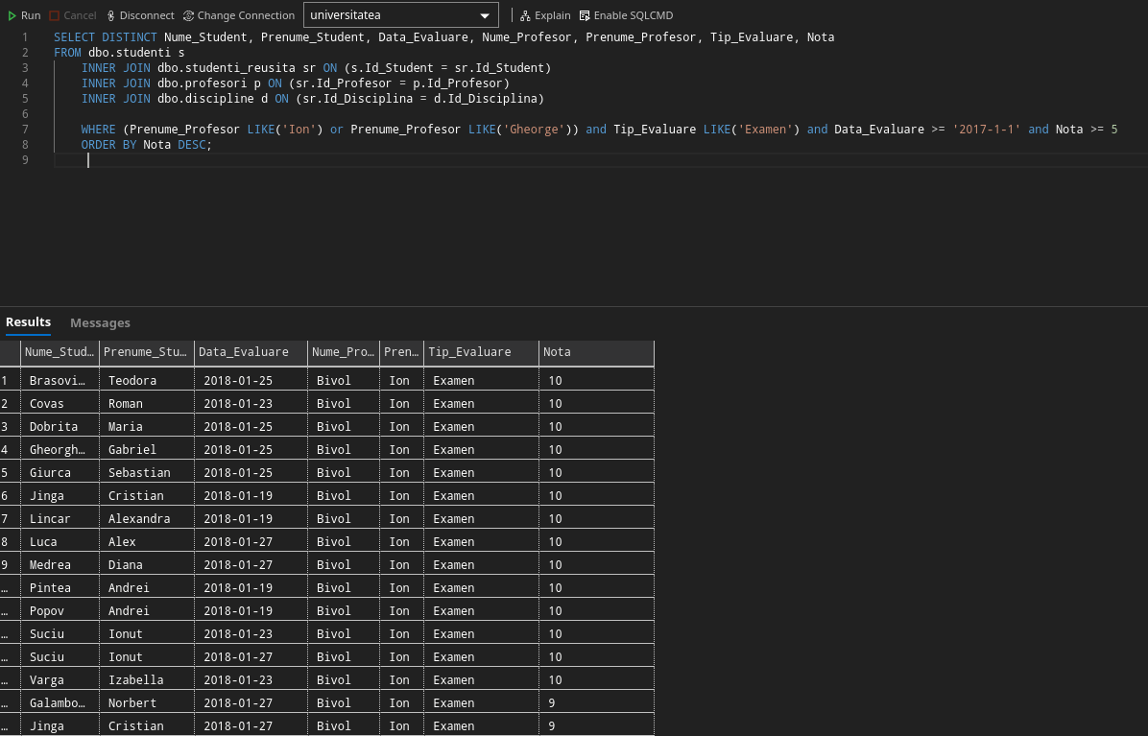

21: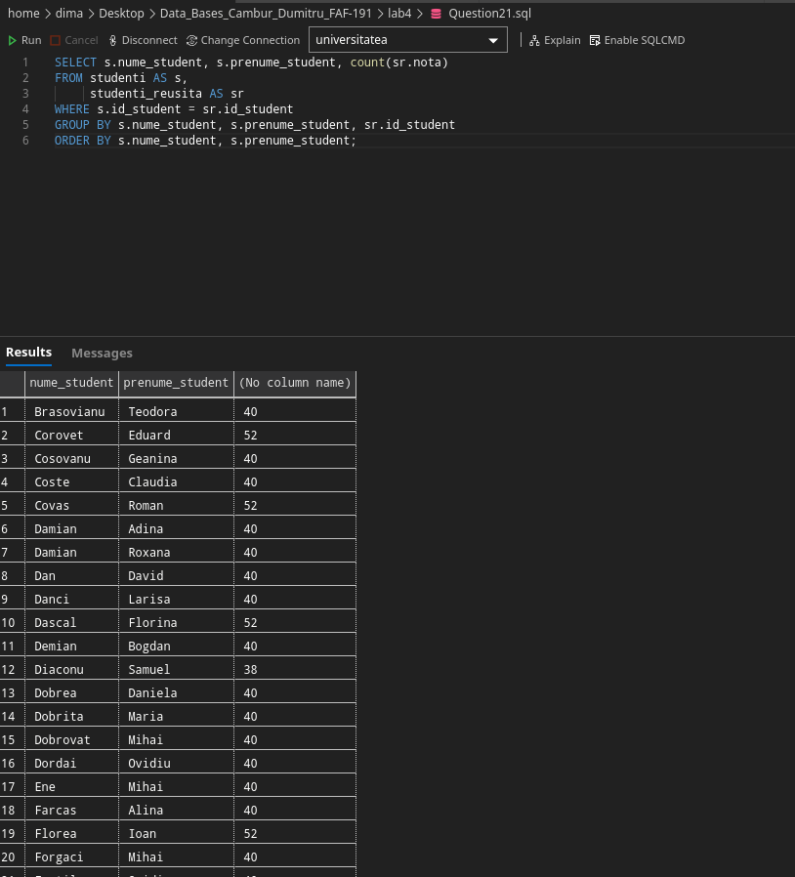

25: 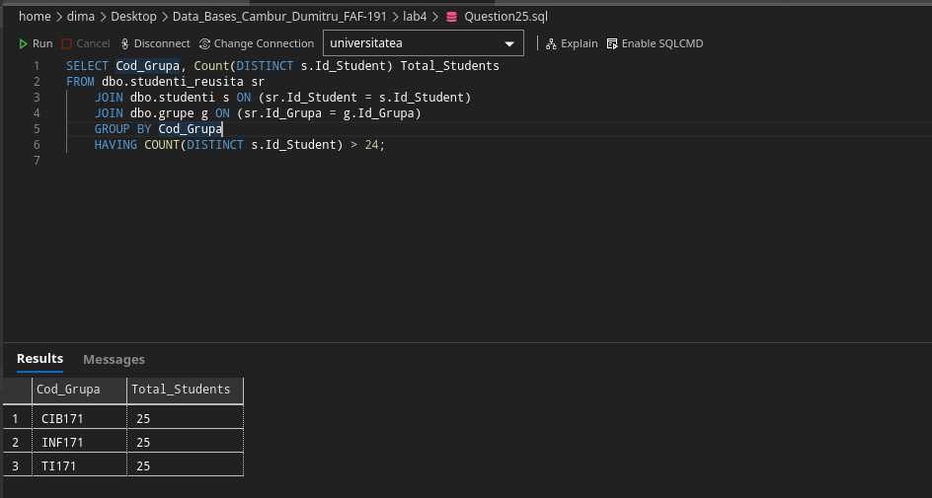

32: 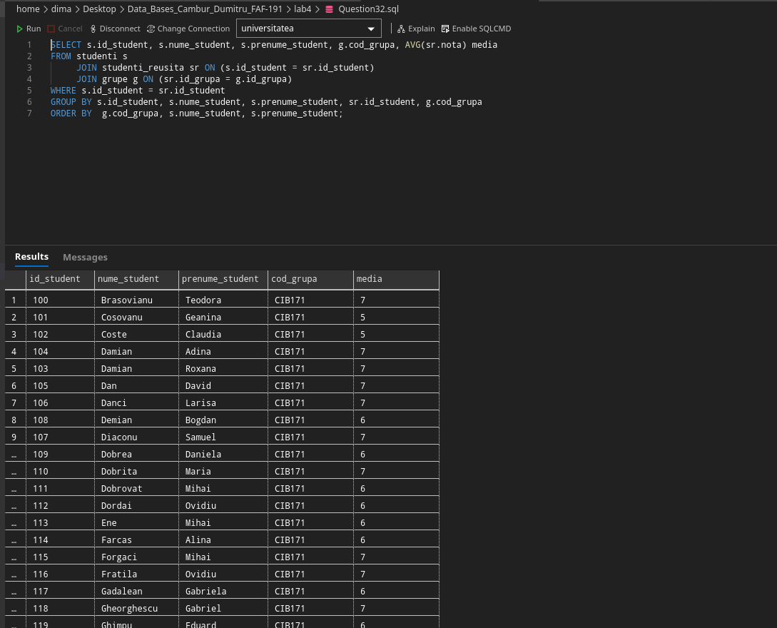

**Conclusion**: After doing this laboratory work i learnt how to work with SELECT queries. How to select by different conditions (DISTINCT, TOP, LIMIT e.t.c) , how to make different Joins (like Inner and Outer) , Unions e.t.c between tables.