ME310 – Instrumentation and Theory of Experiments

Lab 3: Drag Coefficient of a Sphere:
Variation with Reynolds Number in Subsonic Flow

CONCEPTS: Flow separation, laminar/turbulent boundary layers,
drag force, pitot-static tube, load cell, pressure transducer, roughness, interference, calibration, hysteresis, wind tunnel operation.
DELIVERABLES: Full lab report (with full uncertainty analysis) document, due in next lab period (2 weeks).

- Introduction
The characteristics of fluid flow past a rounded solid body can undergo significant variation when the flow character in the boundary layer on the body changes from laminar to turbulent. The flow past a sphere is a prominent example of this phenomenon. It is found that the drag coefficient of a smooth sphere decreases considerably as the Reynolds number (based on diameter) is increased above about 3 x 10⁵, the value at which the boundary layer on the sphere undergoes transition from laminar to turbulent flow. This transition Reynolds number can be lower if the surface of the sphere is roughened. This experiment examines the variation of the drag coefficient of spheres with different levels of roughness for different Reynolds numbers in the vicinity of this critical value.

- Theory
The drag on a sphere is composed of viscous drag and pressure (or form) drag. Viscous drag is the effect of fluid friction on the surface of the sphere. Pressure drag occurs because of the distribution of pressure on the sphere. In flow situations corresponding to very low Reynolds numbers, the pressure distribution is symmetric front to back on the sphere and there is no pressure drag. At higher Reynolds numbers, the pressure on the downstream half of the sphere is lower than that on the upstream half and there is a net force on the sphere in the same direction as the velocity. The difference in pressure comes about because of flow separation. When the boundary layer on the sphere is laminar, separation occurs near the equator (i.e., the circle of maximum diameter on the sphere with plane perpendicular to the flow) and there is a large separation region with low pressure downstream of the sphere. However, when the boundary layer becomes turbulent, the fluid elements near the surface have more energy because of better mixing and hence stay attached to the surface beyond the circle of maximum diameter. The separation region is smaller and thus the pressure drag is lower. Thus, when the boundary layer character is changed from laminar to turbulent, there is a sudden decrease in the drag coefficient of the sphere. (See Figures 1 through 5 below).

Prelab: Based on the images below, is the laminar to turbulent transition occurring in the approach flow or in the boundary layer on the sphere?

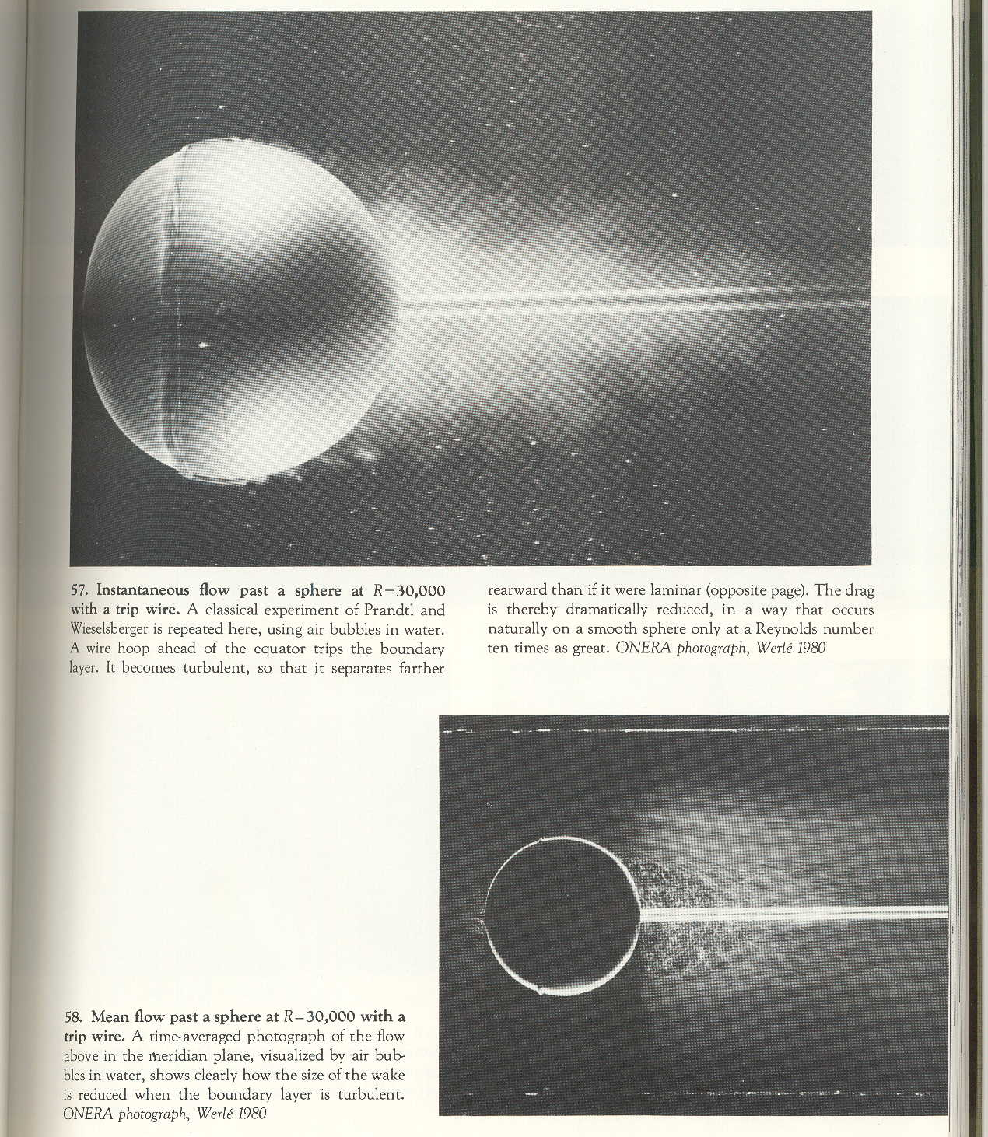
Figure 1: Flow (left to right) visualized around a sphere with a trip wire [1].

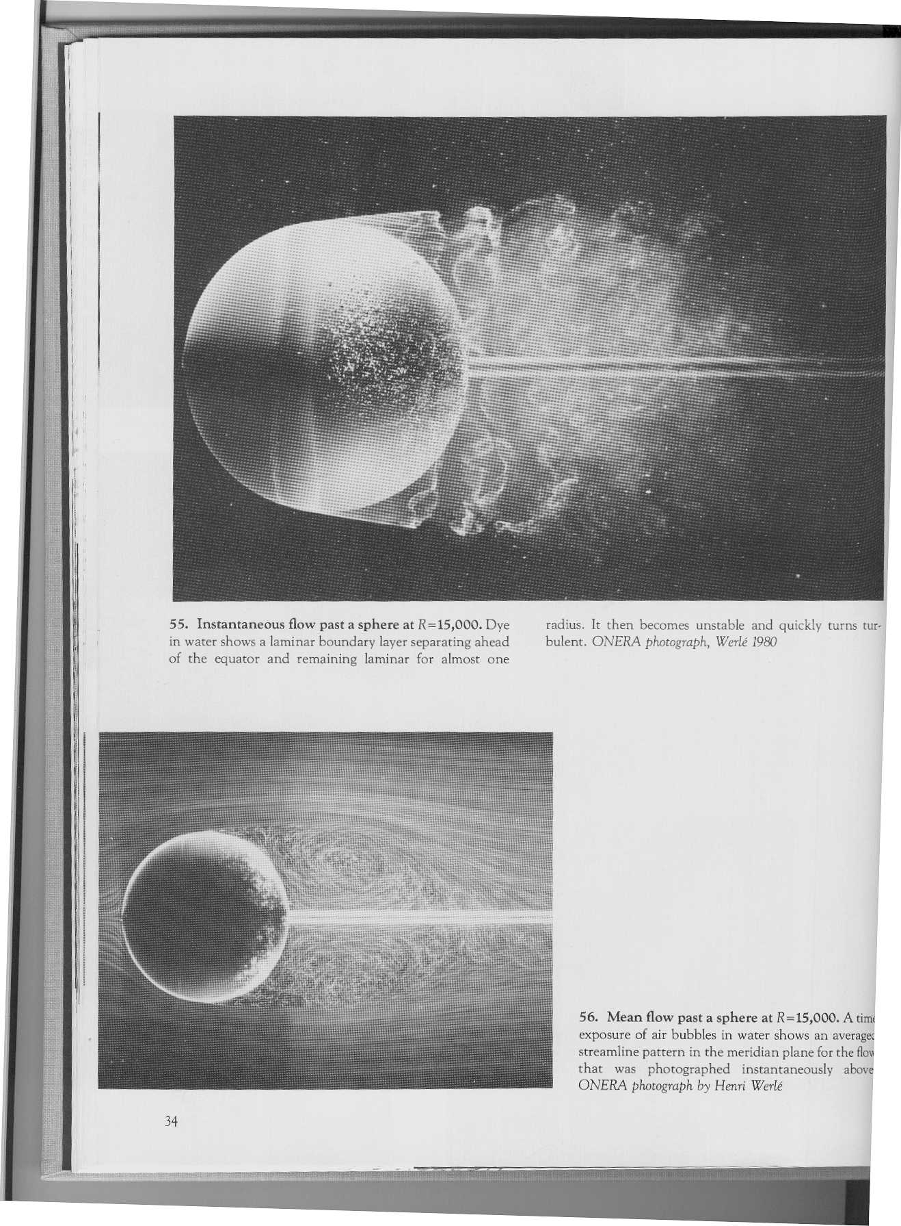
Figure 2: Flow (left to right) past a sphere; the top figure shows the instantaneous field, while the bottom shows the time-averaged field [1].

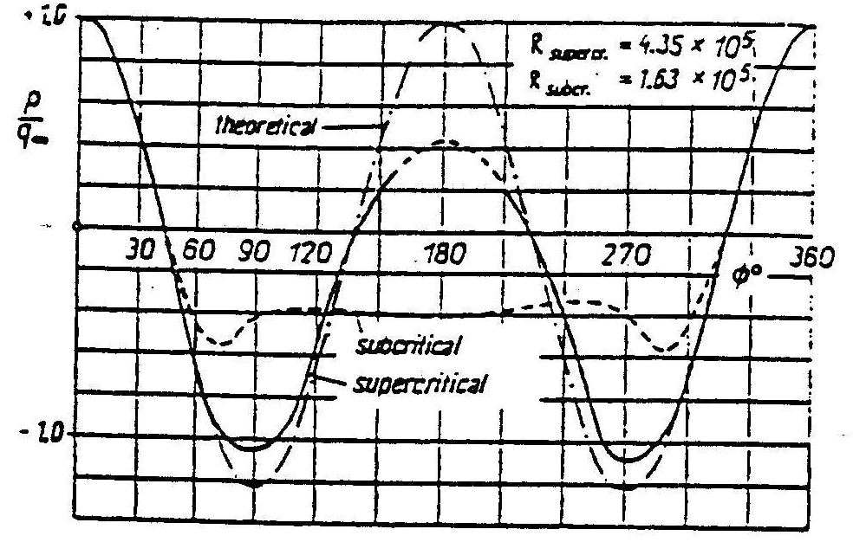
Figure 3: Pressure distribution around a sphere in the subcritical and supercritical range of Reynolds numbers [2].

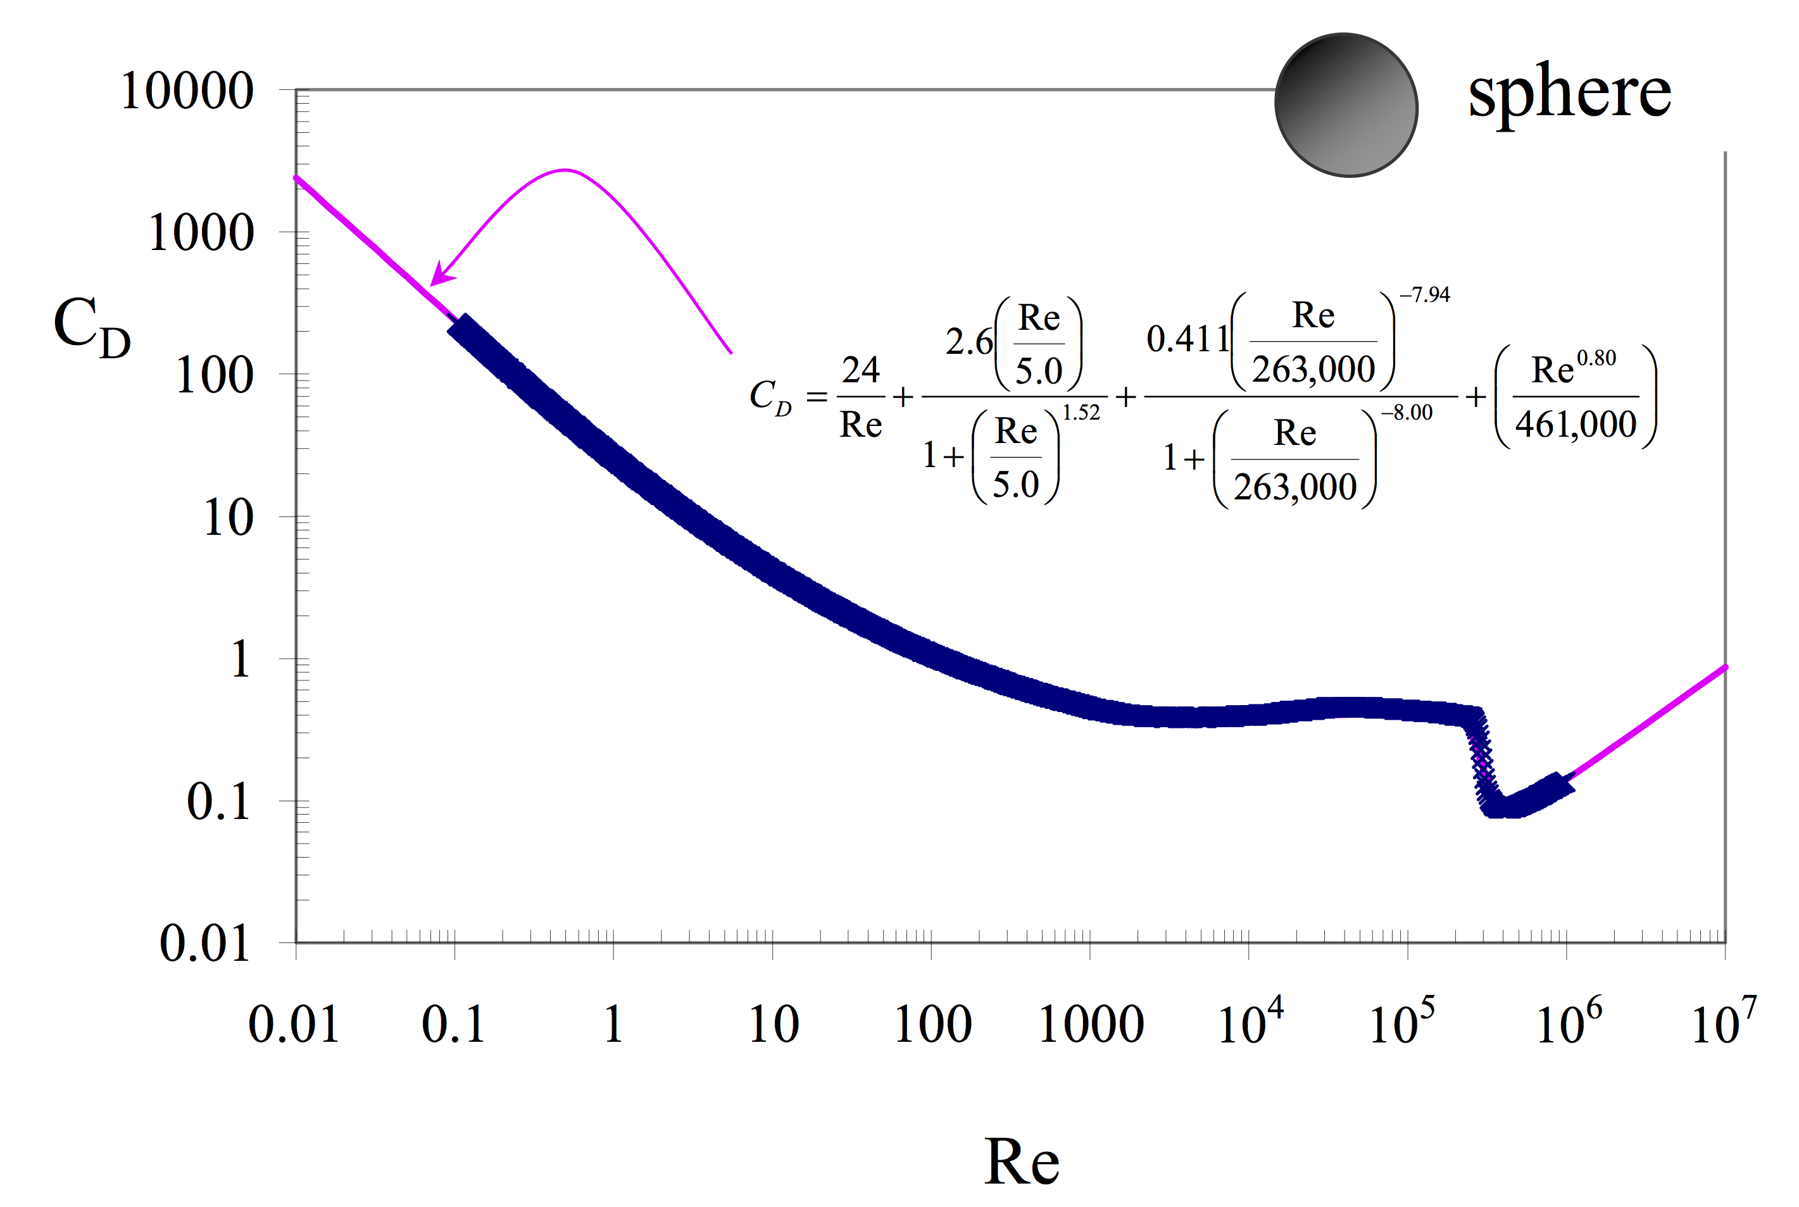
Figure 4: Computational fit of drag coefficient as a function of Reynolds number over the entire Reynolds-number range of available experimental data (labeled by arrow, in pink), as determined by Morrison [3]. Also shown (in dark blue) are data for uniform flow around a sphere [2]. Use beyond Re = 10⁶ is not recommended.

The pressure drag force (D) actually depends on four physical parameters of the flow: The diameter of the sphere (d), the flow velocity (U), and the fluid's density (ρ) and viscosity (μ). Determining how the pressure drag changes with changes in all of these parameters would involve a great many expensive tests (e.g. we would have to use different model spheres to vary the diameter and different fluids to vary the density without changing its viscosity, and it might be impossible to find fluids with different densities but the same viscosity). However, the powerful analytical tool called dimensional analysis (which you learned in ME 303!) tells us that if we consider a dimensionless pressure-drag coefficient (C_{D}) instead of the pressure drag itself, this coefficient can be shown for a smooth sphere to be a function of only one single dimensionless parameter, namely the Reynolds number, Re (which is a combination of the four parameters mentioned above). ε is the roughness length. For a roughened sphere the dimensionless roughness, ε/d also affects C_{D}.

D = funct(d,U,ρ,μ,ε) (1)

but it can be shown by dimensional analysis (PRELAB: Show this derivation) that

C_{D} = funct (Re) (2)

in which (3)

where S is the frontal area of the sphere (πd²/4), and

(4)
Dimensional analysis itself, however, cannot tell us how the drag coefficient changes with changes in the Reynolds number. This functional relationship must be found from known physical laws or from experiment. In this lab you will be determining the functional relationship experimentally. Dimensional analysis lets you determine the complete functional relationship between the drag coefficient of a sphere with a fixed ε /d and the Reynolds number by varying only one parameter in your experiment (the velocity, which is easy to vary) instead of all four parameters.

In order to determine C_{D} and Re, we need to know each parameter in their respective equation. Some of these are physical constants that we can look up via a reference and others we need to measure. PRELAB: For each parameter in Eqs. (3) and (4), write down whether it is a reference parameter (e.g., not affected or changed by the experimental setup) and identify its value, or an experimental parameter.

- Experiment

The experiment consists of placing a sphere in a uniform airflow and measuring the velocity of the flow and the drag force on the sphere at various airspeeds. The Reynolds number and the drag coefficient can be computed from the data.

The uniform airflow is created in a low-speed wind tunnel (see Figure 6). The model sphere is mounted in the test-section where the air velocity can be varied between about 5 m/s and 50 m/s. [Note, the test section interior dimensions are: Length 48”, width 18”, height 18”]. The velocity of the flow is measured by means of a pitot static probe placed in the tunnel upstream of the sphere. A pitot probe is basically a (small) guide for the air in the tunnel and allows us to measure the static pressure at that position. The difference between the static and total pressures coming from the probe is measured with an inclined tube manometer and a pressure transducer, with the voltage output from the pressure transducer being sent to a PC.

The wind tunnel system is an Eiffel type suction tunnel. Air is drawn into the radiused inlet, through a honeycomb and screen pack and is accelerated through the contraction into the test section. The system air regains static pressure through the downstream diffuser. Flow continues through the axial fan and acoustic diffuser and is discharged to the atmosphere. An in-line centrifugal type fan is used to control the tunnel. The fan is driven by a 25 Hp variable speed AC induction motor. A transistor invertor type variable frequency controller regulates fan shaft RPM. A speed control station, located at the upstream end of the diffuser, regulates the test section velocity. The invertor may be controlled using either the keypad or a 0-10VDC input. For this experiment the 0-10VDC input is provided through the BNC-2090 box and controlled by the PC.

Note: The tunnel can be stopped in an emergency by switching off the power at the speed control station!

Flow Conditioners
Test Section
Tunnel Speed Indicator (Keypad)
Fan
Acoustic
Diffuser
Mount
Diffuser
Power Control Station
Figure 6: Low-speed wind tunnel, with air flowing from right to left.

The drag force on the sphere is measured by means a load cell on the wind tunnel mount (see Figs 8 and 9). The load cell is mounted within the arm of the mount for the purpose of measuring the forces applied to the mount arm by the sphere. Load cells are transducers that produce electrical signals proportional to the applied load. Although the mount is designed to measure the lift, drag and pitching moment on the model, only the drag force will be measured in this experiment. The power for the load cell is provided by a separate power supply, with the resulting output signal from the load cell being sensed by a digital multimeter, from which it is sent to the PC using a GPIB connection (see Fig 7); a GPIB is a data transfer protocol that uses a board installed on the computer to collect data from one or more digital measurement devices.

Ideally, we would like to measure the drag force on an isolated sphere when it is in an infinitely large flow field, without introducing any extraneous bodies to measure the force. However, this is not possible in reality and we have to use a finite sized test-section as well as an external support to hold the sphere.
Figure 7: Experimental arrangement. Fig. 9 shows a detailed view of the Tunnel Test Section.

By inserting the load cells in the arm of the mount and attaching them only to the tip of the arm, the load cells only measure force applied directly to the tip of the arm by the sphere, thus minimizing the effect of the mount on the measurement. [Note: the mount could still have an effect on the results due to its presence disturbing the flow downstream of the sphere]

Experiments with wind tunnels have shown that if the projected frontal area of the body (sphere in this case) is less then 10% of the cross-sectional area of the test section, then the test-section walls do not influence the flow on the body significantly. Of course, we should place the sphere inside the test-section centrally and not in close proximity to one or more walls. If the blockage (ratio of frontal area of body to the area of the test-section) is significantly more than 10% we have to make corrections to account for the presence of the walls.

- Detailed Procedure

The experimental procedure consists of several steps. Extreme care should be exercised in performing the experiment. NOTE: Use and attachment of this Procedure for your prelab is permitted, but make sure to address the following prelab question:

PRELAB QUESTION (discuss at the end of Theory section): What physical parameters are measured in this lab and how are they helpful for the accompanying analysis? Which physical instruments are involved in measuring these parameters?

  - Set-up of Measurement System

GSTs: Prelab checks:
- The Pitot tube has two airlines. Each line runs out of the wind tunnel chamber and splits via a valve to 2 airlines; one line leads to the manometer (on the bench – not the multichannel upright manometer bank!) and the other leads to the pressure transducer unit (above the manometer). The control valves are clearly labeled on a red display board at the top of the tunnel chamber. Make sure both stopcocks are pointing (long arm to the right) towards ‘Vertical Manometer’, for both the static and total lines.
- Turn on power to Pressure Transducer system, digital multimeter, PC, and tunnel.
- Position mount arm 9 inches above floor of tunnel (this may already be completed). Use the supplied level to make sure that the arm is horizontal.
- Position tip of the pitot static probe upstream of the center of the sphere, half way between the top of the sphere and the tunnel roof (Position: X=0.150 m and Y=0.368 m on assembly readout). Pitot static probe can be positioned using knobs on pitot probe mount above tunnel (this step may already be completed).
- With pitot-static probe lines open, ‘Zero’ pressure reading on digital readout by adjusting ‘zero’ dial on pressure indicator on the Digital Readout Assembly until reading approaches zero.

Students: Prior to starting procedure:
Check set-up is connected as shown in Figure 7. Draw your own block diagram that shows all the signal connections between the instruments. Make sure you can identify which instruments are being used in this lab – they’re not necessarily obvious or familiar (see prelab question above).

Discussion question: As the load cell measures the force applied along the axis of the mount arm, what error in the measured drag would be seen if the mount arm wasn’t perfectly horizontal?

Calibration
    - Calibration of Force Load Cell
WARNING: The following steps require work within the test section of the tunnel. Be extremely careful when working around load cell! The load cell is extremely delicate - excessive load or torque on the load cell will damage it!

1. Open side door to tunnel test section by releasing clamps. [Warning: hold on to door when opening, as the door is spring loaded. Be careful to avoid snagging any wires when opening door!]

2. Carefully place calibration connector onto end of mount arm and place calibration rig in tunnel as shown in Figure 8.

3. Open LabVIEW program “Load Cell Calibration_310.exe,” located in the “ME310 vi’s” Folder on the desktop of the PC.
Calibration Rig
Load cells
Calibration
Connector
Mass
Wire
Figure 8: Positioning of Calibration Rig.

4. Input required information into LabVIEW program (i.e. date and group number).

5. Start Program by ‘left clicking’ on the play button () at the top left of the LabVIEW control panel screen.

6. Incrementally apply a load to the calibration rig. Increase the mass from 0 to 1.0 kg in 0.1 kg steps and test for hysteresis by decreasing the mass in 0.1 kg steps after reaching 1 kg. The required mass will be indicated on the control panel of the LabVIEW program.
7. Hit ‘TAKE READING’ button in LabVIEW program to record voltage corresponding to added load. (Note: for each reading the average value and standard deviation from 50 samples is automatically recorded and saved to a file, the sample rate is approximately 5 Hz, check the user manual of the multimeter for the resolution of the measurement).

8. Record mean voltage from multimeter readout as computer reads data. You will have to estimate the value because the display will fluctuate.

9. SPOT CHECK: LabVIEW plots the raw voltage for each run and the ongoing results in the upper-right side of the screen. Make sure these values change in a sensible fashion as the tunnel velocity changes throughout the experiment.

10. Repeat steps 6 through 9 for each required load.

11. Note down values and units for ‘Slope’ and ‘Intercept’ from LabVIEW curve-fit. This information shall be required to carry out the experiment.

Open test section and remove calibration rig.

On completion of program, results will be sent to the file location indicated in the LabVIEW program. The output file will include mass and corresponding output voltage information. Check the file to make sure the values make sense.

    - Calibration of Pressure Transducer

WARNINGS:
1. Make sure calibration rig and all attachments have been removed from tunnel!
2. Be extremely careful when handling sphere and load cell attachment – do NOT apply excessive force to load cell! Each sphere has a threaded brass nut that sits in the bore of the sphere; the sphere attaches to the load cell via the threaded rod on the end of the sting.

1. Choose one of the spheres and measure/record its diameter. Attach the sphere onto the sting by sliding it on and carefully screwing the brass connector onto the end of the sting. CAUTION: Do NOT over tighten connector, since this may damage the load cell. (See Fig. 9). The press fit should be snug, but do not use an impact or screwing motion.

Mount Arm
Load Cells

Sensor
Brass Connector
Sphere
Signal to
and from PC

Figure 9: Positioning of sphere on the sting.

2. Close and seal tunnel door.

3. Open LabVIEW program ‘Transducer calibration.exe,’ located in the “ME310 vi’s” Folder on the desktop of the PC.

4. Input required information into LabVIEW program (i.e. date, group number and temperature).

5. Start Program by ‘left clicking’ on the play button () at the top left of the LabVIEW control panel screen.

6. Hit ‘CONTINUE’ button to set tunnel to required speed (the input voltage corresponding to each calibration speed is indicated in the program).

7. Once tunnel speed has reached steady state (i.e. when indicator on tunnel readout and reading on manometer have reached constant value) read height (in inches of water) corresponding to dynamic pressure in tunnel.

8. Input the height into the LabVIEW program and record the manometer reading.

9. Hit ‘TAKE READING’ button to read voltage data from pressure transducer (Note: for each reading the average value and standard deviation from 10000 samples is automatically recorded, the sampling rate is displayed on the front panel of the vi, the data acquisition board taking the samples is a 16 bit board, and measures in the range of -10 to 10 V).

10. SPOT CHECK: LabVIEW plots the raw voltage for each run and the ongoing results in the upper-right side of the screen. Make sure these values (the mean voltage) change in a sensible fashion as the tunnel velocity changes throughout the experiment.

11. Repeat steps 7 through 10 for each required tunnel speed. The program will perform both an incremental and decremental sequence to check for hysteresis.

12. Note down values for ‘Slope’ and ‘Intercept’ from LabVIEW linear curve-fit for voltage vs load. The calibration data information is required to carry out the experiment.

On completion of program, results will be sent to the file location indicated in the LabVIEW program. Output file will include height and output voltage information. Check the file to make sure the values make sense.

Once all data has been taken, the tunnel will automatically power down.

  - Drag Measurements
This subsection is to be repeated three times, once for each of the three sphere samples. Use care in the handling and mounting of the spheres. Store spheres in their drawer when not in use. Leave the sphere that is already mounted on the sting in place.

1. Measure sphere diameter and carefully mount sphere to the sting in the tunnel (slide the sphere onto the sting and screw clockwise to thread the brass connector onto the sting threads. Do NOT apply impact or torque when fitting sphere to mount arm).

2. Close and seal tunnel door.

3. SPOT CHECK: What physical parameters are being measured/detected in this lab (please don’t say ‘voltage’…)? How are these parameters helpful for the analysis? Make sure you clearly identify the relevant physical instruments used in this lab.

4. Open LabVIEW program ‘Drag Measurements.exe,’ located in “ME310 vi’s” folder on the desktop of the PC.

5. Input ‘slope’ and ‘intercept’ data for both the load cell and pressure transducer into LabVIEW program.

6. Input required information into program (i.e. date, group #, sphere and temperature).

7. Start Program by ‘left clicking’ on the play button () at the top left of the LabVIEW control panel screen.

8. Hit ‘CONTINUE’ button to set tunnel to required speed (the input voltage corresponding to that speed is indicated in the program).

9. Once tunnel speed reaches steady state (when tunnel readout indicator and reading on manometer reach constant value) hit ‘TAKE PROFILE’ button to take readings.

10. Record height from manometer and estimated average voltage from multimeter. These values are for reference and backup purposes only; use them in your analysis only if the digital files are corrupted or missing.

11. Repeat steps 8 - 11 for each required speed, as noted on LabVIEW screen. The program will perform both an incremental and decremental sequence.

Discussion question: Why perform the experiment for both increasing and decreasing velocity changes? Does transition from laminar to turbulent conditions occur at the same Reynolds Number as that from turbulent to laminar?

Once all data has been taken, the tunnel will automatically power down.

On completion of program, results will be sent to the file location indicated in the LabVIEW program. Output file will include pressure transducer and load cell output voltage information, and corresponding C_{D} and Re. Check the file to make sure the values make sense.

5. Results
Note: A full uncertainty analysis is expected for all results EXCEPT for the Reynolds number. You are responsible for finding the data sheets for the relevant instruments on your own. Make sure to reference your Equipment List for the necessary information. The relevant ADC acquisition information appears in the procedure.

1. (a) Plot voltage against force for the data collected during the load cell calibration.
(b) fit a linear curve to the data.
(c) Calculate the standard error of the fit.
(d) Invert the linear relationship to get a calibration curve for the load cell.

2. (a) Plot voltage against dynamic pressure for the pressure transducer calibration data.
(b) fit a linear curve-fit to plot.
(c) Calculate the standard error of the fit.
(d) Invert the relationship to get a calibration curve for the pressure transducer. (e) Discuss the accuracy of the linear curve-fits.

3. (a) Using the curve-fit information, calculate the drag of the spheres. Calculate the drag coefficients for all three cases, and the Reynolds numbers, at the different airspeeds tested. Use the diameter of the sphere as the characteristic length and the sphere frontal area as the characteristic area in all three cases.
(b) Compare results from computer outputs to those obtained by manually reading results from manometer and multimeter.

4. Note: The values and their related uncertainty on these plots should be from the results obtained using your own calibration data (not the computer-generated calibration) and that obtained from your own calculations (not the computer-generated Re, Cd results).
(a) On a single graph, plot the drag coefficients of all three spheres as functions of the spheres’ Reynolds number (use separate symbols for increasing and decreasing Re data for each sphere). Remember that U_Re is not a required analysis.
(b) On a second graph, plot the drag coefficients of all three spheres as a function of Re, for increasing Re only, and also the accepted functional relationship as shown in Figure 4. Use logarithmic scaling on both axes, as in Figure 4.

5. (a) Discuss the results obtained.
(b) What did you learn from this experiment?
(c) What was the blockage ratio for your experiment?
(d) Did transition occur where you would expect from accepted results?
(e) Compare and contrast the results for the three spheres.
(f) Comment on the difference seen in the increasing and decreasing Re data.
(g) Use Figure 5 to estimate the dimensionless roughness (ε/d) of the two roughened spheres.

- Analysis Guidance: Try to think about these questions while you’re performing the lab.
- What physical instruments did you use in these experiments and what is their information useful for?
- What physical parameters do you need information on, in order to calculate C_{D} and Re? Note that this question is closely tied to the answer for question 1 above.
- What instrument was used to digitize the voltage from the load cell? What instrument was used to digitize the voltage from the pressure transducer?
- What uncertainty sources apply to the (a) data that was acquired; (b) the instruments that you used to acquire them; and (c) the relationship between the measured voltage and the physical parameters that you need to calculate C_{D} and Re?

- Additional Information
Find kinematic viscosity and density of air from tables. Calculate correct values for your temperature. The specific gravity of Meriam red oil is 0.827. The inclined tube manometer in the experiment contains Meriam red oil, but the scale has been calibrated to give a reading in inches of water, so the density of water should be used in the calculations.

Symbols Used
Re - Reynolds number
U - Free system velocity
d - Diameter of sphere
D - Drag on sphere
S - Frontal area of sphere
μ - Kinematic viscosity of air
ρ - Density of air
ε - Roughness

- Additional Reading
Beckwith, Thomas G., N. Lewis Buck, and Roy D. Marangoni. Mechanical
Measurements. Reading, Massachusetts: Addison-Wesley, 1982. Pgs: 421-430 and 501-504.
Binder, Raymond D. Fluid Mechanics. Englewood Cliffs, NJ: Prentice-Hall, 1973. Pgs. 144-156.
Dally, James W., William F. Riley, and Kenneth G. McConnell. Instrumentation for Engineering Measurements. 2nd ed. John Wiley & Sons, 1992. Pgs. 242-253, 461-
466.
Figliola, Richard S. and Donald E. Beasley. Theory and Design for Mechanical
Measurements. 2nd ed. New York: Wiley, 1995. Sections 8.3 and 8.7.
Gerhart, Phillip M. and Richard J. Gross. Fundamentals of Fluid Mechanics. Reading, Massachusetts: Addison-Wesley, 1985. Pgs. 526-531.
Kuethe, Arnold M. and Chuen-Yen Chow. Foundations of Aerodynamics. 3rd ed. New York: Wiley, 1976. Pgs. 373-377.

- References
- Gerhart and Gross, Fundamentals of Fluid Mechanics, Addison-Wesley, pp. 526-531, 1992.
- H. Schlichting, Boundary Layer Theory, McGraw-Hill, NY, 1955.
- Faith A. Morrison, “Data Correlation for Drag Coefficient for Sphere,” Dept Chem Eng, Michigan Technological University http://www.chem.mtu.edu/~fmorriso/DataCorrelationForSphereDrag2013.pdf

- Authors
Written by B. Bharadvaj (Aug. 1982). Most recent revision: C. Farny (February 2018).

