ME421 – Aerodynamics
Flow past a Right Circular Cylinder

(Revised by G. Dewar - Sep. 2000, Sheryl Grace – Jan. 2018, Austin Thai – Jan. 2019)

- Introduction

The flow normal to a circular cylinder is “canonical” in that it is a simple fluid dynamic system, which may represent flow past nearly any non-streamlined body. The flow presents some interesting features, including boundary layer separation and vortex shedding. In this laboratory, we will measure average pressures and visually observe streamlines for flow over a cylinder. We will compare the measurements to the values generated by potential flow theory.

- Laboratory Information

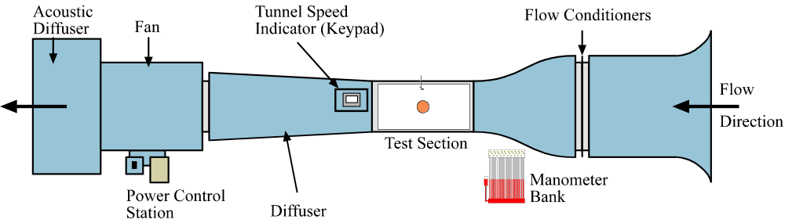

Figure 1: Low Speed Wind Tunnel.

The purpose of this lab is to investigate the pressure profile on the surface of a right circular cylinder for a set Reynolds number (Re_{D}=U∞D/v) and compare the results to those predicted from potential flow theory. The experiment will be carried out in the low speed wind tunnel (see Figure 1), at Reynolds numbers given by the TF.
The low speed wind tunnel is fitted with a 2-inch diameter cylinder in its 18-inch by 18-inch test section. The cylinder has 10 pressure taps around its circumference at 20º intervals, the positions of which can be controlled by rotation of the cylinder within its housing. These pressure taps are connected via tubing to a pressure transducer and digital readout assembly. A Pitot probe (measuring P_{T}) and static tap (measuring 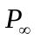) are installed in the wind tunnel to determine the freestream velocity.
The digital readout assembly will collect differential pressures 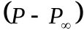 for each port (1 through 18, corresponding to angles 0º through 340º at 20º intervals) and Pitot-static pressure 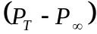 at the designated Reynolds number. The speed of the tunnel will be chosen based on the desired Reynolds number. The inclined manometer and computer interface will not be used for this lab.

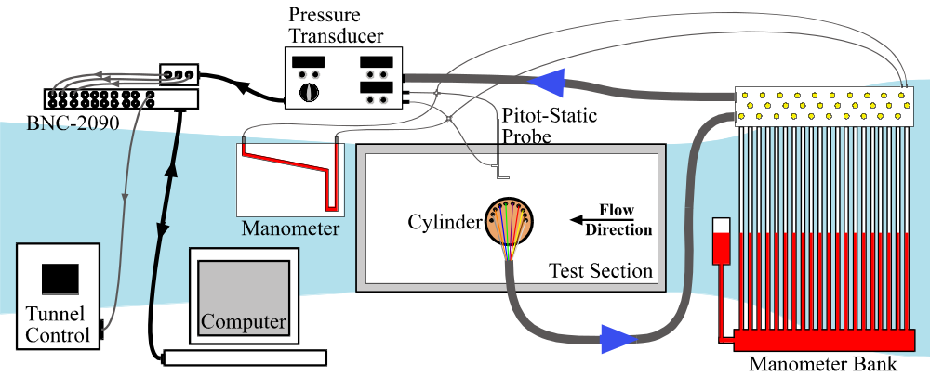

Figure 2: Experimental Setup for Tunnel Test Section

To read the pressure at each port turn the dial on the digital readout assembly to the appropriate port number. Port ‘0’ reads the Pitot- static pressure , while ports ‘1’ through ‘9’ reads the differential pressure on the cylinder surface, with port ‘1’ corresponding to the upstream edge of the cylinder when it is set at 0º. The pressures can also be obtained manually from the manometer bank attached to the cylinder pressure ports. Valves above the manometer bank allow readings to be taken by either the pressure transducer or the manometer bank. The coordinate system used for the cylinder can be seen in Figure 3.

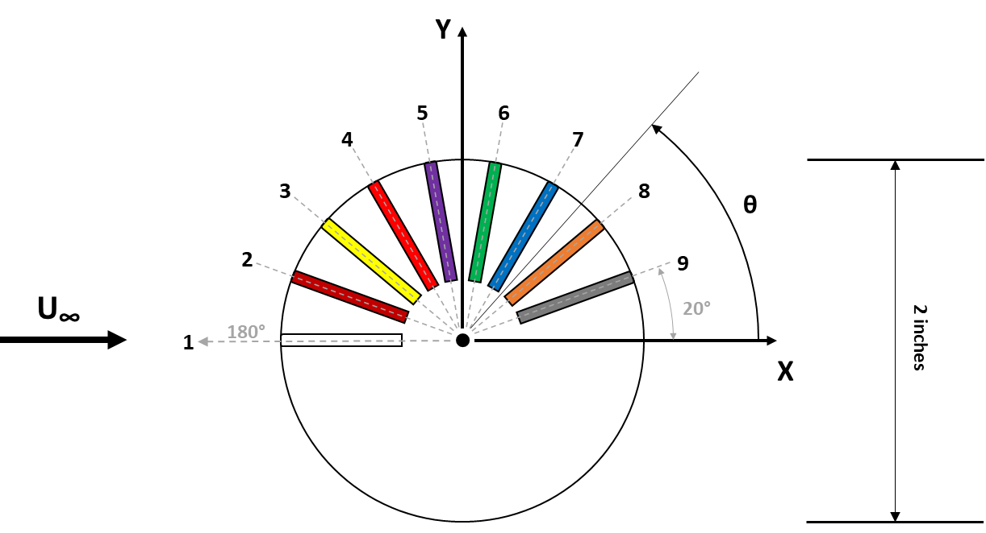

Figure 3: Coordinate system for Cylinder.
- Theory

  - Potential Flow Theory

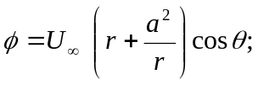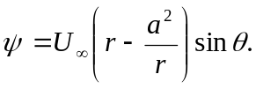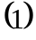Potential flow theory (which assumes inviscid irrotational two-dimensional flow) may be used to predict the flow over a cylinder. Superimposing a doublet (a source-sink combination) with a uniform flow yields the following velocity potential, φ, and the stream function, ψ, representing flow with freestream velocity 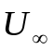from right to left over a cylinder of radius ‘a’:
Note that in this coordinate system θ is 0º at the leading edge (upstream) of the cylinder and r = 0 at the cylinder centerline.
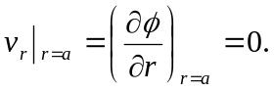 The velocity at any point on the surface of the cylinder is purely tangential:
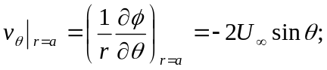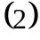
The tangential velocity is zero at θ = 0º and θ = 180º, corresponding to the upstream stagnation point and downstream stagnation point of the cylinder, respectively. Applying Bernoulli’s equation along a streamline from far upstream, the pressure on the surface of the cylinder is:
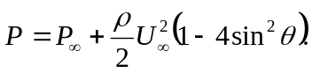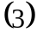
The drag force due to pressure acting on the cylinder is the horizontal component of force per unit area integrated over the whole surface area of the cylinder. Thus, potential flow predicts no drag on the cylinder due to pressure. Potential flow also predicts no viscous drag because it is inviscid by definition.

  - Pressure Drag Calculations for Viscous Flow

In real fluids, cylinders exhibit drag. Bertin & Smith describe the flow over a cylinder in detail in section 3.13 {Bertin and Smith, Aerodynamics for Engineers, Third Edition, Prentice-Hall, 1998}. Viscous boundary layers – laminar (or turbulent, depending on the Reynolds number) – form on the surface of the cylinder. The boundary layers separate due to the strong adverse pressure gradient. The wake of the cylinder is characterized by vortices, which shed periodically from the cylinder. The pressure within the separated zone is no longer the pressure predicted by potential flow theory, and a net force due to pressure exists.
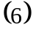 For a broad range of Reynolds numbers, the Strouhal number associated with vortex shedding is constant, approximately 0.2.

The Strouhal number ‘St’ is defined as:
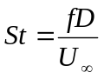
Where f is the vortex shedding frequency, D is the cylinder diameter, and 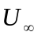is the freestream velocity. The freestream velocity can be calculated from the differential pressure, where 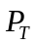 is the total pressure measured by the Pitot probe, and 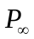 is the static pressure measured from the static tap. From Bernoulli’s equation, the freestream velocity can then be found:
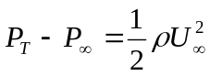 (7)

The pressure difference at each surface point can be numerically integrated to determine the resultant drag on the cylinder, 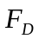. The drag coefficient for the cylinder can then be calculated as:
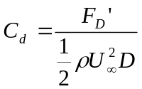 (11)

where D is the diameter of the cylinder. Similarly, the lift coefficient is;

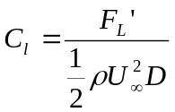 (12)

- Experimental Procedure

  - Smoke Tunnel

At some time during the lab, the teaching fellow will take you to the smoke tunnel and explain how to visualize flow past the circular cylinder. Observe the separation of the boundary layers on the cylinder, noting the location of separation. Observe the wake of the cylinder and the vortex shedding frequency’s dependence on the velocity. If you assume that the Strouhal number is 0.2, can you use the shedding frequency to determine the velocity, and thus the Reynolds number? Calculate the Reynolds Number for this case.
The flow over the surface of an airfoil shall also be demonstrated at this time. This demonstration will be important for labs 2 and 3. Sketch your observations for each case.

Low-Speed Wind Tunnel

  - Transducer and wind speed calibration

- Place cylinder in tunnel and attach all pressure ports to the manometer bank.

- Make sure the pitot-static probe is positioned well in the tunnel. Pitot-static probe can be positioned using knobs on pitot probe mount above tunnel.

- Open Excel or MATLAB.

- Choose at least 5 frequencies between 0 and 50 Hz (including these values).

- Turn the tunnel on, and use the manual pad to run the tunnel. For each frequency, read the static and total values from the manometer bank and the pressure transducer reading (on channel 0). Make sure the inclined manometer is closed off but the transducer feed is open. At each frequency, let the tunnel reached steady state (i.e. when indicator on tunnel readout settles) before taking the readings. Go up in frequency and then down to check your readings and for any hysteresis.

- Record manometer and transducer readings (on paper and in Excel or MATLAB).

- Create calibration curves (slope and intercept) for wind tunnel speed vs. frequency and for transducer reading vs. pressure differential.

4.3 Cylinder Pressure Measurements

WARNING: Do not open tunnel test section if cylinder is in tunnel!

WARNING: Do not turn the cylinder by grabbing on to the attached tubes. Use the handles provided!

WARNING: Failure to set transducer to correct position will ruin experiment.

- Determine the tunnel speed necessary to obtain the Reynolds number of interest. Determine the frequency that will give this tunnel speed.

- Enter this frequency and wait until tunnel has reached steady state (i.e. Output frequency reading on Tunnel Speed Indicator is constant).

WARNING: Failure to wait until the tunnel has reached steady state will result in bad results!

- Check that the valves to the to manometer bank tubes 1 through 9 are correctly set. Check that the inclined manometer is shut off and the transducer is on.

- Move the cylinder until the total pressure port indicated that it is positioned directly upstream. (Should be attached to tube 1).

- Compare the pressure distribution indicated on the manometer bank to that predicted by the potential flow equations. (Note: the manometer shows only the distribution over one half of the cylinder at a time). Note down the tube liquid heights on the attached data sheet and in Excel or MATLAB. Be sure to include the static and total pressure tubes also.

- Take the transducer readings for all of the tap locations by turn the Pressure Selector from port ‘0’, to port '1', port ‘2’, etc. Use your calibration information to check that the transducer and bank agree.

- Turn cylinder counter-clockwise by 180 degrees.

- Check that the most forward probe is identically forward by using the liquid level in the manometer tube.

- Again, note down all of the relevant values from the manometer bank.

- Take the pressure transducer values (making sure to match the port/tube of interest). Check that the pressure transducer and bank agree.

- Required Calculations & Analysis

- Plot Differential Pressure versus Voltage for the pressure transducer calibration. Include the linear curve-fit to this data on the plot and state the slope and intercept values for the curve-fit.

- Calculate the differential pressure and non-dimensional pressure coefficient, C_{P}, predicted by potential flow theory at each angle.

- Calculate the differential pressure and non-dimensional pressure coefficient, C_{P}, from the experimental data at each angle.

- Tabulate the calculated differential pressure and C_{P} values for both potential flow theory and the experimental data.

- On a single graph, plot the Differential Pressure versus the Angle for both potential flow theory and the experimental data.

- On a single graph, plot C_{P} versus angle for both potential flow theory and the experimental data.

- Discuss any similarities or differences in the curves.

- Calculate F_{D} and F_{L} using the given discretized equations.

- Calculate C_{D} and C_{L}. Comment on these results.

- Tabulate Re, velocity, F_{D}, C_{D}, F_{L}, C_{L}.

- Question: Drag consists of viscous drag and pressure drag. The experiment measures only pressure drag. Comment on your results based on this.

For this lab, you will only turn in your analysis and the required discussions. A full lab report is not required.

Data Sheet

Room Temperature (ºF)

Reynolds Number

Manometer Bank Readings:

Reading | Normal: Height (inches) | Flipped: Height (inches)
1
2
3
4
5
6
7
8
9
Static
Total

Output File Locations:

Calibration Data

Cylinder Data

