ME421 – Aerodynamics
Pressure Distribution on Airfoils

(Revised by G. Dewar - Oct. 2000, Sheryl Grace – Jan. 2018, Austin Thai – Jan. 2019)

- Introduction

The forces on a body moving through a fluid are the result of the pressure and shear stress distributions over the surface of the body. The resultant force can then be resolved into the lift and drag components. The purpose of this laboratory is to measure the pressure distribution over the surface of two NACA airfoils and use these measurements to calculate the resulting aerodynamic forces on the airfoils. These measurements can then be compared to known results.

- Laboratory Information

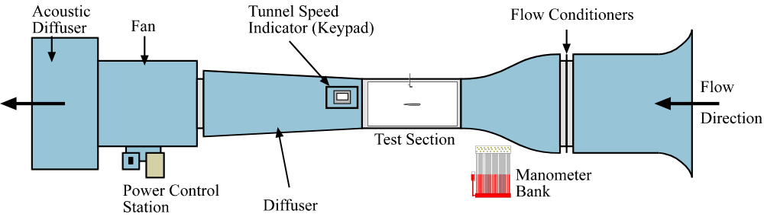

Figure 1: Low Speed Wind Tunnel.

The low speed wind tunnel (figure 1) is fitted with a 6-inch chord length NACA airfoils in its 18-inch by 18-inch test section. The airfoils have 18 pressure taps respectively along their length, the positions of which can be found in the appendix section of this handout. These pressure taps are connected via tubing to a manometer bank and a pressure transducer with digital readout assembly. A Pitot probe (measuring P_{T}) and static tap (measuring 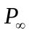) are installed in the wind tunnel to determine the freestream velocity.
The digital readout can be used to obtain the transducer values for differential pressures 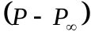 for each port (1 through 18) by turning the dial and Pitot-static pressure 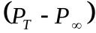 which is read when the dial is in position ‘0’. The computer sets the speed of the tunnel from the Reynolds numbers the user inputs at the start of the program, as described in part 4 of this report. The required Reynolds number will be supplied by the Teaching Fellow.
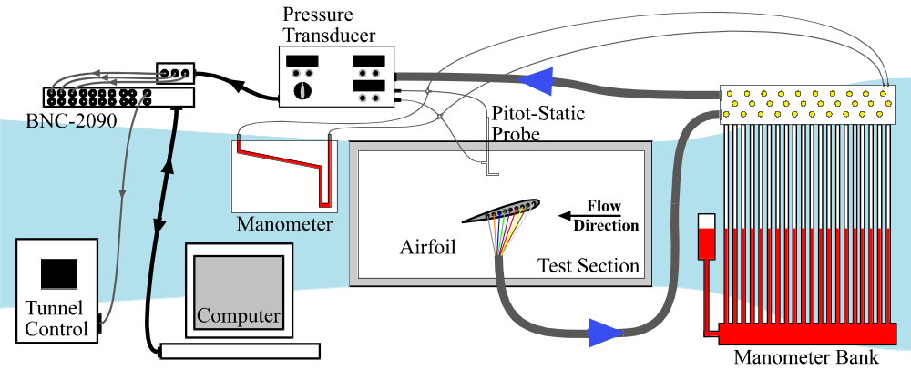

Figure 2: Experimental Setup for Tunnel Test Section

The airfoils are a 6-inch chord length NACA 0012 symmetric airfoil with 18 surface pressure ports spaced along the upper surface of the airfoil from the leading edge to near the trailing edge, and a 6-inch chord NACA 4412 airfoil with 18 surface pressure ports spaced around the surface of the airfoil, with 1 at the leading edge, 9 on the upper surface and 8 on the lower surface. The positions of the 18 pressure ports on each airfoil are shown in figures 3a and 3b, with the corresponding position and angle data being given in the appendix section of this handout.

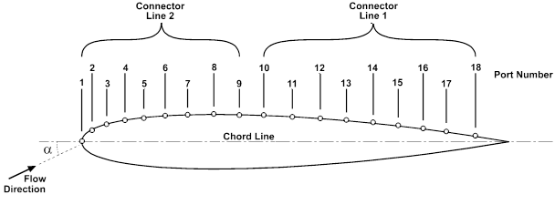

Figure 3a: Coordinate system for NACA0012 Airfoil.
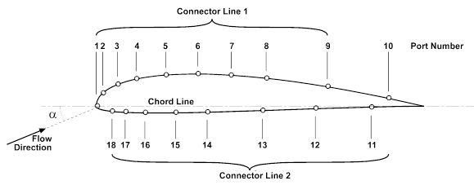

Figure 3b: Coordinate system for NACA4412 Airfoil.

Ports 1 through 9 and 10 through 18 are attached to the tubing bundles, which are in turn attached to the manometer bank. The pressure transducer can only take measurements for one bundle (9 tubes) at a time, so during the experiment the control valves on the manometer bank will have to be set to allow the required pressure to be measured by the transducer (Note: the experimental procedure is given in section 4 of this handout). The angle of attack, α, for the airfoil can be controlled by rotating the airfoil within its housing using the attached handles.
The ‘zero’ position for the airfoil is indicated by a red mark on the rim of the housing. To set the airfoil to zero degrees line up this mark with the corresponding ‘0’ mark on the tunnel test section wall. An indicator card on the airfoil housing is marked at 4º intervals. To set α to the required angle, line up the appropriate mark on the indicator card with the ‘0’ mark on the tunnel.
The valves above the manometer bank control the direction of the pressure readings from the airfoil. The bottom two rows control the manometer bank while the top set of valves control which pressures are sent to the transducer.

For the NACA 0012 airfoil, as the airfoil is symmetric, taking readings for a negative angle of attack provides data equivalent to that on the lower surface of the airfoil when at the corresponding positive angle of attack. For this laboratory, profiles will be taken at several angles, with the results for the equivalent negative angle of attack being combined with those for the positive angle of attack to give a complete profile for the required angle. Note that for a symmetric airfoil at 0º, the upper and lower surface profiles are equivalent.
For the NACA 4412 airfoil, the pressure ports are spread over both the upper and lower surfaces, so a full profile can be obtained directly at the required angle of attack.

- Theory

The freestream velocity can be calculated from the differential pressure 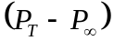, where 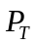 is the total pressure measured by the Pitot-probe, and 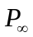 is the static pressure measured from the static tap. The freestream velocity, 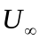, can then be found from Bernoulli’s equation;

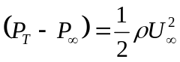 (1)

The corresponding Reynolds number can then be found;

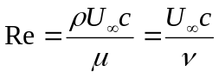 (2)

where c is the chord length of the airfoil. If the differential pressure is known at a point on the surface of the airfoil, the coefficient of pressure at that point can then be defined as;

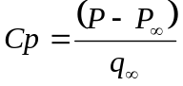 (3)
where,
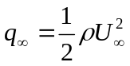 (4)

Defining the resultant force per unit span along the direction of the chord as A’ and the resultant force per unit span normal to the chord as N’, the lift and drag on an airfoil can be defined as:

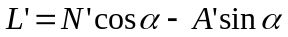 (5)
and
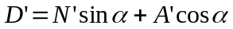 (6)

where the lift per unit span, L’, is defined as the resultant force normal to the freestream velocity and the drag per unit span, D’, is the resultant force in the direction of the freestream velocity. The angle of attack, α, is defined as the angle between the chord and the freestream velocity (see figure 4).

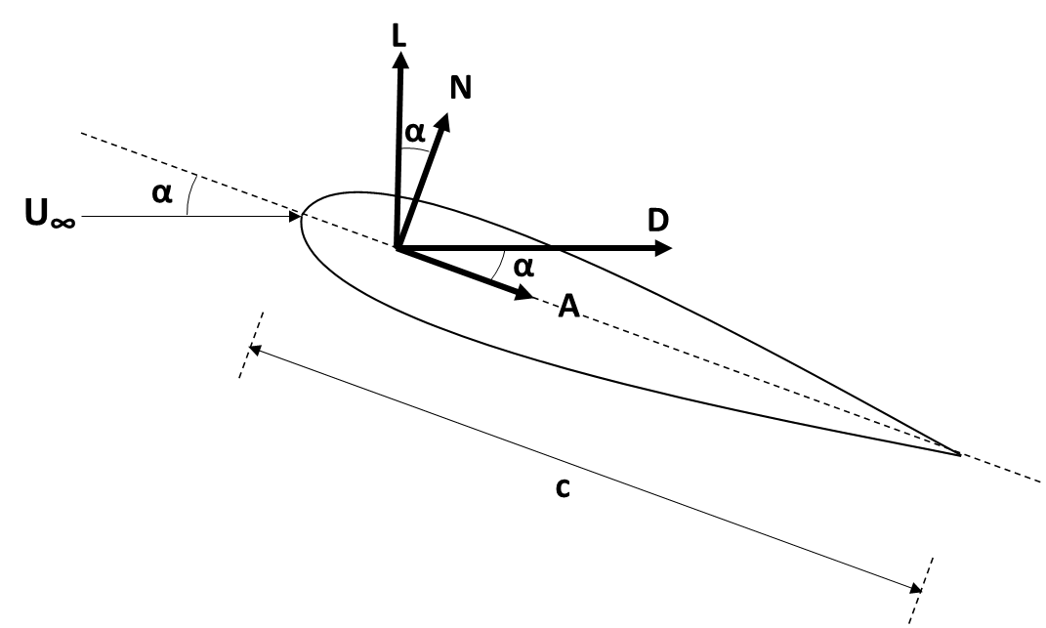

Figure 4: Resultant aerodynamic forces on airfoil.

The angles at which the pressures on the surface of the airfoil act are defined in figure 5. They are measured from vertical: positive if clockwise, and negative if counterclockwise. The angle, θ, at each port on the airfoil is given in the appendix. The subscripts ‘u’ and ‘l’ correspond to ‘upper’ and ‘lower’ respectively.

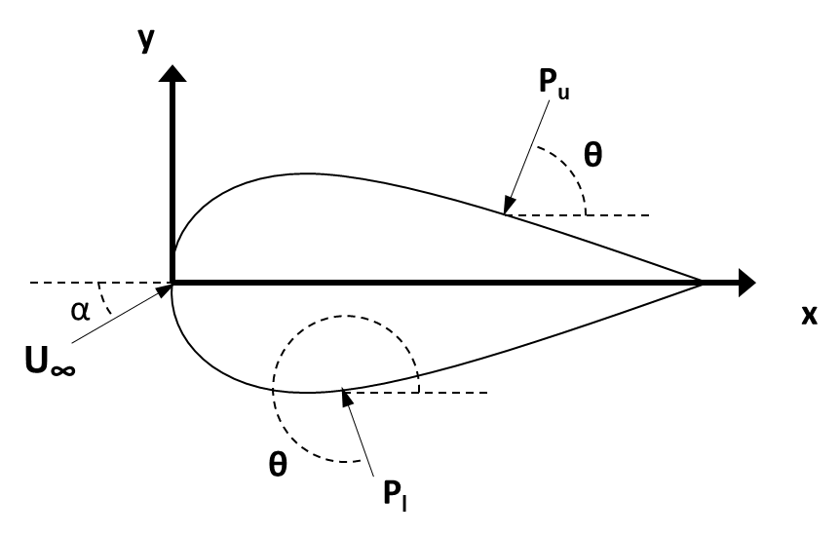
Figure 5: Nomenclature for Pressure Distribution on airfoil surface.

Neglecting the contribution of the shear stress, the normal and axial forces per unit span are;

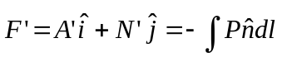 (7)

Where dl is the length of the airfoil segment, or panel, and can be constructed from the airfoil points. You will estimate the integral using a summation.
These values can then be inserted into equations (5) and (6) to obtain the lift and drag forces per unit span. The coefficients of lift and drag can then be calculated using:

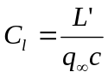 (8)
and,
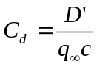 (9)

- Experimental Procedure

  - Transducer and wind speed calibration

- With nothing in the tunnel, make sure the pitot tubes are attached to the manometer bank. Make the tubes open to both the manometer bank and the pressure transducer (on the red tube connection area both have to be open: inclined and vertical). However, make sure that the inclined manometer is shut off at both ports. The lines should only feed the pressure transducer and vertical manometer.

- Check that the pitot-static probe is positioned well in the tunnel. Pitot-static probe can be positioned using knobs on pitot probe mount above tunnel.

- Open Excel or MATLAB.

- Choose 5 frequencies between 0 and 50 Hz (including these values).

- Turn the tunnel on, and use the manual pad to run the tunnel (click the remote button, use the arrows to adjust the frequency and hit the run button). For each frequency, read the static and total values from the manometer bank and the pressure transducer reading (on channel 0). Make sure the inclined manometer is closed off but the transducer feed is open. At each frequency, let the tunnel reached steady state (i.e. when indicator on tunnel readout settles) before taking the readings. Go up in frequency and then down to check your readings and to look for any hysteresis.

- Record manometer and transducer readings (on paper and in Excel or MATLAB).

- Create calibration curves (slope and intercept) for wind tunnel speed vs. frequency and for pressure differential vs. transducer reading.

  - Airfoil measurements

This procedure is to be carried out for each of the airfoils. Remember, for the NACA 0012 symmetric airfoil, data must be taken at both the positive and corresponding negative angles of attack to obtain a full profile.

WARNING: Be extremely careful when handling airfoils! Do not remove or insert an airfoil unless the TF is present.

WARNING: Do not open tunnel test section if airfoil is in tunnel!

WARNING: Do not turn the airfoil by grabbing on to the attached tubes. Use the handles provided!

WARNING: Failure to set transducer to correct position will ruin experiment.

- Put the airfoil into the tunnel and connect the pressure lines.

- Make sure Pressure Selector on Digital Readout Assembly is set to port '0'. (Note: this gives the Pitot Probe reading)

- Set the bottom two sets of valves above the manometer bank to ‘fully open’ (i.e. allowing pressure readings both to the manometer bank and transducer).

- Set the top set of valves above the manometer bank to open ports ‘1’ through ‘9’ only.

- Make sure Pitot Probe is positioned correctly (i.e. X = 0m, Y = 0.368m on readout assembly).

- Place airfoil at the required angle of attack.

- Determine required speed for Reynolds number of interest and tunnel frequency to obtain that speed.

- Program that frequency and turn the tunnel on (from the pad on the side of the tunnel).

- Wait until tunnel has reached steady state (i.e. the output frequency reading on the Tunnel Speed Indicator and the manometer bank readings are constant).

WARNING: Failure to wait until the tunnel has reached steady state will result in bad results!

- Observe readings for pressure profile on manometer bank ports 1 through 18. Sketch the manometer bank “profile.” Enter the relevant values from the manometer bank into your spreadsheet. Remember that in the end you want to calculate determine P-P∞ for each surface pressure port.

- Now take the pressure differential reading using the pressure transducer. Turn Pressure Selector to port '1', wait for the value to settle and record. Repeat steps xvi and xvii for ports '2' through '9'.

- Set the top set of valves above the manometer bank to open ports ‘10’ through ‘18’ only.

- Turn Pressure Selector port '1', wait for the value to settle and record the differential pressure for physical port 10. Continue for Selector ports ‘2’ through ‘9’ to record physical ports 12 through 18.

- For the symmetric airfoil, reposition the airfoil at its negative angle of attack and take the measurements again to obtain the pressure side data.

You will repeat this for 3 angles of attack so that you can obtain a good approximation of the lift curve slope for this airfoil.

Before continuing to a second angle of attack, check your C_{p} values for your airfoil against results from Xfoil run at the relevant Reynolds number. You should also check the C_{l} and C_{d} that you compute from the data. If everything looks good, continue to your next angle of attack or the 2nd airfoil.

4.3 Determine stall angles

- Determine the positive and negative stall angles visually. Use the manometer bank. Turn the airfoil through both positive and negative angles of attack slowly up and down, down and up. Record the angles when positive and negative stall appears and when it then disappears again (there should be hysteresis). Do this for both airfoils.

- Required Calculations & Analysis

- For each airfoil and angle, calculate the non-dimensional pressure coefficient at each port. Include the sketch of the manometer bank “profile” and discuss if consistent with what is expected.

- Tabulate port number, x and y position, surface normal angle, differential pressure and C_{p} for each airfoil and angle.

- For each airfoil and angle, plot C_{p} versus x-position over the full airfoil surface for both the experimental data and the Xfoil results at relevant Reynolds number (on one figure).

- For each airfoil and angle, calculate N’, A’, L’ and D’.

- For each airfoil and angle, calculate C_{l} and C_{d}.

- Tabulate α, velocity, N’, A’, L’, D’, C_{l} and C_{d}.

- Tabulate the stall angles for each airfoil. Comment on stall properties of each airfoil.

- Compare your results to those given in Abbott & Von Doenhoff and those from Xfoil at the relevant Reynolds number.

6 Laboratory Report

The purpose of this lab is not only to apply your understanding of aerodynamics to a simple experiment but also to give you practice in communicating your findings. As such, the quality of the writing will be evaluated in terms of grammar, spelling, clarity, organization, legibility and presentation of figures and tables. The report should be understandable to someone who is not necessarily familiar with the specifics of the lab. The quality of the writing will count for a portion of your grade.

Please follow the departmental lab format guidelines found at:
http://www.bu.edu/eng/departments/me/general-resources-students/current-undergraduate-students/lab-report-format/

Appendix 1: Airfoil Information

NACA 0012

 |  | Upper |  | Lower
Port | x-position (in.) | y-position (in.) | Angle, θ (degrees) | y-position (in.) | Angle, θ (degrees)
1 | 0 | 0 | 180 | 0 | 180
2 | 0.21 | 0.1826 | 111.12 | -0.1826 | 248.88
3 | 0.526 | 0.2676 | 100.87 | -0.2676 | 259.13
4 | 0.842 | 0.3145 | 96.41 | -0.3145 | 263.59
5 | 1.158 | 0.3417 | 93.61 | -0.3417 | 266.39
6 | 1.474 | 0.3558 | 91.59 | -0.3558 | 268.41
7 | 1.79 | 0.3601 | 90.04 | -0.3601 | 269.96
8 | 2.106 | 0.3568 | 88.81 | -0.3568 | 271.19
9 | 2.422 | 0.3473 | 87.8 | -0.3473 | 272.2
10 | 2.738 | 0.3329 | 86.97 | -0.3329 | 273.03
11 | 3.054 | 0.3142 | 86.28 | -0.3142 | 273.72
12 | 3.37 | 0.2919 | 85.68 | -0.2919 | 274.32
13 | 3.686 | 0.2666 | 85.17 | -0.2666 | 274.83
14 | 4.002 | 0.2386 | 84.71 | -0.2386 | 275.29
15 | 4.318 | 0.2082 | 84.29 | -0.2082 | 275.71
16 | 4.634 | 0.1755 | 83.89 | -0.1755 | 276.11
17 | 4.95 | 0.1405 | 83.49 | -0.1405 | 276.51
18 | 5.265 | 0.1035 | 83.08 | -0.1035 | 276.92

NACA 4412

Upper Surface
Lower Surface

Port | x-position (in.) | y-position (in.) | Angle, θ (degrees)
1 | 0 | 0 | 180
2 | 0.15 | 0.203 | 122.818
3 | 0.3 | 0.284 | 114.77
4 | 0.6 | 0.396 | 106.975
5 | 1.2 | 0.528 | 95.855
6 | 1.8 | 0.586 | 92.736
7 | 2.4 | 0.588 | 88.081
8 | 3 | 0.551 | 85.363
9 | 4.2 | 0.402 | 80.519
10 | 5.4 | 0.162 | 78.091
Port | x-position (in.) | y-position (in.) | Angle, θ (degrees)
1 | 0 | 0 | 180
11 | 5.15 | -0.016 | 271.1
12 | 4.2 | -0.039 | 271.252
13 | 3 | -0.084 | 271.663
14 | 1.8 | -0.136 | 272.287
15 | 1.2 | -0.164 | 272.829
16 | 0.6 | -0.172 | 272.354
17 | 0.36 | -0.157 | 271.319
18 | 0.24 | -0.139 | 269.921

Appendix 2: Data of Interest

Calibration Information
Tunnel: | Slope
 | Intercept
Transducer: | Slope
 | Intercept
Test Conditions
Required Re
Required α's
Measured Velocity (m/s)
Temperature ('F)
Stall Information
 |  | Positive | Negative
NACA 0012: | α(+ve)
 | α(-ve)
NACA 4412: | α(+ve)
 | α(-ve)

Appendix 3: Airfoil Data

Airfoil data for both NACA 0012 and NACA 4412 airfoils are given on the following pages. These data were obtained from:

Abbott, I. H. & Von Doenhoff, A. E., ‘Theory of Wing Sections’, Dover Publications Inc., New York, 1959.

