SMART AGRICULTURE

Team-5

**ABSTRACT:**

This project aims to revolutionize the face of agriculture by providing farmers with accurate real-time analysis over various aspects of the farmland. "Smart Agriculture" system proposes to make use of the yet to be evolved technology of automation in the field of agriculture. To emphasize on the novel methods of innovative farming like Greenhouse farming automation which monitors the temperature and soil moisture levels with the help of sensors. The sensors used in Smart Agriculture are broadly classified into digital and analog sensors which includes pH sensor, dht11 temperature sensor, hygrometer moisture sensor and many more. Cameras too are utilized for live image detections. The weather alarm, live stock monitoring and Maarufu Greenhouse farming which is integrated with smart sprinklers are administered by this project. Smart Farming system garners the use of solar panels which provides power to the embedded devices. These solar panels facilitates the modules on being placed anywhere on the field. It is ideally designed to obtain highly efficient agriculture production and not only helps the farmer to survey a vast field in an instant but also cuts down on the unnecessary labor costs and support. Also, this Smart Agriculture system is prepared considering the economical state of the farmers and hence the project is being delivered at reasonable costs.

**KEYWORDS:**

Agriculture, Smart farming, Sensors, Wireless technology, IOT, Economic development.

**AUTHORS:**

* Ashu Kumar: SRM IST, Chennai.
* M. Pandyamanian: SRM IST, Chennai
* Madhu kumar: VIT, Vellore
* SAJIT: CMREC, Hyderabad
* K. SRIJITH: LPU, Punjab
* NEHA: DAVIET, Jalandhar
* S. UJWALA: KARE, Madhurai
* BIRISHANA: TKMCE, Kerala
* DIMPLE KUMARI PRASAD: ITER, Bhubhaneshwar
* ABHISHEKTA MAHAPATRA: ITER, Bhubhaneshwar

# Introduction:

T

HE major source of national income of India is obtained from farming. Yet there’s no advancements seen in this field as farmers still resort to the old conventional methods of farming without realizing the perils of modern farming or aptly called as “Smart Farming.” The farming and agricultural industry relies on innovative ideas and technological advancements to help increase yields and allocate better resources. The late 19th century and the 20th century brought a number of mechanical innovations, like tractors and harvesters.

**Today, a driving force in order to attain an increased agricultural production at economical costs will be the IOT.**

With various factors like monsoons being predominantly irregular, improper irrigation methods, lack of mechanization, soil erosion, cost factors etc, resulting in inadequate yield and low productivity. The implementation of technological methods in the field of agriculture can bring about radical changes in the productivity of crops, due to improved efficiency in the farming techniques.

It is essential to create effective intervention in agriculture to which the solution is lOT in integration with Wireless sensor networks. It has potential to change the way of development in agriculture and gives great contribution to make it smart agriculture. The internet of things involves a three-tier system. It includes perception layer, network layer and application layer. Perception layer includes sensor motes. Information communication technology (lCT) enabled devices, sensor devices are building blocks of sensor technology. It includes cameras, RFID tags, sensors and sensor network used to recognize objects and collecting real time information. The network layer is an infrastructure of the lOT to realize universal service. It directs towards the combination of the perception layer and application layer. The application layer is a layer that combines the lOT with the technology of specific industry. Agriculture is one of the important areas which targets millions of people.

A brief outline of the paper is as follows. Section III(keywords) explains literature survey on smart agriculture domain. Section IV(authors) describes proposed problem statement. Section V(products) describes smart agriculture model. The proposed methodology for smart agriculture model is discussed in section VI. The paper is concluded in section VII

# PRODUCTS:

1. **Maruufu greenhouse**

Unlike the conventional Green house, Maarufu green house is an African style green house with smart sprinklers , temperature detection and automation. Such that the exhaust is switched on to reduce the temperature automatically. Hence creating an excellent environment for the plants growth.

The sensors and devices used are DHT 11, Hygrometer, Exhaust fans."

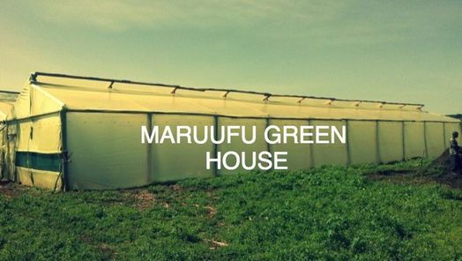

1. **SURVEILLANCE**

Raspberry pi associated with the cameras will be used to monitor the farm and the farmers can watch or keep an eye on the farms . Thereby preventing any mis-happening in the farm. The Rpi camera module and a monitor will be used for this product.

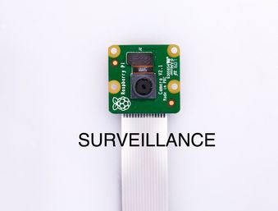

1. **PH ANALYSIS**

Analyzing the soil PH rating to check whether the soil is Acidic or not. Thereby helping the farmers to plan and plant their seeds more precisely. Sensors used will be PH Sensor for Arduino or Nodemcu.

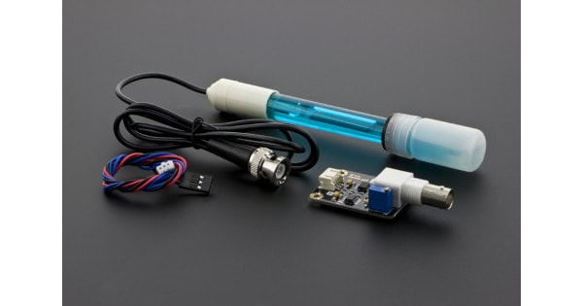

1. **Smart Irrigation**

Smart sprinklers are automatic water system that detects the soil moisture. When the soil is dry the sprinklers waters the plants automatically.There by removing the labor cost and hard work. With the water requirements in irrigation being large, there is a need for a smart irrigation system that can save about 80% of the water. This prototype aims at saving time and avoiding problems like constant vigilance. It also helps in water conservation by automatically providing water to the plants/gardens depending on their water requirements. It can also prove to be efficient in Agricultural fields, Lawns & Parks. As technology is advancing, there is always a chance of reducing risks and making work simpler. Embedded and micro controller systems provide solutions for many problems. This application precisely controls water system for gardens by using a sensor micro controller system. It is achieved by installing sensors in the field to monitor the soil temperature and soil moisture which transmits the data to the microcontroller for estimation of water demands of plants.

1. **SMART WAREHOUSE**

This warehouse will keep track of the number and amount of goods available at the warehouse. Farmers can also enable notification to be received when the amount of certain goods are low.

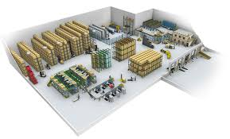

1. **PERFORMANCE REPORT**

Having a detailed performance report on farm such as –temperature, humidity, ph, moisture will be sent to the cloud and the devices. The farmers will be able to keep track of the task.

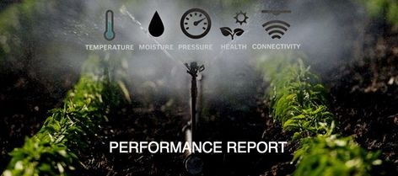

1. **Weather Alaram**

A periodic weather forecast will be sent to the farmers using the Raspberry pi. The Darksky.net weather forecast API will be used to supply the weather details. The details sent will be very accurate and precise.



# SERVICES:

* We offer free installation services.
* Our customer care service is available 24X7.
* We keep the customer updated on the proceedings of our products.
* Regular maintenance is provided.
* Easily accessible through various platforms.
* We offer useful insights required by the customer.
* Accurate analysis is ensured.
* Proper precautionary methods are keenly implemented

# ABOUT US:

"For Farmers and Agriculture Researchers who need efficiency and cost reduction in their farming and research our smart agriculture system is a IOT-based solution that provides brilliant performance reports at a fairly reasonable price, unlike the conventional method of farming and resource."

**CONCLUSION:**

Increase in population and demand for food requires some new methods that could increase the production multiple times utilizing the even lesser resources as shortage of water is increasing day by day and agriculture land is also decreasing. Use of advanced technologies could help us in this regard. The concept of smart agriculture presented could be helpful in achieving the above mentioned goal. Smart agriculture concept is the utilization of different advanced technologies together with the experiences of people as well as the results of the historic events to engender better solution of the problems.

The technologies that were highlighted are sensor network technology, wireless communication, IOT, cloud computing technology.

**ACKNOWLEDGEMENT:**

We would like to extend our sincere thanks to all those who played a role in the completion of this project. Firstly, we are highly indebted to Expertshub for their constant supervision and support. We would also like to thank the trainers for their guidance, and encouragement throughout the project work. Lastly, we are immensely grateful to all those involved in this project as without their inspiration and valuable suggestion it would not have been possible to develop the project within the prescribed time period