

**Polytechnic University of Puerto Rico**

**Department of Computer Engineering and Computer Science**

**COE 4002-39: Capstone I / CS 4002-49: Computer Science Project I**

**WI-20 / Prof. Othoniel Rodriguez**

**Covid-19 Data Visualization & Analysis:**

Sprint Plan

Version 2.0

|  |  |  |
| --- | --- | --- |
| Name | ID | Program |
| Jose M. Lopez Torres | #72583 | CS |
| Elias J. Marrero Ruiz | #97850 | CS |
| Ernesto Feliciano Muniz | #96861 | COE |
| Diego Canals Reyes | #80877 | COE |

# Table of Contents

Table of Contents 2

Table of Figures 4

Introduction 5

Sprint Planning 6

Objectives 6

What Can be Done ? 6

How ? 6

Inputs 6

Outputs 7

Backlog 7

When ? 7

Duration 7

Purpose 7

Daily Scrums/ Stand Ups 8

When ? 8

Duration 8

Purpose 8

Progress Questions 8

Sprint Review 9

When ? 9

Duration 9

Purpose 9

Sprint Retrospective 9

When ? 9

Duration 9

Purpose 10

Areas of Improvement- by Importance 10

Bugs 10

Worked 10

Tactics for Improvement 10

Action Plan 10

Sprint Plan Division 11

Sprint Plan 1 11

Sprint Plan 2 11

Sprint Plan 3 11

Sprint Plan 4 12

Implementation of Sprint Plan 12

Sprint View 12

Figure 1: Sprint Plan - Sprint View 13

Timeline View 14

Figure 2: Sprint Plan - Timeline View 14

Sprint Duration and Complexity 15

Handling Un-Implemented User Stories or Failed Tasks 16

Conclusion 17

# Table of Figures

Figure 1: Sprint Plan - Sprint View 5

Figure 2: Sprint Plan - Timeline View 6

# Introduction

The following document will discuss in detail all the different elements that are required for making sprints that could deliver the web application while following the agile methods. Furthermore, the discussion of all the diverse types of meetings that the team will have. The first element of discussion will be the Sprint Planning Meeting and will consist of different elements that that will be explained to the client. Moreover, the document includes information about the Stand-Up daily meetings of the development team, and their importance for achieving the Agile Approach. Also, the Sprint Retrospective Meeting will present information about some guide questions that will help the team to improve and other tasks that are going to be executed during the period of 12 weeks (about 3 months). The document will also when the team will ask for feedback and how the feedback will be used.

# Sprint Planning

## Objectives

The objectives discussed with the client will be used for the information of the backlog. Meetings will be made with the client and all the members of the development team before starting a new sprint.

## What Can be Done?

Following the establishing of the main objectives that will be cover with the client a discussion with the development team will establish what can be done in the sprint. Tasks that cannot be implemented because lack of resources or any other reason will be discussed with the client in order to reach an understanding. This understanding will cover any concern of the client and the possible division of the task into smaller tasks distributed in other sprint plans.

## 

## How?

The development team will discuss all the possible actions required to complete all the designated tasks. Also, the methodology of agile will be discussed with the client since is the one to be used in the project. This will help enhance the benefits of using such mechanism for developing the sprint plan. Furthermore, the technical details will be discussed, like the frameworks, the programming language and the tools that are going to be used.

## Inputs

The inputs expected by the client will be used for the creation of the backlog that is going to be used in the sprint plan. A thorough discussion of what things are required by the client will take place. Nonetheless, all the information about inputs requested will be documented.

## Outputs

The outputs will hold the outmost importance for discussion with the client. These will be used decide most of the part of how what tools are going to be used and how. Moreover, the discussion of the priority will also be included for classifying the outputs in distinct categories of importance.

## Backlog

The tasks, or items will be included in this section. Some of the elements that will be included are the user stories, bugs to correct, design changes and client requests. These will be presented and discussed with the client for possible tradeoffs with the development team. The priorities of each task will be also discussed and set into corresponding order.

## When?

The sprint planning will consist in a meeting before the start of a new sprint plan. The meeting will be held virtually between all the members of the development and the client. The specific date and hour will be selected beforehand with the client.

## Duration

The expected duration of each meeting designated for the sprint planning will be of one hour.

## Purpose

The purpose of the sprint planning will be to assure that the project in development is coordinated with the objectives and purpose of the client. Moreover, the effective use of resources and the success of the work following the agile guidelines.

# Daily Scrums/ Stand Ups

## When?

The Stand Ups or Scrum will occur daily in a designated time between the development team.

## Duration

The expect duration of these meetings will be 30 minutes.

## Purpose

The purpose of these daily meetings is to notify the progress of the each one of the team members. This will help to assure that team can deliver the designated sprint in a respective due date. Nonetheless, it will also help to notify any new challenge or problem that could impact the established sprint plan.

## Progress Questions

Each member of the development team will answer some guide questions in order to deliver the required information for the stand up in an efficient way. The guideline questions will be the following:

* What work did the member completed the day before?
* What are the tasks that the member is completing the day of the meeting?
* What are the possible bugs, challenges or blocking the member is facing?

## 

# Sprint Review

## When?

The Sprint Review will take place at the end of each sprint. This will take place between all the members of the development team and the client. The date and the hour will be coordinated beforehand.

## Duration

The expected duration of the Sprint Review will be of 30 minutes.

## Purpose

The main purpose of these meeting will be to demonstrate all that had been accomplished by the developing team. The team members will also prepare questions and will ask for the feedback of the client in the Sprint Review. Each one of the team members will be taking notes about the feedback for understanding the current status of the team and their methods. Moreover, tasks that are completed will be marked as done.

# Sprint Retrospective

## When?

The Sprint Retrospective meeting will occur after each sprint plan between all the development team members only. The date and the hour will be previously established by the team.

## Duration

This meeting will last an approximate of 1 hour.

## Purpose

The purpose for this meeting will be to evaluate the performance of the team. It will be a self-evaluation for understanding what methods worked and the ones that did not. This will be helpful because all the weaknesses can be addressed and fixed. This will also contribute to the agile methodology because it will make a continuous improvement at each step of the work.

## Areas of Improvement- by Importance

Team members will write down a list of areas that need to be improved. The elements on the list will be discussed and organized in order of importance by team members.

## Bugs

Possible bugs that are encountered during the development of the project will be presented by the affected team member.

## Worked

Team members will present a list of all the things that where more effective and successful during the current sprint. This list will be discussed between the members for adapt or use the most effective ones.

## Tactics for Improvement

The team will discuss how to address the bugs and the areas for improvement. Each member will research or suggest new tactics that can be implemented to face the problems presented.

## Action Plan

All the suggest tactics will come into action by the design of a concrete plan that will address directly all the flaws previously presented. In this plan the actions that are going to take place will be written in a checklist style and internal due dates will be set. This will improve the team efficiency.

# Sprint Plan Division

The work division will be segregated into 4 sprints and each one of them will consist of three weeks. Each one of the proposed sprint plans will be constituted of certain goals and objectives based on the client specifications. The information regarding the specific needs and how to accomplish them of the Sprint Plans will be detailed in the next sections.

## Sprint Plan 1

The Sprint Plan 1 will be focusing on working on some basic parts of the Front-End and the essential parts of the Back-End. First, the React application will be used for starting to code, and work on the header, container, and footer. Following those actions, the construction of the following components: the summary, references and report components, the summary will be performed. These elements will locate at the top of the page, but the references and report components will be on the footer. Then in the back-end part, the setup the NodeJS will be implemented in order to start working in the back end (task designated in the Sprint 2). Moreover, the configuration and creation of the link of Firebase’s Cloud Firestore will be made.

## Sprint Plan 2

In the Sprint 2, the development team will continue working in the front-end and start styling the UI/UX. One of the tasks for the front-end will be to work on the colorblind button component. In the other hand some graphical components like the pie chart, bar graph, comparation graph and line graph will be developed. The UI/UX of the web-application will be composed of the elements previously approved with the client that include the header and the footer.

## Sprint Plan 3

In the Sprint 3, will be address the tasks from every initiative. The first one, will be in the front-end and it will be to consume the data from the API from within the components. After that, in the back end, we will work with the API methods, that will get the data from the Postman App Covid -19. The UI/UX implementation for the colorblind button’s will be made on CSS and the stylization the graph components. Finally, in the infrastructure, two docker files will be created, one for the front-end and one for the back end.

## Sprint Plan 4

In the Sprint 4, the focus will be work on the Infrastructure. Nonetheless, his task from the back end will be basically the setup of the function that updates the data from the APIs in a daily basis. Moreover, it will focus on the deployment of the application and the full automation of the tests using Selenium IDE.

# Implementation of Sprint Plan

The following pictures will demonstrate our Agile Roadmap in Scrum-style. Here we will detail how and when User Stories will be implemented and tested in each Sprint. These tasks will be organized by four (4) Sprints and subcategorized within each Sprint by Front-End, Back-End, UI/UX, and Infrastructure.

## Sprint View

In this first image, we have the Sprint View, a very minimalistic but not chronological view, in which we show all of our tasks to be completed aligned horizontally by their initiatives and vertically by their Sprints. This is a simpler way for having an idea of what things we need to accomplish within each section.

## Figure 1: Sprint Plan - Sprint View

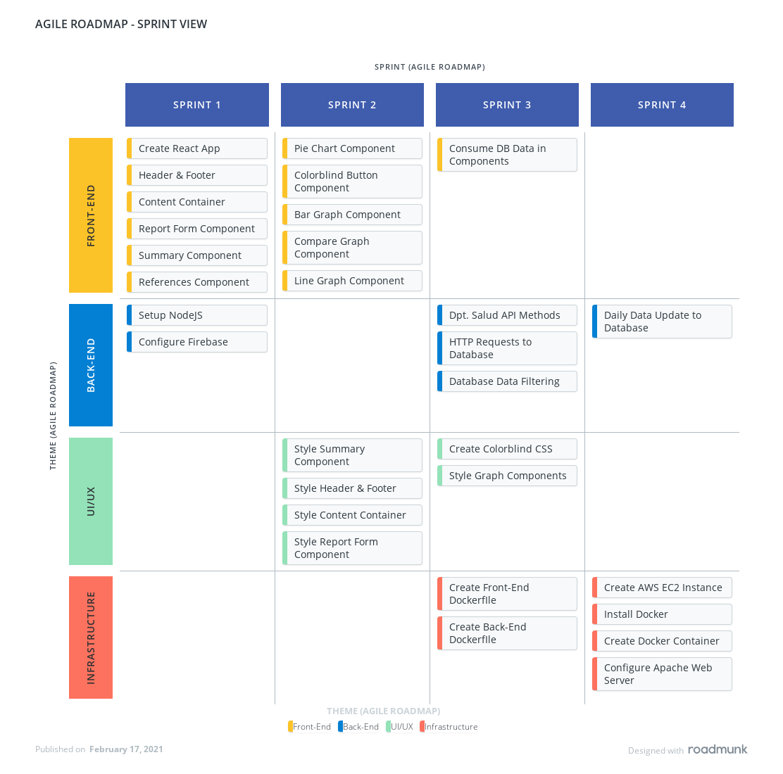

## Timeline View

In this second image, the Timeline View, we have a quite simple and chronological view, in which we present the key tasks and their deadlines, but also organized by the same four (4) initiatives inside each Sprint. Here we get a good idea of the prioritization and workflow of the project’s tasks.

## Figure 2: Sprint Plan - Timeline View

## 

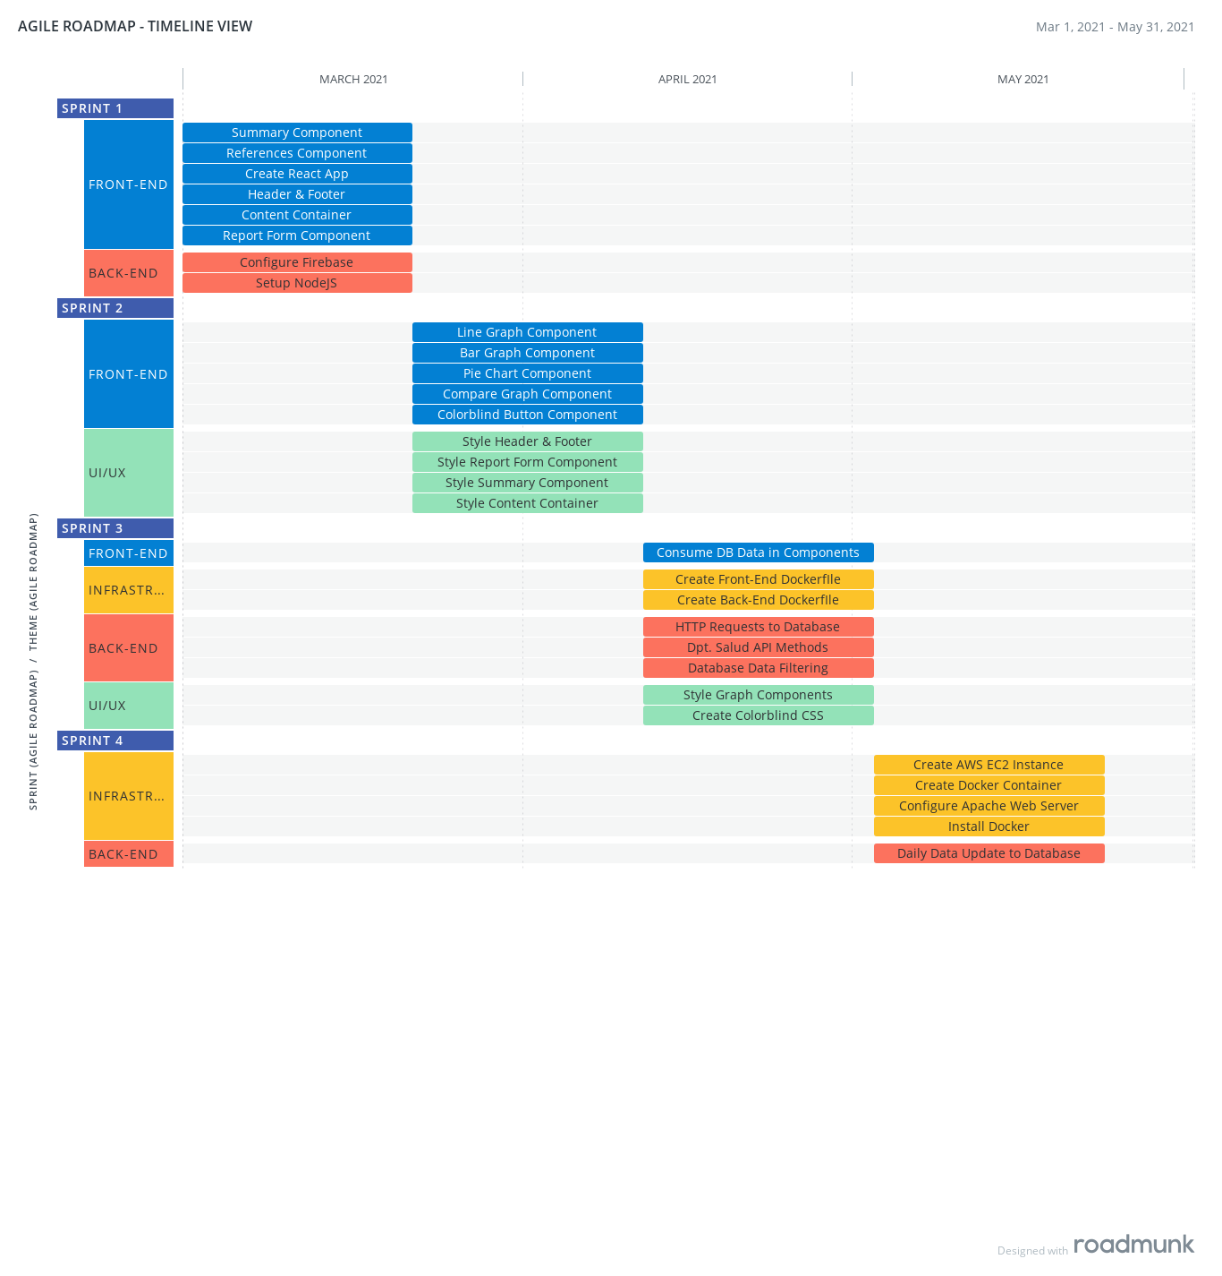

# Sprint Duration and Complexity

Each Sprint will take about three (3) weeks, for a total of four (4) Sprints. The velocity of each Sprint will be calculated by dividing the sum of the complexity points of each task by the days in the Sprint.

* 28points/30days = 0.93 is the velocity of complexity points by day for Sprint 1.
* 30points/30days = 1.00 is the velocity of complexity points by day for Sprint 2.
* 30points/30days = 1.00 is the velocity of complexity points by day for Sprint 3.
* 28points/30days = 0.93 is the velocity of complexity points by day for Sprint 4.

# Handling Un-Implemented User Stories or Failed Tasks

In case any of the user stories is not developed or a task fails the team will first discuss the matter at hand with the client immediately. Nonetheless, before the meeting with the client each failed task or unimplemented user story will be documented beforehand. This documentation will include an analysis of the causes or the reasons that are not permitting to complete the operation. With this document at hand the team leader will discuss viable options and take offs that could be implemented in the next sprint plan. Furthermore, if a member of the development team encounters a difficult of these types it must communicate to the leader immediately. The Scrum master will also send an email at that moment to inform the client of the situation.

# Conclusion

The diverse types of meetings follow the Agile methodology that will help the team deliver the most efficient results in a designated time. The team will be work accordingly each sprint plan that will have direct approval and feedback of the client. In this case the benefits will be mutual because the resources and time will be used in an optimal way.