Tiberiu MĂNESCU
PHD IN MECHANICAL ENGINEERING · HABILITATION · VICE-DEAN
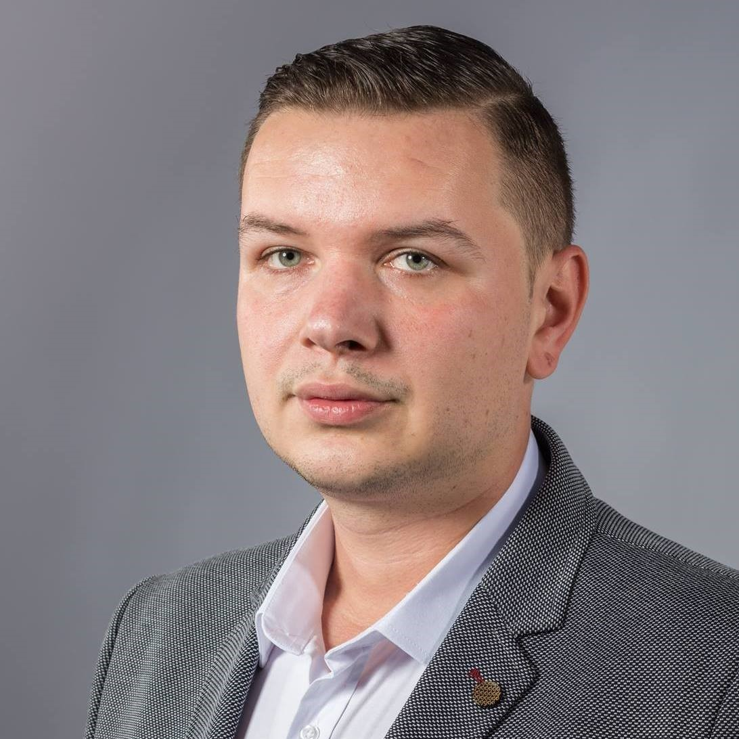  CONTACT DETAILS  Reșița, Romania  2/5/30 Ștefan cel Mare Street  Mobile: +40 728 221 111  manescu.tiberiu@gmail.com  PERSONAL DETAILS  Date of birth: 21 February 1986  Nationality: Romanian  Driving licence: Category B (since 2004)  LANGUAGES  English: Listening C2, Reading C1, Spoken Interaction C2, Spoken Production C2, Writing C2  German: Listening C2, Reading C1, Spoken Interaction C2, Spoken Production C2, Writing C2  TECHNICAL SKILLS  CATIA · Autodesk Inventor · SolidWorks · ANSYS · Cosmos Design Star · Weibull 7++ · Minitab  DISTINCTIONS AND INTERESTS  International Chess Master; former member of Romania’s National Junior and Cadet Chess Team. | PROFESSIONAL PROFILE  University lecturer and mechanical engineer with experience in higher education, research, and industry. Professional work includes academic management, project coordination, product development and testing, and the organization and monitoring of manufacturing processes.  CURRENT APPOINTMENTS  Vice-Dean of the Faculty of Engineering and Associate Professor at “Aurel Vlaicu” University of Arad, with teaching and research responsibilities.  PROFESSIONAL EXPERIENCE  Dec 2021–present | Vice-Dean, Faculty of Engineering  “Aurel Vlaicu” University of Arad · Higher education  Teaching and research.  Sep 2019–present | Associate Professor  “Aurel Vlaicu” University of Arad · Higher education  Teaching and research.  Sep 2017–Sep 2019 | Lecturer  “Aurel Vlaicu” University of Arad · Higher education  Teaching and research.  Jan 2017–Aug 2017 | Research Scientist  SC PLASTOMET SA · Mechanical engineering  Research and development.  2013–2015 | Project Manager  Bosch Rexroth, Blaj, Alba County · Sensor and automotive production  2011–2013 | Process Engineer  INA, Homburg/Saar, Germany · Production of rolling elements for bearings  Monitored manufacturing flows and carried out mechanical testing.  2009–2011 | Electromechanical Engineer / Manufacturing Engineer and Programmer  Resita Machine Works (UCM Reșița), Reșița · Manufacturing of hydropower equipment and industrial engineering  Organized and monitored production.

EDUCATION AND TRAINING
2017 | Habilitation in Mechanical Engineering
University of Pitești
Habilitation certificate issued under Ministry of Education Order No. 5786 of 27 December 2017.
2012–2015 | PhD in Mechanical Engineering
“Eftimie Murgu” University of Reșița, Faculty of Mechanical Engineering
Degree awarded under Ministry of Education Order No. 634 of 11 November 2014, with the distinction “Magna Cum Laude”.
2005–2009 | Bachelor’s degree in Economic Engineering in the Mechanical Field
“Eftimie Murgu” University of Reșița, Faculty of Mechanical Engineering
2001–2005 | High school diploma, Mathematics and Informatics track
“Diaconovici-Tietz” High School, Reșița
Diploma series U, No. 0137824.

PROFESSIONAL SKILLS AND ACTIVITIES
Social skills | Communication and collaboration
International research-program partners; individual and team preparation in the Strength of Materials Circle at U.E.M. Reșița; teamwork in national CEEX research grants; reliability, strong work ethic, and communication skills.
Organizational skills | Chess competition organization
Member of the organizing committee for chess competitions at U.E.M. Reșița: Tiberius Cup, University Cup (international participation), Petre Dodu Memorial, and Reșița Municipal Championship.
Engineering analysis | Design and simulation
Computer-aided design and finite element analysis of stress and strain.
Arad, 2 February 2026

