National College of Ireland

MSc in Web Technologies

2013/2014

Derek Caprani

X09106561

[derek.caprani@student.ncirl.ie](mailto:Derek.caprani@student.ncirl.ie)

[dcaprani@me.com](mailto:dcaprani@me.com)

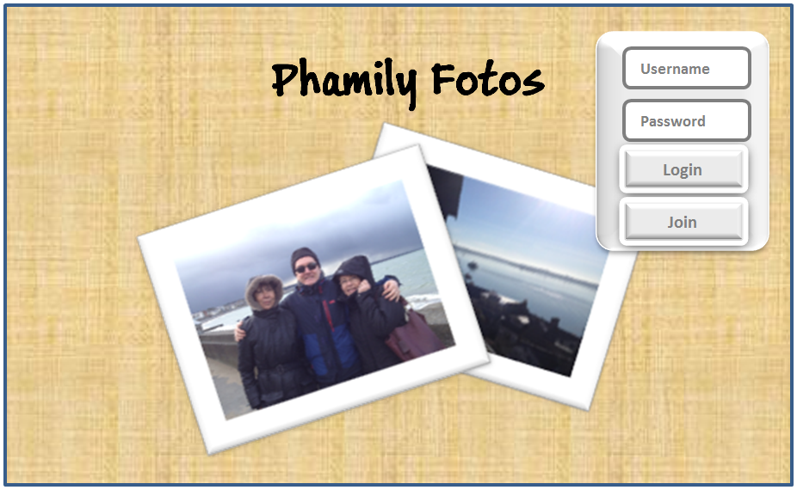

Project Report



Contents

2 Motivation 3

2.1 Project Scope 3

2.2 Area of Contribution 3

3 State of the Art Review 3

3.1 Current Photo Sharing/Storage Platforms 3

3.2 Review of current Social Media & attitudes to rights over content 4

3.3 Privacy Concerns 5

3.4 Security Concerns 5

3.5 Potential challenges raised by the use of DRM (Digital Rights Management) 6

3.6 More?? Survey of users opinions of this applications aims vs current similar applications 7

4 User Interface Design 8

4.1 Design Concept 8

5 Architecture 9

5.1 Application Architecture 9

5.2 Security 10

5.2.1 Usernames & Passwords 10

5.2.2 Intrusion Prevention 10

5.2.3 Photos & Images 10

5.3 Toolkits and Frameworks 11

5.3.1 Front-end 11

5.3.2 Back-end 11

5.4 Data Transfer Strategies 11

6 Appendicies 13

6.1 Appendix A: Terms of Service Relating to Uploaded Content 13

6.1.1 Dropbox 13

6.1.2 Facebook 13

6.1.3 Flickr 13

6.1.4 Google + 13

6.1.5 Instagram 14

6.1.6 LiveShare 14

6.1.7 Path 14

6.1.8 Photobucket 14

6.1.9 Snapchat 14

6.1.10 Snapr 15

6.1.11 Tumblr 15

Phamily Fotos Project Report

# Motivation

This project has been triggered by the notion that by 2020 (if not before) the general public might become disenchanted with the rights Social Media will have over their own private material.

## Project Scope

By referring to private material, this project will deal with images in the form of private family photographs (and videos as a natural evolution) and will enable people to upload images for other family members to view, as well as enabling these other family members to upload and share their photos too.

## Area of Contribution

This application will exercise no rights over the images that are posted and shared by families with each other and will allow all users to retain their rights to these images and will give registered users full access to enable them to delete images as well as upload them, as and when they see fit.

However it will be of vital importance to inform users that Phamily Fotos will be unable to control what happens to images that other users/family members have saved via screenshots or any other methods.

# State of the Art Review

## Current Photo Sharing/Storage Platforms

There are numerous services and platforms offering users different degrees of Photo Sharing and Photo Storage. Facebook, although not strictly speaking a Photo Sharing service would, with 500,000 + registered users and approximately 960,000 visitors each month (findthebest.com, 2014), appear to be the place where most image sharing takes place, this was further bolstered by Facebook’s acquisition of Instagram in April 2012 (Yahoo! Finance, 2012), a move that also signalled how serious Facebook considers photo sharing to be.

The other big player in the Social Media area is Google Plus, whose photo storage and sharing option is, in the opinion of Charlie Sorrell at any rate, *“…a pretty sweet way to manage and view your shared photos.”* (Sorrell, 2011). Sorrell goes on to compare Google’s offering with that of Facebook and sides with Google in terms of ease of use on a number of different levels. Although in Facebook’s defence, I feel it’s worth noting that the photo sharing taking place on their site is normally an extension of a story or event, as opposed to storing and sharing the photo for its own sake, as opposed to, say Flickr where the Photos are the primary area of interest.

Speaking of Flickr, they on the other hand, originated as a photo sharing and storage service before being bought by Yahoo in 2005, now find themselves leaning towards being more of a Social Media Site, having apparently changed their business model, offering massive storage (1TB) for free (with ads) to ordinary users and charging Pro clients just under $500 for 2TB and no ads. (Muchmore, 2013)

In between pure Social Media services who happen to store and share photos and the pure Photo Storage/Sharing platforms that have a Social Media aspect to their service there are pure storage sites, where anything and everything is stored, like Dropbox, Just Cloud, Mozy and Carbonite, to name but a few. Of these, Dropbox has recently ventured into the area of photo sharing with the introduction of a new feature, only released in April of this year, called Carousel (Balakrishnan & Lee, 2014).

Although not a complete change of course for Dropbox, as people were already using Dropbox to store many different things as well as images, this is rather a subtle manoeuvre by Dropbox to enable it to tap into the seemingly insatiable desire by people to take pictures and both store and share them instantly. Some are happy to share with the world in general and anyone else who’s interested, and then there are others (like me) who really only want to share small selections from within their library of photos with very specific groups of people (normally close friends and family)

Where Dropbox would appear to differ from most photo sharing services is in their Terms of Service (See Appendix A). In this respect with statements like “..*These Terms don't give us any rights to Your Stuff except for the limited rights that enable us to offer the Services.*” (Dropbox.com, 2014), Dropbox appear to be at pains to state that they seek no rights over users’ content and have no plans to profit from it.

Outside of all of this Snapchat appears to occupy a space all on its own! Snapchat focuses solely on the sharing of images as “moments in time” and enables users to take pictures with their smartphone, select a name from the app’s list of connected friends, specify (in seconds from 1 – 10) how long the recipient will be able to view the image and then send the photo. Once the target person receives the image it can be viewed for the pre-set time and then it’s deleted from both the recipient’s phone as well as the Snapchat servers. (Creighton, 2012)

As well as appealing to users, the concept of self-deleting photos carries with it the added bonus of Snapchat not having to worry about the overhead attached to storing users’ photos, instead they just need to focus on ensuring there’s enough bandwidth and capacity to handle the throughput of traffic.

## Review of current Social Media & attitudes to rights over content

Changes in the terms of service (or attempted changes in the case of Instagram) (Paul, 2012) by Social Media companies in the recent past signify the broader intention or desire to exercise more control over the content posted by individuals on their sites.

* **Facebook**

*“...you grant us a non-exclusive, transferable, sub-licensable, royalty-free, worldwide license to use any IP content that you post on or in connection with Facebook (IP License).”* (Facebook, 2013)

* **Instagram**

*“...you hereby grant to Instagram a non-exclusive, fully paid and royalty-free, transferable, sub-licensable, worldwide license to use the Content that you post on or through the Service, ...”* (Instagram, 2013)

* **Photobucket**

*“…you grant us a worldwide, non-exclusive, royalty-free license (with the right to sublicense) to copy, distribute, stream, post publicly display (e.g. post it elsewhere), reproduce and create derivative works from it (meaning things based on it), anywhere, whether in print or any kind of electronic version that exists now or is later developed, for any purpose, including a commercial purpose.”* (Photobucket, 2013)

Whilst the above three Social Media/Photo sharing sites are only a sample of a very large, and ever increasing, group of online services[1], the trend is for these companies, through their terms and conditions, to acquire your permission to enable them to use your images/media in any way they wish. Equally the terms and conditions normally contain disclaimers giving them protection against potential litigation arising from their use or a third party’s use of a user’s content.

## Privacy Concerns

The arrival of Social Media and it’s use as a means to share personal information, including photographs has radically changed the notion of what is and isn’t private. From the simple case of one work colleague being able to comment on the new hairstyle of the daughter of another co-worker before this lady has even seen it, to the concerns of a Physician seeing images, upon her return from a foreign mission, of herself along with patients and in some cases body parts, being shared on Facebook without ever having been asked for permission (Karen Michelle Devon, 2013), Social Media is forcing society to consider and reconsider what is private, what is appropriate to share and more importantly what control we have over our own image once someone has taken our picture.

Ironically, these concerns aren’t new and, as outlined in the Working Paper titled SHARING, PRIVACY AND TRUST ISSUES FOR PHOTO COLLECTIONS (Adams, et al., 2007), when Eastman of Kodak fame, introduced his handheld and relatively easy-to-use camera to the masses, society at the time expressed its unease at the idea that someone’s picture could be taken without their permission and the fact that that same person, in the 1902 case of one Miss Abigail M Roberson, might find their image emblazoned on pamphlets promoting barrels of flour! (Adams, et al., 2007) Sadly Miss Roberson failed to win her case (the first of its kind) but the outrage that followed resulted in the right to privacy being enshrined in a statute which was enacted by the State of New York in 1903 and is still valid to this day (Hartmere, 2000).

Figure 1 Image of Abigail M Roberson (Brandeis & Warren, Unknown)

In today’s world of instant communication it would appear, on first glance at any rate, that users of Social Media have little concern for their privacy and, having accepted (without reading) the T’s & C’s (Terms and Conditions) of the many sites of which they’re a member, frequently upload compromising images of themselves for the world to see, giving little thought to the notion that a time might arrive when they may not wish the world to know of this behaviour. This attitude is alluded to by Besmer, Richter Lipford in the conclusions of their 2008 paper were they state *“Users seem to have almost given up on being able to maintain their privacy in online photos, and instead hopelessly are accepting that privacy problems will occur”* (Bsmer & Richter Lipford, 2008)

Phamily Fotos plans to give users full and total control over their images, sharing them as and when they like and permanently deleting should they so wish. Phamily Fotos does not plan to profit from the images posted by users. However, as alluded to in a later section, it will be impossible to control any image or its use once it has been viewed online.

## Security Concerns

The main security issues that arise with online interaction normally revolve around the collection of personal data and how, or perhaps more importantly where and how securely, it’s stored. With the exception of a username, a password and of course, the images themselves, PhamilyFotos has no intentions of gathering data about its users. This means that even if there is a breach in security, any information discovered will be of little use. PhamilyFotos’ main strength in terms of its Security policy, will be the simplicity of the concept. In other words people will only share images posted with people they know and who have been invited to view them. At no point will other users be notified of a new post or that you’ve been tagged.

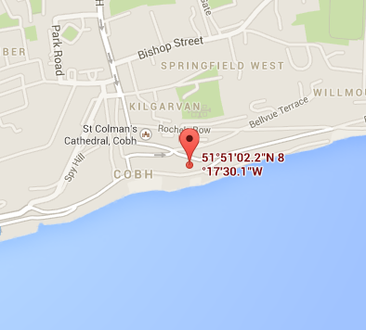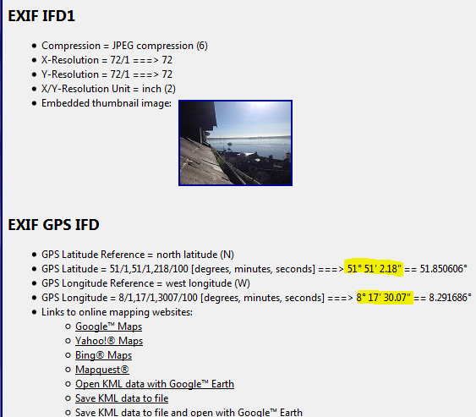Another little known potential security risk is that of Geotagging on photos and that most Smartphones do this automatically. Armed with a Firefox Browser and the EXIF Reader extension, any user can get the exact co-ordinates of where a photo was taken and with a simple click that user can view the exact location on Google Maps.

Whilst this is quite a useful feature if you wanted to create a map of where you’ve been on your holidays, this could also be a potential risk enabling a hacker to establish, not only where you live but also when you were out of the country.

An extreme example of the misuse of Geotagging is recounted in an article WWW.ARMY.MIL website: *“Warren cited a real-world example from 2007. When a new fleet of helicopters arrived with an aviation unit at a base in Iraq, some Soldiers took pictures on the flightline, he said. From the photos that were uploaded to the Internet, the enemy was able to determine the exact location of the helicopters inside the compound and conduct a mortar attack, destroying four of the AH-64 Apaches.”* (Rodewig, 2012)

It is the intention that users be given the option to either include or exclude Geotagging information when uploading a photo to PhamilyFotos. The default setting will be off, thereby eliminating the possibility of someone accidentally including the Geotag data.

## Potential challenges raised by the use of DRM (Digital Rights Management)

The difficulty arising from trying to protect, using DRM, images that are viewable online via either a portable or a desktop device is that, as per the TechDirt article (TechDirt.com, 2014) *“…if they do install the [DRM] plug-in, they can probably still just take a screenshot of the image anyway…”.* This short article refers to the futility of protecting images viewable online with DRM when any user can simply take a screenshot of the image and save a copy for themselves. Internet and, more importantly, social media users need to be aware that any image posted online can be copied in this way.

Some applications such as Snapchat attempt to mitigate against this by allowing people to share images but specify the amount of time for which the recipient can view the image. Although ironically the developers of this App were brought before the US FTC (Federal Trade Commission) for, amongst other things, having *“…failed to disclose its geolocation tracking practices to users.”* (Nichols, 2014)

## More?? Survey of users opinions of this applications aims vs current similar applications

Questions for a survey:

* Are you happy to allow Social Media Sites have full rights over personal images posted on their site by you or by others?
* How would you prefer to share your personal images with family or friends?
  + Viewable by others as well as the friends in question?
  + Viewable only by specified people?
* What control would you like to have over your own images?
  + To be able to delete all content from a service yourself at your discretion?
  + To be able to decide who can view your content?
* Comments?

# User Interface Design

## Design Concept

The main motivation behind the design of the user interfaces was to at first make the experience welcoming, friendly and easy to use. And by virtue of the application’s responsive design using HTML5, CSS3, and JavaScript, the application will be accessible on all devices with an internet connection, ranging from Desktops, to Laptops and down to Tablets and Smart Phones

Figure 2. Welcome / Log in Screen

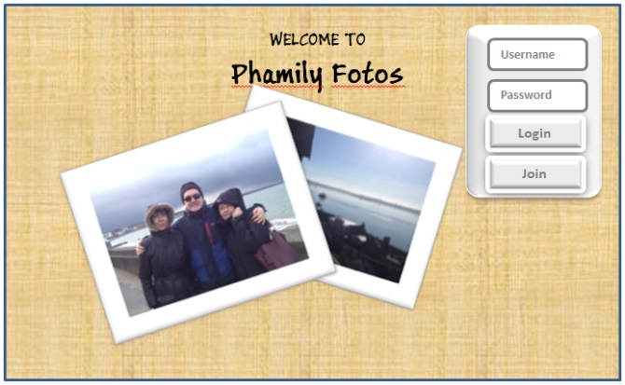

As can be seen in the Welcome screen on the left, it’s important to give the user a sense of confidence in the applications ability to live up to its promise of preserving their privacy on one hand, whilst enabling them to share their images with the close friends and family of their own choosing. This will be achieved by having a well-structured log in and join process, where people can only log in with their own username and password, but equally, when it comes to sharing their content with other people, this will be strictly controlled and will only be achieved by mutual consent of the users concerned.

Figure 3 Mobile Welcome Screen

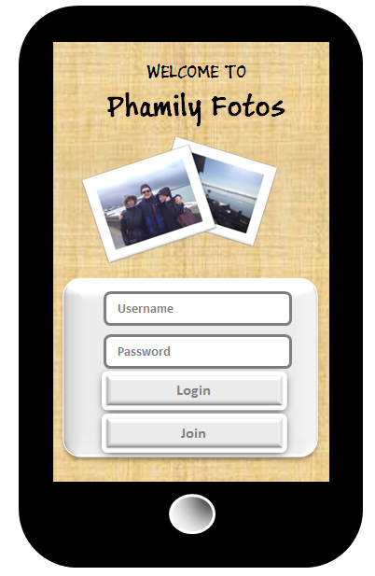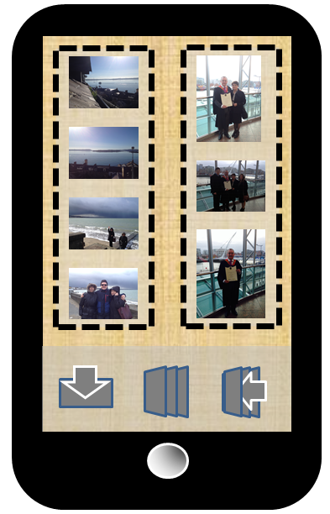

Figure 4 Mobile Gallery Screen

Once logged into the application, the user will be presented with either a gallery of all their own photos or a collection of the various albums they’ve created from their photos. A side or bottom menu will give the user the options to upload new photos, to create a new album and then to add photos to this new album.

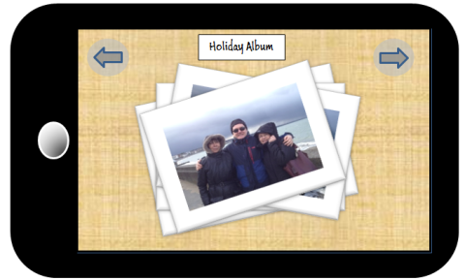

Figure 5 Mobile Phamily Photos Screen

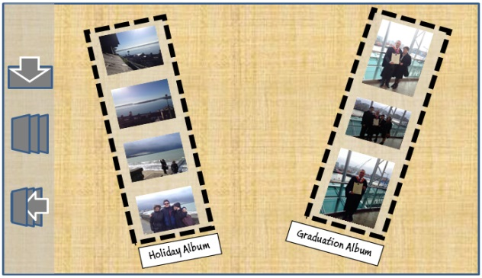

Figure 6 Browse Albums Screen. Plus Side Menus

Having created one or more albums, the user will be able to scroll through thumbnails of the images and then if they select the album for viewing, they’ll be able to see a larger representation of these photos which they can flick through.

Figure 7 View Phamily Fotos Screen

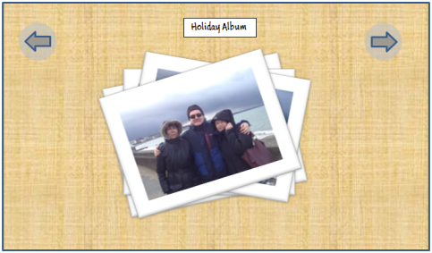

The scrolling of the thumbnail images, as well as the layout of the albums in a Photo Strip and the subsequent display of and flicking through the **“Phamily Fotos”** will all be achieved using HTML5 and CSS3 effects in conjunction with JavaScript and Ajax. The layout of the various screens will depend on the size of screen available, this will be controlled in CSS the @mediaquery feature which establishes the size of the screen available before displaying the webpage and applies the CSS rules appropriate to the size found. Where possible images and icons will be designed and drawn in Inkscape using SVG (Scalable Vector Graphics) which is the W3Schools recommended technology as an Open Source alternative to Flash.

Having tested the Application on Desktops, Laptops, Tablets and Smartphones, it was concluded that keeping the menu Symbol at the bottom left of the screen made little or no difference to the user experience when using a mouse/touchpad on desktops/laptops. However the user experience was vastly improved on touch screen devices, as users tend to hold these devices at the bottom and it’s therefore easier to select the menu symbol with their thumb, without having to let go and then reach up to select the menu.

# Architecture

## Application Architecture

The chosen application architecture will be the standard MVC (Model View Controller) using HTML5, CSS3 with a combination of JavaScript and Ajax at the Front End (the View). The back end or Model will consist of a MySQL database, finally PHP will be used to communicate between the Front and Back Ends acting as the Controller.

Client Side



Server Side

This, to me, is the most obvious approach to take, as, to facilitate sharing, there will be a basic requirement for storage of the images centrally in a secure place. Following on from this, some kind of Graphical User Interface will be required for the users to interact with. Having dealt with these two essential requirements, the application will need some means by which the front and back ends can communicate with each other. By the same token, keeping the storage and the controller functionality on the server side, being accessed by web service API’s, means the client side can be kept light. This strategy will be ideal for users accessing the application on mobile devices where data storage and processing power is at a premium.

## Security

### Usernames & Passwords

Although, apart from the actual photographs stored on the server, there will be no personal information or data stored about users on the system. That being said, every precaution to protect usernames & passwords will be taken and so each password will be encrypted using PHP’s built in md5 encryption algorithm. Md5 encryption takes a regular string as input and converts it to a 32bit hash (W3Schools, 2014), it’s this now encrypted string which will be stored in the database.

### Intrusion Prevention

To protect against unauthorized intrusion, such as a SQL Injection, PHP provides a number of pre-written functions which effectively ignore anything other than regular text (Yank, 2009), the most effective of which is:

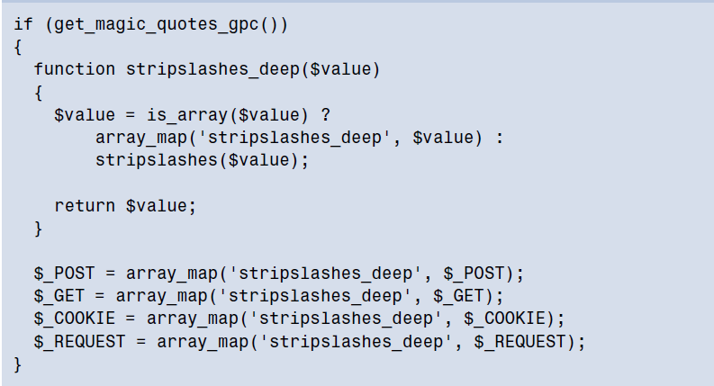

Figure 8 PHP Filtering Code

### Photos & Images

Although the development prototype application currently resides on a fairly basic server using standard HTTP connectivity, the commercial version of Phamily Fotos would operate using the more secure HTTPS connection, this would give some protection to users from Man in the Middle attacks when uploading their images.

However the greatest protection the Phamily Fotos application would offer to users is that the images stored by the application would remain their property and would never be used in any context other than for sharing with friends and family.

All photos uploaded will be saved in two sizes, one small image to be used as a thumb nail image when viewing the larger collection of photos and a second larger image which will be used when viewing slide shows of particular albums, the code for this function was sourced on YouTube (Tutorize, 2011).

## Toolkits and Frameworks

### Front-end

The HTML5, CSS3, JavaScript and PHP were all coded using Notepad++. The individual web pages were tested on the local machine on all the major HTML5 compatible browsers (Chrome, Firefox, Safari and IE) and extensive use was made of the development tools available in each browser to enable the CSS to be refined to take account of each Browsers particular quirks and qualities.

Where the side menus were concerned, the basic code used in its implementation was sourced at a site known as Codrops.com (Lou, 2013)

JQuery plugins were used to implement the Lightbox used to display larger copies of the images when any of the albums are selected. Although this code was sourced at Codrops.com

### Back-end

The Server-Side PHP scripting was also written using Notepad++ and the MySQL database was developed using the Open Source phpMyAdmin.

 Figure 9 PhamilyFotos Database Diagram

The database, as can be seen above, includes look-up tables to take account of

Extensive use was made of PHP Include files. These Include files encapsulate most of the repetitive functionality of the Server Side scripting such as database connectivity and MySQL queries and enable other files/web pages to use and re-use this code, making for more efficient back-end functionality.

## Data Transfer Strategies

Data transfer will be over either a wireless or wired connection, and as such will be over an http connection, however for security and privacy purposes this will have to be an https, offering greater security to the users.

Given that the vast majority of uploads to the site will be images, with only a little text for captions or album titles, it will be important for users to have a fast, reliable data connection. It might be worth considering more than one Data Transfer Strategy depending on what kind of connection is available to the user, with a final fall back offering local storage (in a situation where the quality of connection is insufficient) until such time as the user has access to a better connection.

# Appendicies

## Appendix A: Terms of Service Relating to Uploaded Content

### Dropbox

*“When you use our Services, you provide us with things like your files, content, email messages, contacts and so on ("Your Stuff"). Your Stuff is yours. These Terms don't give us any rights to Your Stuff except for the limited rights that enable us to offer the Services.*

*We need your permission to do things like hosting Your Stuff, backing it up, and sharing it when you ask us to. Our Services also provide you with features like photo thumbnails, document previews, email organization, easy sorting, editing, sharing and searching. These and other features may require our systems to access, store and scan Your Stuff. You give us permission to do those things, and this permission extends to trusted third parties we work with.”* (Dropbox.com, 2014)

### Facebook

*“...you grant us a non-exclusive, transferable, sub-licensable, royalty-free, worldwide license to use any IP content that you post on or in connection with Facebook (IP License).”* (Facebook, 2013)

### Flickr

*“Yahoo does not claim ownership of Content you submit or make available for inclusion on the Yahoo Services. However, with respect to Content you submit or make available for inclusion on publicly accessible areas of the Yahoo Services, you grant Yahoo the following worldwide, royalty-free and non-exclusive license(s), as applicable:”*

### Google +

*“When you upload, submit, store, send or receive content to or through our Services, you give Google (and those we work with) a worldwide license to use, host, store, reproduce, modify, create derivative works (such as those resulting from translations, adaptations or other changes we make so that your content works better with our Services), communicate, publish, publicly perform, publicly display and distribute such content. The rights you grant in this license are for the limited purpose of operating, promoting, and improving our Services, and to develop new ones. This license continues even if you stop using our Services (for example, for a business listing you have added to Google Maps). Some Services may offer you ways to access and remove content that has been provided to that Service. Also, in some of our Services, there are terms or settings that narrow the scope of our use of the content submitted in those Services.”* (Google.com, 2014)

### Instagram

*“...you hereby grant to Instagram a non-exclusive, fully paid and royalty-free, transferable, sub-licensable, worldwide license to use the Content that you post on or through the Service, ...” (Instagram, 2013)*

### LiveShare

*“By Posting Images, you are granting (a) to all members of your private community (for each such Image available to members of such private community), and/or (b) to the general public (for each such Image available anywhere in the Service, other than a private community), permission to use your Images in connection with the use, as permitted by this TOU, of any of the Services, (including, by way of example, and not as a limitation, making prints and gift items which include such Images), and including, without limitation, a non-exclusive, world-wide, royalty-free license to: copy, distribute, transmit, publicly display, publicly perform, reproduce, edit, translate and reformat your Images without having your name attached to such Images, and the right to sublicense such rights to any supplier of the Services.”*

### Path

*“By posting Content to the Service, you grant us the right and license to use, modify, publicly perform, publicly display, reproduce, and distribute such Content on and through the Service. You agree that this license includes the right for us to make your Content available to other users of the Service, who may also use your Content subject to these Terms. You retain any and all of your rights to any Content you submit, post or display on or through the Service and you are responsible for protecting those rights.”*

### Photobucket

*“…you grant us a worldwide, non-exclusive, royalty-free license (with the right to sublicense) to copy, distribute, stream, post publicly display (e.g. post it elsewhere), reproduce and create derivative works from it (meaning things based on it), anywhere, whether in print or any kind of electronic version that exists now or is later developed, for any purpose, including a commercial purpose.” (Photobucket, 2013)*

### Snapchat

*“You retain all ownership rights in your User Content. However, by submitting User Content to Snapchat, you hereby grant us a nonexclusive, worldwide, royalty-free, sublicensable and transferable license to use, reproduce, modify, adapt, publish, create derivative works from, distribute, perform and display such User Content in connection with the Services, subject to your use of privacy settings in the Services to control who can see your User Content.”*

### Snapr

*“By submitting Content through the Services you grant Snapr a worldwide, non-exclusive, perpetual, irrevocable, fully paid, royalty-free license (with the right to sub-license and transfer) to use, copy, process, modify, publish and distribute such Content in any media or distribution methods (now known or later developed) in connection with the Services or promotional materials.”*

### Tumblr

*“When you provide Subscriber Content to Tumblr through the Services, you grant Tumblr a non-exclusive, worldwide, royalty-free, sublicensable, transferable right and license to use, host, store, cache, reproduce, publish, display (publicly or otherwise), perform (publicly or otherwise), distribute, transmit, modify, adapt (including, without limitation, in order to conform it to the requirements of any networks, devices, services, or media through which the Services are available), and create derivative works of, such Subscriber Content.”*

1. See Appendix A for a more comprehensive list of T’s & C’s