- Test Driven Development!!!!!
  - Less bugs get shipped to production as regressions are captured early by the automated tests.
  - Only a failed test will prevent a new change to be deployed to production.
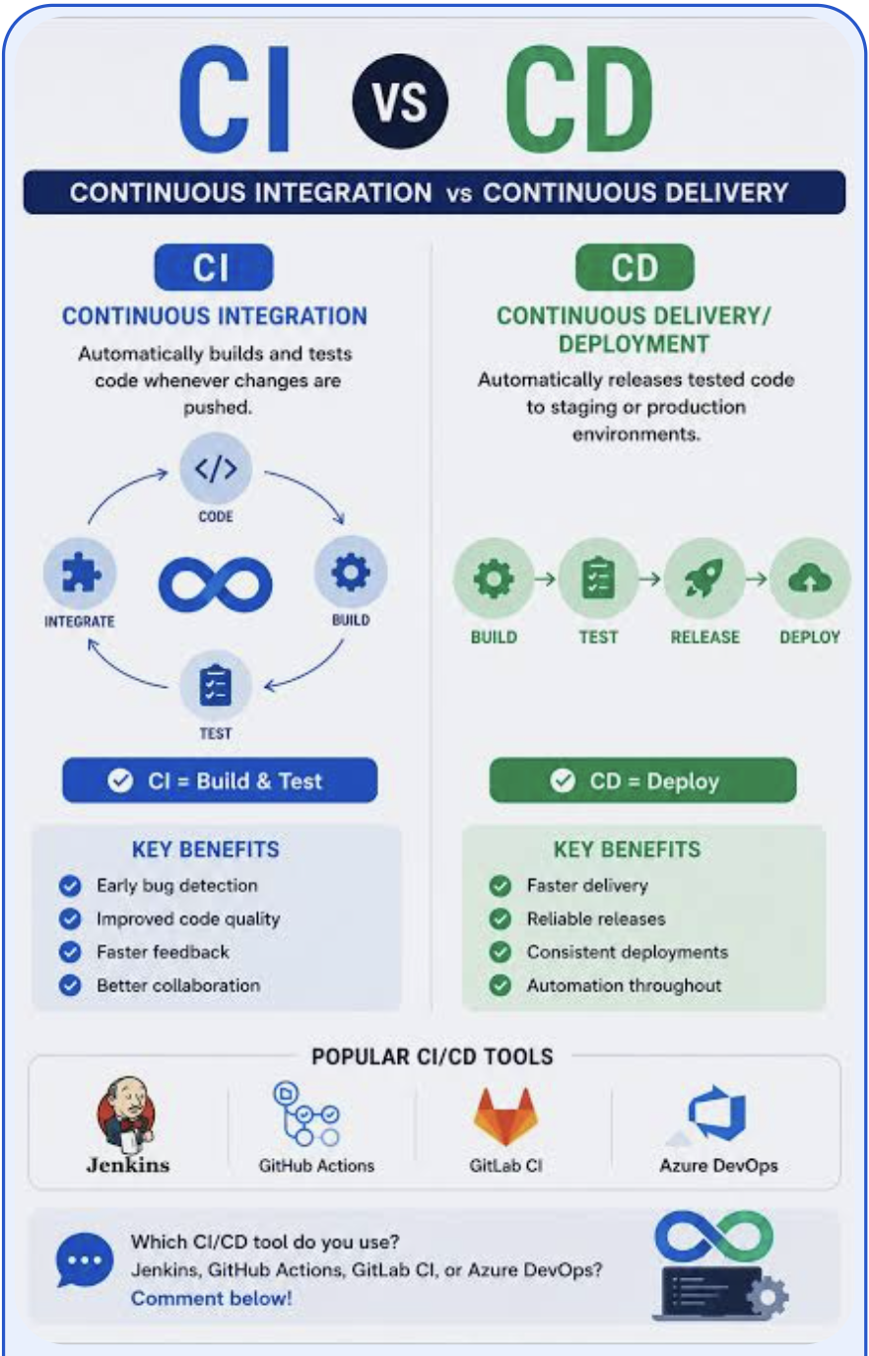
- Your team will most likely need to embrace feature flags so that incomplete features do not affect customers in production.
- What are feature flags?
  - Feature flags are a software development technique that enables teams to toggle functionality on or off at runtime without redeploying code. By separating deployment from release, feature flags enable engineers to target new features to specific user groups rather than the entire user base. Targeted releases reduce risks and enable observation of real-world effects in production. By implementing feature flags, releases to production can become more controlled, reversible, and transparent, transforming a single risky event into a manageable process.
  - Targeted releases are also called “canary releases.” Canary releases are a deployment method in which a new software version is gradually introduced to a small group of users, called the “canaries,” before a complete rollout. This serves as a live test to identify bugs and performance problems early. Canary releases reduce risk for all users. The name comes from the practice of using canaries in coal mines to warn miners of dangerous gases. This approach enables teams to observe real-world performance, collect feedback, and roll back updates if issues arise, ensuring stability and supporting gradual enhancements.
Example: The introduction of Authenticator App using Time-based One Time Passcode (TOTP)

- FTP
  - Slow
  - Insecure,

