Security Awareness Project

**Phishing Training Email**

We are sending out the following email

To all

Hello this is Bank A Security department here to tell you that someone has purchased a high priced item using your account for a price of $2845.00. If you authorized this purchase, then you do not have to do anything. If you did not make this purchase, you need to click on the link below and stop the transaction immediately.

Link [www.BandA.com/securityDept/authorizationdepartment](http://www.BandA.com/securityDept/authorizationdepartment)

You may also call us at 848*789-9456

Thank you and look forward to serving you and keeping you safe.

Sincerely

Bank A Financial Manager

Infographic Creating a Strong Password

Poster -- Be vigilant and Aware

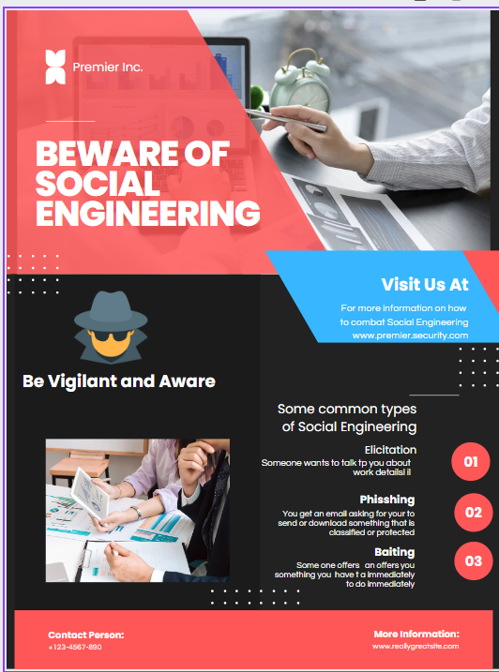

Short Story – Social Engineering – Be Vigilant and Aware

Penelope went to the park to walk her dog as usual. This day she ran into another person a male about her age with a dog as well. The man approached the woman and said “Hello, I am new here, but I see my dog has met a new friend. She said yes, my dog is friendly to other dogs. The man said, oh, well that is great so is my dog. By the way who takes care of your dog when you are at work? I am having trouble finding a dog sitter or dog-walker who can watch over my dog while I am at work. Who do you use? She says well my dog stays at home lonely while I am at work, but I do take here to Dog Haven when I need someone to babysitter. Oh, that sounds great, the man says. I sometimes work long hours although it is king of a boring job. I bet you have a fun job. She says, well I like where I work? Really, he says what do you do? She I work at Company B as a security specialist. Oh, that is great? That sounds fun? I mostly deal with financial data, but I do admire my security team as they keep us safe and effective. I bet you work hard hours and protect your employees. Yes, she says I do. Ok that is great. It is always fun to meet a smart hardworking woman with an awesome dog. I think we have a lot in common. Would you like to have lunch or dinner sometime? I would like to get you and your dog better. Maybe you can tell me some adventures and share our experiences at work? Does that sound good to you?

While this seems like a very casual conversation, this person is using a commonality with dogs to attract the woman and get her to speak more about her experience at work. This could be a way to get more information on her and lead to gathering more credentials and other information about her job. While friendships and camaraderie are always attractive, one has to be careful to not let the conversation go from dog sitting to what you do at work specifically. Be aware and be vigilant at all times.