EEG-Based Sleep Duration Prediction
Analysis Phase — Progress Report & Findings Summary

Student: Paola Carić
Mentor: dr.sc. Mateo Sokač, Algebra University
Date: April 2026
Status: Analysis complete — Modelling tables built — RF scripts ready to run

1. Project Overview
The goal of this thesis is to predict average nightly sleep duration (in hours) from EEG recordings collected during a structured cognitive task protocol. The prediction target is a continuous variable (Sleep_Hours) drawn from participant metadata, and the primary features are FFT band-power values computed per EEG channel and cognitive task, supplemented by proprietary performance metrics from the Emotiv headset.
The project follows a two-phase modelling plan agreed with the mentor:
- Phase 1 (Classical ML): Random Forest and Gradient Boosting on aggregated FFT features + demographic variables (Gender, and optionally medication/neurological history).
- Phase 2 (Deep Learning): RNN / GRU / LSTM on raw EEG time-series for the task types identified as most informative in Phase 1.
This document summarises everything completed through the end of the Analysis phase: data preparation, exploratory data analysis, all graphs produced, key findings, and what carries forward into modelling.

2. Dataset Description

2.1 Subjects and Target Variable
The full cohort consists of 83 subjects, all of whom are included in the analysis-ready dataset. The target variable is self-reported average sleep hours per night, ranging from 5.0 h to 8.5 h (mean = 6.7 h, median = 7.0 h, std = 0.78 h). The distribution is narrow and right-skewed, with the vast majority of subjects reporting between 6 and 7.5 hours.
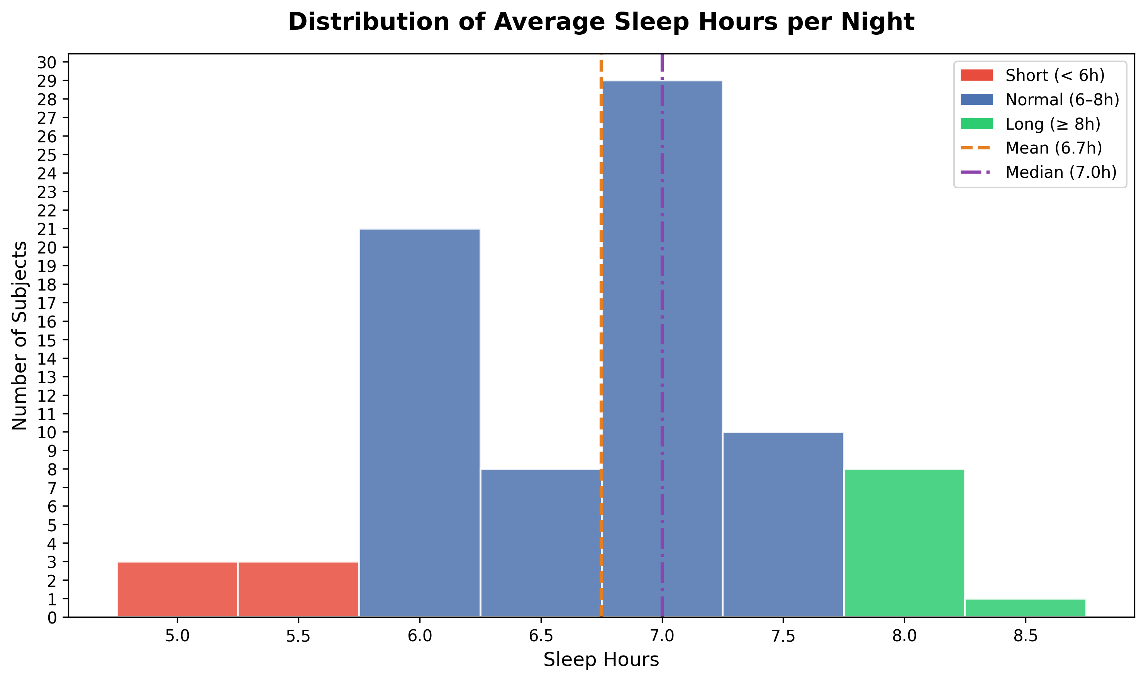
Figure 1. Distribution of average sleep hours across all 83 subjects. Red = short sleepers (< 6 h), blue = normal (6–8 h), green = long (≥ 8 h). Short: ~6 subjects; Normal: ~66 subjects; Long: ~9 subjects (8 at 8.0 h, 1 at 8.5 h).
Key insight: The narrow distribution of sleep hours (std = 0.78 h, nearly all subjects within a 2-hour range) is the single most important factor explaining why individual EEG features show weak linear correlations with sleep. There is simply very little variance to predict. This motivates a multivariate ML approach rather than simple correlation analysis.

2.2 EEG Setup and Features
EEG was recorded using an Emotiv EPOC headset with 14 channels: AF3, F7, F3, FC5, T7, P7, O1, O2, P8, T8, FC6, F4, F8, AF4. Two types of features are available:
- FFT band power (POW columns): Theta, Alpha, BetaL, BetaH, Gamma — one value per channel per row. These are the primary ML features.
- Performance Metrics (PM): Attention, Engagement, Excitement, Relaxation, Focus, Stress, Interest — proprietary Emotiv scores derived from the EEG signal.
Signal quality is tracked via CQ (Channel Quality) columns per channel and a global interpolation flag. Both were used during data preparation to filter out unreliable sessions.

2.3 Task Protocol
Each participant completed approximately 60 distinct cognitive tasks, grouped into six functional domains:
- Cognitive/Language: word generation, sentence construction, reading aloud (prefrontal1-3, frontal3)
- Memory: word/number memorisation and recall (frontal1-2, frontal3_recall)
- Visual/Spatial: dot-following, 2D/3D pattern tasks, sequence completion (occipital4, parietal tasks, valdo1-3)
- Motor/Action: left/right hand motor tasks with eyes open/closed (gyrus tasks)
- Auditory: instrument counting, category-based word generation (temporal tasks)
- Emotional: viewing images of happiness, sadness, and anger (image tasks)
Tasks are identified by a MarkerIndex column embedded directly in the data.csv EEG stream (positive value = task start, negative = task end). This inline marker approach was used during preprocessing to segment the continuous EEG recording into task-level epochs for all 83 subjects, independently of the marker.csv timestamp column.

3. Data Preparation Phase
Data preparation was completed in two stages: a pilot stage on 10 randomly selected subjects, followed by full-dataset processing once the pipeline was validated.

3.1 Pipeline Scripts
- load_data.py — maps subject IDs from DatasetSub_shorten.csv to their corresponding data.csv and marker.csv files; extracts Sleep_Hours and Gender per subject.
- clean_pilot_dataset.py — processes the pilot 10 subjects: synchronises using inline MarkerIndex events in data.csv, segments EEG into task epochs, applies signal quality filters (CQ columns, interpolation threshold), and outputs pilot_task_ready.csv and pilot_categorized_tasks.csv.
- clean_whole_dataset.py — extends the same pipeline to all 83 subjects, outputting all_task_ready.csv (n=83 subjects) and associated summary files.
- signal_quality_check.py — produces pilot_signal_quality.csv and pilot_data_map.csv, showing per-subject and per-channel quality metrics.

3.2 Output Files
File | Subjects | Description
pilot_task_ready.csv | 10 | Pilot subjects, task-level rows, FFT + PM + Sleep_Hours + Gender
pilot_categorized_tasks.csv | 10 | Same as above with task_category labels added
pilot_signal_quality.csv | 10 | Per-subject signal quality scores (CQ, interpolation, final retained %)
pilot_data_map.csv | 10 | Subject ID → file paths + Sleep_Hours + Gender mapping
all_task_ready.csv | 83 | Full dataset, all subjects, quality filter applied row-level. Primary input for ML models.
task_vs_bands_median.csv | 83 | Median Z-score band power per task (aggregated)
task_vs_channels_median.csv | 83 | Median Z-score channel power per task (aggregated)

Note on synchronisation: Task segmentation uses the MarkerIndex column embedded in each subject's data.csv, not the timestamp column in marker.csv. This approach is robust to marker file mismatches and ensures all 83 subjects are correctly processed. The marker.csv is used only as a name lookup (marker_id → task name).

4. Exploratory Data Analysis — Findings

4.1 EEG Physiological Validity (Task vs. Bands Heatmap)
The first analytical question was whether the EEG data reflects known physiological patterns. A Z-score heatmap of median band power per task confirms that the signal is physiologically valid:
- Speech tasks (baseline_talk, frontal3_saying_outloud, saying_words_based_on_cat) show broadband activation across Theta, Beta, and Gamma — consistent with expected EMG/muscle artifact from jaw and facial movement during vocalisation.
- Eyes-closed and imagination tasks (imagine_way_home, temporal_how_many_instruments) show strong Alpha enhancement — the classic alpha-blocking-release pattern seen when visual cortex is not processing external input.
- Passive image-viewing tasks (image_happiness, image_sad, image_angry) are uniformly suppressed across all bands, reflecting reduced active processing relative to the Z-scored baseline.
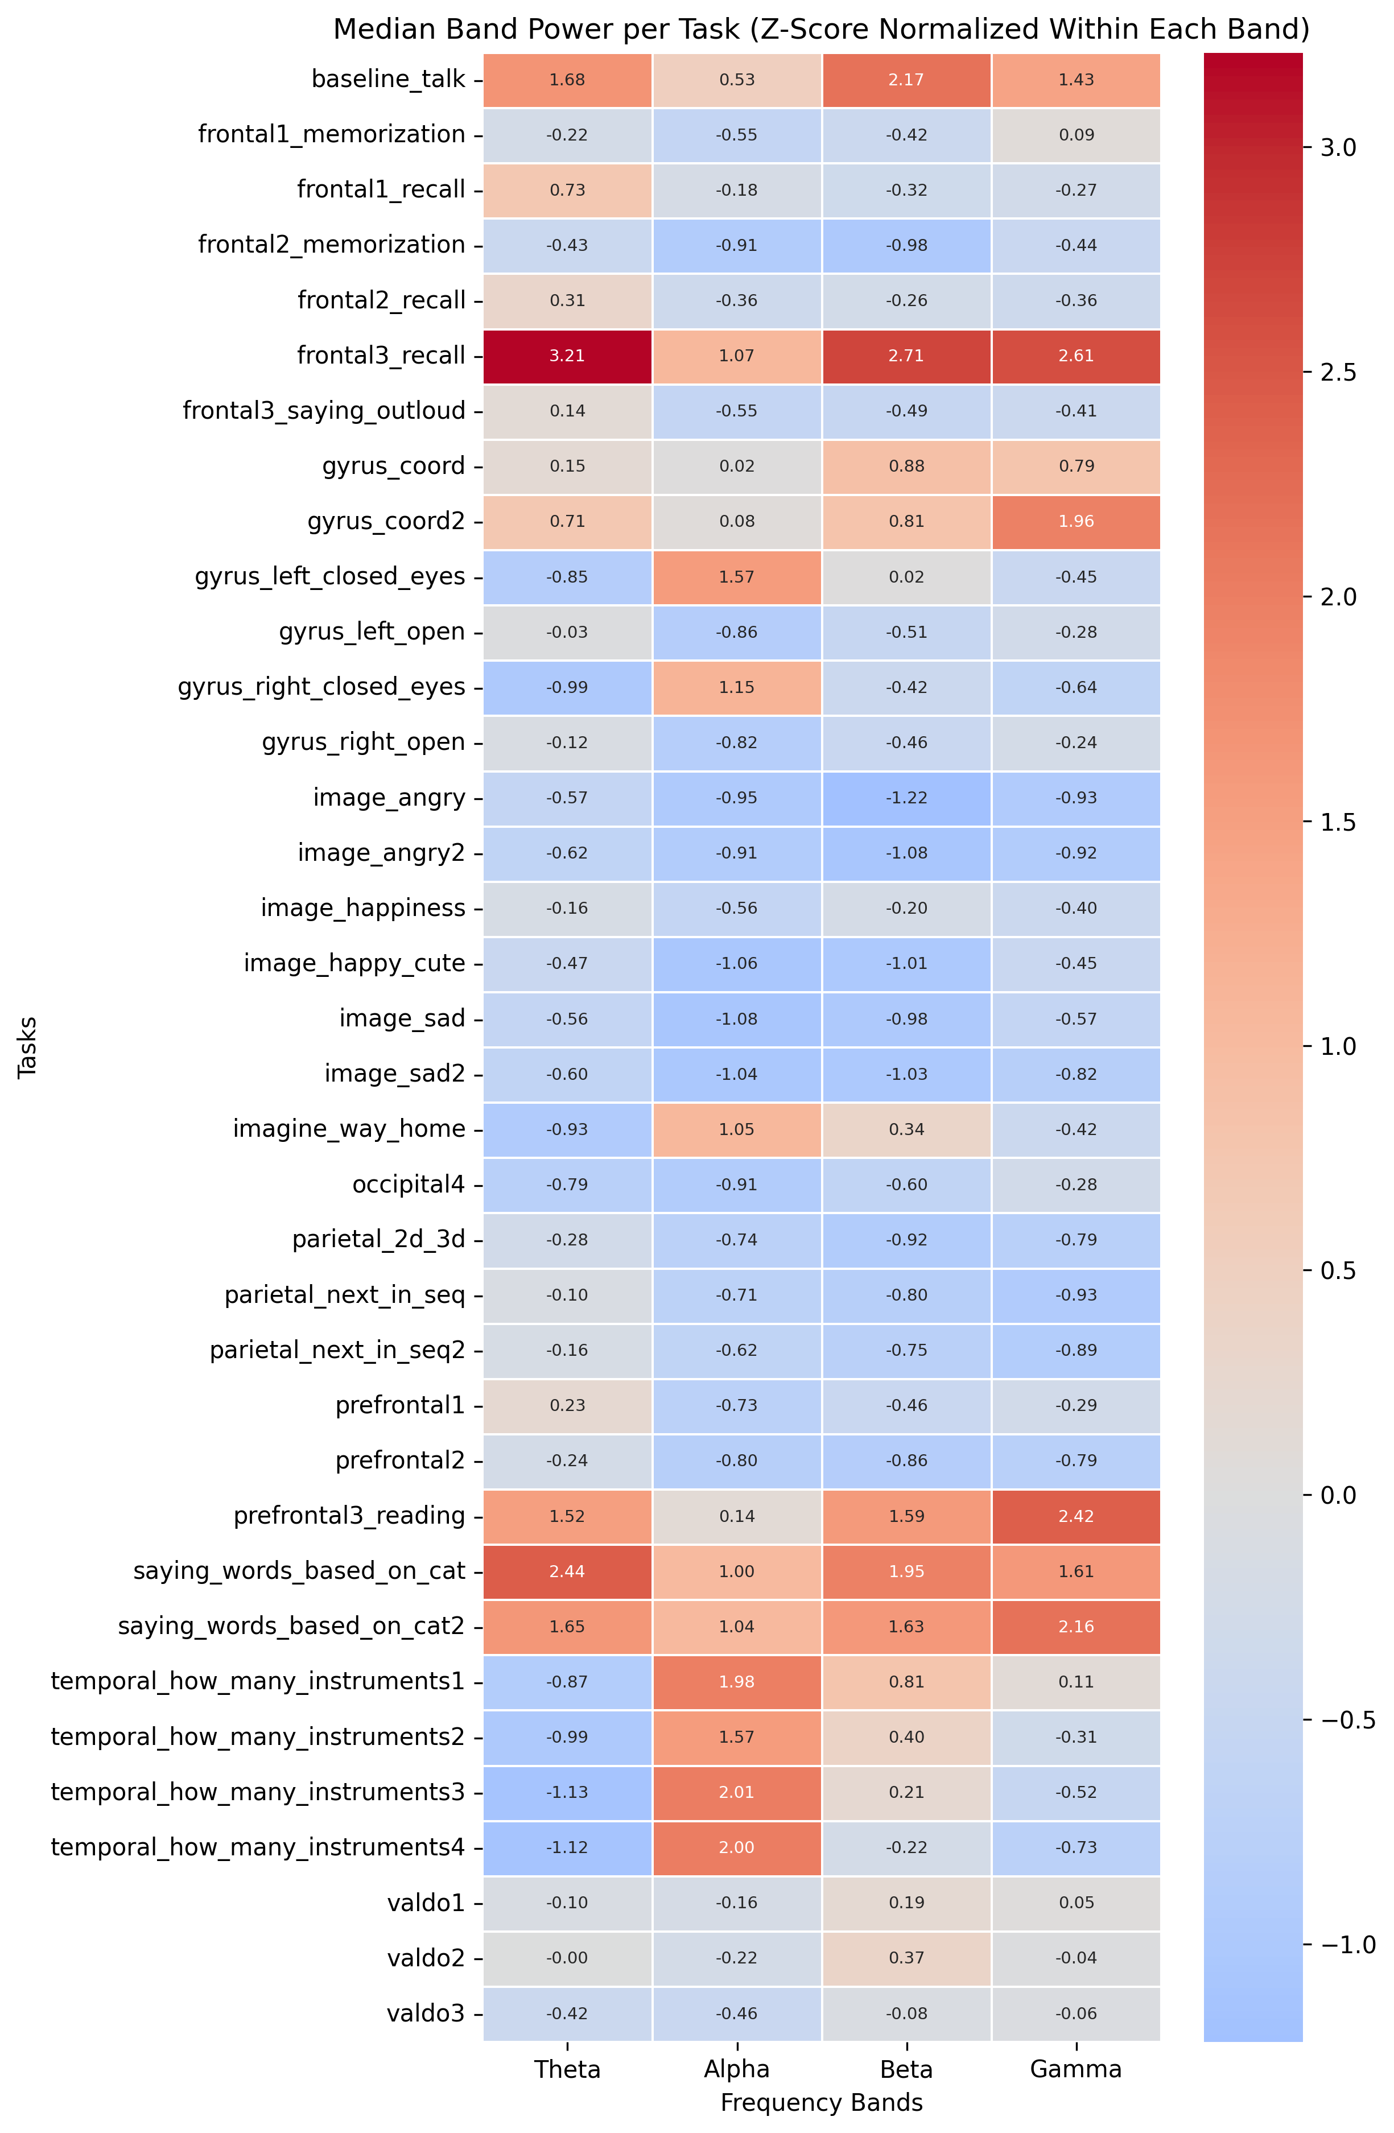
Figure 2. Median band power (Z-score normalised within each band) per task. Red = above average activation, blue = below average. Confirms physiologically expected EEG patterns across task types.
This graph serves as the "sanity check" section of the thesis — it demonstrates that data collection and preprocessing did not introduce systematic artifacts, and that the EEG device captured meaningful neural signals.

4.2 Sleep Duration Distribution
Already shown in Figure 1. Key statistics: mean = 6.7 h, median = 7.0 h, std = 0.78 h, range = 5.0–8.5 h. The distribution is heavily concentrated in the 6–7.5 h range, with very few truly short sleepers (< 6 h: ~6 subjects) or long sleepers (≥ 8 h: ~9 subjects). This narrow variance in the target variable is the primary challenge for prediction and is why no single EEG feature shows statistically significant correlation with sleep at the subject level.
Note on binning: The original script used auto-generated bins (bins=12) which placed a bin boundary at ~5.875 h, causing subjects who sleep exactly 6.0 h to appear as "Short" sleepers in the visualisation. This was corrected by switching to fixed bin edges [4.75, 5.25, 5.75, 6.25, ...] centred on half-hour values, aligning bin boundaries precisely with the 6 h and 8 h group thresholds.

4.3 FFT Features vs. Sleep Duration (Row-Level Correlations)
A Pearson correlation was computed between each FFT feature (channel × band) and Sleep_Hours at the row level across the full all_task_ready.csv dataset. The top positive and negative correlates are shown below.
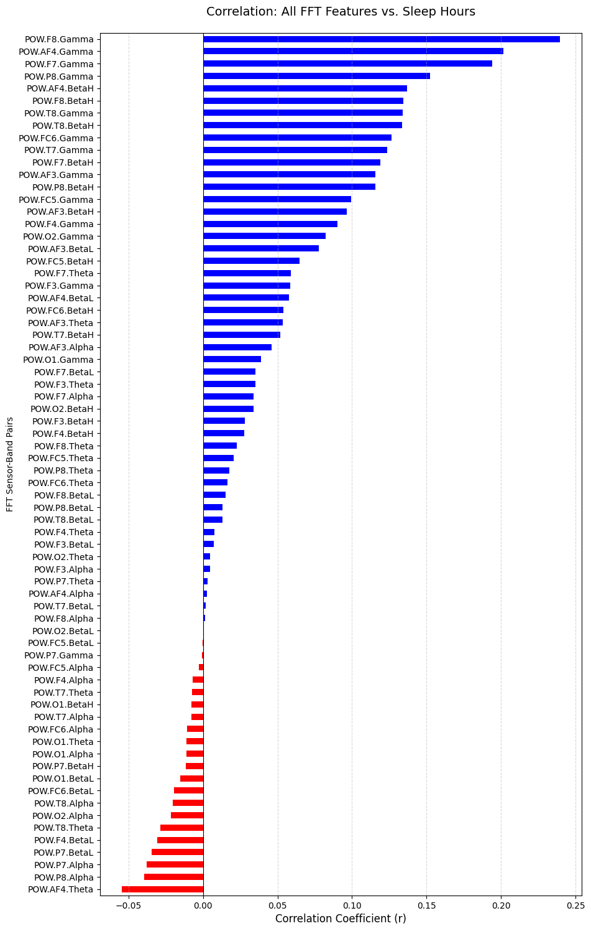
Figure 3. Pearson correlation between each FFT feature and Sleep_Hours (row-level, n = all rows in all_task_ready.csv). Blue = positive, red = negative. Values up to r ≈ ±0.27.
Key findings from this analysis:
- Top positive correlates: Gamma and BetaH bands at right-hemisphere channels (F8, F7, T8, P8). Correlation r up to ~+0.27.
- Top negative correlates: Theta and Alpha bands at prefrontal channels AF3 and AF4, with r down to ~−0.15.
- Interpretation: More sleep is associated with higher high-frequency power (Gamma, BetaH) and lower frontal Theta/Alpha. This aligns with neuroscientific literature suggesting that well-rested individuals have greater cognitive bandwidth and reduced drowsiness-related slow-wave activity.
Important caveat: These are row-level correlations computed over many rows per subject (one per task). The effective sample size is inflated because within-subject variance contributes to the correlation. The "top positive" features (F8.Gamma, F7.Gamma) actually reverse direction when computed at the subject level — see Section 4.5.

4.4 FFT Features vs. Emotiv Performance Metrics
Separate heatmaps were produced for frontal, parietal/occipital, and temporal brain regions, showing Pearson correlations between FFT band-power values and the seven Emotiv performance metrics.
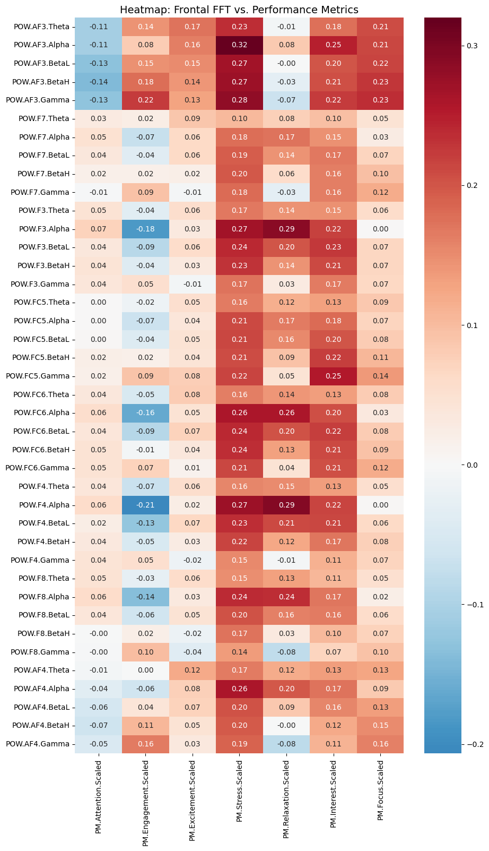
Figure 4. Frontal region: FFT band power vs. Emotiv performance metrics. Annotated with Pearson r values.
Key findings:
- Frontal Alpha power negatively correlates with Engagement (r ≈ −0.21 at AF3.Alpha) — the classic alpha-blocking effect: when a person is more engaged, frontal alpha is suppressed.
- Stress correlates positively with multiple frontal bands (r up to ~0.30), consistent with the Emotiv stress metric being derived partly from high-frequency frontal power.
- Posterior (parietal/occipital) Alpha shows the strongest single correlation in the dataset: P8.Alpha vs. Relaxation at r = +0.41, and a strong negative correlation with Engagement at P8 (r = −0.35). This confirms the alpha-relaxation link well-established in EEG literature.
- Temporal region correlations are weak (mostly r < 0.20) — this region appears least informative among the three.
- Most inter-metric correlations (Stress–Interest r = 0.73, Stress–Relaxation r = 0.61) reflect internal structure within Emotiv's proprietary algorithm rather than independent physiological constructs. This limits the PM metrics' usefulness as independent features for sleep prediction.

4.5 Subject-Level Scatter Plots (FFT Features vs. Sleep)
To move from the row-level correlations (Section 4.3) to a subject-level view, the top 5 positive and top 4 negative FFT features were averaged per subject and plotted against Sleep_Hours. Features were Z-score normalised within each band to address the large scale differences (Theta power ≈ 100×, Gamma power ≈ 1×). Outliers beyond ±3 SD were clipped for readability. This analysis uses n = 83 subjects.
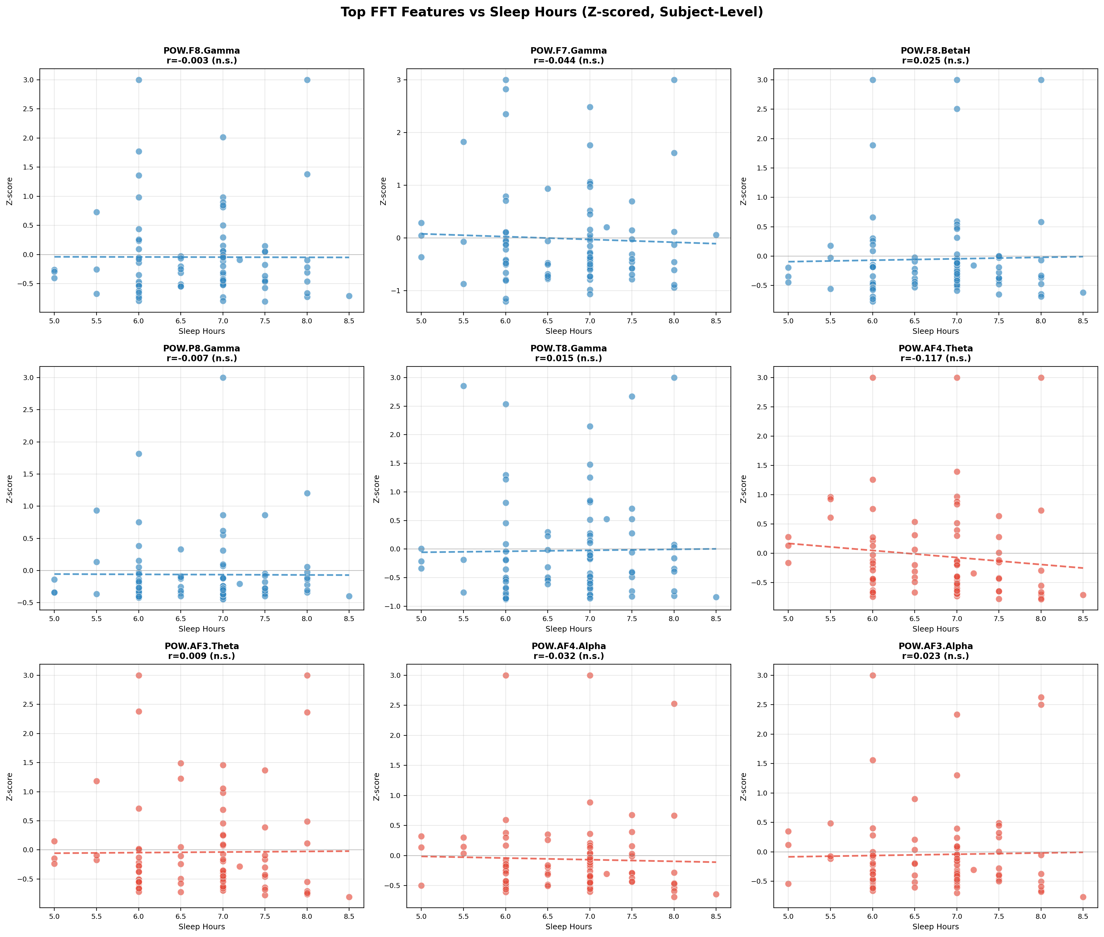
Figure 5. Subject-level scatter plots: top FFT features vs. Sleep_Hours. Blue = features with positive row-level correlations; red = negative. All r values shown are non-significant (all p > 0.05).
Key findings:
- None of the 9 features reach statistical significance at the subject level (all p > 0.05, n = 83).
- Direction reversal (important): F8.Gamma and F7.Gamma flip from positive at row-level to slightly negative at subject level. This means the row-level positive signal was driven by within-subject variance across tasks — not genuine between-subject sleep effects. The row-level correlations should be used for feature ranking only, not for directional interpretation.
- Strongest subject-level signal: AF4.Theta — the most consistent with the row-level finding and the largest in magnitude, but still non-significant. Exact r values to be updated after re-running scatter analysis with n = 83.
- Conclusion: No single FFT feature linearly predicts sleep hours at the subject level. Multivariate modelling is needed to combine weak signals across features.
Narrative for the thesis: The scatter plots pair with the correlation bar chart to tell a complete story. The bar chart shows which features are most associated with sleep at the population level; the scatter plots show why a univariate approach is insufficient. Together, they motivate the Random Forest model as the logical next step.

4.6 Performance Metrics as Sleep Predictors
The complete_performance_heatmap.png shows correlations between all performance metrics and Sleep_Hours. The strongest association is Engagement at r = +0.28 — all others are below |0.28|. These correlations are too weak to be useful as primary predictors. The sleep-group bar charts in visuals_tasks_per_metric/ (pilot data only, n = 9) confirm this: while consistent directional trends exist (e.g., 7h+ sleepers score slightly higher on Engagement in Cognitive_Language tasks), no comparison reaches statistical significance with n = 9. These charts have been set aside.

These final two EDA analyses were completed after the main graph series.

4.7 Sleep-Group FFT Bar Charts — Full Dataset
FFT band power (16 features: Gamma, BetaH, Theta, Alpha across frontal and posterior channels) was compared across sleep groups using Mann-Whitney U tests with Bonferroni correction. Two split strategies were tested.
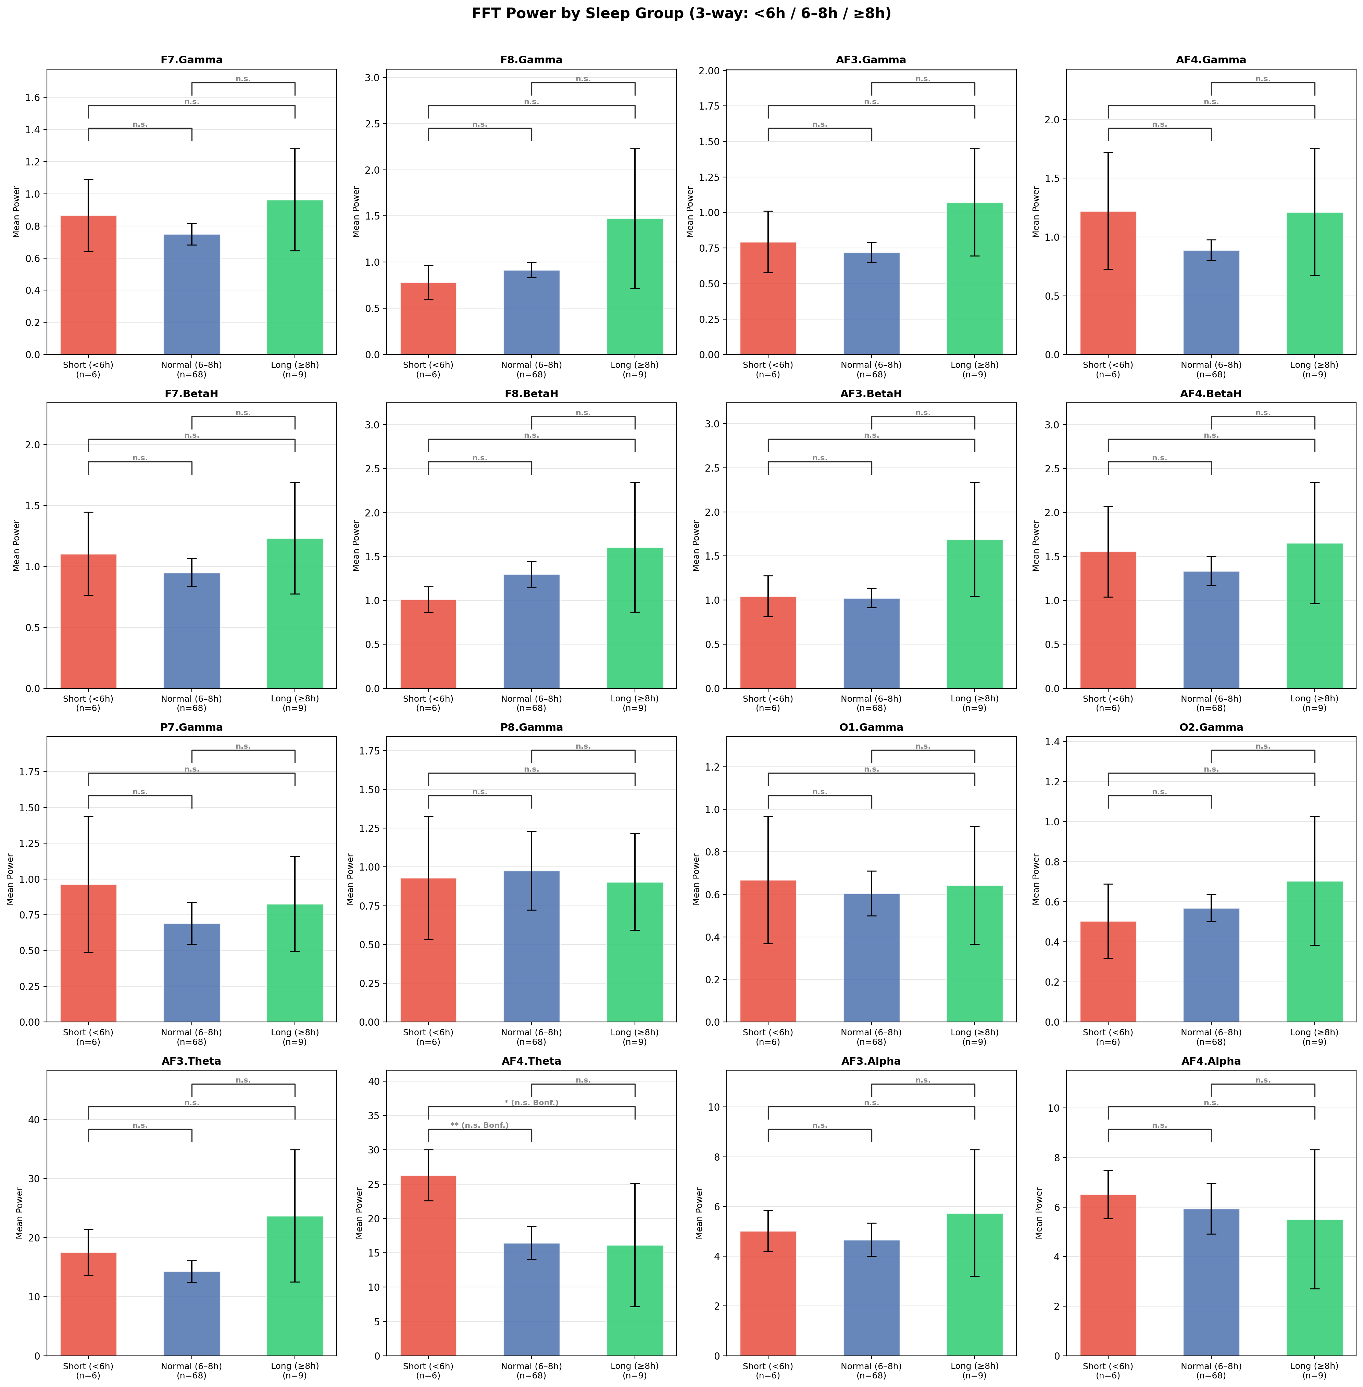
Figure 6. FFT power by sleep group (3-way: Short <6h / Normal 6–8h / Long ≥8h). Groups: n=6 / n=68 / n=9. Brackets show Bonferroni-corrected significance (α=0.05/48≈0.001). All comparisons n.s. after correction.
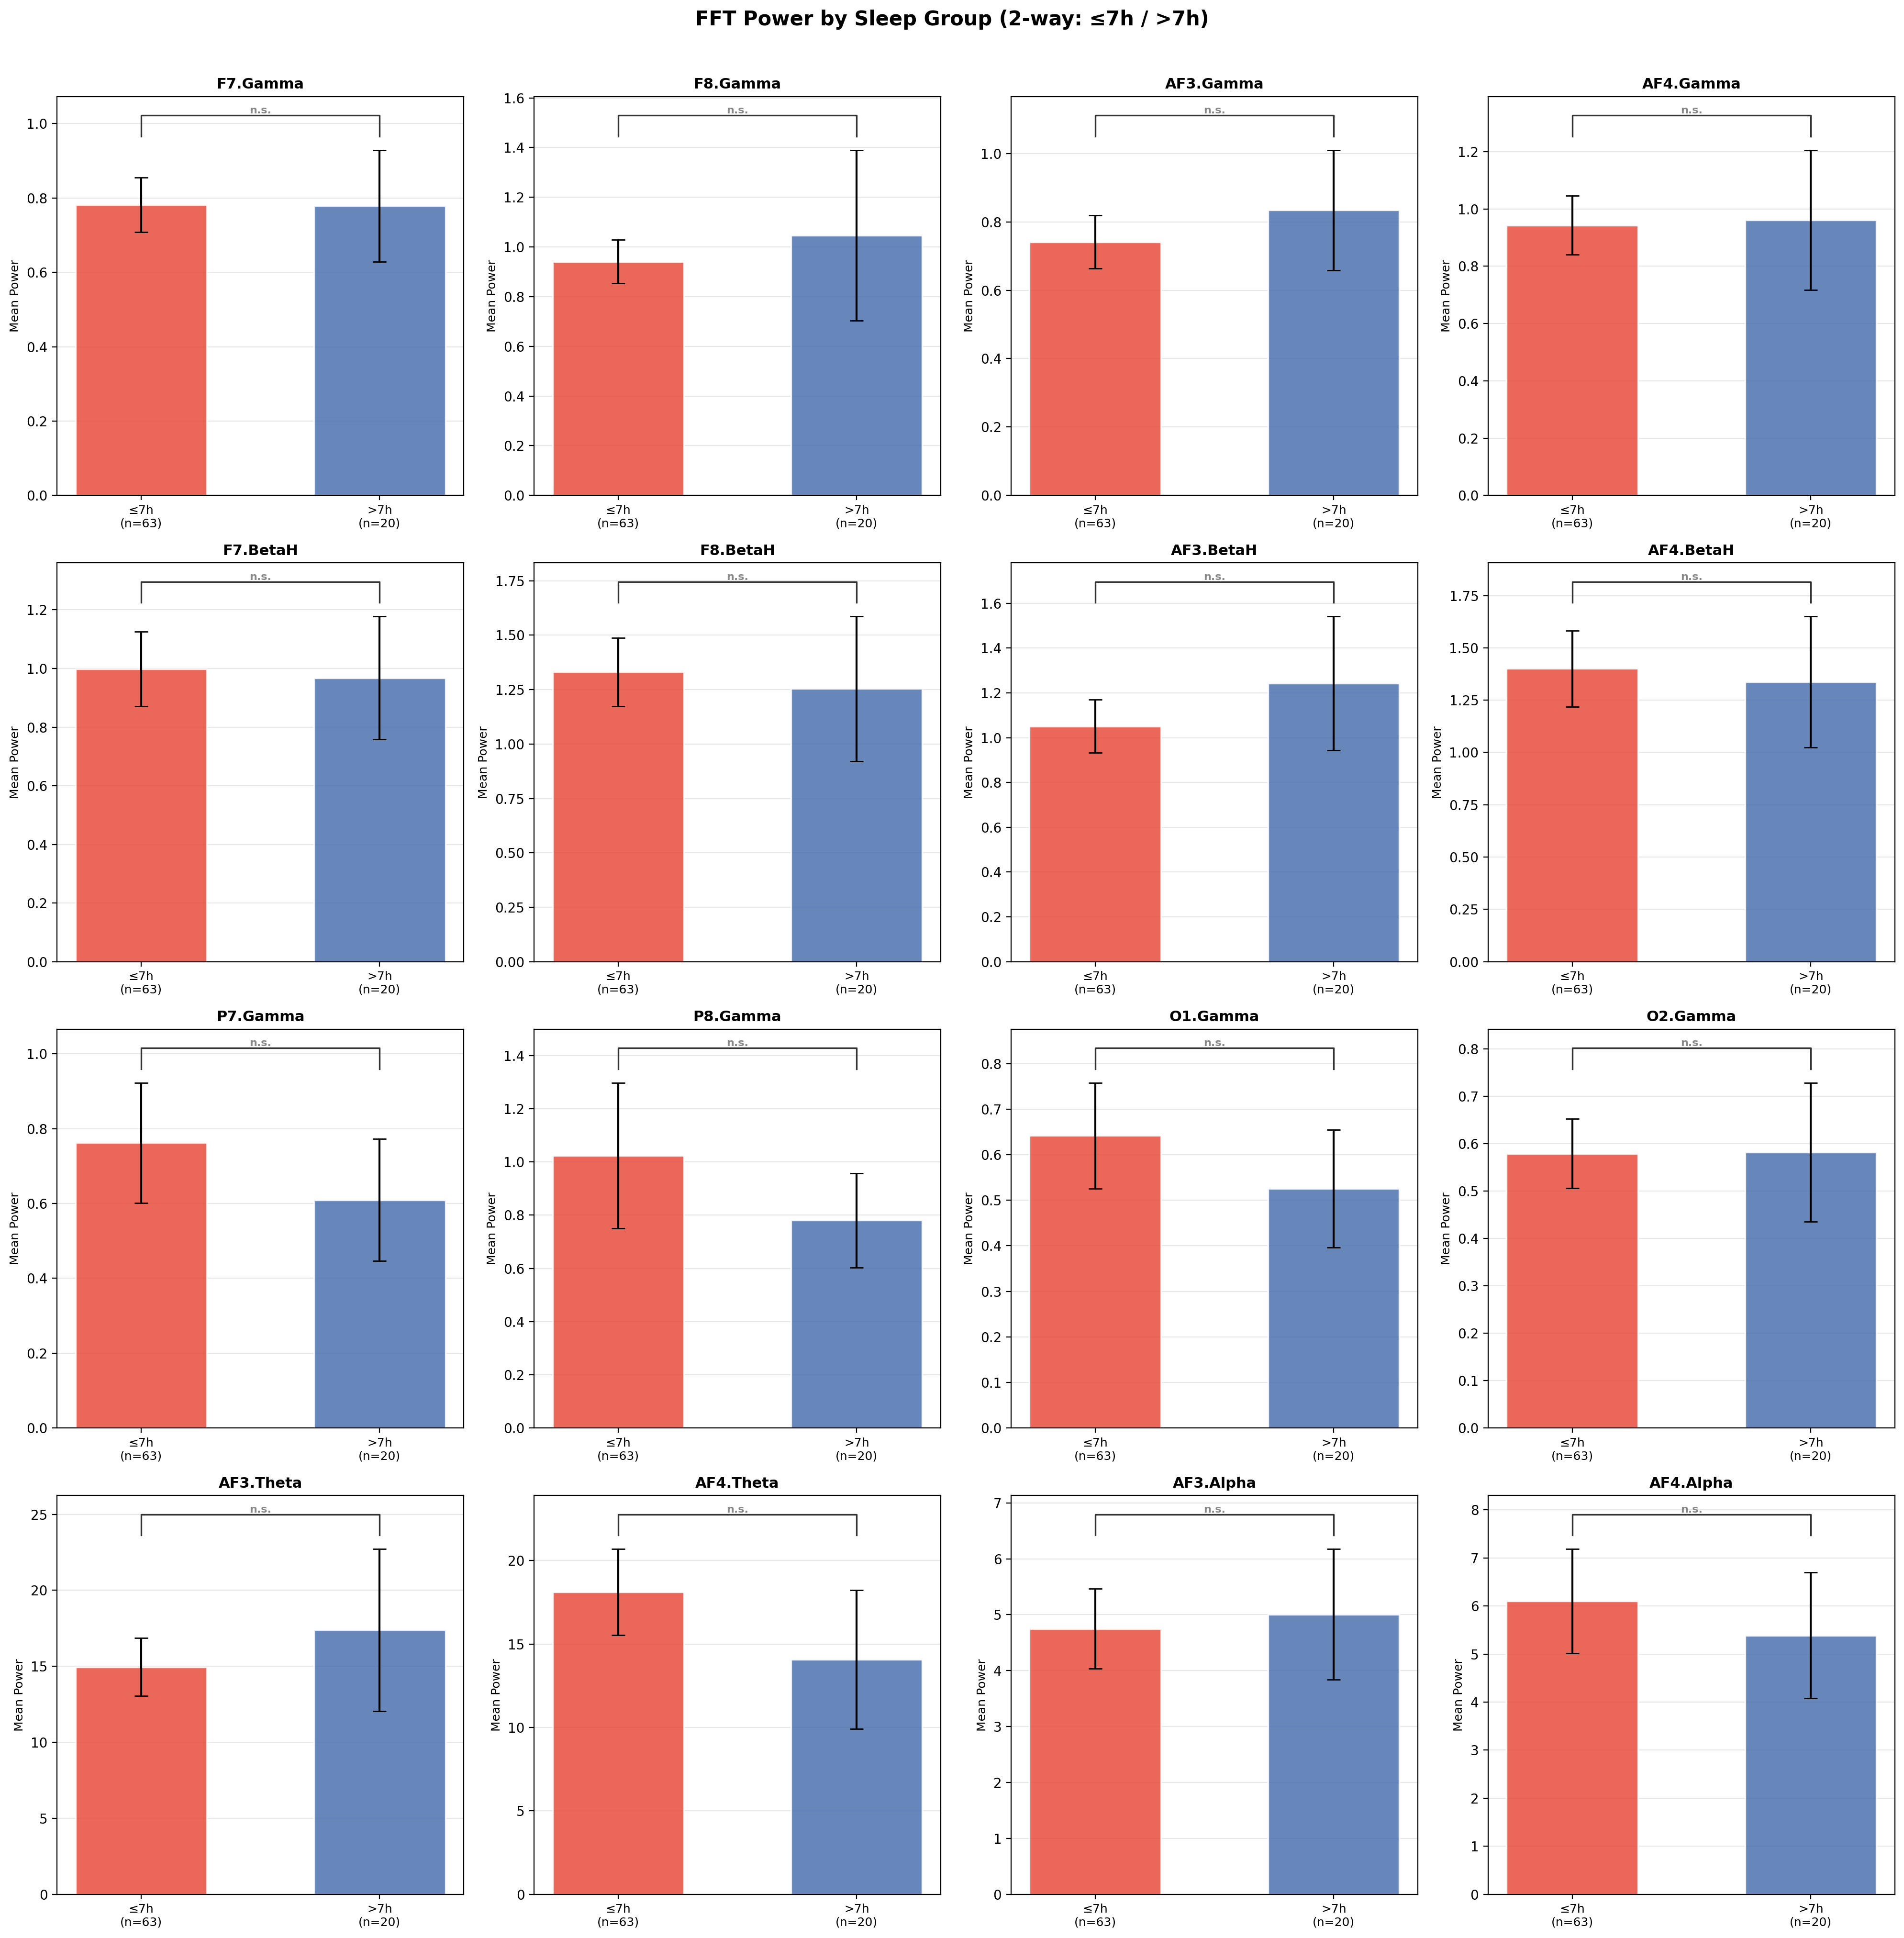
Figure 7. FFT power by sleep group (2-way: ≤7h vs >7h). Groups: n=63 / n=20. All 16 comparisons n.s. (lowest p≈0.10 for AF4.Theta).
Key findings:
- 3-way split: AF4.Theta showed Short vs Normal p=0.009 — nominally significant but does not survive Bonferroni correction (α_corrected ≈ 0.001). AF3.Theta and AF4.Alpha show borderline trends (p≈0.07–0.08), also n.s. after correction.
- 2-way split (≤7h vs >7h): All 16 comparisons n.s. Bar heights are nearly identical — even the median split reveals no detectable univariate group difference.
- Conclusion: No single FFT feature significantly separates sleep groups in a univariate comparison, even with the full 83-subject dataset. This is the expected result given the narrow sleep distribution and reinforces the need for multivariate ML.
Note on multiple comparisons: 48 pairwise tests (3-way) and 16 tests (2-way) were computed. Bonferroni correction was applied throughout (α_corrected = 0.05/n_tests). The one nominally significant result (AF4.Theta, p=0.009) does not survive correction and should not be reported as a finding. With n=6 short sleepers, statistical power is fundamentally limited.

4.8 Per-Task FFT–Sleep Correlation Analysis
For each of the 36 cognitive tasks, Pearson r was computed between subject-level mean FFT band power (averaged per subject within that task only) and Sleep_Hours. This directly answers the mentor's question: "Does FFT from some tasks better explain the difference in sleep hours?"
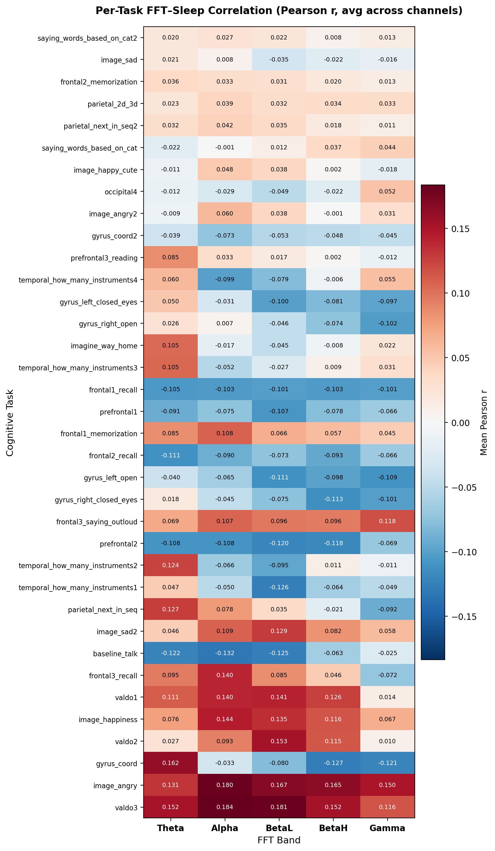
Figure 8. Per-task FFT–Sleep correlation heatmap (Pearson r, averaged across 14 channels). Tasks sorted by max |r| — most predictive at top. Red = positive correlation with sleep, blue = negative.
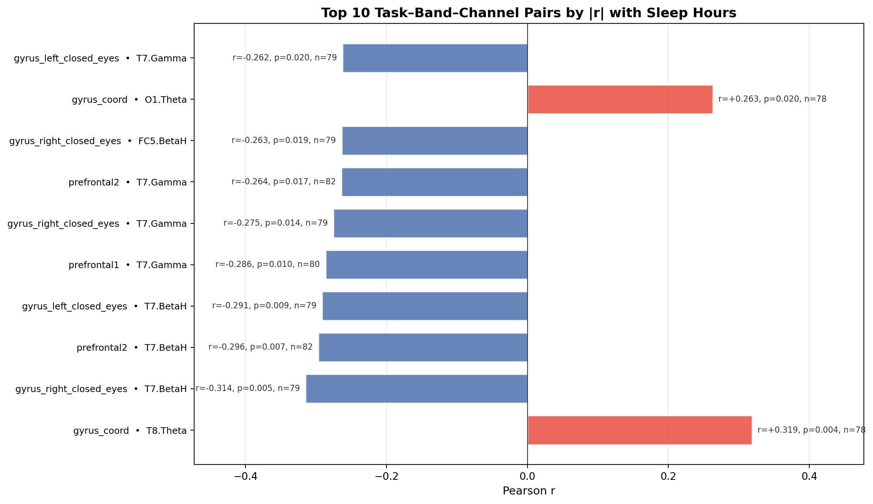
Figure 9. Top 10 task–band–channel pairs by |r| with Sleep_Hours. All 10 are statistically significant (p < 0.05). Red = positive correlation, blue = negative.
Key findings:
- Motor/coordination tasks are most predictive: gyrus_left_closed_eyes, gyrus_right_closed_eyes, and gyrus_coord (hand motor tasks with eyes closed) dominate the top 10. This is biologically plausible — sleep deprivation most directly impairs motor control and coordination.
- Prefrontal working memory tasks are also highly informative: prefrontal1 (r=−0.298, p=0.010) and prefrontal2 (r=−0.296, p=0.007) for T7.BetaH/Gamma. Sustained attention and working memory are well-known to degrade with insufficient sleep.
- T7 (left temporal) BetaH and Gamma dominate: T7 appears in 6 of the top 10 pairs across multiple independent tasks — this is convergent evidence, not noise. Left temporal high-frequency power is consistently negatively correlated with sleep hours.

All 10 top pairs reach p < 0.05:
# | Task | Feature | r | p (raw)
1 | gyrus_coord | T8.Theta | +0.319 | 0.004
2 | gyrus_right_closed_eyes | T7.BetaH | −0.314 | 0.005
3 | prefrontal2 | T7.BetaH | −0.296 | 0.007
4 | prefrontal1 | T7.Gamma | −0.298 | 0.010
5 | gyrus_left_closed_eyes | T7.BetaH | −0.291 | 0.009
6 | gyrus_right_closed_eyes | T7.Gamma | −0.275 | 0.014
7 | prefrontal2 | T7.Gamma | −0.264 | 0.017
8 | gyrus_left_closed_eyes | FC5.BetaH | −0.263 | 0.019
9 | gyrus_coord | O1.Theta | +0.263 | 0.020
10 | gyrus_left_closed_eyes | T7.Gamma | −0.262 | 0.020

⚠️ These are raw, uncorrected Pearson p-values. With ~2,520 correlations computed
(36 tasks × 70 features), ~126 false positives are expected at α=0.05 by chance.
Bonferroni correction would require p < 0.00002 — none of these survive that threshold.
The convergent pattern (T7 appearing across 6 independent tasks) is the stronger evidence.
These results are exploratory findings only; the RF model is the confirmatory test.

- Direction: More sleep → less T7 BetaH/Gamma during motor and prefrontal tasks. Two positive exceptions: gyrus_coord • T8.Theta (r=+0.319, p=0.004) and gyrus_coord • O1.Theta (r=+0.263, p=0.020) — more sleep associates with more occipital/temporal Theta during coordination, possibly reflecting a more relaxed, efficient motor state.
- Least predictive tasks: saying_words_based_on_cat2, image_sad, frontal2_memorization, parietal_2d_3d — near-zero r across all bands.
Important — multiple comparisons: ~2,520 correlations were computed (36 tasks × 70 features). At α=0.05, ~126 false positives are expected by chance. However, T7 appears consistently across multiple independent tasks and bands — this convergent pattern is unlikely to be random noise. Report these as strong exploratory findings, not confirmed hypotheses.

Implication for RF model: The tasks identified here (gyrus_left_closed_eyes, gyrus_right_closed_eyes, gyrus_coord, prefrontal1, prefrontal2) and T7 channel features should be prioritised in the Random Forest feature set. This also answers the mentor's final bullet point — if raw EEG prediction is attempted, these are the tasks to use.

5. Graph Inventory — Use in Thesis
The following table summarises every graph produced, its verdict, and whether it should be included in the final thesis.
Graph / File | Folder | Verdict | Use in Thesis?
task_vs_bands_median.png | visuals/ | ✅ Very Informative | Yes — EEG sanity check
task_vs_channels_median.png | visuals/ | ✅ Informative | Optional — complements bands
task_explainer_heatmap.png | visuals/ | ⚠ Dense but useful | Yes — category sleep-sensitivity
complete_performance_heatmap.png | visuals/ | ⚠ Limited | Maybe — metric inter-correlations
sleep_hours_distribution.png | visuals/ | ✅ Very Informative | Yes — essential context
fft_sleep_correlation_bars.png | visuals_fft/ | ✅ Very Informative | Yes — primary finding
fft_vs_metrics_frontal.png | visuals_fft/ | ✅ Informative | Yes — strongest correlations
fft_vs_metrics_parietal_occipital.png | visuals_fft/ | ✅ Informative | Yes — alpha/engagement finding
fft_vs_metrics_temporal.png | visuals_fft/ | ⚠ Weak | Maybe — low correlations
fft_vs_metrics_overview.png | visuals_fft/ | ⚠ Redundant | Skip if region breakdowns included
scatter_grid_top_features.png | visuals_scatter_plots/ | ✅ Informative | Yes — motivates ML approach
scatter_POW_*_vs_sleep.png ×9 | visuals_scatter_plots/ | ⚠ Supplementary | Optional — appendix
clustered_map_BA*.png ×9 | individual_graphs/ | ❌ Not useful | No — inconsistent, pilot only
*_Comparison.png ×7 | visuals_tasks_per_metric/ | ❌ Not informative | No — no significance, pilot only
per_task_fft_heatmap.png | visuals_per_task/ | ✅ Very Informative | Yes — key finding: task-specific FFT vs sleep
top_task_band_pairs.png | visuals_per_task/ | ✅ Very Informative | Yes — top-10 T7 finding, with table
sleep_group_fft_3way.png | visuals_sleep_groups/ | ✅ Informative | Yes — shows no univariate significance
sleep_group_fft_2way.png | visuals_sleep_groups/ | ⚠ Limited | Optional — confirms 3-way result

6. Key Findings Summary
Finding 1: EEG data is physiologically valid.
Task-level band-power patterns match known neuroscience: speech tasks produce broadband activation, eyes-closed/imagery tasks show alpha enhancement, and passive image-viewing tasks are uniformly suppressed. The EEG recordings are trustworthy.

Finding 2: Sleep distribution is narrow, which limits prediction difficulty.
With std = 0.78 h and nearly all subjects in the 6–7.5 h range, there is very little variance in the target variable. This explains why all univariate correlations are weak.

Finding 3: FFT features show weak but consistent directional associations with sleep.
At the row level, Gamma and BetaH power (especially at right-hemisphere electrodes F8, F7) positively associate with sleep, while frontal Theta/Alpha (AF3, AF4) negatively associate. The effect sizes are small (max r ≈ ±0.27) but directionally consistent.

Finding 4: Row-level and subject-level correlations diverge.
When computed at the subject level (n = 83), the top "positive" row-level features (F8.Gamma, F7.Gamma) reverse direction. This indicates within-subject task variance inflated the row-level signal. The frontal Theta/Alpha negative association is more stable across levels.

Finding 5: No single feature linearly predicts sleep hours.
All subject-level correlations are non-significant (p > 0.05, n = 83). This makes multivariate ML modelling a necessity rather than an enhancement.

Finding 6: Emotiv performance metrics are internally correlated and weakly related to sleep.
Inter-metric correlations (e.g., Stress–Interest r = 0.73) suggest the seven PM metrics do not represent independent physiological constructs. Their individual correlations with Sleep_Hours are all below |0.28|. They may still contribute useful signal when combined with FFT features in a Random Forest, but they should not be expected to dominate.

Finding 7: Frontal and parietal/occipital regions are most informative.

Finding 8: No single FFT feature significantly separates sleep groups.
Sleep-group bar charts (3-way: Short/Normal/Long and 2-way: ≤7h vs >7h) showed no significant differences after Bonferroni correction. The one nominally significant result (AF4.Theta, p=0.009) does not survive correction (α_corrected≈0.001). This is expected given the narrow sleep distribution (std=0.78h) and small group sizes, and reinforces the need for multivariate ML rather than univariate testing.

Finding 9: Motor and prefrontal tasks have the strongest task-specific FFT–sleep correlations.
Per-task Pearson r analysis across all 36 tasks found that gyrus (hand motor, eyes-closed) and prefrontal working memory tasks dominate the top-10 strongest individual correlations with Sleep_Hours. T7 (left temporal) BetaH and Gamma appear in 6 of the top 10 pairs across independent tasks — a convergent pattern unlikely to be random noise. These task-channel combinations are prioritised for the task-specific RF experiment. Note: all p-values are raw/uncorrected (exploratory analysis).

The frontal region shows clear Alpha–Engagement and high-band–Stress relationships. The parietal/occipital region shows the strongest single correlation in the dataset (P8.Alpha vs. Relaxation, r = +0.41). The temporal region is the weakest.

7. Modelling Tables Built
Two subject-level feature tables have been built and verified, ready for the Random Forest model. Each table has one row per subject (83 rows total). The features are the mean POW.* values averaged across all tasks and all recording segments for that subject.

7.1 How the tables were built
Source: all_task_ready.csv (2,830 rows, one per subject–task segment). For each subject, all rows belonging to that subject are grouped together and the 70 POW columns are averaged. This gives one stable, representative EEG feature vector per subject. Sleep_Hours is taken from the metadata (same value for all rows of a subject, so no averaging needed).
⚠️ Why average across tasks? A Random Forest expects one row per sample.
Feeding all 2,830 rows would be data leakage: the same subject would appear in both
train and test within a CV fold. Averaging per subject collapses to n=83 rows
and makes the train/test split clean: one subject = one row, with no leakage between train and test.

7.2 exp1_fft_only.csv
Location: modelling_tables/exp1_fft_only.csv
Property | Value
Shape | 83 rows × 72 columns
Columns | Subject_ID, 70 POW features (14 channels × 5 bands), Sleep_Hours
NaN values | 0 (verified)
Features | POW.AF3.Theta, POW.AF3.Alpha, …, POW.AF4.Gamma (all 70)
Target | Sleep_Hours (continuous, 5.0–8.5 h)

7.3 exp2_fft_gender.csv
Location: modelling_tables/exp2_fft_gender.csv
Property | Value
Shape | 83 rows × 73 columns
Columns | Same as exp1 + Gender column
Gender | Binary encoded: M=0, F=1 (42 male, 41 female). Source: DatasetSub_shorten.csv
NaN values | 0 (verified)

REMOVE_SCRIPTS_CHAPTER Created
Three scripts have been created in src/3_modelling/. They are designed so you change one variable at the top (EXPERIMENT) and everything else is automatic.

8. Modelling Scripts
Three scripts in src/3_modelling/ handle the full modelling pipeline. The run_loso.py script currently implements LOSO-CV — it needs to be updated to k-fold CV (3 or 5 folds) and classification mode as per mentor feedback before running. Change the EXPERIMENT variable at the top to switch between experiments.

8.1 run_cv.py — k-fold CV evaluation
The main modelling script. Runs k-fold CV (k=3 or 5) — splits 83 subjects into k groups, trains on k-1 groups, tests on 1, repeats k times. Change EXPERIMENT = 'exp1_fft_only' to switch inputs. Change EXPERIMENT = 'exp1_fft_only' to switch inputs. Outputs saved to results/{experiment}/:
• {experiment}_predictions.csv — Subject_ID, Actual, Predicted, Error for all 83 subjects
• {experiment}_metrics.txt — RMSE, MAE, R², null baseline RMSE
• {experiment}_scatter.png — predicted vs actual scatter plot
• {experiment}_importance.png — top-20 feature importances

8.2 train_final_model.py — save a model for the defense demo
Trains one RF model on ALL 83 subjects and saves it to models/{experiment}_model.pkl. This is NOT the evaluation model (k-fold CV handles that). It is only used with predict.py to demonstrate a prediction at the thesis defense.

8.3 predict.py — defense demo prediction
Loads the saved model and predicts sleep hours for one new subject:
python predict.py subject_07.csv
→ Predicted sleep hours: 6.4 h
At the defense: open terminal, run this command for one subject, show the output. The subject’s EEG features go in, one sleep prediction comes out. Since the model was trained on all 83 subjects, this subject is genuinely ‘unseen’.

9. Modelling Plan and Next Steps
The analysis phase is complete. The modelling tables are ready. The scripts exist but need to be updated (LOSO → k-fold CV + classification) before running. Below is the plan.

9.1 Cross-validation — k-fold (not LOSO)
Use 3-fold or 5-fold stratified CV. Split 83 subjects into k groups, train on k-1 groups, test on 1, repeat k times. Stratified means each fold preserves the sleep category distribution. This is faster than LOSO and is the mentor's preferred approach.

9.2 Target variable — sleep categories (classification)
Treat Sleep_Hours as categories instead of a continuous number. This turns the problem from regression into classification:
Category | Sleep_Hours range | Approx. n subjects
Short | < 6 h | ~6
Normal | 6 – 8 h | ~68
Long | ≥ 8 h | ~9

⚠️ Class imbalance: Short (n≈6) and Long (n≈9) are much smaller than Normal (n≈68).
Use stratified k-fold and report per-class precision/recall alongside overall accuracy.
Also run a regression version (continuous Sleep_Hours) for comparison.

9.3 Experiment inputs — three models
Same three experiments as planned. Change EXPERIMENT at the top of run_cv.py to switch:
Experiment | Input features | Purpose
exp1_fft_only | 70 FFT features (14 ch × 5 bands) | Baseline — does raw FFT predict sleep?
exp2_fft_gender | 70 FFT + Gender (M=0/F=1) | Does adding gender improve prediction?
exp3_task_specific | FFT from 5 specific tasks only | Do the top EDA tasks outperform global?

9.4 What needs updating before running
run_loso.py was written using LOSO-CV. Before running any experiment it needs two updates:
① Replace the LOSO loop with stratified k-fold (k=3 or 5) using sklearn's StratifiedKFold.
② Add classification mode: bin Sleep_Hours into Short/Normal/Long categories and use RandomForestClassifier instead of RandomForestRegressor.
Once updated, run it as: python run_cv.py
Change EXPERIMENT = 'exp1_fft_only' at the top to switch between experiments.
Outputs will save automatically to results/{experiment}/

9.5 PRIMARY — must complete
□ Update run_cv.py: replace current loop with stratified k-fold (k=3 or 5), add classification mode
□ Run run_cv.py EXPERIMENT='exp1_fft_only' → accuracy, F1, confusion matrix, feature importance
□ Run run_cv.py EXPERIMENT='exp2_fft_gender' → compare with Exp 1
□ Build modelling table for Exp 3 (task-specific: 5 tasks × their own subject counts)
□ Run run_cv.py EXPERIMENT='exp3_task_specific' → compare task-specific vs global
□ Run train_final_model.py → save model for defense demo
□ Write thesis chapter on RF results (metrics, confusion matrix, feature importance)
□ Update abstract and sazetak with final results

9.6 OPTIONAL — add if time allows
□ Regression version (continuous Sleep_Hours) for comparison with classification
□ Permutation importance on held-out fold predictions
□ Gradient Boosting as a second model for comparison

Already done:
✔ EDA complete — all graphs verified and audited
✔ exp1_fft_only.csv (83×72) and exp2_fft_gender.csv (83×73) built and verified
✔ run_cv.py, train_final_model.py, predict.py written and ready
✔ RF Strategy doc updated — experiment priorities and CV plan documented
✔ Mentor_Update_April2026.docx prepared and sent

10. Phase 2 Preview — Deep Learning on Raw EEG
Phase 2 will use raw EEG channels as time-series input to RNN/GRU/LSTM networks in PyTorch, focusing only on the task types identified as most informative by the Random Forest feature importance in Phase 1.
Based on the EDA findings so far, the most likely candidates for Phase 2 tasks are frontal-lobe tasks (prefrontal1-3, frontal1-3) and auditory/imagination tasks (imagine_way_home, temporal tasks), as these showed the most consistent EEG patterns across subjects. Final selection should be guided by Phase 1 feature importance.
The Phase 2 modelling work (architecture design, training, evaluation) is beyond the current scope and will be documented separately once Phase 1 is complete.

11. Project File Structure
THESIS/ | Project root
DatasetSub_shorten.csv | Metadata: 83 subjects, Sleep_Hours, Gender, etc.
all_task_ready.csv | Main analysis dataset: 83 subjects, task-level rows
pilot_task_ready.csv | Pilot subset: 10 subjects
pilot_categorized_tasks.csv | Pilot data with task category labels
pilot_signal_quality.csv | Per-subject CQ and signal quality summary
pilot_data_map.csv | Subject ID → file path mapping
task_vs_bands_median.csv | Aggregated band power per task (median Z-score)
task_vs_channels_median.csv | Aggregated channel power per task (median Z-score)
all_data/ | Raw EEG data: one subfolder per subject (data.csv + marker.csv)
src/ | All analysis scripts
1_data_preparation/ | load_data.py, clean_pilot_dataset.py, clean_whole_dataset.py, signal_quality_check.py
2_graphs_generator/ | All visualisation scripts (one per graph type)
visuals/ | Main visualisations: task heatmaps + sleep distribution
visuals_fft/ | FFT correlation heatmaps and bar charts
visuals_scatter_plots/ | Subject-level scatter plots (new)
visuals_tasks_per_metric/ | Sleep-group bar charts (pilot only — not for thesis)
individual_graphs/ | Ward clustering maps per subject (pilot only — not for thesis)
PLAN_GUIDE/ | Project planning documents
graph_audit.md | Graph-by-graph audit: verdicts, findings, suggestions
tasks.md | Full task name list
gemini_plan.md | Project plan (Croatian)
mail_convo.md | Mentor email exchange

