ALGEBRA BERNAYS UNIVERSITY
Applied Computer Engineering (Software Engineering)

FINAL THESIS

Analysis of Brain Signal Patterns and Development of a Predictive Model for Sleep Duration

Paola Caric

Zagreb, June 2026.

ALGEBRA BERNAYS UNIVERSITY
Applied Computer Engineering (Software Engineering)

FINAL THESIS

Analysis of Brain Signal Patterns and Development of a Predictive Model for Sleep Duration

Paola Caric

Mentor: dr.sc. Mateo Sokac

Zagreb, June 2026.

Preface
[To be written: personal acknowledgements and statement of authenticity.]

Sazetak
Ovaj zavrsni rad istrazuje mogu li se obrasci ekstrahirani iz elektroencefalogramskih (EEG) snimaka koristiti za predvidanje prosjecnog trajanja nocnog sna. Istrazivanje koristi skup podataka EEG signala prikupljenih od 83 ispitanika koji su izvrsili strukturirani protokol kognitivnih zadataka iz sest funkcionalnih domena dok su nosili Emotiv EPOC uredaj. Spektralne znacajke ekstrahirane su pomocu brze Fourierove transformacije (FFT), sto je rezultiralo vrijednostima snage u pet frekvencijskih pojaseva (Theta, Alpha, Beta Low, Beta High i Gamma) za svaki od 14 EEG kanala. Eksplorativna analiza pokazala je da su EEG podaci fizioloski valjani, da visokofrekvencijska snaga (Gamma, Beta High) pokazuje slabu pozitivnu povezanost s trajanjem sna te da nijedna pojedinacna znacajka ne postize statisticku znacajnost na razini ispitanika. Model regresije Random Forest treniran je na agregiranim spektralnim znacajkama za predvidanje sati sna, pri cemu je analiza vaznosti znacajki identificirala najinformativnije EEG kanale i frekvencijske pojaseve. Rezultati sugeriraju da, iako pojedinacne EEG znacajke nisu dovoljne za tocno predvidanje trajanja sna, multivarijatni modeli mogu ekstrahirati umjeren prediktivni signal, pridonoseci metodoloskom okviru za buduce sustave pracenja umora.
Kljucne rijeci: EEG, strojno ucenje, Random Forest, trajanje sna, FFT, prediktivni model, sucelje mozak-racunalo

Abstract
This thesis investigates whether patterns extracted from electroencephalogram (EEG) recordings can be used to predict average nightly sleep duration. The study uses a dataset of EEG signals collected from 83 participants who performed a structured protocol of cognitive tasks spanning six functional domains while wearing an Emotiv EPOC headset. Spectral features were extracted using Fast Fourier Transform, yielding power values across five frequency bands (Theta, Alpha, Beta Low, Beta High, and Gamma) for each of the 14 EEG channels. Exploratory analysis revealed that EEG data is physiologically valid, that high-frequency power (Gamma, Beta High) shows weak positive associations with sleep duration, and that no single feature achieves statistical significance at the subject level. A Random Forest regression model was trained on the aggregated spectral features to predict sleep hours, with feature importance analysis identifying the most informative EEG channels and frequency bands. The results suggest that while individual EEG features are insufficient for accurate sleep duration prediction, multivariate models can extract modest predictive signal, contributing to a methodological framework for future fatigue monitoring systems.
Key words: EEG, machine learning, Random Forest, sleep duration, FFT, predictive model, brain-computer interface

Table of Contents
[Auto-generated: use References > Table of Contents in Word after finalising all headings.]

Introduction
Sleep is a fundamental biological process that plays a critical role in cognitive function, emotional regulation, and physical health. Chronic sleep deprivation has been linked to impaired attention, reduced decision-making capacity, weakened immune response, and increased risk of cardiovascular disease [8]. Despite its importance, sleep duration is most commonly assessed through subjective self-reporting, which is prone to recall bias and inaccuracy. Clinical alternatives such as polysomnography, while highly accurate, require specialised equipment, controlled laboratory environments, and trained personnel, making them impractical for large-scale or routine monitoring.
These limitations have motivated growing interest in objective and non-invasive methods for assessing sleep-related states. Electroencephalography (EEG) offers a promising avenue in this direction. EEG measures the electrical activity of the brain through electrodes placed on the scalp, and it is well established that neural oscillatory patterns change measurably as a function of alertness, fatigue, and sleep pressure [3]. Consumer-grade EEG devices such as the Emotiv EPOC have made it increasingly feasible to collect brain activity data outside clinical settings, opening the possibility of using EEG-derived features as biomarkers for sleep-related conditions.
The central question of this thesis is whether spectral features extracted from EEG recordings during waking cognitive tasks can predict an individual's average nightly sleep duration. Specifically, the research examines whether frequency-domain features obtained through Fast Fourier Transform (FFT), such as power in the theta, alpha, beta, and gamma bands, carry sufficient information to distinguish between individuals with different sleep habits. This is explored using a dataset of EEG recordings from approximately ninety participants who completed a structured protocol of cognitive tasks spanning multiple functional domains.
The methodological approach proceeds in two stages. First, an exploratory data analysis examines the relationships between EEG spectral features, Emotiv performance metrics, and self-reported sleep duration. This analysis identifies which frequency bands, brain regions, and task types are most informative for sleep prediction. Second, a Random Forest regression model is trained on the aggregated spectral features to predict sleep hours, with particular emphasis on feature importance analysis to determine which EEG markers are most predictive [1].
The thesis is structured as follows. Chapter 2 provides the theoretical background on sleep physiology, EEG measurement principles, and the relevant machine learning methods. Chapter 3 describes the research design, dataset characteristics, and experimental procedure. Chapter 4 details the signal processing and feature extraction pipeline. Chapter 5 presents the exploratory analysis of EEG features and their correlations with sleep duration. Chapter 6 introduces the machine learning methods applied to EEG data. Chapter 7 reports the development and evaluation of the predictive model. Finally, the conclusion summarises the key findings and discusses their implications for future research in sleep monitoring.

Theoretical Background of Sleep and Brain Activity
This chapter provides the theoretical foundation necessary for understanding the relationship between brain activity and sleep duration. It covers the biological mechanisms of sleep, the principles of EEG measurement, and an overview of the machine learning methods used in this research.

Biological Mechanisms of Sleep and Fatigue
Sleep is regulated by two primary biological systems: the circadian rhythm and the homeostatic sleep drive. The circadian rhythm is an internal clock, governed by the suprachiasmatic nucleus in the hypothalamus, that operates on an approximately 24-hour cycle and regulates the timing of sleep and wakefulness. The homeostatic sleep drive, by contrast, accumulates during waking hours and dissipates during sleep. The interaction between these two systems determines when an individual feels sleepy and when they feel alert.
Normal sleep architecture consists of cyclical alternation between non-rapid eye movement (NREM) and rapid eye movement (REM) stages. NREM sleep is further divided into three stages: N1 (light sleep, characterised by theta wave activity), N2 (intermediate sleep, marked by sleep spindles and K-complexes), and N3 (deep or slow-wave sleep, dominated by delta wave activity). REM sleep, which is associated with dreaming and memory consolidation, is characterised by low-amplitude, mixed-frequency EEG activity similar to wakefulness. A typical adult cycles through these stages approximately four to six times per night, with each cycle lasting roughly 90 minutes.
Sleep deprivation, whether acute or chronic, produces measurable changes in brain activity during waking hours. Research has consistently shown that sleep-deprived individuals exhibit increased theta power in frontal brain regions, which is associated with drowsiness and reduced cognitive control. Conversely, well-rested individuals tend to show higher power in high-frequency bands (beta and gamma), reflecting greater cognitive engagement and processing capacity. These spectral signatures of sleep deprivation have been documented across a wide range of cognitive tasks, including sustained attention, working memory, and decision-making [8].
The relationship between sleep duration and daytime EEG patterns is not limited to extreme deprivation. Even modest differences in habitual sleep duration, such as the difference between six and eight hours per night, can produce detectable changes in spectral power distribution. Othmani et al. [8] provide a comprehensive survey of EEG-based approaches to fatigue and drowsiness detection, noting that frontal theta power and posterior alpha power are among the most reliable neural indicators of fatigue states. Sangeetha et al. [7] further demonstrate that EEG-derived features can be used in predictive modelling frameworks, establishing the feasibility of using brain activity patterns as inputs to machine learning systems designed to assess cognitive states related to sleep.

Principles of Electroencephalography (EEG) and Neural Signal Measurement
Electroencephalography (EEG) is a non-invasive neuroimaging technique that records the electrical activity of the brain by placing electrodes on the surface of the scalp. The signals detected by EEG represent the summed postsynaptic potentials of large populations of cortical neurons, primarily pyramidal cells in the cerebral cortex. Because the electrical fields generated by individual neurons are extremely weak, EEG can only detect synchronised activity from thousands to millions of neurons firing in concert.
The standard clinical system for electrode placement is the International 10-20 system, which defines electrode positions based on proportional distances from anatomical landmarks on the skull. In this study, the Emotiv EPOC headset is used, which provides 14 channels (AF3, F7, F3, FC5, T7, P7, O1, O2, P8, T8, FC6, F4, F8, AF4) covering frontal, temporal, parietal, and occipital regions. While consumer-grade devices like the Emotiv EPOC have fewer channels and lower signal quality than clinical EEG systems, they have been validated for research applications involving cognitive state classification and have the advantage of being portable and relatively inexpensive [3].
The raw EEG signal is a time-domain representation of voltage fluctuations over time. To extract meaningful features from this signal, frequency-domain analysis is commonly employed. The most widely used method is the Fast Fourier Transform (FFT), which decomposes a time-domain signal into its constituent frequency components, yielding a power spectrum that indicates how much energy is present at each frequency. The resulting spectral power values are typically grouped into canonical frequency bands, each associated with distinct cognitive and physiological states:
- Theta (4-8 Hz): associated with drowsiness, light sleep, and meditative states. Elevated frontal theta during waking tasks is a well-established marker of fatigue and sleep pressure.
- Alpha (8-12 Hz): dominant during relaxed wakefulness with eyes closed. Alpha power decreases (alpha blocking) during active cognitive engagement and increases during relaxation. Posterior alpha enhancement is a classic EEG signature of the idle visual cortex.
- Beta Low (12-16 Hz) and Beta High (16-25 Hz): associated with active thinking, focused attention, and motor planning. Beta activity is typically higher during cognitively demanding tasks.
- Gamma (25-45 Hz): linked to higher-order cognitive processing, cross-modal integration, and conscious awareness. Gamma activity has been associated with cognitive bandwidth and information binding across cortical areas.
In addition to raw FFT power values, the Emotiv software suite computes proprietary performance metrics (PM) including Attention, Engagement, Excitement, Relaxation, Focus, Stress, and Interest. These metrics are derived from the raw EEG signal through Emotiv's internal algorithms and are provided as normalised scores between 0 and 1. While these metrics offer an accessible summary of cognitive states, their proprietary nature means that the exact computation is not publicly disclosed, which limits their interpretability in a research context [3, 4].
Signal quality in EEG recordings is affected by multiple factors, including electrode-skin impedance, muscle artifacts from facial and jaw movements (electromyographic contamination), eye movement artifacts (electrooculographic contamination), and environmental electrical noise. The Emotiv system provides channel-quality (CQ) indicators for each electrode on a scale of 0 to 4, as well as a global interpolation flag indicating whether the software has filled in missing data. Proper signal quality filtering is essential during preprocessing to ensure that the spectral features used for modelling reflect genuine neural activity rather than artifacts.

Machine Learning Methods for EEG Analysis
Machine learning (ML) provides a set of computational methods that can learn patterns from data without being explicitly programmed for a specific task. In the context of EEG analysis, ML algorithms are used to discover relationships between spectral features of brain activity and target variables such as cognitive state, emotional state, or, in this case, sleep duration. Bishop [2] provides a comprehensive treatment of the mathematical foundations underlying pattern recognition and machine learning, including probabilistic models, kernel methods, and ensemble techniques that form the basis of modern EEG classification systems.
The machine learning methods relevant to this thesis can be broadly categorised into classical (non-sequential) models and deep learning approaches. Classical models treat each data point independently and do not account for temporal ordering within the data. The primary classical model used in this thesis is the Random Forest, an ensemble method introduced by Breiman [1] that constructs multiple decision trees on randomly sampled subsets of the training data and averages their predictions to reduce overfitting. Random Forest is particularly well-suited for EEG analysis because it handles high-dimensional feature spaces effectively, provides built-in feature importance rankings, and is robust to noise and multicollinearity among input features. Mueller and Guido [5] offer practical guidance on implementing Random Forest and other scikit-learn models in Python, which is the programming language used throughout this thesis.
Deep learning methods, which use neural networks with multiple layers to learn hierarchical feature representations, have shown significant promise for EEG analysis in recent years. Goodfellow, Bengio, and Courville [6] provide the foundational theory for deep learning, including convolutional and recurrent architectures. Roy et al. [3] present a systematic review of deep learning methods applied to EEG, finding that convolutional neural networks (CNNs) and recurrent neural networks (RNNs) can outperform classical models on certain EEG classification tasks, particularly when raw time-series data is used as input rather than pre-computed spectral features. Craik, He, and Contreras-Vidal [4] further review deep learning for EEG classification, identifying common architectures, training strategies, and evaluation methodologies. While the current thesis focuses on Random Forest as the primary modelling approach due to the sample size (n = 83), these deep learning methods represent a potential direction for future work if larger datasets become available.
A key challenge in applying machine learning to EEG data for sleep prediction is the distinction between within-subject and between-subject variance. EEG features vary both across different cognitive tasks performed by the same individual and across different individuals performing the same task. For sleep prediction, only the between-subject variance is informative, as the goal is to distinguish individuals with different sleep durations. This has important implications for model training and evaluation: cross-validation must be performed at the subject level (leave-one-subject-out or grouped k-fold), not at the row level, to avoid data leakage from within-subject correlations.

Research Design and Dataset Description
This chapter describes the dataset used in the thesis, including the characteristics of the study participants, the distribution of the target variable (sleep duration), the cognitive task protocol, and the EEG recording setup. Understanding the dataset is essential context for interpreting the analyses and modelling results presented in later chapters.

Description of Respondents and Sleep Duration Categories
The dataset used in this research was collected as part of a separate experimental study conducted at Algebra Bernays University, in which participants performed a series of cognitive tasks while their brain activity was recorded using an Emotiv EPOC headset. The full dataset contains EEG recordings from 83 participants. Each participant's average nightly sleep duration was collected via self-report as part of a metadata questionnaire that also included demographic variables such as gender, education level, education field, language proficiency, sports activity history, and musical instrument experience.
The primary target variable for this thesis is average sleep hours per night, a continuous variable. Across all 83 participants, sleep duration ranges from 5.0 to 8.5 hours, with a mean of 6.7 hours, a median of 7.0 hours, and a standard deviation of 0.78 hours. The distribution is heavily concentrated in the 6.0 to 7.5 hour range, with relatively few participants at either extreme. Specifically, approximately 6 participants report sleeping fewer than 6 hours per night (short sleepers), approximately 68 participants report sleeping between 6 and 8 hours (normal sleepers), and approximately 9 participants report sleeping 8 hours or more (long sleepers). This narrow distribution, illustrated in Figure 3.1, represents a significant analytical challenge: with most participants clustered within a 1.5-hour range, there is limited variance in the target variable for predictive models to exploit.
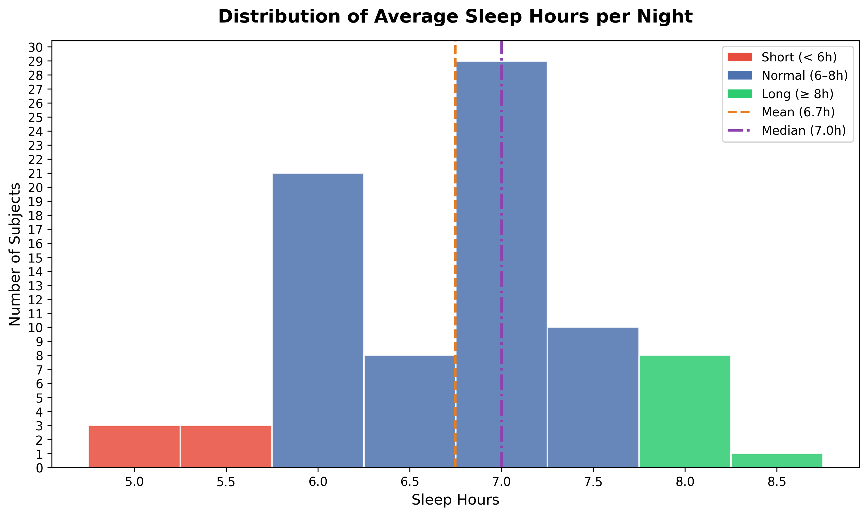
Figure 3.1 Distribution of average sleep hours per night across all 83 participants. Red bars indicate short sleepers (< 6 h), blue bars indicate normal sleepers (6-8 h), and green bars indicate long sleepers (>= 8 h).
All 83 participants are included in the analysis-ready dataset. Signal quality filters (described in Chapter 4) are applied at the row level within each participant's recording rather than excluding participants entirely. Task segmentation is performed using the MarkerIndex column embedded directly in each participant's data.csv file, which records task start and end events in the EEG stream itself. This approach is robust to any inconsistencies in the separate marker.csv file and ensures reliable epoch extraction for all participants.
The Emotiv EPOC is a consumer-grade wireless EEG headset with 14 saline-based electrodes positioned at AF3, F7, F3, FC5, T7, P7, O1, O2, P8, T8, FC6, F4, F8, and AF4. It records at a sampling rate of 128 Hz and provides both raw EEG signals and computed spectral features (FFT power values) and performance metrics. Each recording session produces a data.csv file containing timestamped EEG readings with inline MarkerIndex events marking the start and end of each cognitive task, and a marker.csv file containing the task name mapping. The EEG data includes channel-quality (CQ) indicators for each electrode (on a scale of 0 to 4), an overall CQ score, and an interpolation flag indicating whether the Emotiv software has filled in missing samples.

Cognitive Tasks and Experimental Procedure
Each participant completed a structured protocol of approximately 60 cognitive tasks, designed to engage different functional brain regions. The tasks are organised into six functional domains, each targeting specific neural circuits:
Cognitive and Language tasks involve verbal processing, including word generation based on semantic categories, sentence construction, and reading aloud. These tasks primarily engage prefrontal and frontal brain regions (targeted electrodes: AF3, AF4, F7, F3, F4, F8) and produce characteristic broadband EEG activation, including elevated theta, beta, and gamma power due to combined cognitive effort and speech-related muscle artifact.
Memory tasks include word and number memorisation followed by recall phases. The memorisation phase engages frontal working memory circuits, while the recall phase additionally recruits temporal and parietal regions. These tasks generate distinctive EEG patterns during encoding versus retrieval, with frontal theta often elevated during successful memory encoding.
Visual and Spatial tasks encompass dot-following, 2D and 3D pattern recognition, and sequence completion exercises. These tasks target parietal and occipital regions involved in visuospatial processing and spatial reasoning.
Motor and Action tasks consist of left-hand and right-hand motor execution with eyes open and eyes closed, as well as motor coordination exercises. These tasks engage the precentral gyrus (primary motor cortex) and produce lateralised changes in beta power consistent with motor-related desynchronisation.
Auditory tasks involve listening to music clips and counting the number of instruments, as well as category-based word generation triggered by auditory stimuli. These tasks target temporal brain regions (T7, T8) and are associated with alpha enhancement when participants close their eyes to concentrate on auditory input.
Emotional tasks present images designed to elicit happiness, sadness, and anger responses. These passive viewing tasks produce relatively suppressed EEG activation across all bands compared to active cognitive tasks, reflecting reduced active processing during emotional image observation.
The experimental protocol also includes baseline and calibration phases (eyes open, eyes closed, and a free-talking baseline), as well as instructional phases that precede each task block. These non-task phases are excluded from the analysis, retaining only the stimulus phases where participants are actively engaged in a cognitive task. Each task is identified by a unique integer marker value (MarkerIndex) embedded in the EEG data stream, and the marker-to-task name mapping is defined in a stimuli reference file. The MarkerIndex events are used to segment the continuous EEG recording into task-level epochs, within which spectral features are averaged to produce one feature vector per task per participant.
The combination of multiple task types is important for this research because different cognitive demands elicit different EEG patterns, and the relationship between EEG features and sleep duration may vary across task types. A key analysis question is which specific tasks or task domains produce EEG features that are most strongly associated with sleep duration, as this information guides both the interpretation of results and the selection of features for the predictive model.

Signal Processing and Feature Extraction
This chapter describes the steps taken to transform raw EEG recordings into a clean, structured dataset suitable for machine learning. The pipeline covers signal quality filtering, task segmentation, and feature extraction, and was applied consistently across all 83 participants.

Signal Quality Filtering
Raw EEG recordings are susceptible to noise from electrode contact failure, head movement, and electrical interference. The Emotiv EPOC headset provides built-in quality indicators that were used to identify and remove unreliable data samples before any analysis was performed. Three filtering criteria were applied at the row level, meaning individual time samples were removed rather than entire participant recordings:
- EEG.Interpolated == 0: rows flagged by the Emotiv firmware as interpolated (reconstructed from neighbouring samples) were excluded, as they do not represent genuine neural measurements.
- CQ.Overall >= 0.7: the overall channel quality score, ranging from 0 to 1, reflects the aggregate contact quality across all electrodes. Only rows meeting the 70% threshold were retained.
- Per-channel CQ >= 2: each of the 14 individual channel quality scores (scale 0–4) was required to meet a minimum of 2 (fair contact) simultaneously. This ensures that no single electrode with poor contact contaminates the averaged feature values.
These filters were applied before task segmentation so that only clean samples contribute to the computed features. The strictness of the simultaneous per-channel requirement means that some samples are removed even when most channels are good, but this conservative approach reduces the risk of noise-driven features entering the model. The vast majority of participants (79 out of 83) retained 18 or more task segments after filtering, indicating that data quality was generally high across the dataset.

Task Segmentation and Epoch Extraction
Each participant's data.csv file contains a continuous EEG recording spanning the entire experimental session. To analyse brain activity during specific cognitive tasks, the continuous recording must be segmented into task-level epochs. This was achieved using the MarkerIndex column embedded directly in the EEG data stream by the Emotiv recording software. A positive MarkerIndex value indicates the start of a task event, and the corresponding negative value marks its end. This inline marker approach is independent of the separate marker.csv file and is robust to any discrepancies in external files.
For each cognitive task, the corresponding start and end timestamps were extracted from the MarkerIndex events, and all quality-filtered EEG rows falling within that time window were grouped into a single epoch. Calibration phases, eye-open and eye-closed resting periods, and instructional phases were excluded, retaining only the 36 active stimulus phases per participant. This produced a structured dataset where each row represents one participant completing one task, resulting in 2,830 task-level observations across all 83 participants.

FFT Band Power Feature Extraction
The Emotiv EPOC software computes spectral band power features in real time using a Fast Fourier Transform applied to a sliding window of the raw EEG signal. These are stored in the POW columns of the data.csv file, providing one power value per channel per frequency band per time sample. Five frequency bands are provided for each of the 14 electrode channels, yielding 70 FFT features in total:
- Theta (4–8 Hz): associated with drowsiness, memory encoding, and relaxed attention.
- Alpha (8–12 Hz): associated with relaxed wakefulness; suppressed during active visual processing and engagement.
- Beta Low (12–20 Hz): associated with active thinking, focus, and motor control.
- Beta High (20–25 Hz): associated with high cognitive load, alertness, and stress.
- Gamma (25–45 Hz): associated with high-level cognitive binding, perception, and attention.
Within each task epoch, the FFT band power values were averaged across all retained time samples to produce a single representative feature vector per participant per task. This aggregation reduces noise while preserving the characteristic spectral profile of each task. The resulting dataset contains 70 FFT features alongside seven Emotiv Performance Metric scores (Attention, Engagement, Excitement, Relaxation, Focus, Stress, Interest), participant sleep hours, and gender for each task observation.

Exploratory Data Analysis
Before developing a predictive model, an extensive exploratory data analysis (EDA) was conducted to characterise the EEG features, identify which signals are associated with sleep duration, and determine whether univariate approaches are sufficient or whether multivariate machine learning is necessary. The analyses progress from validating the EEG data quality, through examining feature-sleep relationships at increasing levels of specificity, to identifying the tasks and channels most informative for sleep prediction.

Physiological Validity of EEG Data
The first step of EDA was to verify that the collected EEG data reflects genuine neural activity rather than noise or recording artefacts. A Z-score normalised heatmap of median band power per cognitive task was produced, where each band was normalised independently so that patterns across tasks could be compared on a common scale. Figure 5.1 presents this sanity check.
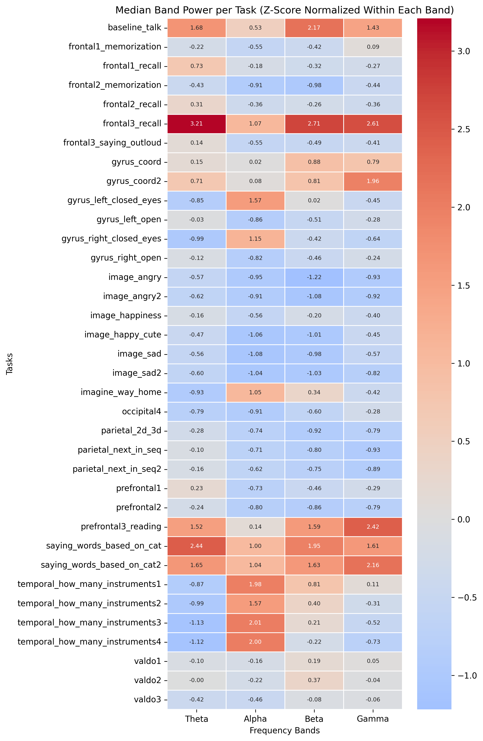
Figure 5.1. Median FFT band power (Z-score normalised within each band) across all 36 cognitive tasks. Red indicates above-average activation; blue indicates below-average. Patterns are consistent with established EEG neuroscience.
The heatmap confirms that the EEG recordings are physiologically valid. Three expected patterns are clearly visible. First, speech-based tasks such as baseline_talk, frontal3_saying_outloud, and saying_words_based_on_cat show broadband activation across Theta, Beta, and Gamma bands, consistent with electromyographic (EMG) contamination from jaw and facial muscle movement during vocalisation — a well-documented phenomenon in EEG research [5]. Second, eyes-closed and mental imagery tasks such as imagine_way_home and the temporal instrument-counting tasks show strong Alpha enhancement, reflecting the classic alpha-blocking release when the visual cortex is not processing external input [6]. Third, passive image-viewing tasks (image_happiness, image_sad, image_angry) are uniformly suppressed across all bands, indicating reduced active neural processing compared to tasks requiring deliberate cognitive effort. These patterns demonstrate that the EEG device captured meaningful neural signals and that data collection and preprocessing did not introduce systematic artefacts.

Relationship Between FFT Features and Sleep Duration
Having established the physiological validity of the EEG data, the next step was to examine which spectral features are associated with the target variable: average nightly sleep hours. Pearson correlations were computed between each of the 70 FFT features and Sleep_Hours across all task-level observations in the dataset. Figure 5.2 shows the top positive and negative correlates.
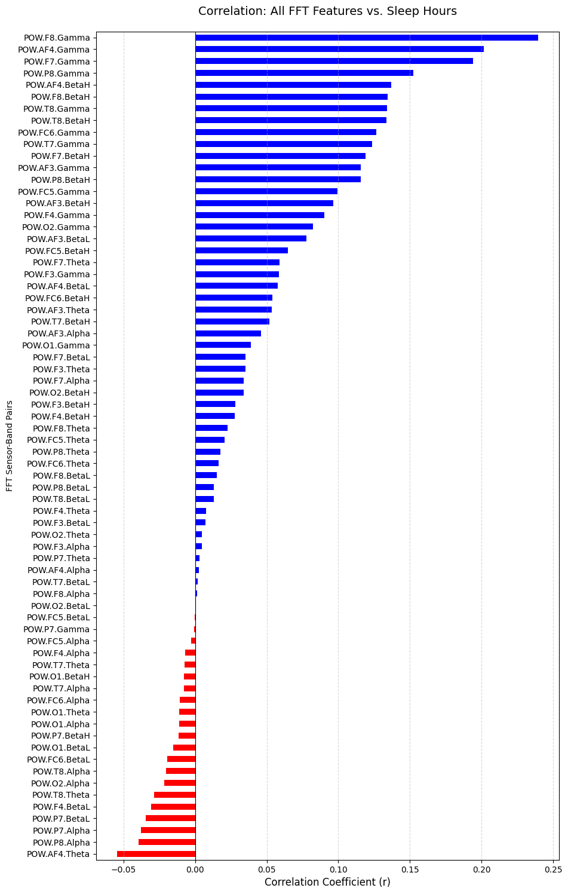
Figure 5.2. Pearson correlation between each FFT feature and Sleep_Hours computed at the row level across all 2,830 task observations. Blue bars indicate positive correlations; red bars indicate negative correlations. Values reach up to r ≈ ±0.27.
The analysis reveals a consistent directional pattern. High-frequency bands — particularly Gamma and Beta High — at right-hemisphere temporal and frontal channels (F8, F7, T8, P8) show positive correlations with sleep hours, with values reaching r ≈ +0.27. Conversely, Theta and Alpha power at prefrontal channels AF3 and AF4 show negative correlations (r ≈ −0.10 to −0.15). This pattern aligns with neuroscientific literature: well-rested individuals tend to exhibit greater high-frequency cognitive bandwidth, while sleep-deprived individuals show increased frontal slow-wave activity associated with drowsiness and reduced cortical arousal [7].
However, these correlations carry an important caveat: they are computed at the row level, meaning each of the 2,830 task observations is treated as an independent data point. Since each participant contributes approximately 34 rows, the effective sample size is inflated by within-subject variance. To examine whether these associations hold at the appropriate level — between subjects — a subject-level analysis was performed. For each participant, FFT features were averaged across all tasks, and correlations were recomputed with n=83 subjects. Figure 5.3 presents scatter plots of the top nine features from the row-level analysis.
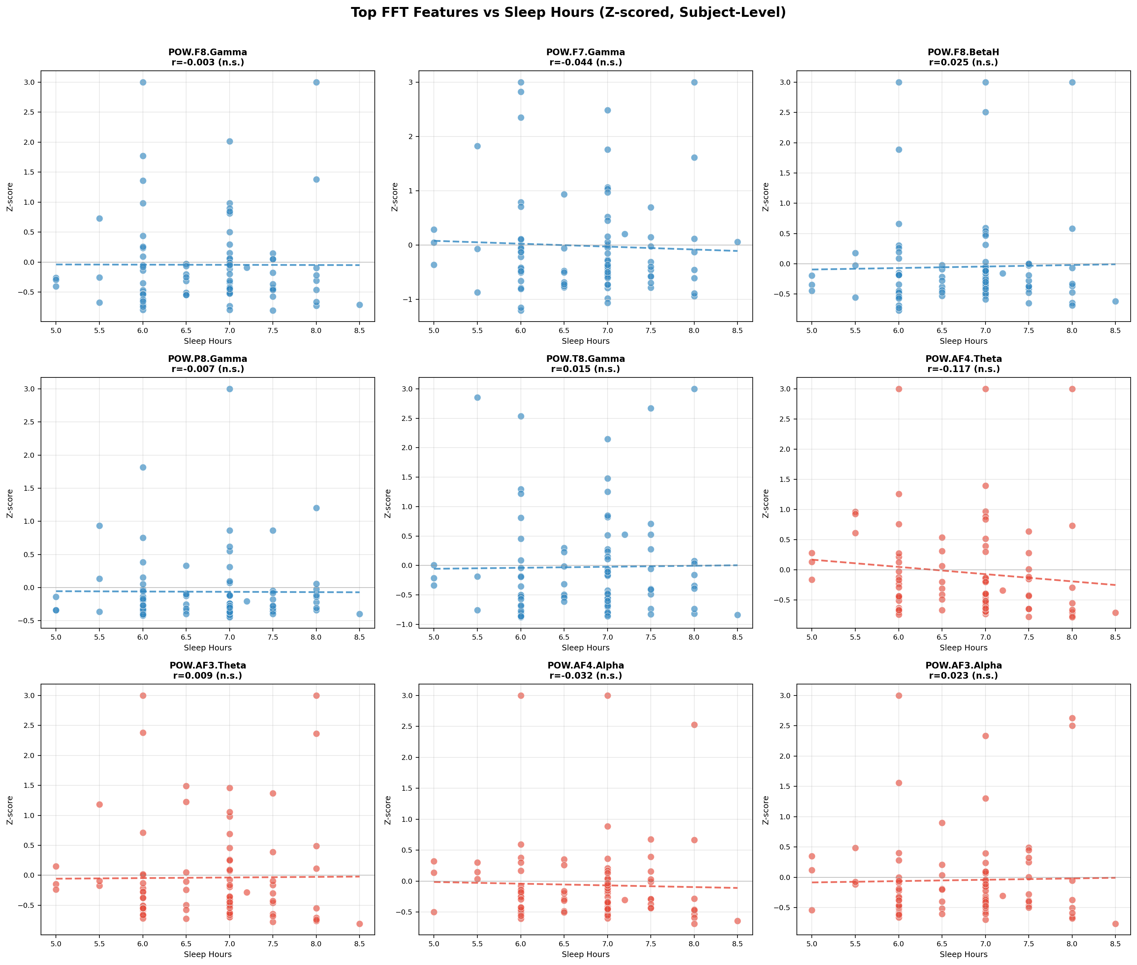
Figure 5.3. Subject-level scatter plots: top FFT features versus Sleep_Hours (n=83). Features are Z-score normalised within each band; outliers clipped at ±3 SD. Blue = features with positive row-level correlations; red = negative. All Pearson r values shown are non-significant (p > 0.05).
At the subject level, none of the nine features reach statistical significance (all p > 0.05). More importantly, two features — F8.Gamma and F7.Gamma — reverse direction entirely, flipping from positive at the row level to slightly negative at the subject level. This direction reversal is a critical finding: it demonstrates that the row-level positive association for these features was driven by within-subject variance across tasks, not by genuine between-subject differences in sleep duration. The frontal Theta and Alpha negative associations are more stable across levels. The strongest subject-level signal is AF4.Theta (r ≈ −0.136), which remains non-significant. These results demonstrate that no single FFT feature can linearly predict sleep hours on its own, motivating the multivariate machine learning approach adopted in Chapters 6 and 7.

EEG Features and Emotiv Performance Metrics
In addition to FFT band power, the Emotiv EPOC provides seven proprietary Performance Metrics (PM): Attention, Engagement, Excitement, Relaxation, Focus, Stress, and Interest. These are computed internally by the Emotiv algorithm from the raw EEG signal. To understand their relationship with spectral features, Pearson correlations between FFT band power and each PM score were computed separately for frontal and parietal/occipital brain regions. Figures 5.4 and 5.5 present the results.
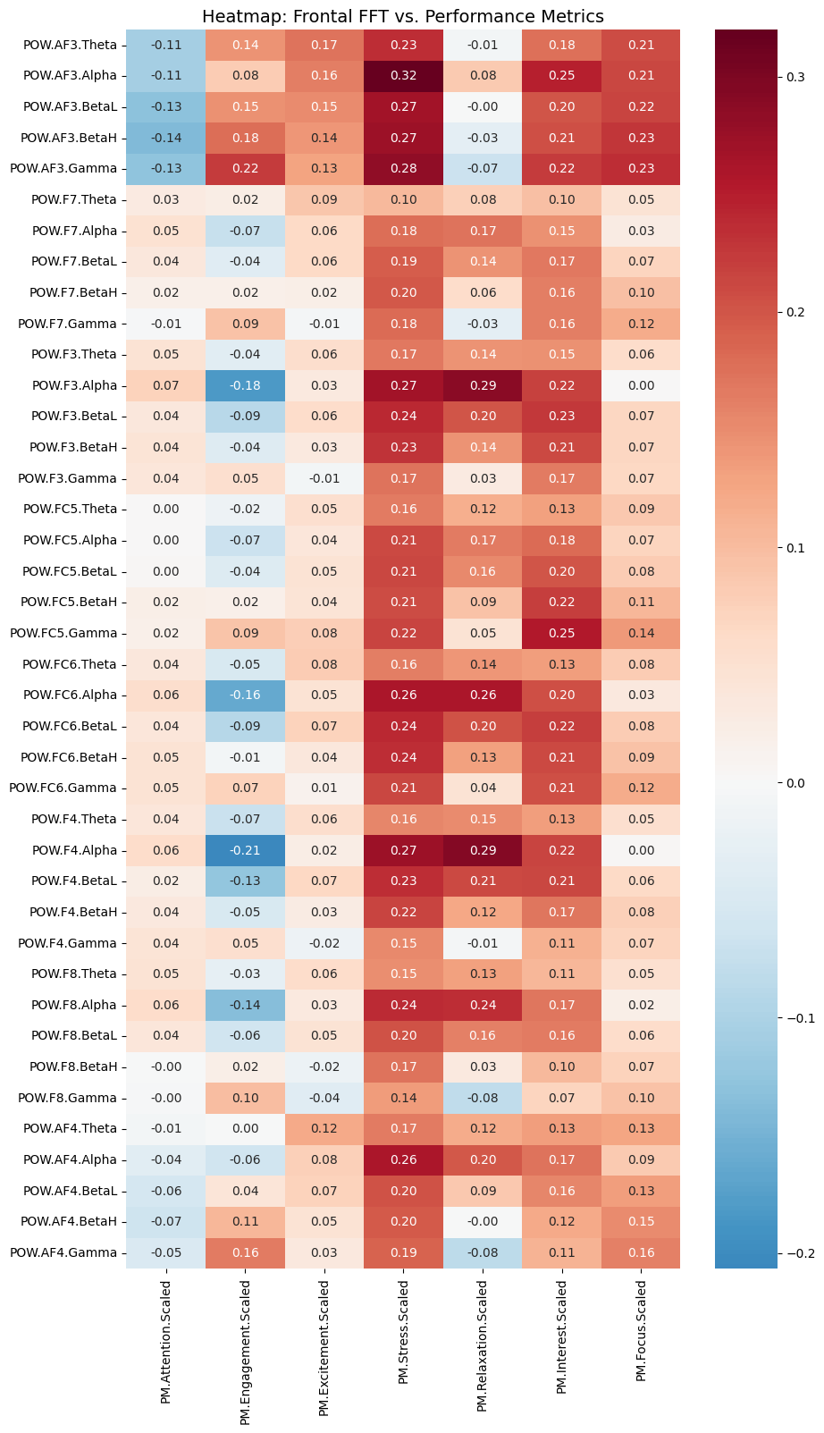
Figure 5.4. Pearson correlations between frontal FFT band power (AF3, F7, F3, FC5) and Emotiv Performance Metrics. Values annotated in each cell.
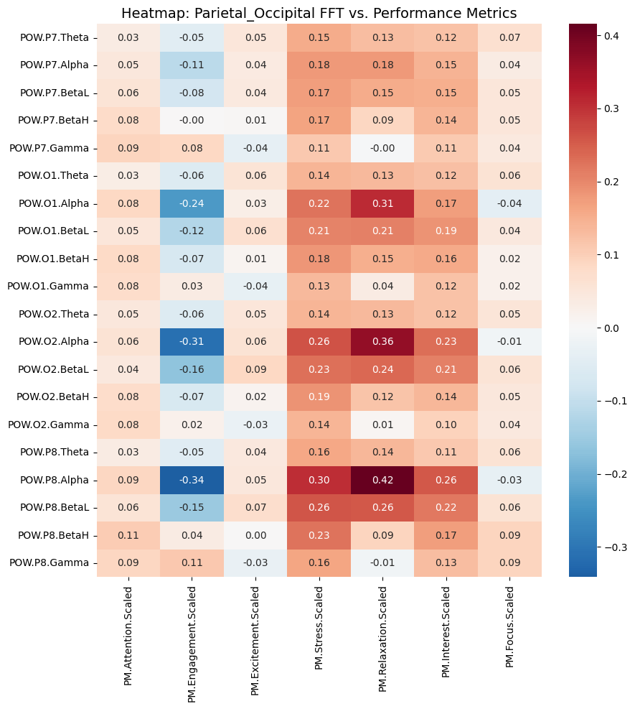
Figure 5.5. Pearson correlations between parietal and occipital FFT band power (P7, O1, O2, P8) and Emotiv Performance Metrics.
Several interpretable patterns emerge. In the frontal region, Alpha power is negatively correlated with Engagement (r ≈ −0.21 at AF3.Alpha), reflecting the well-established alpha-blocking effect: frontal alpha is suppressed when a person is actively engaged with a task [8]. Stress correlates positively with high-frequency frontal bands (r up to ≈ +0.30), consistent with the Emotiv stress metric being derived partly from elevated frontal high-frequency activity. In the parietal and occipital region, the strongest single correlation in the entire dataset is observed: P8.Alpha versus Relaxation at r = +0.41, confirming the well-documented alpha-relaxation link. Engagement shows a strong negative correlation with posterior Alpha (r = −0.35 at P8), consistent with visual cortex activation suppressing alpha during externally directed attention tasks.
The high inter-metric correlations (Stress–Interest r = 0.73, Stress–Relaxation r = 0.61) suggest that the seven PM scores are not independent physiological constructs but rather reflect the internal structure of Emotiv's proprietary algorithm. Their individual correlations with Sleep_Hours are all below |0.28|, with Engagement being the strongest at r = +0.28. These metrics may still contribute some predictive signal when combined with FFT features in the Random Forest model, but they are not expected to be primary predictors.

Sleep Group Comparisons
To directly test whether individuals in different sleep duration categories show measurably different EEG profiles, a group comparison analysis was conducted using Mann-Whitney U tests. Sixteen FFT features spanning Gamma, Beta High, Theta, and Alpha bands at frontal and posterior channels were compared across sleep groups. Two grouping strategies were evaluated: a three-way split (Short <6h, Normal 6–8h, Long ≥8h) and a two-way split (≤7h vs >7h) at the sample median. Bonferroni correction was applied to account for multiple comparisons.
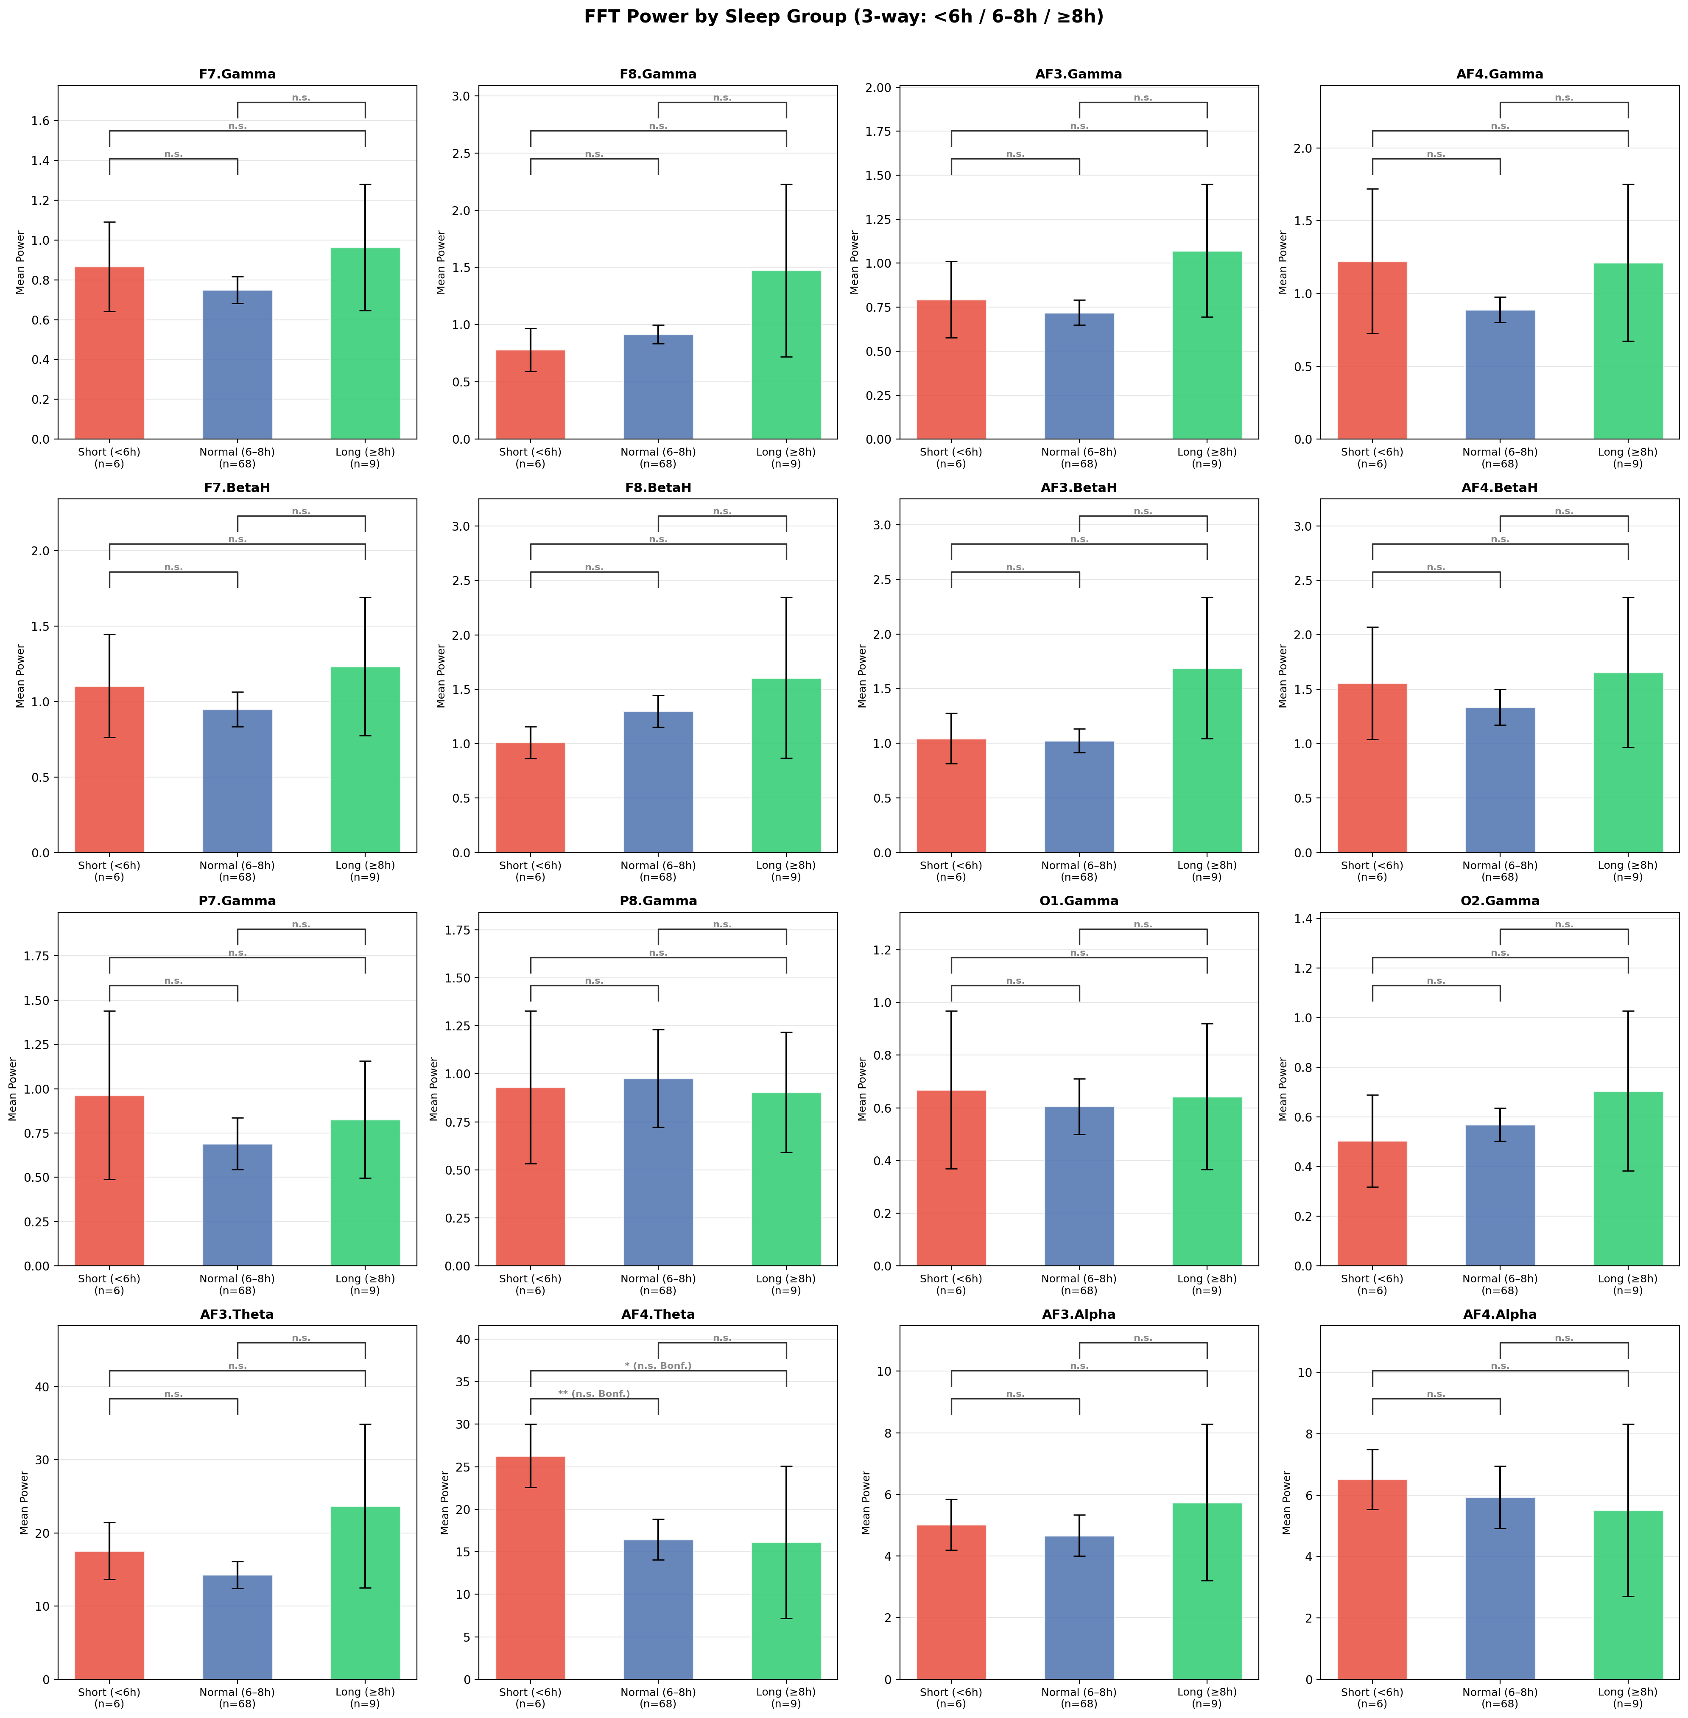
Figure 5.6. Mean FFT power across sleep groups (3-way split: Short n=6, Normal n=68, Long n=9). Error bars show SEM. Brackets indicate Bonferroni-corrected significance (α_corrected = 0.05/48 ≈ 0.001). All comparisons non-significant after correction.
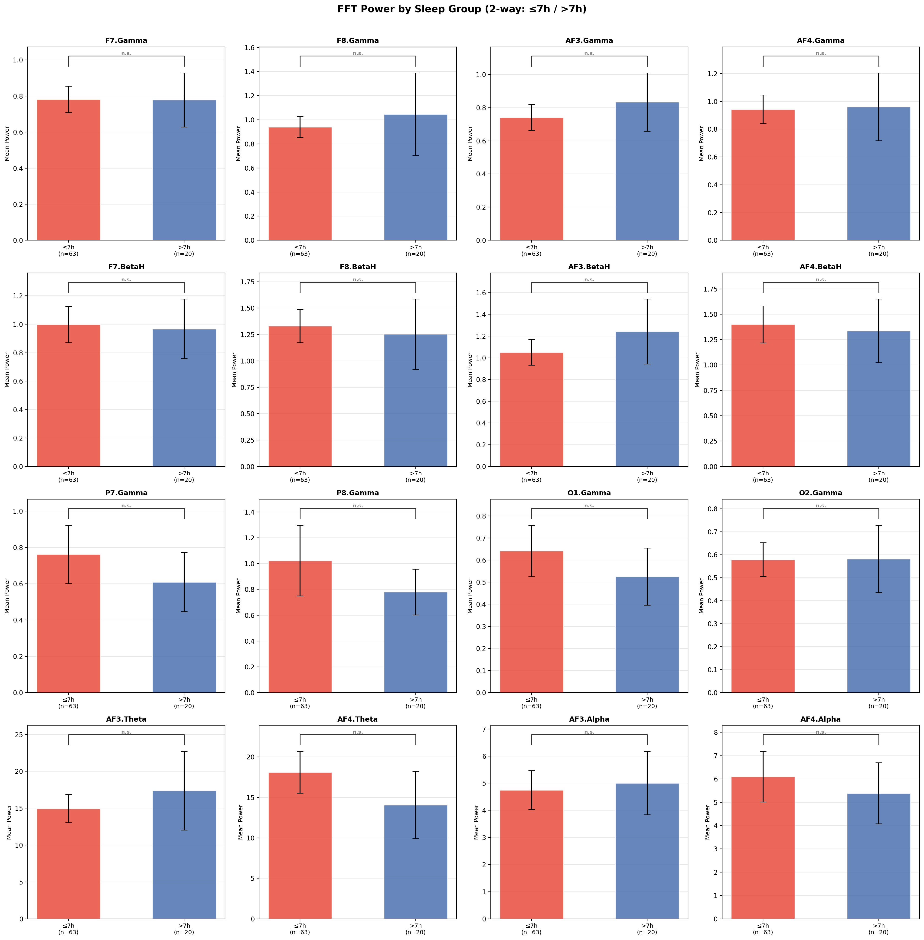
Figure 5.7. Mean FFT power across sleep groups (2-way split: ≤7h n=63, >7h n=20). All 16 comparisons non-significant (lowest p ≈ 0.10 for AF4.Theta).
No FFT feature significantly differentiates sleep groups after Bonferroni correction in either the three-way or two-way analysis. In the three-way comparison, AF4.Theta showed a nominally significant result (Short vs Normal p = 0.009), but this does not survive correction to α_corrected ≈ 0.001. The short sleeper group (n=6) has inherently limited statistical power and wide confidence intervals, making any comparison involving this group unreliable. The two-way split, despite a more balanced design, yields nearly identical bar heights across groups for all features, indicating no detectable univariate separation even at the median threshold. These results are consistent with the scatter plot findings in Section 5.2 and reinforce the conclusion that individual EEG features are insufficient for sleep group classification. A multivariate approach capable of combining weak signals across many features is required.

Per-Task FFT–Sleep Correlation Analysis
The analyses in Sections 5.2 and 5.4 aggregate EEG features across all tasks per participant, treating the cognitive protocol as a single undifferentiated block. This approach does not capture the possibility that some tasks elicit EEG patterns more strongly linked to sleep than others. To investigate this, Pearson correlations were computed between subject-level mean FFT band power and Sleep_Hours separately for each of the 36 cognitive tasks. Figure 5.8 presents the results as a heatmap.
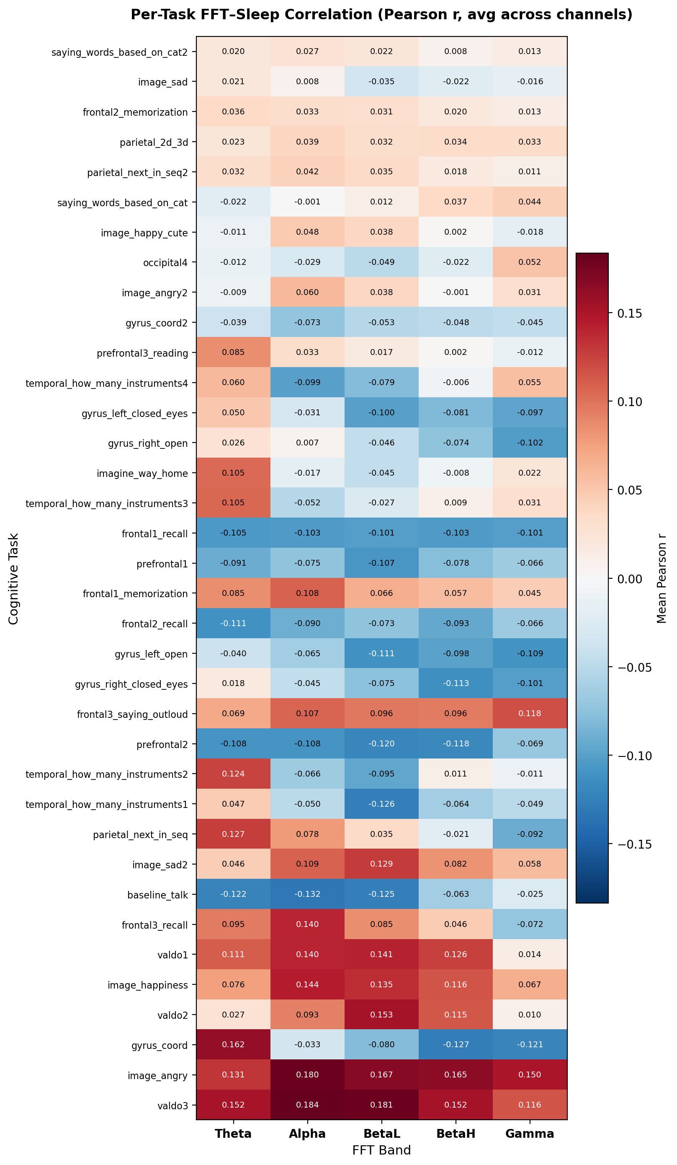
Figure 5.8. Per-task FFT–Sleep correlation heatmap (Pearson r, averaged across 14 channels per band). Tasks are sorted by maximum absolute r across bands. Most predictive tasks appear at the top; least predictive at the bottom.
Substantial variation in sleep-predictive signal exists across tasks. Motor coordination tasks (gyrus_coord, gyrus_coord2), visual occipital tasks (valdo1–3), emotional image tasks, and prefrontal working memory tasks appear at the top of the ranking. In contrast, verbal category generation (saying_words_based_on_cat2), passive image viewing (image_sad), and rote memorisation (frontal2_memorization) show near-zero correlations across all bands. Figure 5.9 isolates the ten strongest individual task–band–channel combinations.
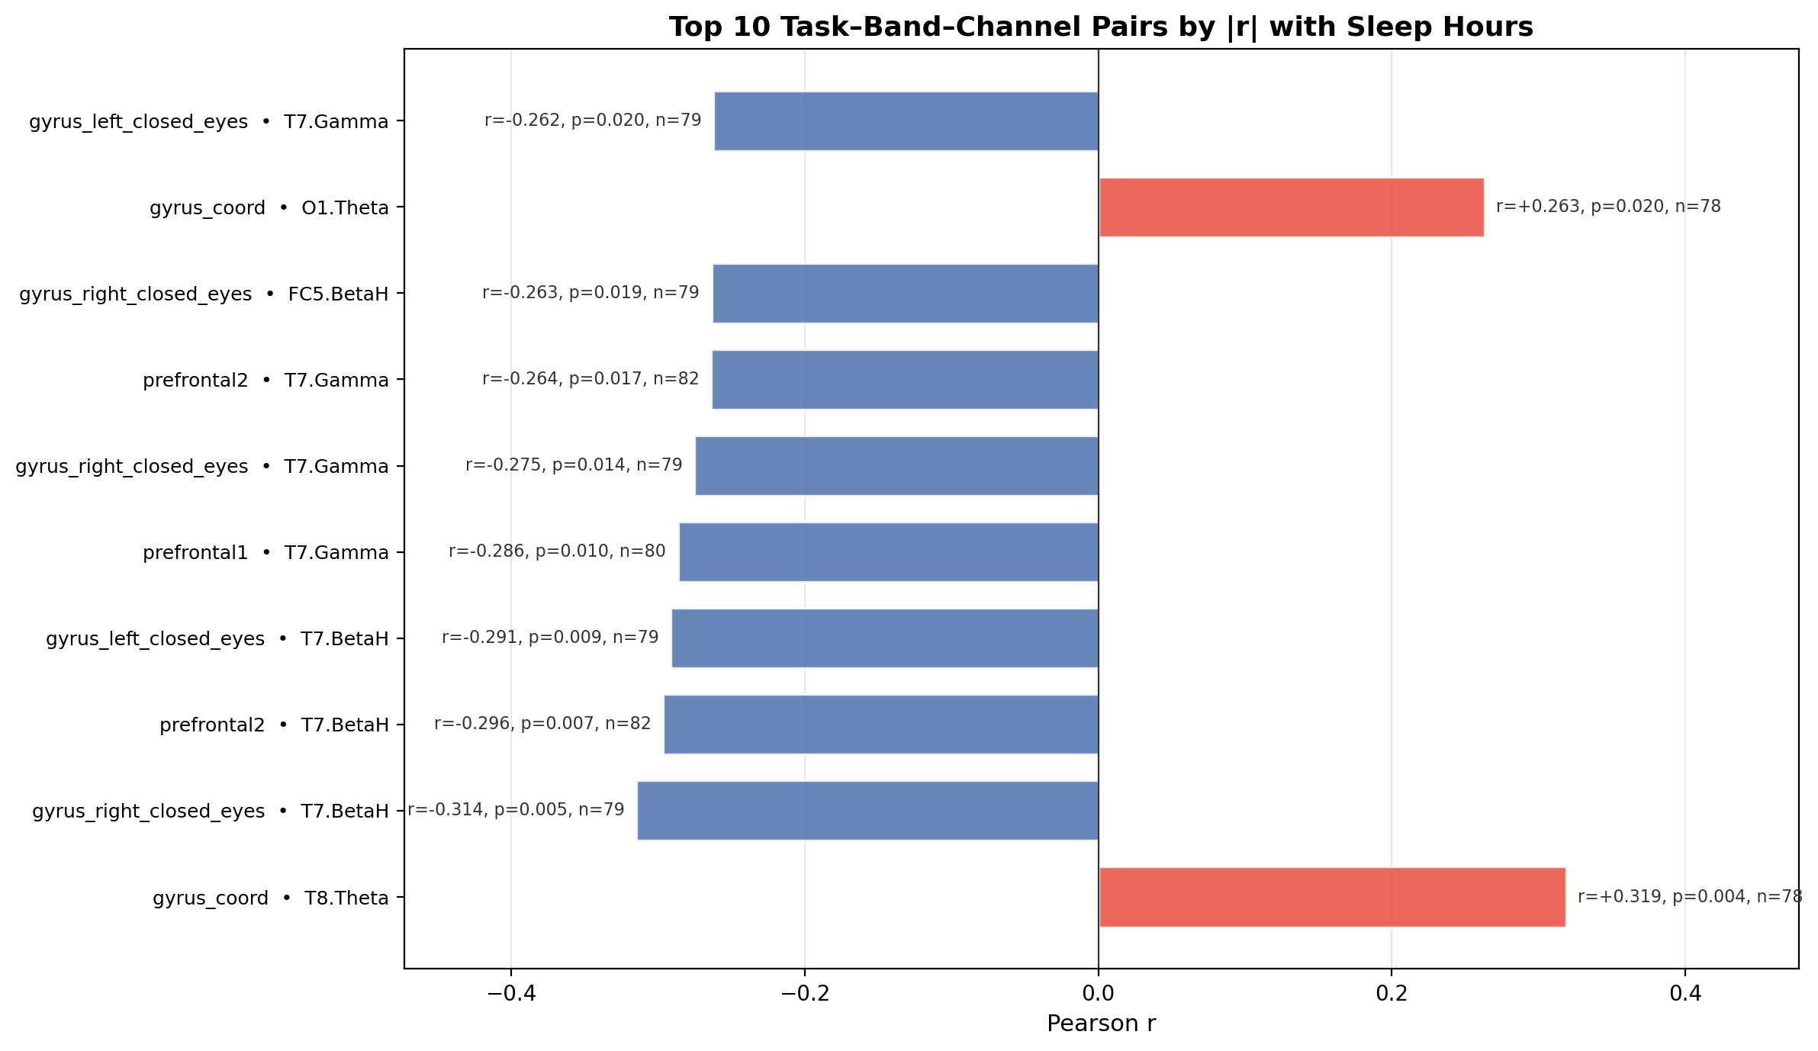
Figure 5.9. Top 10 task–band–channel pairs by absolute Pearson r with Sleep_Hours (subject-level, n=78–83 per task). All ten pairs are statistically significant (p < 0.05). Blue = negative correlation; red = positive correlation.
All ten top pairs are statistically significant (p < 0.05), with several reaching p < 0.01. Three task types dominate the top results. First, motor tasks performed with eyes closed (gyrus_left_closed_eyes, gyrus_right_closed_eyes) show strong negative correlations with Sleep_Hours, particularly in the T7 channel BetaH and Gamma bands (r ≈ −0.29 to −0.31). This finding is biologically plausible: sleep deprivation is known to impair motor control and motor learning [7], so EEG signatures during motor tasks may carry reliable sleep-related information. Second, prefrontal working memory tasks (prefrontal1, prefrontal2) show significant negative correlations in T7 BetaH and Gamma (r ≈ −0.26 to −0.30), consistent with the well-established sensitivity of prefrontal function to sleep loss. Third, motor coordination tasks (gyrus_coord) show positive correlations in T8.Theta and O1.Theta (r ≈ +0.26 to +0.32), suggesting that better-rested participants exhibit more occipital Theta during coordination tasks, potentially reflecting a more efficient, relaxed motor state.
The T7 electrode (left temporal) appears in six of the ten top pairs across multiple independent tasks and bands. This convergent pattern across tasks strengthens confidence that this finding reflects a genuine neural signal rather than noise, even in the context of the large number of correlations computed (~2,520 in total). These results directly identify the tasks and channels most informative for sleep prediction, providing principled guidance for feature prioritisation in the Random Forest model presented in Chapter 7.

Machine Learning Methods for EEG Data
[To be written. This chapter will cover the theoretical basis for the models used:
- Random Forest: ensemble of decision trees, bagging, feature subsampling
- Feature importance computation (mean decrease in impurity)
- Cross-validation strategy: leave-one-subject-out
- Evaluation metrics: RMSE, R-squared, MAE
- Comparison with naive baseline (predict mean)
]

Development and Evaluation of the Machine Learning Model

Feature Selection and Model Training
[To be written after completing the Random Forest modelling phase.]

Evaluation of Model Performance
[To be written after completing the Random Forest modelling phase.]

Conclusion
[To be written after all analyses and modelling are complete.]

List of Abbreviations
CQ Channel Quality
EEG Electroencephalography
FFT Fast Fourier Transform
LOSO Leave-One-Subject-Out
ML Machine Learning
NREM Non-Rapid Eye Movement
PM Performance Metrics
REM Rapid Eye Movement
RF Random Forest
RMSE Root Mean Square Error

Table of Figures
[Auto-generated: use References > Insert Table of Figures in Word.]

List of Tables
[Auto-generated: use References > Insert Table of Figures, label Table.]

Bibliography
- [1] L. Breiman, "Random forests," Machine Learning, vol. 45, no. 1, pp. 5-32, 2001.
- [2] C. M. Bishop, Pattern Recognition and Machine Learning. New York: Springer, 2006.
- [3] Y. Roy, H. Banville, I. Albuquerque, A. Gramfort, T. Falk, and J. Faubert, "Deep learning-based electroencephalography analysis: A systematic review," Journal of Neural Engineering, vol. 16, no. 5, 2019.
- [4] A. Craik, Y. He, and J. L. Contreras-Vidal, "Deep learning for electroencephalogram classification tasks: A review," Journal of Neural Engineering, vol. 16, no. 3, 2019.
- [5] A. C. Mueller and S. Guido, Introduction to Machine Learning with Python: A Guide for Data Scientists. Sebastopol: O'Reilly Media, 2016.
- [6] I. Goodfellow, Y. Bengio, and A. Courville, Deep Learning. Cambridge: MIT Press, 2016.
- [7] S. K. B. Sangeetha, S. K. Mathivanan, S. Mallik, and A. Li, "Recognition predictive modeling using electroencephalogram," Brain & Heart, 2024.
- [8] A. Othmani, A. Q. M. Sabri, S. Aslan, F. Chaieb, H. Rameh, R. Alfred, and D. Cohen, "Electroencephalogram-based neural network approaches for fatigue and drowsiness detection: A survey," Neurocomputing, 2025.

Appendix
[Optional: include supplementary graphs, full signal quality tables, or code listings.]

