Stimulus-Level EEG Modeling Report
Raw-data sampling strategy, generated CSV tables, modeling scripts, and interpretation of the final majority-vote results.

1. Data Overview
The new approach starts from the raw folder all_data, which contains 83 subject folders and the experiment task definition file stimuli.csv. Each subject folder contains at least data.csv and marker.csv, and some folders also contain additional survey or baseline files. The modeling pipeline only uses the task recording data and the marker timing information.
Each cleaned row in data.csv already contains the EEG spectral representation for that moment. In practice, this means that every valid cleaned row already includes the 70 FFT power features named POW.* and the 7 performance or mood features named PM.*. In the new pipeline, one cleaned row inside a valid task segment is treated as one FFT window.
- Raw source folder: /Users/dcaric/Working/pythonWorking/PaolaFinalWork/all_data
- Metadata file: /Users/dcaric/Working/pythonWorking/PaolaFinalWork/DatasetSub_shorten.csv
- Tasks or stimuli file: /Users/dcaric/Working/pythonWorking/PaolaFinalWork/all_data/stimuli.csv
- Number of subjects with raw folders: 83
- Sleep label attached to each subject: Average Sleep Hours per Night

2. Why the Sampling Strategy Changed
The older pipeline aggregated the EEG data too early and reduced each subject to one averaged feature vector. That produced a subject-level matrix close to 81 by 70 and likely removed useful within-subject information across windows and stimuli. The professor suggested keeping the data at a finer level, either as subject by stimulus by window rows, or as subject by stimulus rows after taking the median across windows. Final subject-level prediction should then be obtained by majority vote across the stimulus predictions for that subject.

3. New CSV Files Created from the Raw Data
The new preparation script builds two main CSV datasets and one diagnostics file.
- Window-level dataset: /Users/dcaric/Working/pythonWorking/PaolaFinalWork/enhanced_preparation/all_task_window_ready.csv
- Stimulus-level median dataset: /Users/dcaric/Working/pythonWorking/PaolaFinalWork/enhanced_preparation/all_task_stimulus_median_ready.csv
- Diagnostics: /Users/dcaric/Working/pythonWorking/PaolaFinalWork/enhanced_preparation/all_task_window_ready_diagnostics.csv
Meaning of each file:
- all_task_window_ready.csv: one row per subject, stimulus, and window. This is the most detailed representation and preserves within-task variation.
- all_task_stimulus_median_ready.csv: one row per subject and stimulus, created by taking the median across all windows belonging to that stimulus for that subject.
- all_task_window_ready_diagnostics.csv: records whether each marker segment was processed successfully, filtered out, or skipped because of missing start or end markers.
Final sizes on the full dataset were as follows: 322,893 window-level rows, 2,830 subject-by-stimulus rows, 83 subjects, and 36 unique tasks. Diagnostics recorded 2,830 valid task segments, 5,322 excluded non-task markers, and 148 missing start or end cases.

4. Scripts Used and What Each Script Does
- enhanced_preparation/build_windowed_stimulus_datasets.py: reads the raw data from all_data, applies quality filtering, aligns markers to task windows, creates the window-level dataset, collapses it with a median into the stimulus-level dataset, and saves extraction diagnostics.
- src/3_modelling/run_stimulus_majority_vote_cv.py: runs the 3-class model using subject-safe leave-one-subject-out cross-validation on the stimulus-level dataset, predicts one class per stimulus row, and collapses the predictions to one final subject label using majority vote.
- src/3_modelling/run_stimulus_majority_vote_binary_cv.py: runs the binary version of the same majority-vote pipeline using LowSleep for subjects with less than 7 hours and HigherSleep for subjects with 7 or more hours.

5. End-to-End Workflow
- Run enhanced_preparation/build_windowed_stimulus_datasets.py to generate the new raw-derived CSV files.
- Run src/3_modelling/run_stimulus_majority_vote_cv.py for the 3-class experiment Short, Normal, Long.
- Run src/3_modelling/run_stimulus_majority_vote_binary_cv.py for the binary experiment LowSleep below 7 hours versus HigherSleep at or above 7 hours.
- Inspect the result CSV files, metrics text files, and generated images in the corresponding results folders.
Result folders:
- 3-class outputs: /Users/dcaric/Working/pythonWorking/PaolaFinalWork/results/stimulus_majority_vote_cv
- Binary outputs: /Users/dcaric/Working/pythonWorking/PaolaFinalWork/results/stimulus_majority_vote_binary_cv

6. Generated Result Files
The 3-class run generates:
- subject_majority_vote_predictions.csv
- stimulus_level_predictions.csv
- task_prediction_summary.csv
- stimulus_majority_vote_metrics.txt
- subject_majority_vote_confusion.png
- subject_majority_vote_overview.png
- task_prediction_distribution.png
- task_prediction_heatmap.png
The binary run generates:
- binary_subject_majority_vote_predictions.csv
- binary_stimulus_level_predictions.csv
- binary_task_prediction_summary.csv
- binary_stimulus_majority_vote_metrics.txt
- binary_subject_majority_vote_confusion.png
- binary_subject_majority_vote_overview.png
- binary_task_prediction_distribution.png
- binary_task_prediction_heatmap.png

7. Three-Class Result
The full 3-class subject-level majority-vote model used 2,830 stimulus rows from 83 subjects and 77 features. Its overall subject-level accuracy was 0.8193, but the macro F1 score was only 0.3002. This happened because the model predicted almost everyone as Normal. It correctly classified 68 Normal subjects, but it completely failed to recover the Short and Long classes. This means the richer subject-by-stimulus representation was technically successful, but it still did not solve the class-separation problem for the original 3-class target.
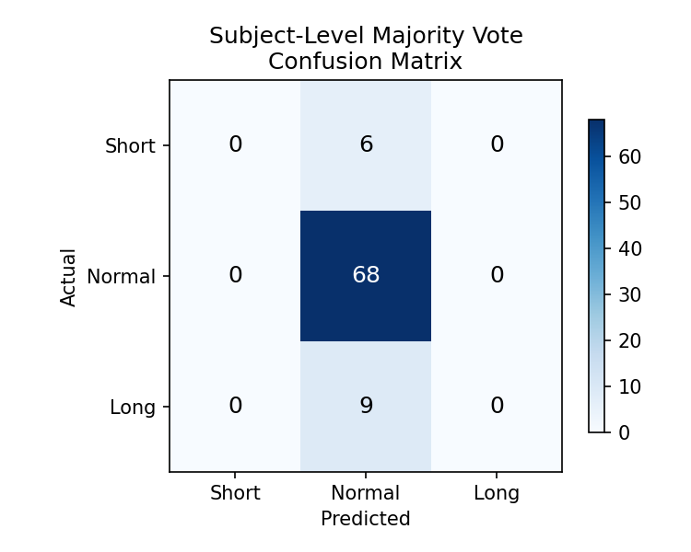
Figure 1. Three-class subject-level confusion matrix. Every subject was effectively pushed into the Normal class, which explains the high accuracy but poor macro F1.
Reading Figure 1: rows show the actual class and columns show the predicted class. The matrix shows zero correct predictions for Short and zero correct predictions for Long. All six Short subjects and all nine Long subjects were predicted as Normal. Therefore, the model benefited from the dominant Normal class but did not learn useful discriminative structure for the minority classes.

8. Binary Result: LowSleep versus HigherSleep
The binary version simplified the target to LowSleep for subjects with less than 7 hours of sleep and HigherSleep for subjects with 7 or more hours. This model performed substantially better. Subject-level accuracy was 0.6386 and macro F1 was 0.6025. It correctly detected 14 of 35 LowSleep subjects and 39 of 48 HigherSleep subjects. This is not a perfect model, but it is clearly more informative than the 3-class version and demonstrates that the new subject-by-stimulus sampling strategy can recover meaningful signal once the target is simplified.
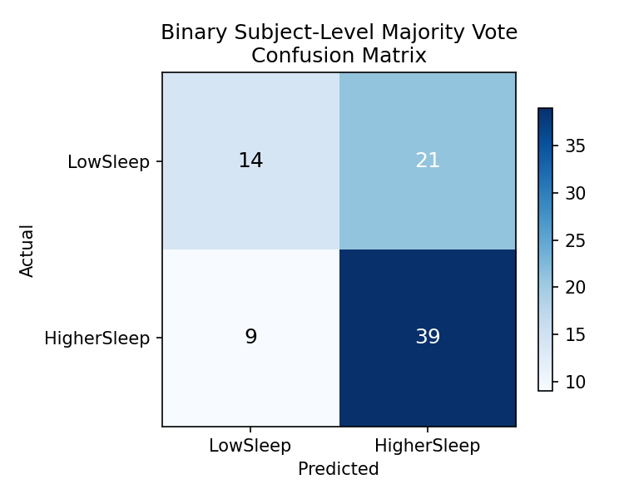
Figure 2. Binary subject-level confusion matrix for LowSleep below 7 hours and HigherSleep at or above 7 hours.
Reading Figure 2: the top-left cell with 14 means that 14 LowSleep subjects were correctly predicted as LowSleep. The top-right cell with 21 means that 21 LowSleep subjects were missed and predicted as HigherSleep. The bottom-left cell with 9 means that 9 HigherSleep subjects were incorrectly predicted as LowSleep. The bottom-right cell with 39 means that 39 HigherSleep subjects were correctly predicted. The model is therefore better at recognizing HigherSleep than LowSleep, but unlike the 3-class version it is no longer collapsing completely to one class.

9. Additional Binary Diagnostic Images
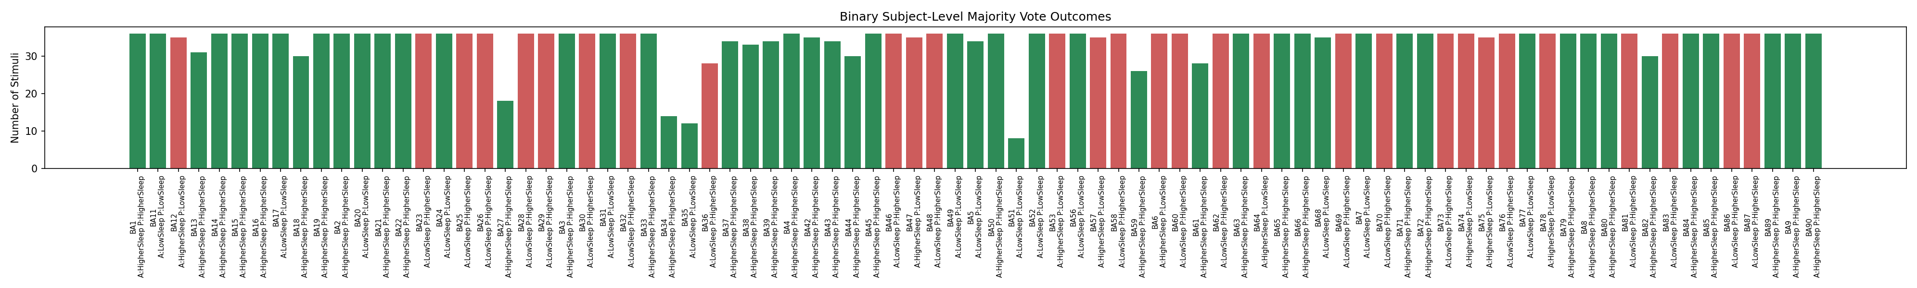
Figure 3. Subject-level majority-vote overview. Each bar represents one subject, and the label shows the actual and predicted binary class.
Figure 3 is useful for identifying which individual subjects were classified correctly and which ones were not. It also shows how many stimuli contributed to each final majority vote, so it is possible to see whether some subjects had fewer valid tasks than others.
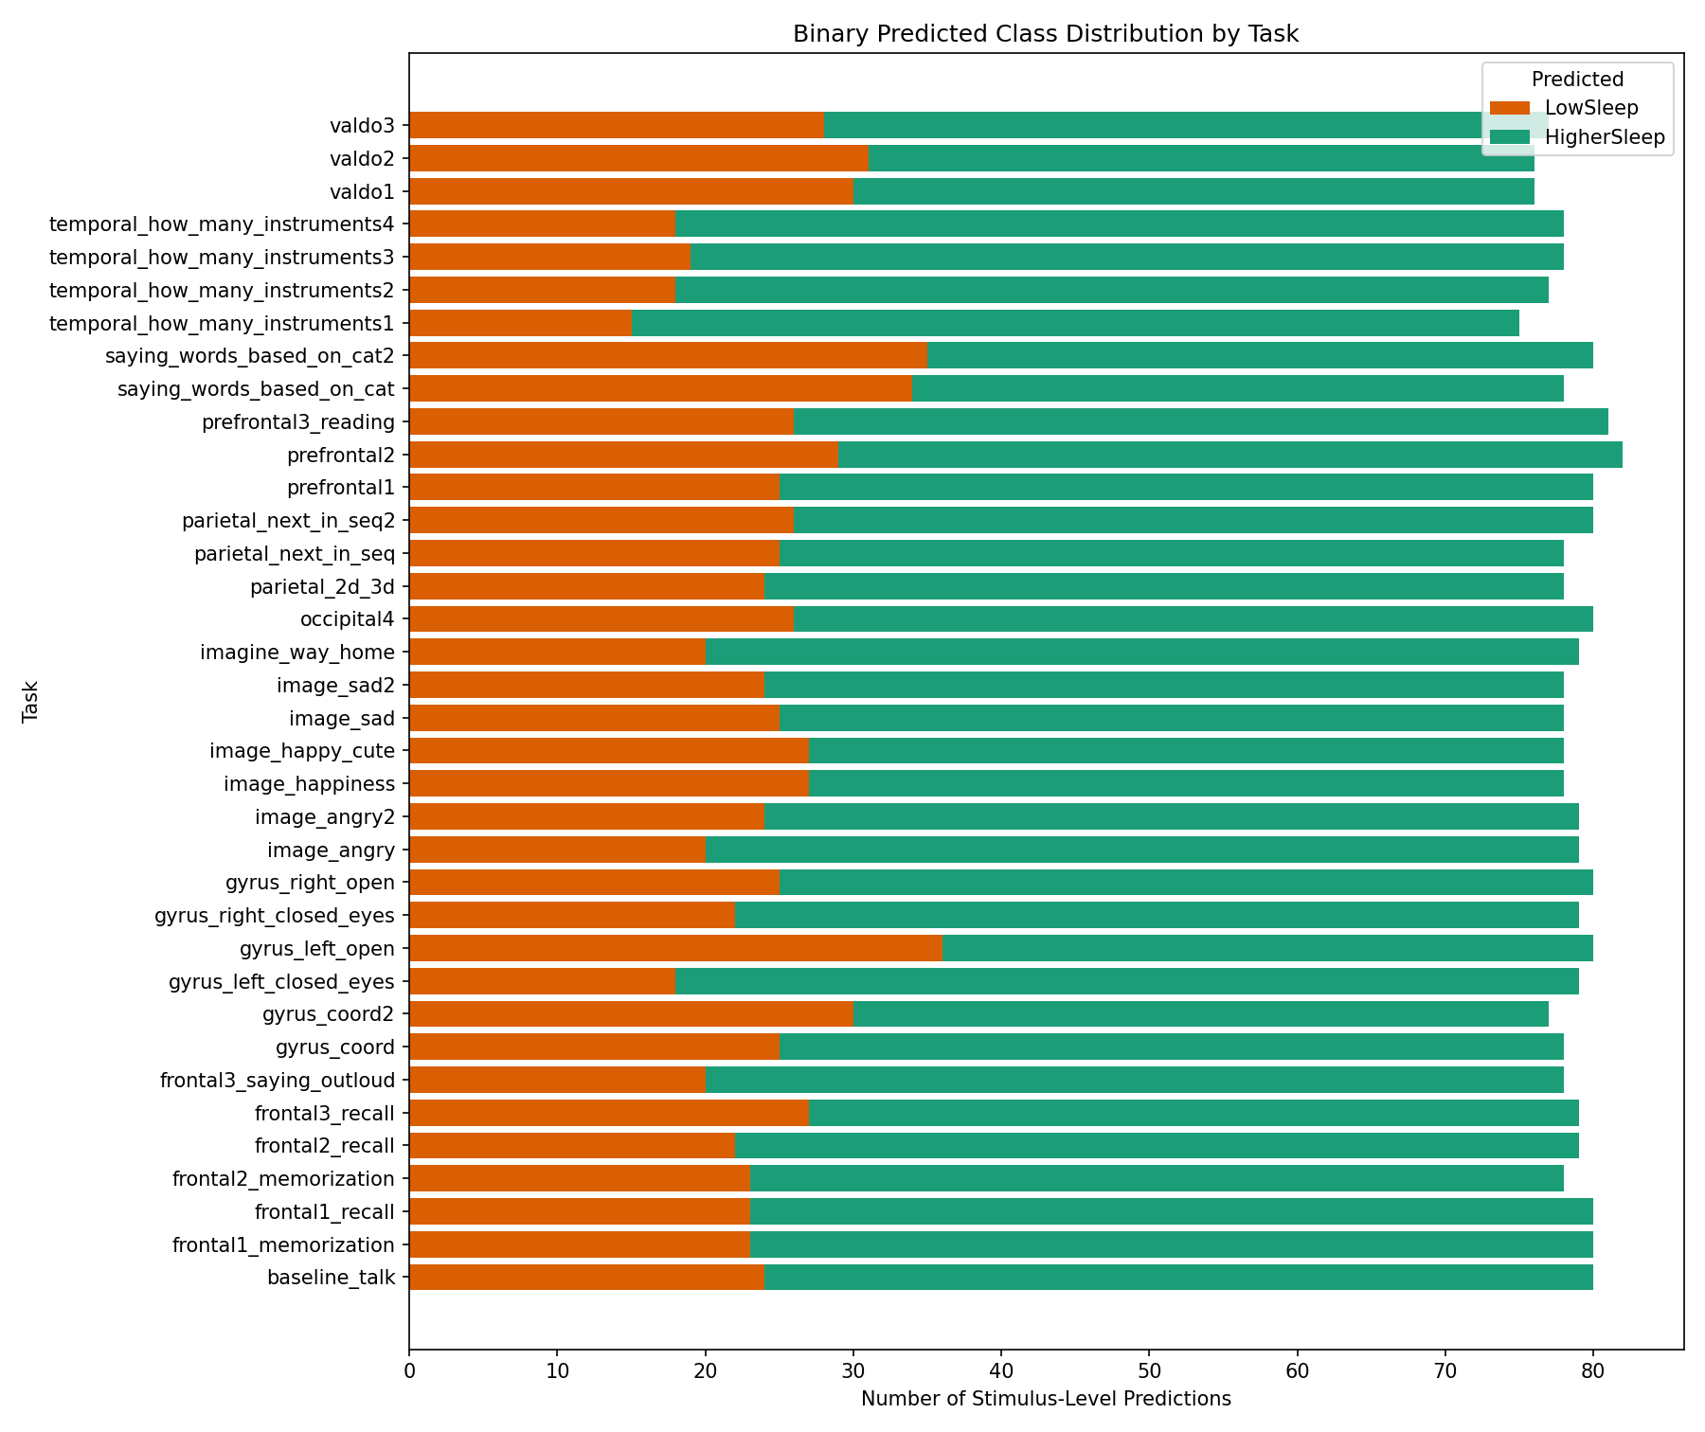
Figure 4. Distribution of binary predicted classes across tasks.
Figure 4 shows how often each task pushed the model toward LowSleep or HigherSleep. This figure is useful for the thesis because it connects the final subject prediction back to the experimental stimuli and makes it possible to discuss whether some tasks appear more sleep-sensitive than others.
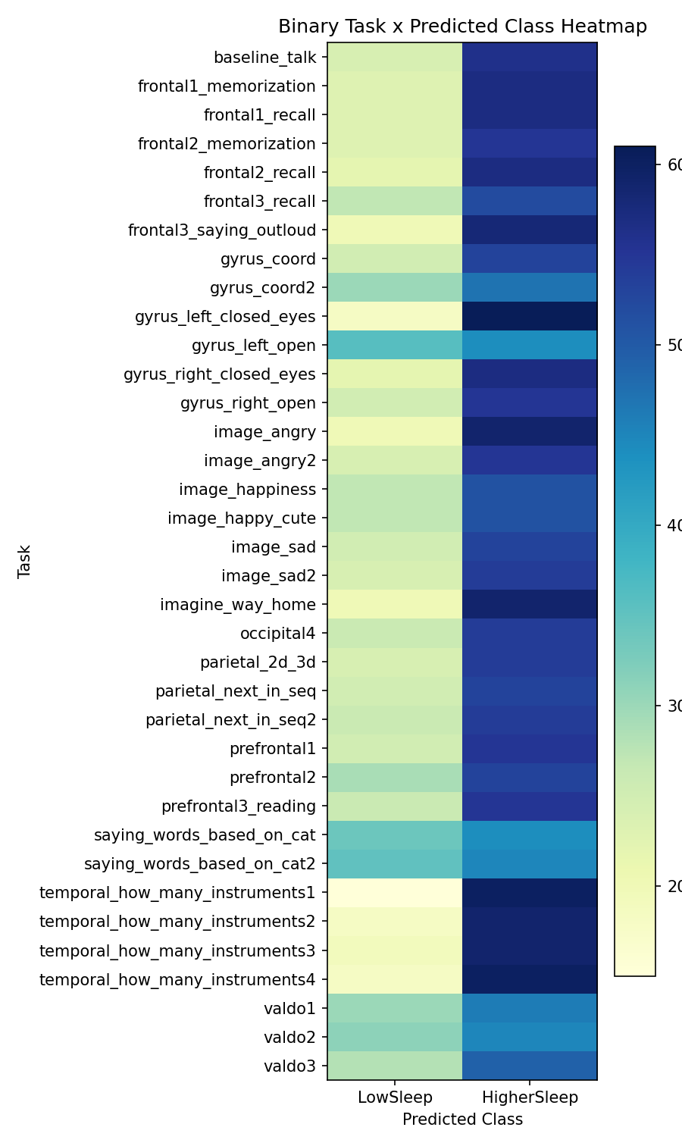
Figure 5. Heatmap of task by predicted class in the binary model.
Figure 5 gives the same task-level information in heatmap form. Darker cells indicate that the model predicted that class more often for that task. This view is helpful when scanning for tasks that consistently lean toward one binary class.

10. Overall Interpretation
The new raw-data sampling strategy achieved two important goals. First, it tested the professor’s suggestion directly by preserving subject-by-stimulus structure instead of collapsing each person into one single average vector too early. Second, it showed that the negative result of the original thesis pipeline was not only caused by over-aggregation. Even with the richer representation, the 3-class task still failed. However, the binary formulation LowSleep versus HigherSleep was noticeably better, which suggests that the dataset contains some useful sleep-related signal, but not enough for stable 3-class separation.
This means the new pipeline is scientifically valuable even if it does not produce a final perfect model. It clarifies where the signal becomes usable, identifies a better target formulation, and provides task-level outputs that can be discussed in the thesis.

11. Downsampled All-Window Binary Result
A further experiment was carried out using the full window-level dataset rather than the stimulus-level median table. Because the raw all-window table was extremely large, a lighter version was used: at most 80 windows were kept per subject and stimulus, and a 100-tree Random Forest was trained under the same leave-one-subject-out evaluation setup. Predictions were made per window, then aggregated from windows to stimulus votes, and finally from stimuli to a single subject-level majority-vote prediction.
- Input file: enhanced_preparation/all_task_window_ready.csv
- Original window rows: 322,893
- Downsampled window rows: 205,607
- Subjects: 83
- Tasks: 36
- Max windows per stimulus after downsampling: 80
- Random Forest size: 100 trees
The final subject-level binary result from this downsampled all-window pipeline was weaker than the earlier stimulus-median binary model.
- Downsampled all-window accuracy: 0.5663
- Downsampled all-window macro F1: 0.4848
- LowSleep precision: 0.47
- LowSleep recall: 0.20
- LowSleep F1: 0.28
- HigherSleep precision: 0.59
- HigherSleep recall: 0.83
- HigherSleep F1: 0.69
- Earlier stimulus-median binary accuracy: 0.6386
- Earlier stimulus-median binary macro F1: 0.6025
This comparison is important because it shows that preserving every available FFT window did not improve the binary classification task. On the contrary, performance deteriorated relative to the subject-by-stimulus median approach. The most likely explanation is that the rawer window-level representation introduced additional within-task noise and subject-specific variability, while the median-per-stimulus representation removed enough of that noise to provide a more stable feature summary for classification.
In practical terms, the binary stimulus-median pipeline remains the strongest result among the professor-guided new sampling strategies. The all-window downsampled experiment is still valuable, however, because it demonstrates that more granular data are not automatically better. This strengthens the methodological conclusion that some aggregation within each stimulus is beneficial, and that the main useful signal for this dataset seems to emerge more clearly after window-level reduction rather than before it.
A concise interpretation suitable for the thesis is: “The downsampled all-window binary experiment did not outperform the stimulus-level median representation. This suggests that retaining individual FFT windows introduced more noise than useful discriminative information for subject-level sleep classification, whereas median aggregation within each stimulus produced a more robust representation.”

Script Used for This Additional Test
- src/3_modelling/run_stimulus_majority_vote_binary_all_window_downsampled_cv.py
- results/stimulus_majority_vote_binary_all_window_downsampled_cv/

Appendix: Raw Console Log for the Last Downsampled All-Window Binary Run
The following block reproduces the terminal output from the final downsampled all-window binary run exactly as recorded, so that the report contains both the interpreted summary and the original execution evidence.
(venv) dcaric@Darios-M3 PaolaFinalWork % python3 src/3_modelling/run_stimulus_majority_vote_binary_all_window_downsampled_cv.py
Loaded raw window-level table: (322893, 85)
Downsampled window-level table: (205607, 86)
Features: 77
Subjects: 83 | Window rows: 205607
Tasks: 36 | Category counts: {'HigherSleep': np.int64(118417), 'LowSleep': np.int64(87190)}
Max windows per stimulus after downsampling: 80
Fold 1/83: subject=BA1, windows=2539, stimuli=36, actual=HigherSleep, predicted=HigherSleep, votes={'HigherSleep': 36}
Fold 2/83: subject=BA11, windows=2619, stimuli=36, actual=LowSleep, predicted=LowSleep, votes={'HigherSleep': 14, 'LowSleep': 22}
Fold 3/83: subject=BA12, windows=2540, stimuli=35, actual=HigherSleep, predicted=LowSleep, votes={'LowSleep': 33, 'HigherSleep': 2}
Fold 4/83: subject=BA13, windows=2074, stimuli=31, actual=HigherSleep, predicted=HigherSleep, votes={'HigherSleep': 31}
Fold 5/83: subject=BA14, windows=2619, stimuli=36, actual=HigherSleep, predicted=HigherSleep, votes={'HigherSleep': 36}
Fold 6/83: subject=BA15, windows=2619, stimuli=36, actual=HigherSleep, predicted=HigherSleep, votes={'HigherSleep': 36}
Fold 7/83: subject=BA16, windows=2619, stimuli=36, actual=HigherSleep, predicted=HigherSleep, votes={'HigherSleep': 32, 'LowSleep': 4}
Fold 8/83: subject=BA17, windows=2619, stimuli=36, actual=LowSleep, predicted=LowSleep, votes={'LowSleep': 24, 'HigherSleep': 12}
Fold 9/83: subject=BA18, windows=2140, stimuli=30, actual=HigherSleep, predicted=HigherSleep, votes={'HigherSleep': 26, 'LowSleep': 4}
Fold 10/83: subject=BA19, windows=2620, stimuli=36, actual=HigherSleep, predicted=HigherSleep, votes={'LowSleep': 17, 'HigherSleep': 19}
Fold 11/83: subject=BA2, windows=2579, stimuli=36, actual=HigherSleep, predicted=HigherSleep, votes={'HigherSleep': 27, 'LowSleep': 9}
Fold 12/83: subject=BA20, windows=2619, stimuli=36, actual=LowSleep, predicted=HigherSleep, votes={'HigherSleep': 26, 'LowSleep': 10}
Fold 13/83: subject=BA21, windows=2618, stimuli=36, actual=HigherSleep, predicted=HigherSleep, votes={'HigherSleep': 32, 'LowSleep': 4}
Fold 14/83: subject=BA22, windows=2617, stimuli=36, actual=HigherSleep, predicted=HigherSleep, votes={'HigherSleep': 35, 'LowSleep': 1}
Fold 15/83: subject=BA23, windows=2618, stimuli=36, actual=LowSleep, predicted=HigherSleep, votes={'HigherSleep': 36}
Fold 16/83: subject=BA24, windows=2620, stimuli=36, actual=LowSleep, predicted=LowSleep, votes={'LowSleep': 36}
Fold 17/83: subject=BA25, windows=2619, stimuli=36, actual=LowSleep, predicted=LowSleep, votes={'LowSleep': 20, 'HigherSleep': 16}
Fold 18/83: subject=BA26, windows=2620, stimuli=36, actual=LowSleep, predicted=HigherSleep, votes={'HigherSleep': 35, 'LowSleep': 1}
Fold 19/83: subject=BA27, windows=1440, stimuli=18, actual=HigherSleep, predicted=HigherSleep, votes={'HigherSleep': 18}
Fold 20/83: subject=BA28, windows=2620, stimuli=36, actual=LowSleep, predicted=HigherSleep, votes={'HigherSleep': 27, 'LowSleep': 9}
Fold 21/83: subject=BA29, windows=2620, stimuli=36, actual=LowSleep, predicted=HigherSleep, votes={'HigherSleep': 36}
Fold 22/83: subject=BA3, windows=2540, stimuli=36, actual=HigherSleep, predicted=HigherSleep, votes={'HigherSleep': 32, 'LowSleep': 4}
Fold 23/83: subject=BA30, windows=2619, stimuli=36, actual=LowSleep, predicted=HigherSleep, votes={'HigherSleep': 21, 'LowSleep': 15}
Fold 24/83: subject=BA31, windows=2620, stimuli=36, actual=LowSleep, predicted=HigherSleep, votes={'HigherSleep': 32, 'LowSleep': 4}
Fold 25/83: subject=BA32, windows=2620, stimuli=36, actual=LowSleep, predicted=HigherSleep, votes={'LowSleep': 10, 'HigherSleep': 26}
Fold 26/83: subject=BA33, windows=2619, stimuli=36, actual=HigherSleep, predicted=HigherSleep, votes={'HigherSleep': 27, 'LowSleep': 9}
Fold 27/83: subject=BA34, windows=847, stimuli=14, actual=HigherSleep, predicted=HigherSleep, votes={'HigherSleep': 14}
Fold 28/83: subject=BA35, windows=960, stimuli=12, actual=LowSleep, predicted=LowSleep, votes={'LowSleep': 12}
Fold 29/83: subject=BA36, windows=1976, stimuli=28, actual=LowSleep, predicted=HigherSleep, votes={'HigherSleep': 28}
Fold 30/83: subject=BA37, windows=2459, stimuli=34, actual=HigherSleep, predicted=HigherSleep, votes={'LowSleep': 1, 'HigherSleep': 33}
Fold 31/83: subject=BA38, windows=2379, stimuli=33, actual=HigherSleep, predicted=HigherSleep, votes={'HigherSleep': 33}
Fold 32/83: subject=BA39, windows=2521, stimuli=34, actual=HigherSleep, predicted=HigherSleep, votes={'LowSleep': 1, 'HigherSleep': 33}
Fold 33/83: subject=BA4, windows=2579, stimuli=36, actual=HigherSleep, predicted=HigherSleep, votes={'LowSleep': 18, 'HigherSleep': 18}
Fold 34/83: subject=BA42, windows=2580, stimuli=35, actual=HigherSleep, predicted=HigherSleep, votes={'HigherSleep': 34, 'LowSleep': 1}
Fold 35/83: subject=BA43, windows=2513, stimuli=34, actual=HigherSleep, predicted=HigherSleep, votes={'HigherSleep': 34}
Fold 36/83: subject=BA44, windows=2139, stimuli=30, actual=HigherSleep, predicted=HigherSleep, votes={'HigherSleep': 28, 'LowSleep': 2}
Fold 37/83: subject=BA45, windows=2619, stimuli=36, actual=HigherSleep, predicted=HigherSleep, votes={'HigherSleep': 36}
Fold 38/83: subject=BA46, windows=2619, stimuli=36, actual=LowSleep, predicted=HigherSleep, votes={'HigherSleep': 36}
Fold 39/83: subject=BA47, windows=2538, stimuli=35, actual=HigherSleep, predicted=LowSleep, votes={'LowSleep': 25, 'HigherSleep': 10}
Fold 40/83: subject=BA48, windows=2619, stimuli=36, actual=LowSleep, predicted=HigherSleep, votes={'HigherSleep': 34, 'LowSleep': 2}
Fold 41/83: subject=BA49, windows=2619, stimuli=36, actual=LowSleep, predicted=LowSleep, votes={'HigherSleep': 13, 'LowSleep': 23}
Fold 42/83: subject=BA5, windows=2455, stimuli=34, actual=LowSleep, predicted=HigherSleep, votes={'HigherSleep': 22, 'LowSleep': 12}
Fold 43/83: subject=BA50, windows=2620, stimuli=36, actual=HigherSleep, predicted=HigherSleep, votes={'HigherSleep': 36}
Fold 44/83: subject=BA51, windows=640, stimuli=8, actual=LowSleep, predicted=HigherSleep, votes={'HigherSleep': 5, 'LowSleep': 3}
Fold 45/83: subject=BA52, windows=2619, stimuli=36, actual=LowSleep, predicted=HigherSleep, votes={'HigherSleep': 24, 'LowSleep': 12}
Fold 46/83: subject=BA53, windows=2619, stimuli=36, actual=HigherSleep, predicted=HigherSleep, votes={'LowSleep': 12, 'HigherSleep': 24}
Fold 47/83: subject=BA56, windows=2620, stimuli=36, actual=LowSleep, predicted=HigherSleep, votes={'HigherSleep': 35, 'LowSleep': 1}
Fold 48/83: subject=BA57, windows=2540, stimuli=35, actual=HigherSleep, predicted=HigherSleep, votes={'HigherSleep': 32, 'LowSleep': 3}
Fold 49/83: subject=BA58, windows=2619, stimuli=36, actual=LowSleep, predicted=HigherSleep, votes={'HigherSleep': 36}
Fold 50/83: subject=BA59, windows=2080, stimuli=26, actual=HigherSleep, predicted=HigherSleep, votes={'LowSleep': 5, 'HigherSleep': 21}
Fold 51/83: subject=BA6, windows=2580, stimuli=36, actual=HigherSleep, predicted=LowSleep, votes={'HigherSleep': 14, 'LowSleep': 22}
Fold 52/83: subject=BA60, windows=2619, stimuli=36, actual=LowSleep, predicted=HigherSleep, votes={'HigherSleep': 36}
Fold 53/83: subject=BA61, windows=1981, stimuli=28, actual=HigherSleep, predicted=HigherSleep, votes={'HigherSleep': 22, 'LowSleep': 6}
Fold 54/83: subject=BA62, windows=2619, stimuli=36, actual=LowSleep, predicted=HigherSleep, votes={'HigherSleep': 32, 'LowSleep': 4}
Fold 55/83: subject=BA63, windows=2619, stimuli=36, actual=HigherSleep, predicted=LowSleep, votes={'HigherSleep': 17, 'LowSleep': 19}
Fold 56/83: subject=BA64, windows=2619, stimuli=36, actual=HigherSleep, predicted=HigherSleep, votes={'HigherSleep': 24, 'LowSleep': 12}
Fold 57/83: subject=BA65, windows=2624, stimuli=36, actual=HigherSleep, predicted=HigherSleep, votes={'HigherSleep': 33, 'LowSleep': 3}
Fold 58/83: subject=BA66, windows=2619, stimuli=36, actual=HigherSleep, predicted=HigherSleep, votes={'HigherSleep': 36}
Fold 59/83: subject=BA68, windows=2540, stimuli=35, actual=LowSleep, predicted=HigherSleep, votes={'HigherSleep': 29, 'LowSleep': 6}
Fold 60/83: subject=BA69, windows=2619, stimuli=36, actual=LowSleep, predicted=HigherSleep, votes={'HigherSleep': 28, 'LowSleep': 8}
Fold 61/83: subject=BA7, windows=2659, stimuli=36, actual=LowSleep, predicted=LowSleep, votes={'LowSleep': 33, 'HigherSleep': 3}
Fold 62/83: subject=BA70, windows=2615, stimuli=36, actual=LowSleep, predicted=HigherSleep, votes={'HigherSleep': 36}
Fold 63/83: subject=BA71, windows=2619, stimuli=36, actual=HigherSleep, predicted=LowSleep, votes={'LowSleep': 19, 'HigherSleep': 17}
Fold 64/83: subject=BA72, windows=2620, stimuli=36, actual=HigherSleep, predicted=HigherSleep, votes={'HigherSleep': 36}
Fold 65/83: subject=BA73, windows=2620, stimuli=36, actual=LowSleep, predicted=HigherSleep, votes={'HigherSleep': 32, 'LowSleep': 4}
Fold 66/83: subject=BA74, windows=2623, stimuli=36, actual=HigherSleep, predicted=LowSleep, votes={'LowSleep': 24, 'HigherSleep': 12}
Fold 67/83: subject=BA75, windows=2542, stimuli=35, actual=HigherSleep, predicted=LowSleep, votes={'LowSleep': 21, 'HigherSleep': 14}
Fold 68/83: subject=BA76, windows=2619, stimuli=36, actual=LowSleep, predicted=HigherSleep, votes={'HigherSleep': 36}
Fold 69/83: subject=BA77, windows=2620, stimuli=36, actual=LowSleep, predicted=HigherSleep, votes={'LowSleep': 14, 'HigherSleep': 22}
Fold 70/83: subject=BA78, windows=2619, stimuli=36, actual=HigherSleep, predicted=LowSleep, votes={'LowSleep': 26, 'HigherSleep': 10}
Fold 71/83: subject=BA79, windows=2618, stimuli=36, actual=HigherSleep, predicted=HigherSleep, votes={'LowSleep': 14, 'HigherSleep': 22}
Fold 72/83: subject=BA8, windows=2619, stimuli=36, actual=HigherSleep, predicted=HigherSleep, votes={'HigherSleep': 36}
Fold 73/83: subject=BA80, windows=2620, stimuli=36, actual=HigherSleep, predicted=HigherSleep, votes={'HigherSleep': 32, 'LowSleep': 4}
Fold 74/83: subject=BA81, windows=2623, stimuli=36, actual=LowSleep, predicted=HigherSleep, votes={'HigherSleep': 36}
Fold 75/83: subject=BA82, windows=2141, stimuli=30, actual=HigherSleep, predicted=HigherSleep, votes={'HigherSleep': 29, 'LowSleep': 1}
Fold 76/83: subject=BA83, windows=2620, stimuli=36, actual=LowSleep, predicted=HigherSleep, votes={'HigherSleep': 34, 'LowSleep': 2}
Fold 77/83: subject=BA84, windows=2620, stimuli=36, actual=HigherSleep, predicted=HigherSleep, votes={'HigherSleep': 34, 'LowSleep': 2}
Fold 78/83: subject=BA85, windows=2620, stimuli=36, actual=HigherSleep, predicted=HigherSleep, votes={'HigherSleep': 36}
Fold 79/83: subject=BA86, windows=2619, stimuli=36, actual=LowSleep, predicted=HigherSleep, votes={'HigherSleep': 18, 'LowSleep': 18}
Fold 80/83: subject=BA87, windows=2619, stimuli=36, actual=LowSleep, predicted=HigherSleep, votes={'HigherSleep': 35, 'LowSleep': 1}
Fold 81/83: subject=BA89, windows=2620, stimuli=36, actual=HigherSleep, predicted=HigherSleep, votes={'HigherSleep': 35, 'LowSleep': 1}
Fold 82/83: subject=BA9, windows=2658, stimuli=36, actual=HigherSleep, predicted=HigherSleep, votes={'HigherSleep': 31, 'LowSleep': 5}
Fold 83/83: subject=BA90, windows=2620, stimuli=36, actual=HigherSleep, predicted=HigherSleep, votes={'HigherSleep': 35, 'LowSleep': 1}
Subject-level downsampled all-window binary majority-vote results
Accuracy : 0.5663
F1 (macro) : 0.4848
precision recall f1-score support
LowSleep 0.47 0.20 0.28 35
HigherSleep 0.59 0.83 0.69 48
accuracy 0.57 83
macro avg 0.53 0.52 0.48 83
weighted avg 0.54 0.57 0.52 83
Saved outputs to: /Users/dcaric/Working/pythonWorking/PaolaFinalWork/results/stimulus_majority_vote_binary_all_window_downsampled_cv

12. Stimulus-Level Regression Result
A regression experiment was also carried out on the same stimulus-level median CSV used for the classification runs. In this setup, the model predicted a continuous sleep-hours value for each subject-by-stimulus row, and those stimulus-level predictions were then aggregated back to one final subject-level prediction by either the mean or the median.
- Input file: enhanced_preparation/all_task_stimulus_median_ready.csv
- Rows: 2,830 subject-by-stimulus observations
- Subjects: 83
- Tasks: 36
- Features: 77
- Evaluation: leave-one-subject-out cross-validation
- Random Forest size: 500 trees
The final result showed only a negligible improvement over the dummy baseline. The dummy baseline RMSE was 0.7805, while the Random Forest achieved 0.7678 under mean aggregation and 0.7684 under median aggregation. The corresponding R² values were 0.0081 and 0.0065, which are both effectively zero. This means that the richer subject-by-stimulus representation did not substantially improve prediction of exact sleep duration.
This result is important in combination with the classification experiments. It shows that the new sampling strategy helped most when the target was simplified to the binary distinction below 7 hours versus 7 or more hours. In contrast, for continuous prediction of exact sleep hours, the available EEG features still carried only very weak recoverable signal.
A concise thesis-style interpretation is: “The stimulus-level regression experiment produced only negligible improvement over the dummy baseline, with RMSE decreasing from 0.7805 to 0.7678 and R² remaining near zero. This indicates that the richer subject-by-stimulus representation did not materially improve prediction of exact sleep duration, even though it was more informative for the simplified binary classification task.”

Appendix: Raw Console Log for the Stimulus-Level Regression Run
The following block reproduces the terminal output from the full stimulus-level regression run so that the document contains the original execution record alongside the interpretation.
(venv) dcaric@Darios-M3 PaolaFinalWork % time python3 src/3_modelling/run_stimulus_regression_cv.py
Loaded stimulus-level table: (2830, 83)
Features: 77
Subjects: 83 | Stimulus rows: 2830
Tasks: 36 | Sleep mean=6.74, std=0.78, range=[5.0, 8.5]
Fold 1/83: subject=BA1, stimuli=36, actual=7.00, pred_mean=6.65, pred_median=6.61
Fold 2/83: subject=BA11, stimuli=36, actual=6.00, pred_mean=6.54, pred_median=6.56
Fold 3/83: subject=BA12, stimuli=35, actual=7.00, pred_mean=6.53, pred_median=6.54
Fold 4/83: subject=BA13, stimuli=31, actual=7.00, pred_mean=6.97, pred_median=6.97
Fold 5/83: subject=BA14, stimuli=36, actual=7.00, pred_mean=6.97, pred_median=6.98
Fold 6/83: subject=BA15, stimuli=36, actual=7.00, pred_mean=7.13, pred_median=7.11
Fold 7/83: subject=BA16, stimuli=36, actual=8.00, pred_mean=6.54, pred_median=6.52
Fold 8/83: subject=BA17, stimuli=36, actual=6.50, pred_mean=6.67, pred_median=6.69
Fold 9/83: subject=BA18, stimuli=30, actual=7.50, pred_mean=6.79, pred_median=6.79
Fold 10/83: subject=BA19, stimuli=36, actual=7.50, pred_mean=6.77, pred_median=6.74
Fold 11/83: subject=BA2, stimuli=36, actual=7.00, pred_mean=6.94, pred_median=6.99
Fold 12/83: subject=BA20, stimuli=36, actual=6.00, pred_mean=6.55, pred_median=6.53
Fold 13/83: subject=BA21, stimuli=36, actual=7.50, pred_mean=6.68, pred_median=6.65
Fold 14/83: subject=BA22, stimuli=36, actual=7.20, pred_mean=6.99, pred_median=7.01
Fold 15/83: subject=BA23, stimuli=36, actual=6.00, pred_mean=6.98, pred_median=7.01
Fold 16/83: subject=BA24, stimuli=36, actual=6.00, pred_mean=6.48, pred_median=6.47
Fold 17/83: subject=BA25, stimuli=36, actual=5.50, pred_mean=6.62, pred_median=6.62
Fold 18/83: subject=BA26, stimuli=36, actual=6.50, pred_mean=6.82, pred_median=6.82
Fold 19/83: subject=BA27, stimuli=18, actual=7.50, pred_mean=7.14, pred_median=7.11
Fold 20/83: subject=BA28, stimuli=36, actual=5.50, pred_mean=6.79, pred_median=6.83
Fold 21/83: subject=BA29, stimuli=36, actual=6.50, pred_mean=6.63, pred_median=6.61
Fold 22/83: subject=BA3, stimuli=36, actual=7.00, pred_mean=6.79, pred_median=6.77
Fold 23/83: subject=BA30, stimuli=36, actual=6.00, pred_mean=6.66, pred_median=6.67
Fold 24/83: subject=BA31, stimuli=36, actual=6.50, pred_mean=6.60, pred_median=6.61
Fold 25/83: subject=BA32, stimuli=36, actual=6.00, pred_mean=6.55, pred_median=6.53
Fold 26/83: subject=BA33, stimuli=36, actual=7.50, pred_mean=6.61, pred_median=6.63
Fold 27/83: subject=BA34, stimuli=14, actual=7.00, pred_mean=6.83, pred_median=6.85
Fold 28/83: subject=BA35, stimuli=12, actual=6.50, pred_mean=6.35, pred_median=6.32
Fold 29/83: subject=BA36, stimuli=28, actual=6.00, pred_mean=6.79, pred_median=6.80
Fold 30/83: subject=BA37, stimuli=34, actual=7.00, pred_mean=6.70, pred_median=6.68
Fold 31/83: subject=BA38, stimuli=33, actual=7.50, pred_mean=6.82, pred_median=6.85
Fold 32/83: subject=BA39, stimuli=34, actual=7.00, pred_mean=6.59, pred_median=6.59
Fold 33/83: subject=BA4, stimuli=36, actual=8.00, pred_mean=6.76, pred_median=6.78
Fold 34/83: subject=BA42, stimuli=35, actual=8.50, pred_mean=7.05, pred_median=7.10
Fold 35/83: subject=BA43, stimuli=34, actual=7.00, pred_mean=6.65, pred_median=6.62
Fold 36/83: subject=BA44, stimuli=30, actual=7.50, pred_mean=6.80, pred_median=6.80
Fold 37/83: subject=BA45, stimuli=36, actual=7.00, pred_mean=7.00, pred_median=7.03
Fold 38/83: subject=BA46, stimuli=36, actual=6.00, pred_mean=6.78, pred_median=6.79
Fold 39/83: subject=BA47, stimuli=35, actual=7.00, pred_mean=6.56, pred_median=6.54
Fold 40/83: subject=BA48, stimuli=36, actual=6.00, pred_mean=6.73, pred_median=6.71
Fold 41/83: subject=BA49, stimuli=36, actual=6.00, pred_mean=6.67, pred_median=6.68
Fold 42/83: subject=BA5, stimuli=34, actual=6.00, pred_mean=6.83, pred_median=6.78
Fold 43/83: subject=BA50, stimuli=36, actual=7.00, pred_mean=6.61, pred_median=6.60
Fold 44/83: subject=BA51, stimuli=8, actual=6.00, pred_mean=6.79, pred_median=6.82
Fold 45/83: subject=BA52, stimuli=36, actual=6.00, pred_mean=6.60, pred_median=6.55
Fold 46/83: subject=BA53, stimuli=36, actual=7.00, pred_mean=6.54, pred_median=6.55
Fold 47/83: subject=BA56, stimuli=36, actual=5.00, pred_mean=6.60, pred_median=6.59
Fold 48/83: subject=BA57, stimuli=35, actual=7.00, pred_mean=6.67, pred_median=6.67
Fold 49/83: subject=BA58, stimuli=36, actual=6.50, pred_mean=6.94, pred_median=6.96
Fold 50/83: subject=BA59, stimuli=26, actual=7.00, pred_mean=6.78, pred_median=6.79
Fold 51/83: subject=BA6, stimuli=36, actual=8.00, pred_mean=6.39, pred_median=6.36
Fold 52/83: subject=BA60, stimuli=36, actual=5.50, pred_mean=6.98, pred_median=6.97
Fold 53/83: subject=BA61, stimuli=28, actual=7.50, pred_mean=6.93, pred_median=6.90
Fold 54/83: subject=BA62, stimuli=36, actual=6.00, pred_mean=6.75, pred_median=6.74
Fold 55/83: subject=BA63, stimuli=36, actual=7.00, pred_mean=6.80, pred_median=6.80
Fold 56/83: subject=BA64, stimuli=36, actual=7.00, pred_mean=6.48, pred_median=6.50
Fold 57/83: subject=BA65, stimuli=36, actual=8.00, pred_mean=6.97, pred_median=7.00
Fold 58/83: subject=BA66, stimuli=36, actual=7.00, pred_mean=6.86, pred_median=6.88
Fold 59/83: subject=BA68, stimuli=35, actual=6.00, pred_mean=6.83, pred_median=6.83
Fold 60/83: subject=BA69, stimuli=36, actual=6.00, pred_mean=6.64, pred_median=6.68
Fold 61/83: subject=BA7, stimuli=36, actual=6.00, pred_mean=6.47, pred_median=6.46
Fold 62/83: subject=BA70, stimuli=36, actual=5.00, pred_mean=6.98, pred_median=7.01
Fold 63/83: subject=BA71, stimuli=36, actual=7.00, pred_mean=6.77, pred_median=6.80
Fold 64/83: subject=BA72, stimuli=36, actual=8.00, pred_mean=7.07, pred_median=7.06
Fold 65/83: subject=BA73, stimuli=36, actual=6.00, pred_mean=6.87, pred_median=6.90
Fold 66/83: subject=BA74, stimuli=36, actual=7.50, pred_mean=6.56, pred_median=6.57
Fold 67/83: subject=BA75, stimuli=35, actual=7.50, pred_mean=6.51, pred_median=6.56
Fold 68/83: subject=BA76, stimuli=36, actual=6.50, pred_mean=6.93, pred_median=6.97
Fold 69/83: subject=BA77, stimuli=36, actual=6.00, pred_mean=6.59, pred_median=6.61
Fold 70/83: subject=BA78, stimuli=36, actual=7.00, pred_mean=6.41, pred_median=6.39
Fold 71/83: subject=BA79, stimuli=36, actual=7.00, pred_mean=6.49, pred_median=6.54
Fold 72/83: subject=BA8, stimuli=36, actual=7.00, pred_mean=7.01, pred_median=7.00
Fold 73/83: subject=BA80, stimuli=36, actual=7.00, pred_mean=6.61, pred_median=6.62
Fold 74/83: subject=BA81, stimuli=36, actual=6.00, pred_mean=6.90, pred_median=6.94
Fold 75/83: subject=BA82, stimuli=30, actual=8.00, pred_mean=6.67, pred_median=6.71
Fold 76/83: subject=BA83, stimuli=36, actual=5.00, pred_mean=6.64, pred_median=6.63
Fold 77/83: subject=BA84, stimuli=36, actual=7.00, pred_mean=6.70, pred_median=6.62
Fold 78/83: subject=BA85, stimuli=36, actual=7.00, pred_mean=6.98, pred_median=7.02
Fold 79/83: subject=BA86, stimuli=36, actual=6.50, pred_mean=6.74, pred_median=6.73
Fold 80/83: subject=BA87, stimuli=36, actual=6.00, pred_mean=6.69, pred_median=6.71
Fold 81/83: subject=BA89, stimuli=36, actual=8.00, pred_mean=6.99, pred_median=6.99
Fold 82/83: subject=BA9, stimuli=36, actual=8.00, pred_mean=6.76, pred_median=6.77
Fold 83/83: subject=BA90, stimuli=36, actual=7.00, pred_mean=6.69, pred_median=6.71
Subject-level regression results
Dummy baseline RMSE : 0.7805
RF mean-agg RMSE : 0.7678
RF mean-agg MAE : 0.6298
RF mean-agg R² : 0.0081
RF median-agg RMSE : 0.7684
RF median-agg MAE : 0.6305
RF median-agg R² : 0.0065
Saved outputs to: /Users/dcaric/Working/pythonWorking/PaolaFinalWork/results/stimulus_regression_cv
python3 src/3_modelling/run_stimulus_regression_cv.py 628.19s user 4.40s system 678% cpu 1:33.23 total

13. XGBoost Binary Follow-Up
A further binary experiment was carried out on the same stimulus-level median table using XGBoost instead of Random Forest. The target remained LowSleep for subjects with less than 7 hours of sleep and HigherSleep for subjects with 7 or more hours. This test was important because gradient-boosted trees are among the strongest remaining classical tabular methods for structured physiological data.
- Input file: enhanced_preparation/all_task_stimulus_median_ready.csv
- Rows: 2,830 subject-by-stimulus observations
- Subjects: 83
- Tasks: 36
- Features: 77
- Model: XGBClassifier
- Evaluation: leave-one-subject-out cross-validation with subject-level majority vote
- Accuracy: 0.6024
- Macro F1: 0.5908
- LowSleep precision: 0.53
- LowSleep recall: 0.51
- LowSleep F1: 0.52
- HigherSleep precision: 0.65
- HigherSleep recall: 0.67
- HigherSleep F1: 0.66
Compared with the earlier binary Random Forest stimulus-median result, XGBoost was slightly weaker overall. The earlier Random Forest achieved accuracy 0.6386 and macro F1 0.6025, whereas XGBoost achieved accuracy 0.6024 and macro F1 0.5908. However, XGBoost still produced a reasonably balanced LowSleep detection profile, which shows that the binary problem contains some real structure even if the overall gain remains limited.
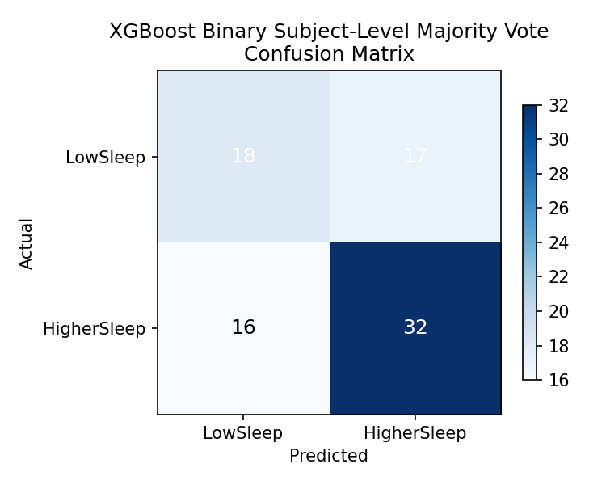
Figure 6. XGBoost binary subject-level confusion matrix. The model detects both LowSleep and HigherSleep subjects, but it does not outperform the earlier Random Forest majority-vote pipeline.
A concise thesis-style interpretation is: “XGBoost confirmed that the binary LowSleep versus HigherSleep problem is partially learnable from the stimulus-level EEG summaries, but it did not outperform the best earlier Random Forest model. This suggests that the remaining limitation is more likely the dataset and target definition than the absence of a stronger classical tabular algorithm.”

14. XGBoost Regression Follow-Up
A matching regression experiment was then run with XGBoost on the same stimulus-level median dataset. As in the earlier Random Forest regression, the model predicted one sleep-hours value for each held-out stimulus row and then aggregated those predictions back to one subject-level estimate by mean and median.
- Input file: enhanced_preparation/all_task_stimulus_median_ready.csv
- Rows: 2,830 subject-by-stimulus observations
- Subjects: 83
- Tasks: 36
- Features: 77
- Model: XGBRegressor
- Evaluation: leave-one-subject-out cross-validation
- Dummy baseline RMSE: 0.7805
- XGBoost mean-aggregation RMSE: 0.7621
- XGBoost mean-aggregation MAE: 0.6157
- XGBoost mean-aggregation R²: 0.0228
- XGBoost median-aggregation RMSE: 0.7669
- XGBoost median-aggregation MAE: 0.6197
- XGBoost median-aggregation R²: 0.0103
This result is slightly better than the earlier Random Forest stimulus-level regression, whose mean-aggregation result was RMSE 0.7678 and R² 0.0081. So XGBoost became the best exact-hours stimulus-level regressor tested so far, but only by a small margin. The most important point is that the subject-level R² value still stayed very close to zero, which means the model explained only a tiny fraction of the real sleep-hours variability.
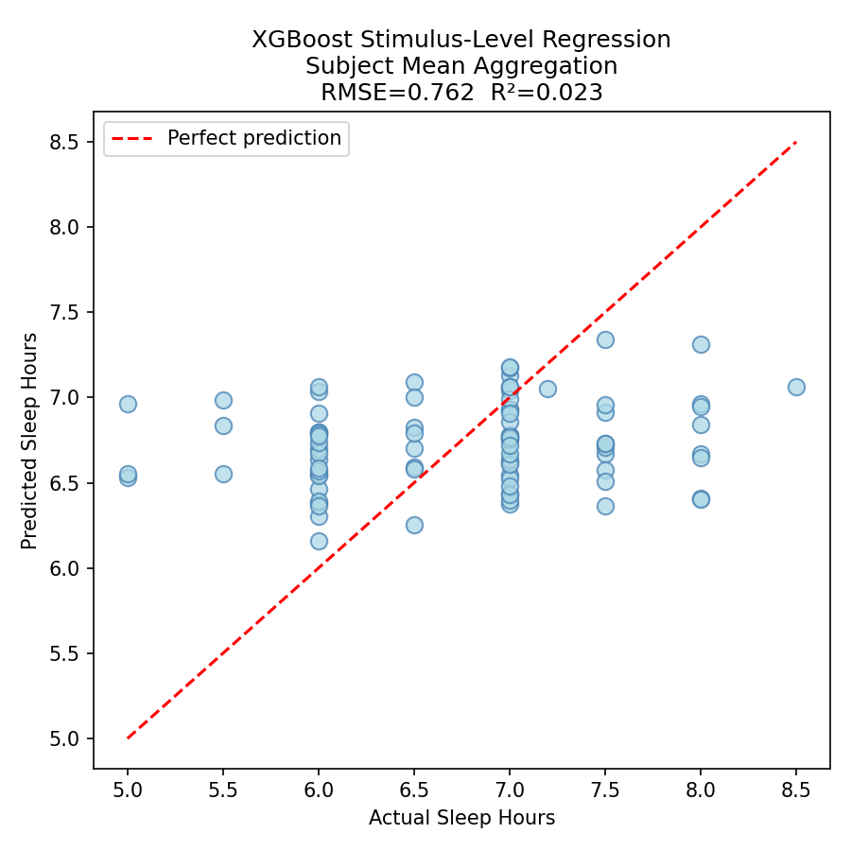
Figure 7. XGBoost stimulus-level regression with subject mean aggregation. The predictions remain compressed toward the middle of the sleep-hours range, which explains why the improvement over baseline is only marginal.
A concise thesis-style interpretation is: “XGBoost slightly improved the exact-hours regression compared with the earlier Random Forest result, but the improvement remained too small to support a practically useful subject-level sleep-duration predictor. The regression target therefore still appears to be weakly recoverable from the current EEG summary features.”

15. Updated Overall Comparison
Taken together, the new XGBoost follow-up strengthens the previous conclusion rather than overturning it. For binary classification, the earlier Random Forest stimulus-median majority-vote pipeline remains the strongest result. For regression, XGBoost is the best model tested so far on the stimulus-level median table, but only with a very small gain over Random Forest and still with R² close to zero. This makes the methodological message stronger: several strong classical algorithms were tested, and none produced a robust final predictor of exact sleep duration on the present dataset.

