Author Guidelines for DCASE 2026 Proceedings Manuscripts
First Author^{1,2}, Second Author¹, Third Author³, Fourth Author²
¹University 1, Somewhere, USA ²Industry Lab, Major Tech Hub, Asia
³University 2, Historic University Town, Europe

Abstract— In order to help authors prepare their manuscripts for submission to DCASE 2026, we compile a list of guidelines and put together two templates for users of both LATEX and Microsoft Word, which can be downloaded from the workshop website at [1]. These guidelines and templates are modified from those for ICASSP and past WASPAA workshops. The paper can be written using American or British spelling, provided the usage is consistent. As last year, the DCASE 2026 style file is based on IEEEtran.cls, and that there have been many changes to the formatting from previous editions. Please make sure to adhere to the new formatting style.
Index Terms— One, two, three, four, five

1. INTRODUCTION
The guidelines given below, including complete descriptions of the fonts, spacing, and related information for producing your proceedings manuscripts, are critical to produce the DCASE 2026 proceedings with a more uniform look and IEEE Xplore-compatible PDFs.

2. CONSIDERING USING LATEX
We strongly encourage everyone planning to use the Word template to consider using the LaTeX template instead. Using LaTeX will result in a much better-looking paper. Nowadays, using LaTeX is very simple on a website such as overleaf.com, which is free to use.

3. FORMATTING YOUR PAPER
All manuscripts must be submitted electronically as PDF files. All manuscripts must be formatted for white US letter paper (8.5 × 11 inches). Please do not use A4-size. All printed material, including text, illustrations, and charts, must be kept within a print area of 7.14 inches (181.35 mm) wide by 9.32 inches (236.85 mm) high. Do not write or print anything outside the print area. The top margin from the edge of the paper to the top of a capital T on the first line of text must be 0.75 inch (19.05 mm), except for the title page (see Section 7), the bottom margin must be 0.93 inch (23.62 mm), the left and right margin must be 0.68 inch (17.3 mm). All text must be in a two-column format. Columns are to be 3.487 inches (88.57 mm) wide, with a 0.166 inch (4.22 mm) space between them. Text must be fully justified.

4. NUMBER OF PAGES
You are allowed a total of 5 pages for your document. Up to 4 pages may contain technical content, figures, and references, while the 5th page may contain only references. This is the maximum number of pages that will be accepted, including all figures, tables, and references. Any document that exceeds the 5-page limit will be rejected. Any document with a 5th page containing anything other than references will be rejected.

5. PAGE TITLE SECTION
The paper title (on the first page) should begin 0.949 inches, or 24.10 mm, from the edge of the page if using 9pt font (0.984 inches, or 25.00 mm, if using 10pt font). It should be centered, in Title Case, and in Times 17-point if using 9pt font (in Times 20-point if using 10pt font), regular (non-bold) type. The authors’ name(s) and affiliation(s) appear below the title in capital and lowercase letters (i.e., with their customary capitalization). The authors' name(s) should be italicized, and the affiliation upright (non-italicized). Papers with multiple authors and affiliations may require two or more lines for this information.

6. TYPE-STYLE AND FONTS
To achieve the best rendering in the proceedings, we strongly encourage you to use Times Roman font. In addition, this will give the proceedings a more uniform look. Use a font that is no smaller than 9pt type for the body text. The abstract, figure captions, and tables should be in 8pt font.
In 9pt type font, capital letters are 2 mm high. If you use the 9pt size, the interline spacing should be 3.9 mm (0.153 inch), and there should thus be no more than 2.57 lines/cm (6.54 lines/inch) vertically. This is a minimum spacing. Larger type sizes require correspondingly larger vertical spacing. Please do not double-space your paper. True-Type 1 fonts are preferred.
The first paragraph in each section should not be indented, but all the following paragraphs within the section should be indented, as these paragraphs demonstrate.

7. MAJOR HEADINGS
Major headings, for example, “1. INTRODUCTION”, should appear in all capital letters, bold face, centered in the column, with one blank line before, and one blank line after. Use a period (“.”) after the heading number, not a colon. Sections can be referenced using Section 10, Section 10.1, and Section 10.1.1.

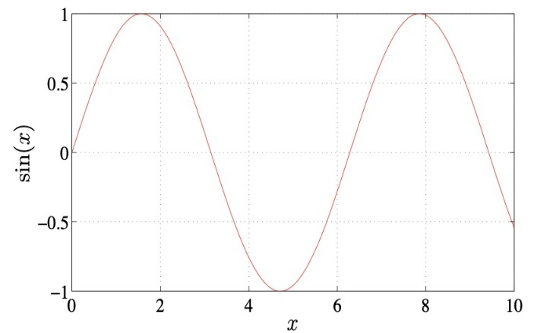
Fig. 1: Example of a figure with experimental results, where the caption is long and wraps on the next line.

7.1. Subheadings
Subheadings should appear in lower case (initial word capitalized) in boldface. They should start at the left margin on a separate line.

7.1.1. Sub-subheadings: Sub-subheadings, as in this paragraph, are discouraged. However, if you must use them, they should appear in lower case (initial word capitalized), indented on a separate line, with the paragraph text following on the same line. Sub-subheadings should be in italics.

8. PAGE NUMBERING, HEADER, AND FOOTER
Please do not paginate your paper. Page numbers, session numbers, and conference identification will be inserted when the paper is included in the proceedings. In addition, please do not change and remove the header and footer.

9. FIGURES
Illustrations must appear within the designated margins. They may span the two columns. If possible, position illustrations at the top of columns, rather than in the middle or at the bottom. Caption and number every illustration. All halftone illustrations must be clear black and white prints. Colors may be used, but they should be selected so as to be readable when printed on a black-only printer, or markers and line styles should be used to make figures readable without relying on colors.
An example of how to include images is presented in Fig. 1.

10. TABLES
Table captions should be placed above the table, as in Table 1. We highly encourage to properly format and align numbers in table columns.

11. EQUATIONS
Equations should be placed on separate lines and consecutively numbered with equation numbers in parentheses flush with the right margin, as illustrated in (1) that gives the homogeneous acoustic wave equation in Cartesian coordinates [3],
$$Δ^{2}p\left(x,t\right)-\frac{1}{c^{2}}\frac{∂^{2}p\left(x,t\right)}{∂t^{2}}=0,$$ | (1)
where p(x,t) is an infinitesimal variation of acoustic pressure from its equilibrium value at position $x∈R^{3}$and time $t$, and where c denotes the speed of sound.

Table 1: Some experimental results with SI-SNR in [dB] and WER in [%].
 | Dataset A |  | Dataset B
 | SI-SNR ↑ | WER↓ | SI-SNR ↑ | WER↓
No Processing | 0.0 | 98.76 | 0.0 | 87.65
Baseline | 3.2 | 54.32 | 4.3 | 43.21
Proposed | 12.3 | 10.98 | 23.4 | 1.23

Symbols in your equation should be defined before the equation appears or immediately following. Use (1), not Eq. (1) or equation (1), except at the beginning of a sentence: “Equation (1) is ...”

12. FOOTNOTES
Use footnotes sparingly and place them at the bottom of the column on the page on which they are referenced. Use Times 9-point type, single-spaced. To help your readers, avoid using footnotes altogether and include necessary peripheral observations in the text (within parentheses, if you prefer, as in this sentence).

13. REFERENCES
List and number all bibliographical references at the end of the paper. The references should be numbered in order of appearance in the document. When referring to them in the text, type the corresponding reference number in square brackets as shown at the end of this sentence [4], [5]. The References section should not be numbered.

14. ACKNOWLEDGMENTS
The preferred spelling of the word acknowledgment in the United States is without an “e” after the “g.” Try to avoid the stilted expression, “One of us (R. B. G.) thanks ...” Instead, try “R. B. G. thanks ...” Put sponsor acknowledgments in the unnumbered footnote on the first page. Please include acknowledgments only in the camera-ready version, and NOT in the version of the paper submitted for review.

REFERENCES
- DCASE Website, http://dcase.community/workshop2026/.
- IEEE Xplore Requirements, https://conferences.ieeeauthorcenter.ieee.org/write-your-paper/meet-ieee-xplore-requirements/
- E. Williams, Fourier Acoustics: Sound Radiation and Nearfield Acoustic Holography, London, UK: Academic Press, 1999.
- C. Jones, A. Smith, and E. Roberts, “A sample paper in conference proceedings,” in Proc. ICASSP, vol. II, Apr. 2003, pp. 803-806.
- A. Smith, C. Jones, and E. Roberts, “A sample paper in journals,” IEEE Trans. Signal Process., vol. 62, pp. 291-294, Jan. 2000.

or not at all!

