Application Letter
​Takudzwanashe Musere
0775 649 488
takudzwamusere@gmail.com

​4 June 2026
Dear Sir/Madam,

​Dear Hiring Manager,
RE: Application for the Service Desk Analyst (Grade C5) Position

I am writing to express my interest in the Service Desk Analyst position advertised by ZINARA. I recently completed a Bachelor of Science degree in Information Technology and am eager to apply my technical knowledge and skills in a professional environment.

During my industrial attachment, I gained practical experience in IT support, including network maintenance, troubleshooting hardware and software issues, user support and maintaining computer systems. This experience strengthened my problem-solving, communication, and customer service skills, which I believe are essential for a Service Desk Analyst role.

I am a hardworking, adaptable and enthusiastic individual with a strong passion for information technology. I am confident that my academic background and practical experience would enable me to contribute positively to your organization while continuing to develop my professional skills.

I have attached my curriculum vitae and supporting documents for your consideration. I would welcome the opportunity to discuss my application further and demonstrate how I can contribute to ZINARA.

Thank you for your time and consideration. I look forward to hearing from you.

Yours faithfully,

Takudzwanashe Musere

CURRICULUM VITAE FOR:

TAKUDZWANASHE MUSERE
Email: takudzwamusere@gmail.com Mobile: +263775649488 LinkedIn: linkedin.com/in/takudzwa-musere GitHub: github.com/takudzwanashemusere Address: Budiriro 1, Harare, Zimbabwe
Date of birth: 22 April 2002

EDUCATION

Chinhoyi University of Technology August 2022 – June 2025
Bachelor of Science (HONOURS) - Information Technology

Advanced Level January 2020 - November 2021
3 A' Level passes

Ordinary Level January 2016 - November 2019
11 O' Level passes including English Language and Mathematics

SKILLS SUMMARY

Software Development & Frameworks
- Flutter (Mobile & Cross-platform Development)
- React & React Native (Frontend Development)
- Java, Python, PHP – Backend & API Development
- FastAPI for high-performance Python APIs
- Mobile, Web, Desktop and Backend Development

Databases & DevOps Tools
- MongoDB – NoSQL data management
- Firebase – Real-time database and authentication
- MySQL, Microsoft SQL Server
- Git & GitHub – Version control and collaboration
- RESTful API design and integration
- Basic CI/CD tools and pipelines
- DHIS2 system support and data entry

Programming Languages & Certifications
- Languages: Dart (Flutter), Python, Java, PHP, JavaScript, HTML/CSS
- Machine Learning with Python – Model training and fine-tuning
- Scientific Computing with Python
- Legacy Responsive Web Design (JavaScript, HTML, CSS) – FreeCodeCamp Certificate
- AI/LLM integration in mobile and web applications

Professional & Soft Skills
- Strong analytical and problem-solving ability
- Excellent written and verbal communication
- Fast learner with proactive problem-solving mindset
- Strong teamwork and collaboration skills
- Technical documentation and user guide writing
- Attention to detail and structured thinking

WORK EXPERIENCE

Computer Science Assistant (All Souls High School) August 2025 - November 2026
- Taught Computer Science to O' Level and A' Level students, covering the ZIMSEC syllabus.
- Guided A' Level and O' Level students in designing and completing their final IT projects.
- Supported students in building system design, logic flow, and documentation skills.

IT Intern (Luisa Guidotti Hospital) August 2024 - June 2025
- Assisted hospital staff in resolving hardware and software issues, ensuring minimal downtime.
- Supported data entry of health records into the DHIS2 system and cleaned duplicate files.
- Facilitated technical support during system upgrades and installation of Starlink network using fibre optic cables.
- Monitoring Network security and upgrading firmware
- Developed new software during the attachment period and automated comprehensive user guides using PHP.
- Worked on mobile, web and backend development to address operational needs.

ACADEMIC PROJECTS
Projects on my Githhub account

ReelScholar – AI Mobile Application for Students at CUT
A microlearning mobile application built with Flutter and Laravel (PHP) to modernize student engagement at Chinhoyi University of Technology. The platform leverages AI to filter and deliver curriculum-aligned video content, replacing static learning with an interactive mobile-first experience. Features include hackathons, quizez , real time messaging for student engagement at a school level.

School Portal System
Developed a full-stack web portal for a secondary school allowing three user roles: Admin (Headmaster) to manage teachers and view performance metrics; Students to view results and apply for school places; and Staff to manage student data and upload term marks. Built for real-time operation and ease of use.

LICENSES AND CERTIFICATIONS
Certifcations on my Linkedinn account
Legacy Responsive Web Design Certificate (freeCodeCamp) Scientific Computing with Python Certificate (freeCodeCamp) Machine Learning with Python Certificate (freeCodeCamp)

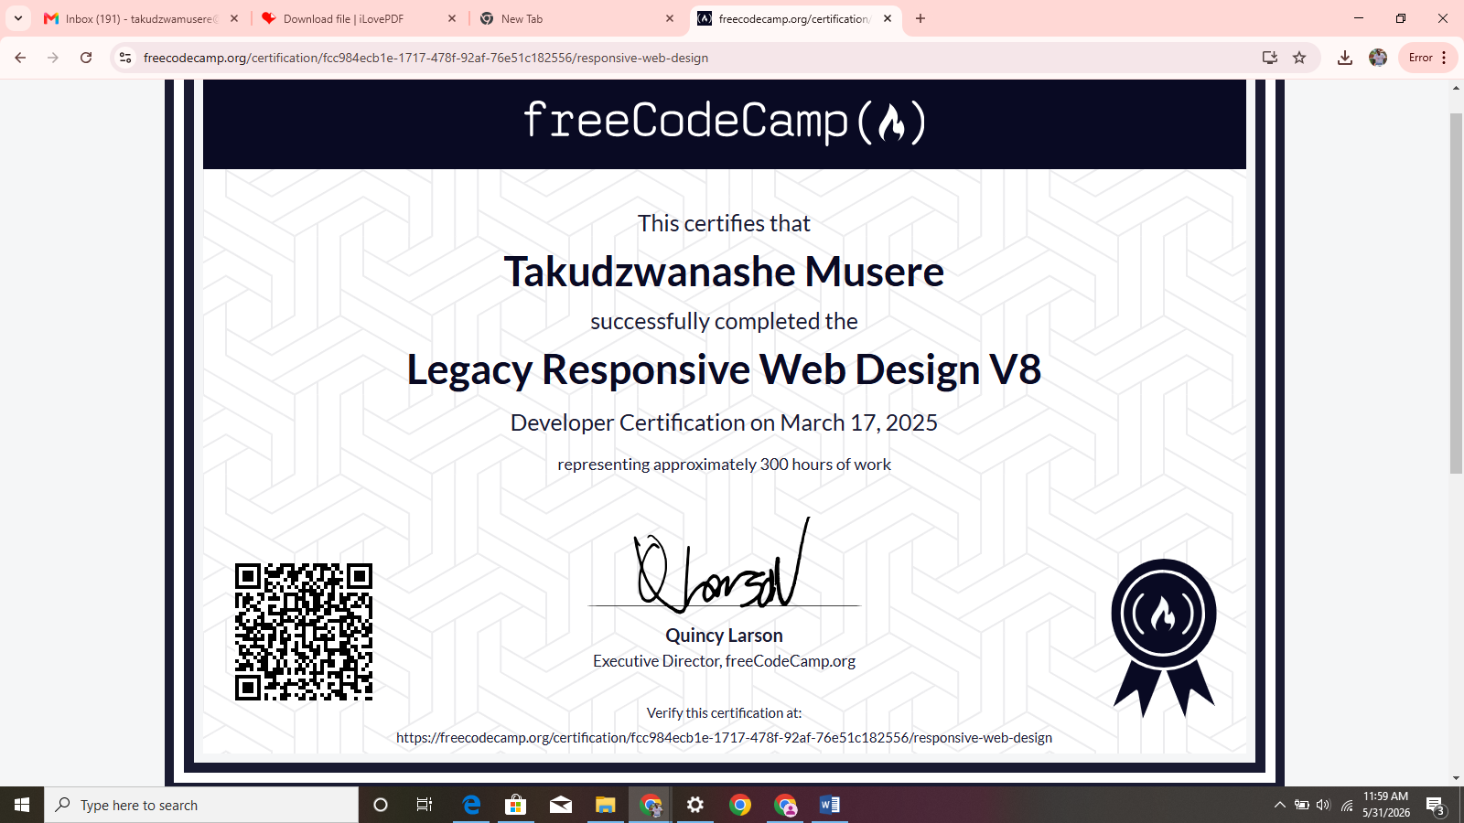

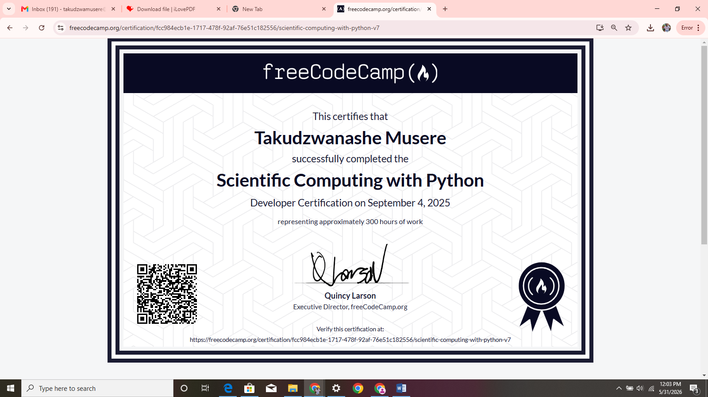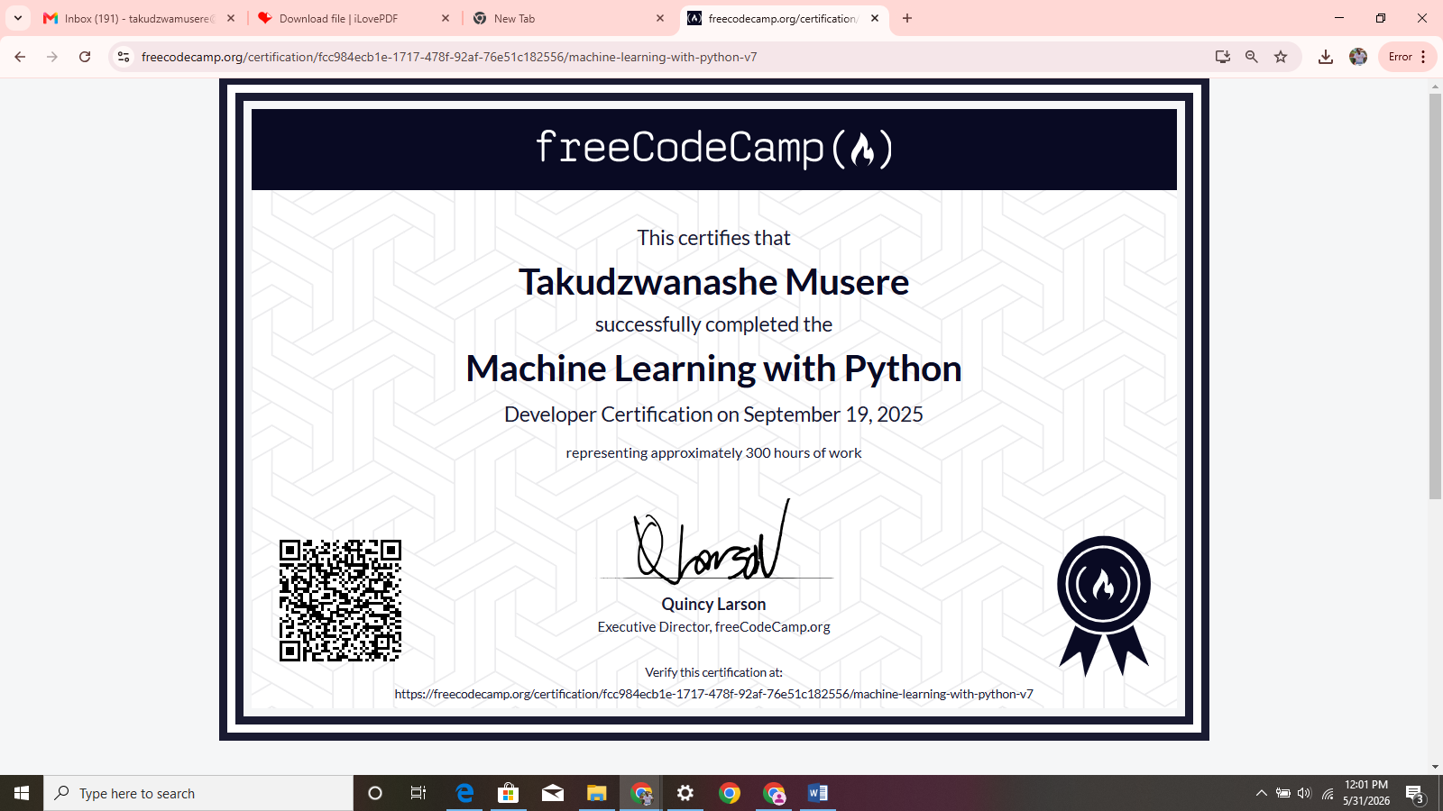

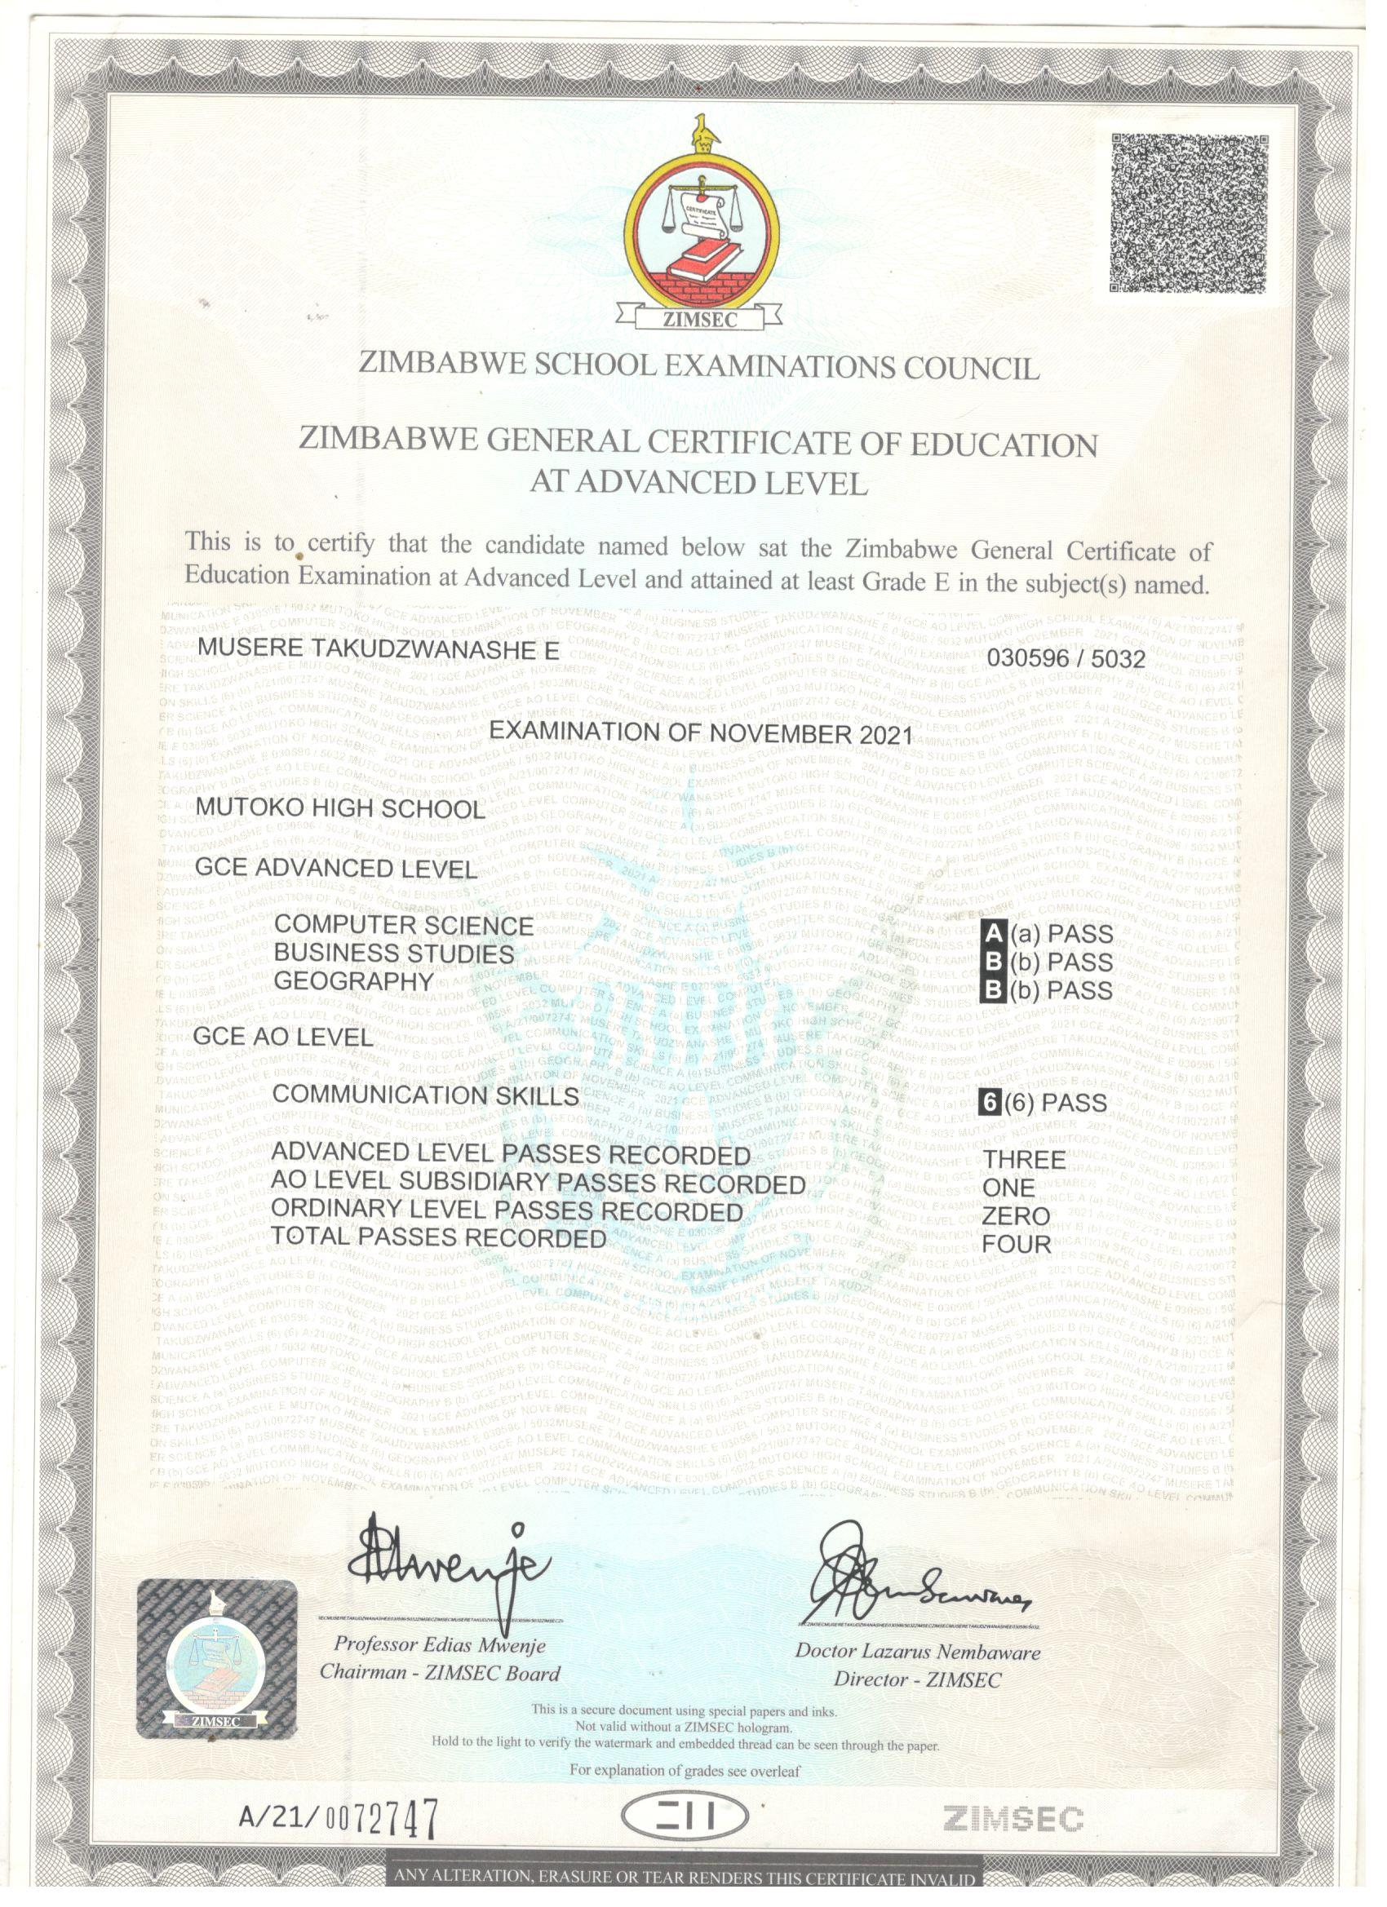

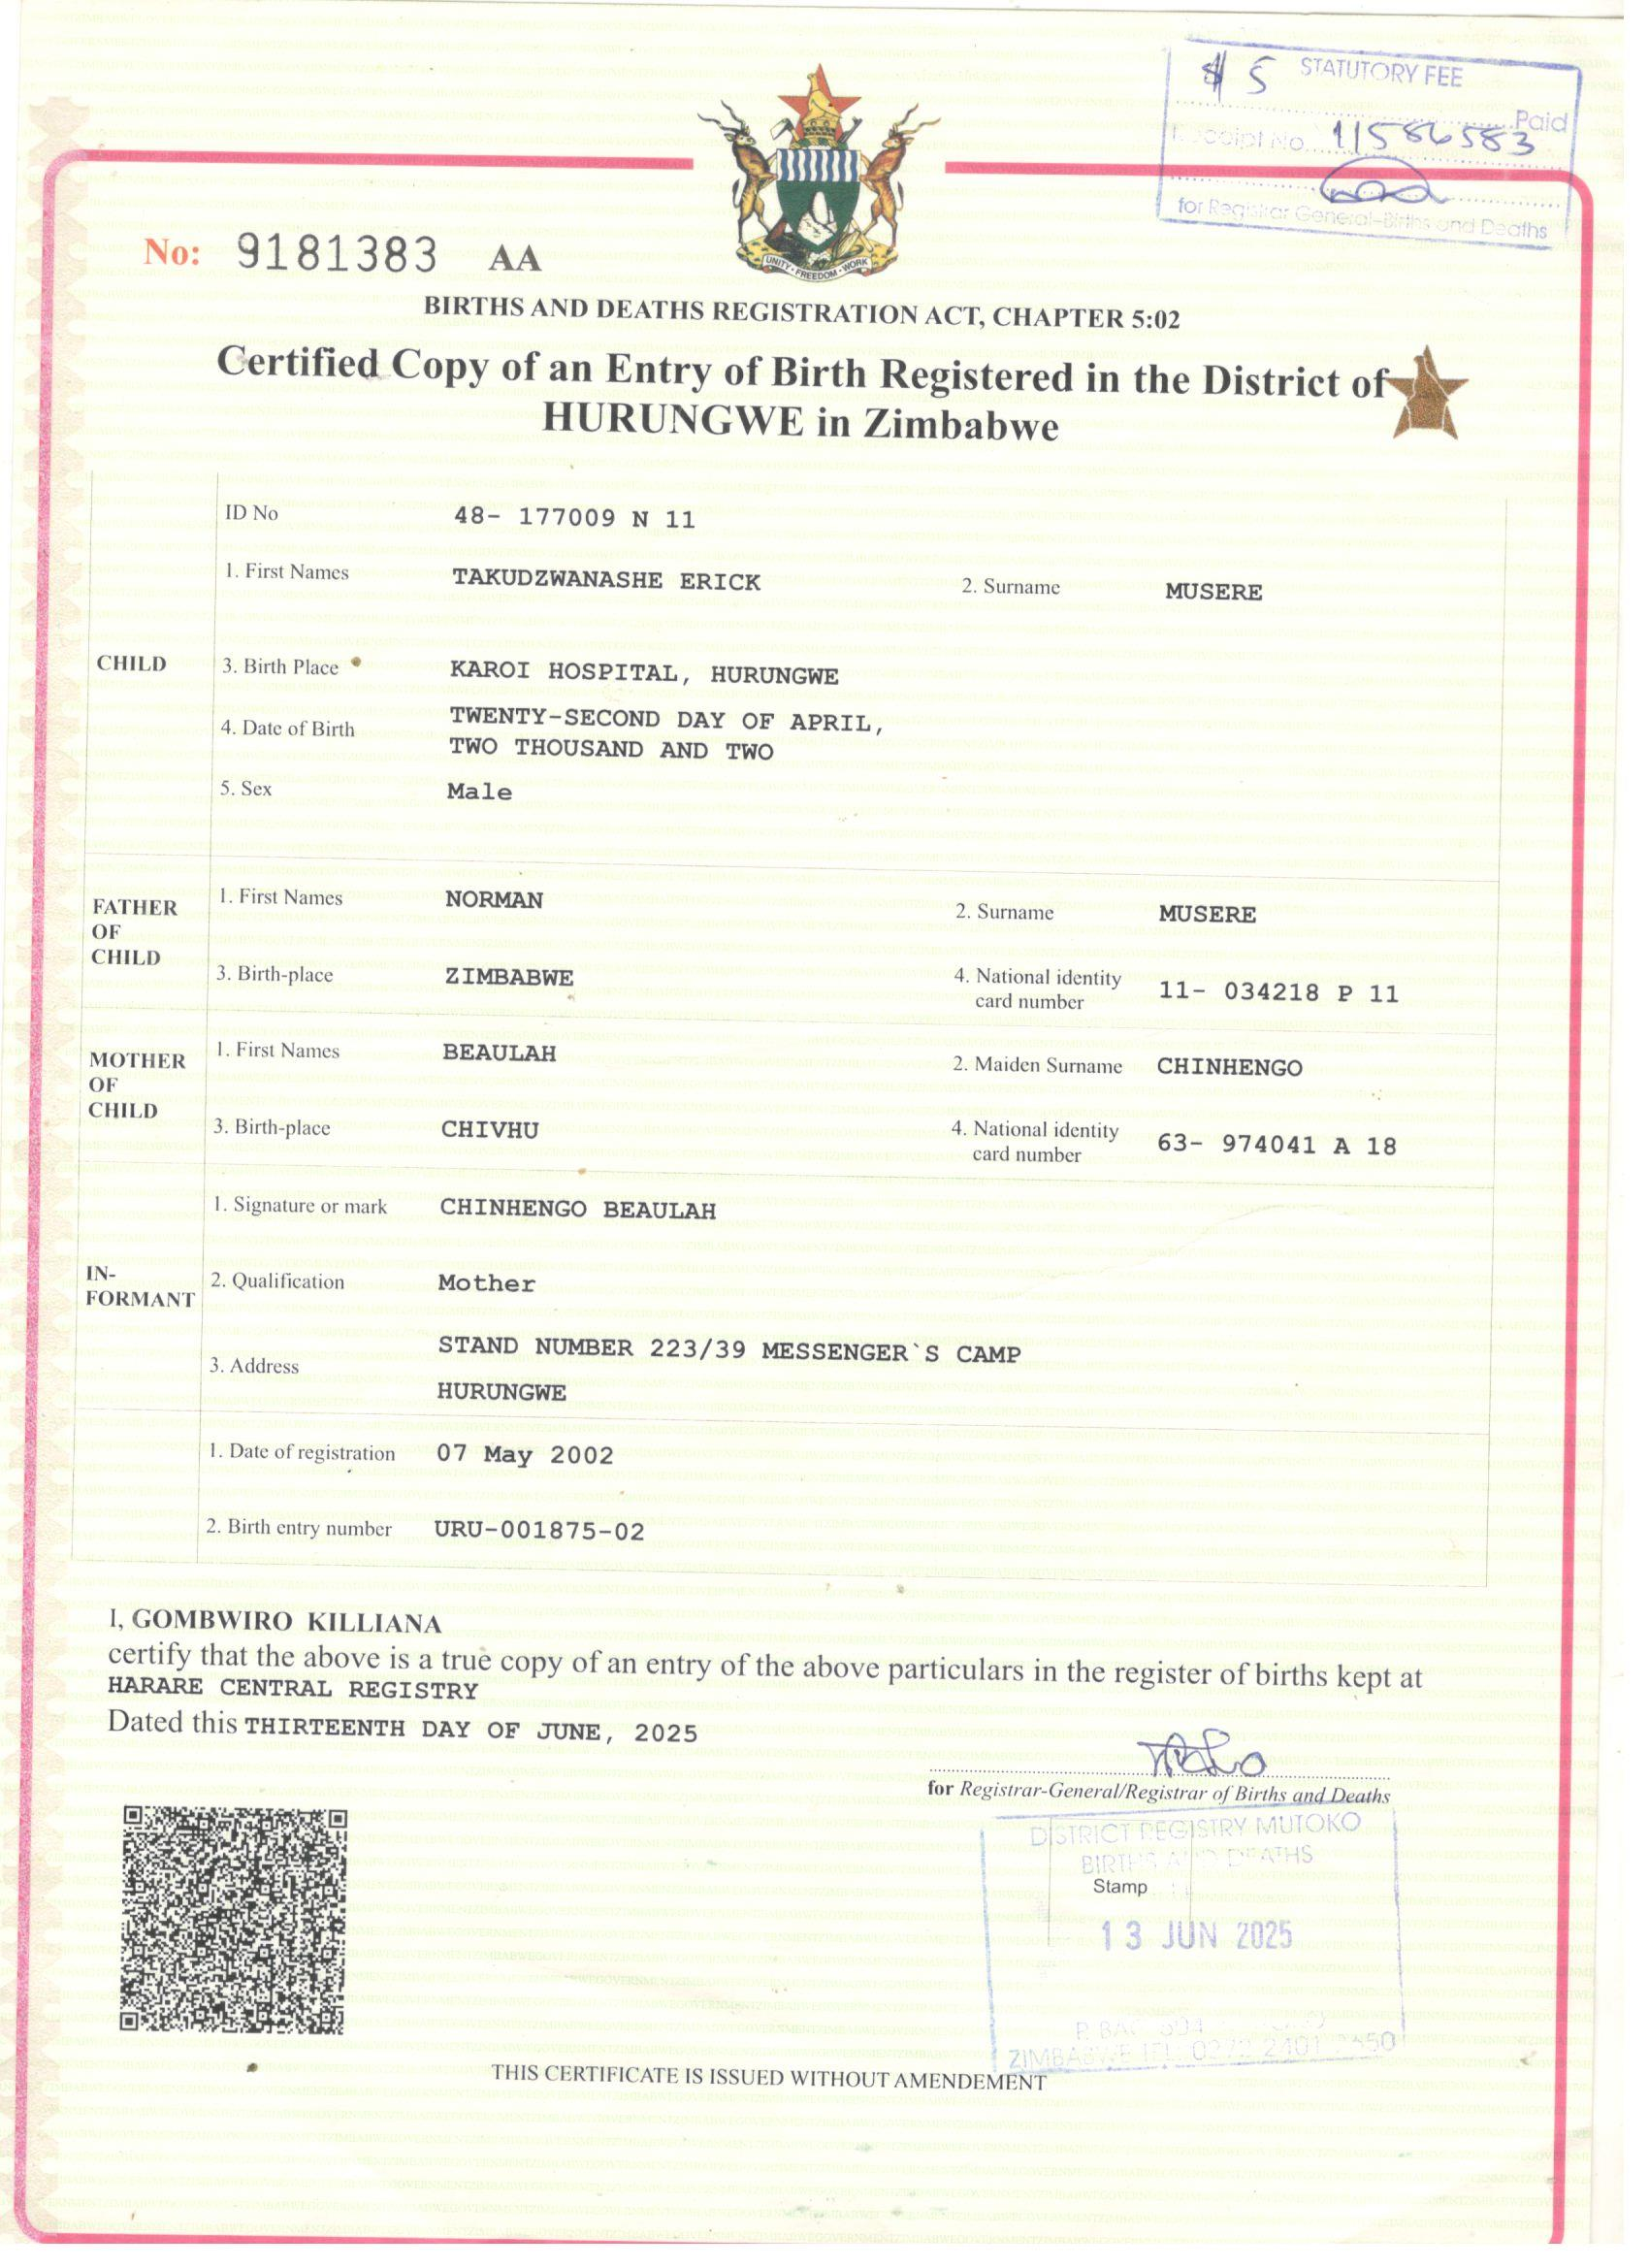

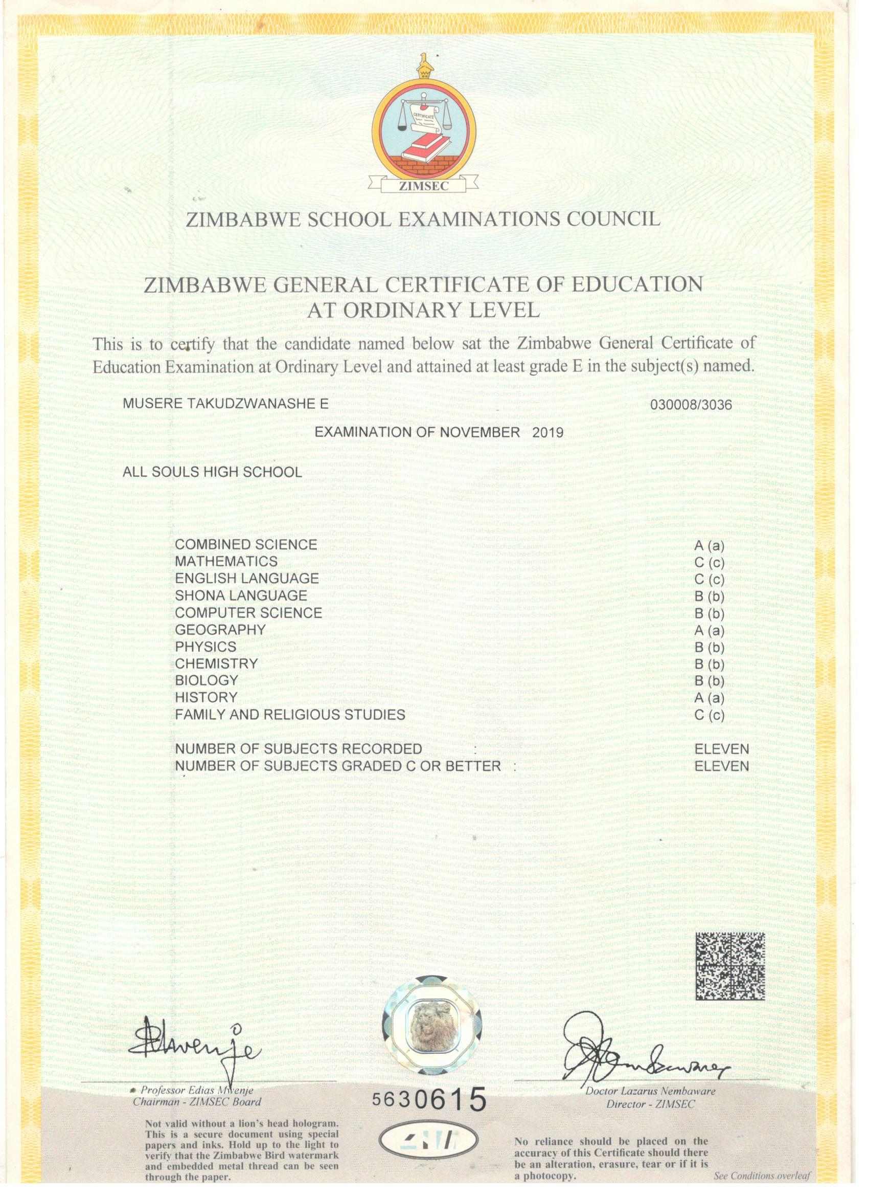

REFERENCES

Mr Matanga– Attachment Supervisor, Luisa Guidotti Hospital
++263 78 002 9895

Mr Shoko – Headmaster, All Souls Mission High School
+263 77 489 8103

