Photon OS Package Report
Generated: 2026-06-01

1. Package Health Timeline
Packages matching UrlHealth=200, UpdateAvailable with version, and correct UpdateDownloadName (name-version.tar.*), per branch over time.
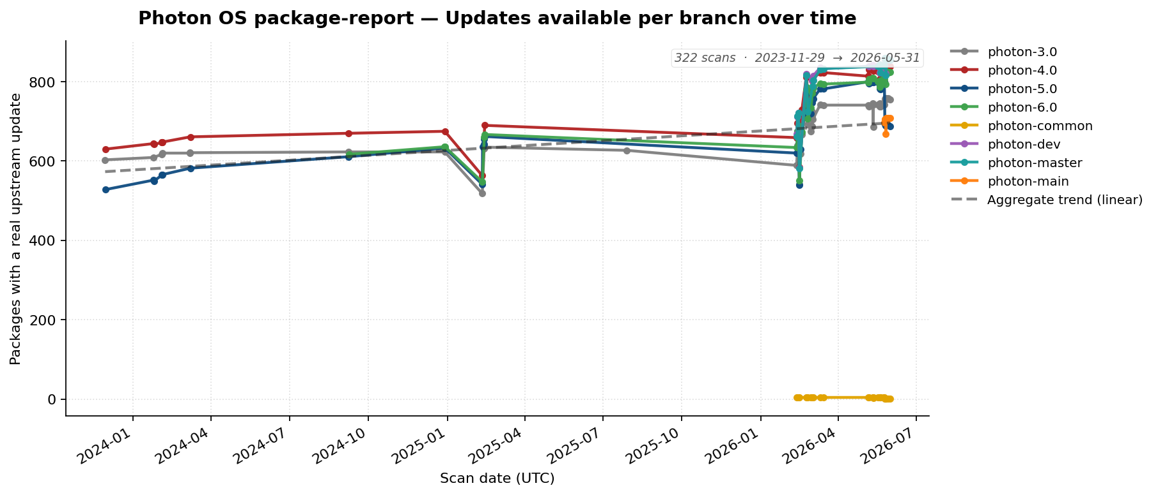

2. Top 10 Most-Changed Packages (all branches, 2023-current)
Package | 2023 | 2024 | 2025 | 2026 | Total | Branches
openjdk | 0 | 0 | 0 | 523 | 523 | 4.0,5.0,6.0,dev,main,master
linux | 0 | 15 | 4 | 355 | 374 | 3.0,4.0,5.0,6.0,common,dev,main,master
docker | 0 | 17 | 5 | 217 | 239 | 3.0,4.0,5.0,6.0,dev,main,master
vim | 0 | 22 | 10 | 195 | 227 | 3.0,4.0,5.0,6.0,dev,main,master
postgresql | 0 | 0 | 0 | 187 | 187 | 3.0,4.0,5.0,6.0,dev,main,master
python-botocore | 0 | 16 | 12 | 151 | 179 | 3.0,4.0,5.0,6.0,dev,main,master
python-boto3 | 0 | 16 | 12 | 151 | 179 | 3.0,4.0,5.0,6.0,dev,main,master
nodejs | 0 | 13 | 5 | 159 | 177 | 3.0,4.0,5.0,6.0,dev,main,master
containerd | 0 | 13 | 5 | 158 | 176 | 3.0,4.0,5.0,6.0,dev,main,master
apache-tomcat | 0 | 7 | 1 | 167 | 175 | 3.0,4.0,5.0,6.0,dev,main,master

3. Least-Changed Packages (all branches, 2023-current)
Packages with the same release version in every scan. Excludes VMware-internal and archived packages.
64 packages: PyPAM, abupdate, alternatives, apr-util, asciidoc3, autoconf213, backward-cpp, basic, blktrace, bluez-tools, build-essential, c-rest-engine, ca-certificates, calico-bgp-daemon, calico-bird, calico-confd, calico-libnetwork, cbindgen, cereal, cloud-utils, connect-proxy, copenapi, cppunit, crash-gcore-command, cyrus-sasl, dbxtool, dcerpc, dhcp, dhcpcd, distcc, distrib-compat, docker-pycreds, docker-vsock, duktape, dwz, erlang-sd_notify, erofs-utils, fakeroot, fcgi, finger, fipsify, flex, fmt, gnome-common, gperf, grub2-theme, hawkey, heapster, help2man, hwdata, initramfs, inotify-tools, iptraf, iptraf-ng, ipvsadm, isa-l, kube-controllers, lasso, libICE, libXinerama, libdb, libdnet, libecap, libestr

4. Source Category Drift
Distribution of packages by source URL domain for branch 5.0 (latest scan). Categories below 3% are merged into Other.

Category percentage drift over time for 5.0 branch.

