Photon OS Package Report
Generated: 2026-08-10

1. Package Health Timeline
Packages matching UrlHealth=200, UpdateAvailable with version, and correct UpdateDownloadName (name-version.tar.*), per branch over time.
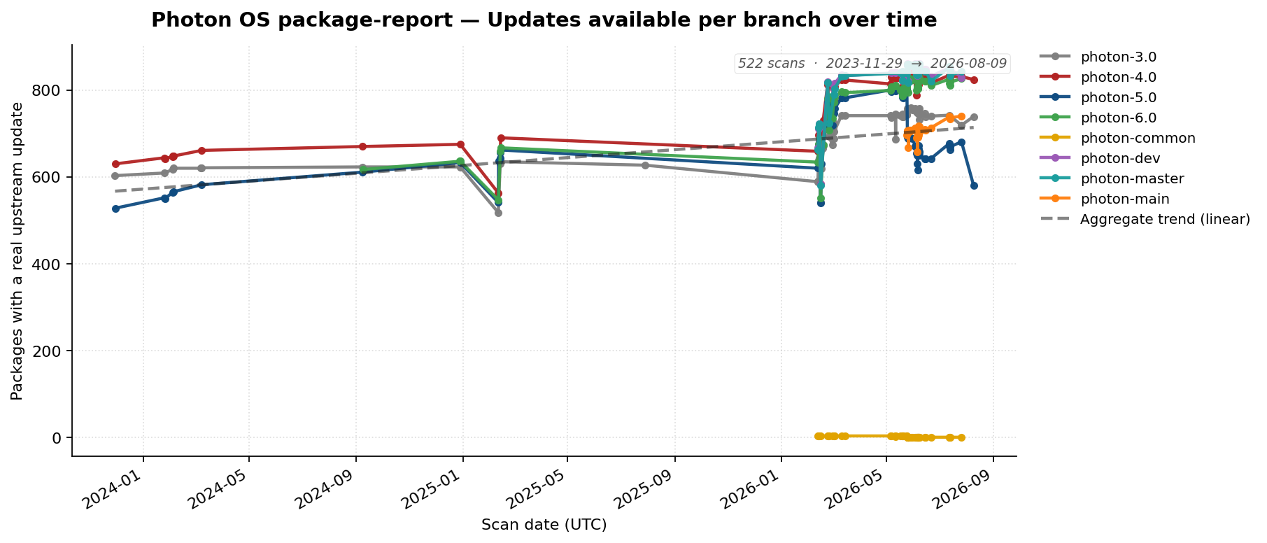

2. Top 10 Most-Changed Packages (all branches, 2023-current)
Package | 2023 | 2024 | 2025 | 2026 | Total | Branches
openjdk | 0 | 0 | 0 | 1043 | 1043 | 4.0,5.0,6.0,dev,main,master
linux | 0 | 15 | 4 | 654 | 673 | 3.0,4.0,5.0,6.0,common,dev,main,master
postgresql | 0 | 0 | 0 | 599 | 599 | 3.0,4.0,5.0,6.0,dev,main,master
docker | 0 | 17 | 5 | 386 | 408 | 3.0,4.0,5.0,6.0,dev,main,master
vim | 0 | 22 | 10 | 358 | 390 | 3.0,4.0,5.0,6.0,dev,main,master
nodejs | 0 | 13 | 5 | 322 | 340 | 3.0,4.0,5.0,6.0,dev,main,master
apache-tomcat | 0 | 7 | 1 | 321 | 329 | 3.0,4.0,5.0,6.0,dev,main,master
libselinux | 0 | 6 | 9 | 310 | 325 | 3.0,4.0,5.0,6.0,dev,main,master
openssl | 0 | 5 | 6 | 311 | 322 | 3.0,4.0,5.0,6.0,dev,main,master
python-botocore | 0 | 16 | 12 | 290 | 318 | 3.0,4.0,5.0,6.0,dev,main,master

3. Least-Changed Packages (all branches, 2023-current)
Packages with the same release version in every scan. Excludes VMware-internal and archived packages.
64 packages: PyPAM, abupdate, alternatives, asciidoc3, autoconf213, backward-cpp, basic, blktrace, bluez-tools, build-essential, c-rest-engine, ca-certificates, calico-bgp-daemon, calico-bird, calico-confd, cereal, connect-proxy, copenapi, cppunit, crash-gcore-command, cyrus-sasl, dbxtool, dcerpc, dhcp, distcc, distrib-compat, docker-pycreds, docker-vsock, duktape, erlang-sd_notify, fcgi, finger, fipsify, flex, gnome-common, gperf, grub2-theme, hawkey, heapster, help2man, initramfs, inotify-tools, iptraf, iptraf-ng, ipvsadm, kube-controllers, lasso, libICE, libXinerama, libdnet, libecap, libestr, libev, libgd, libgsystem, libgudev, liblognorm, libmd, libmnl, libndp, libnetfilter_cthelper, libnfnetlink, libnsl, libpwquality

4. Source Category Drift
Distribution of packages by source URL domain for branch 5.0 (latest scan). Categories below 3% are merged into Other.

Category percentage drift over time for 5.0 branch.

