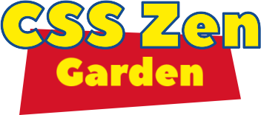

**1-The names of all members of the group**

Diego Scarpa

Som Ehone Helse =)

**2- A description of the theme you have chosen and ideas about how you will incorporate it into your design**

This year is the 25th anniversary of the Toy Story Movie. My intention is to use and show characters, colors, landscapes, fonts, colors of the film. I imagine that I will develop some animation related to the movie. I don't just want to put a Toy story background, I want to create an atmosphere inspired by the movie.

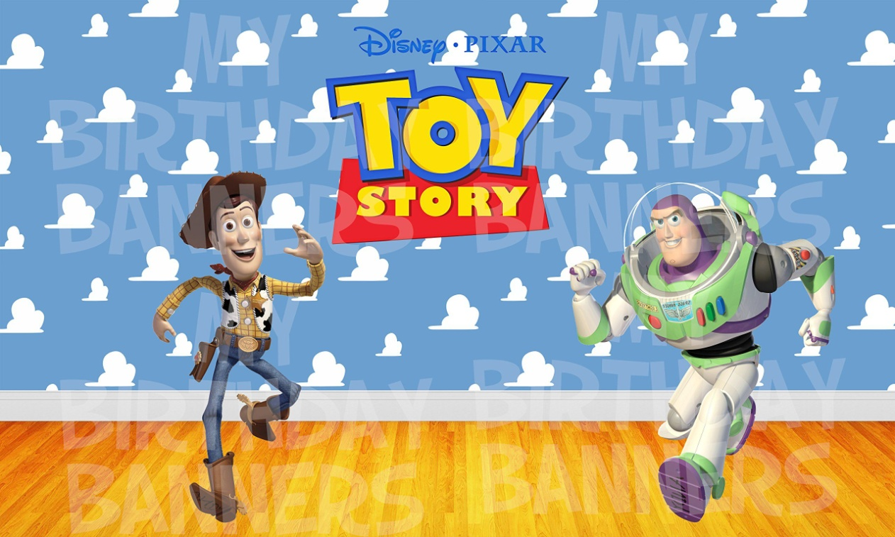



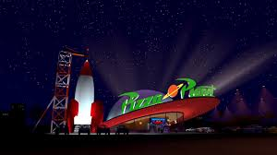

**Colors**

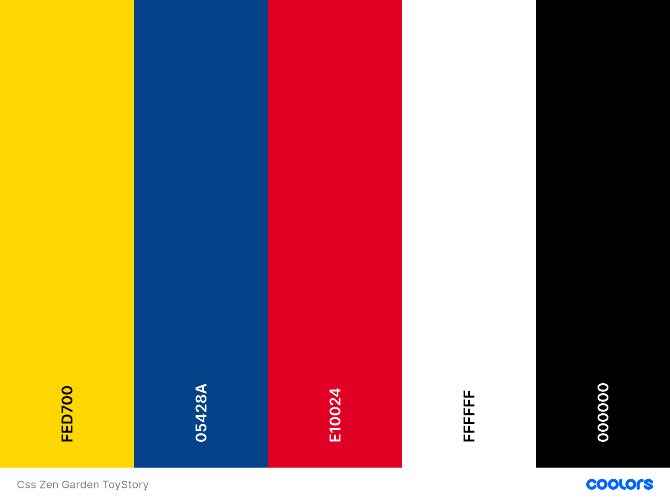

**3- and images of at least 2 wireframes.**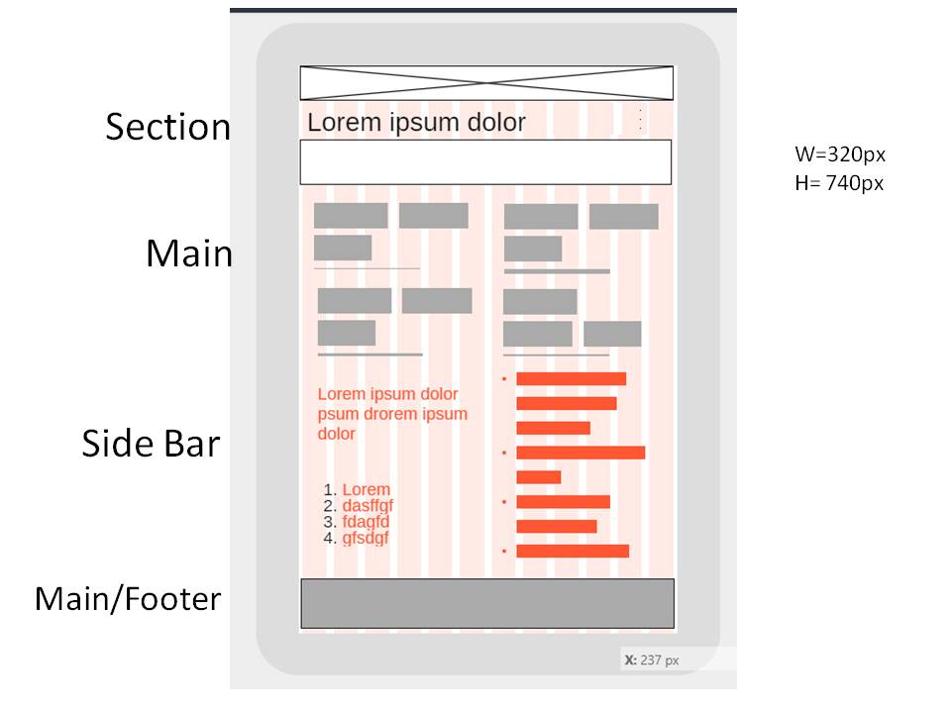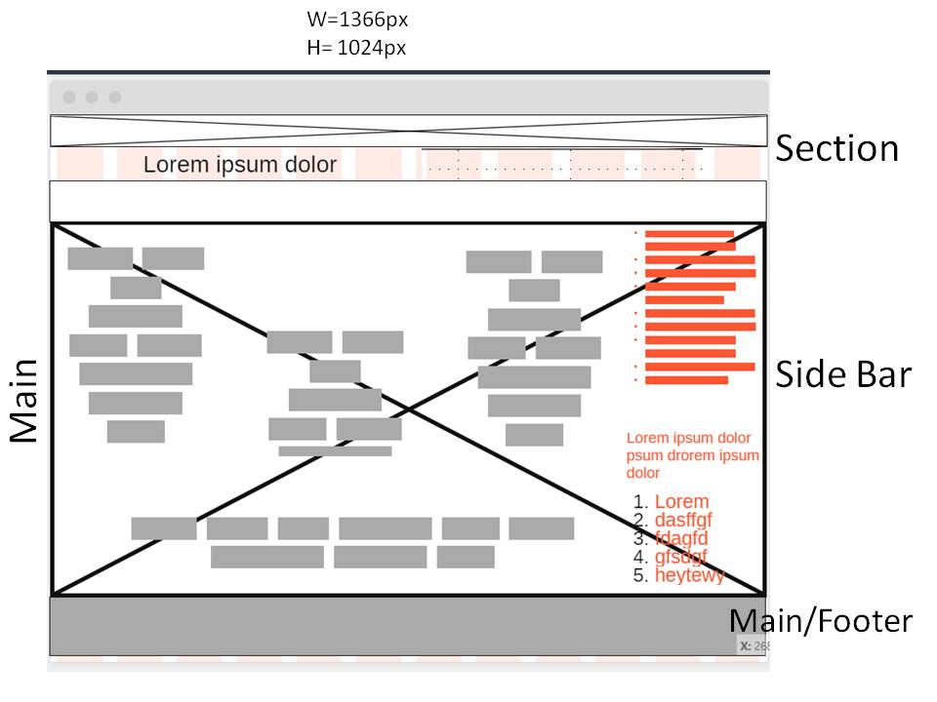

**All of the content from the Zen Garden**

**Body**

**Section Banner / Summary /preamble**

**Main Explanation / Participation/ Benefits / Requirement / Footer**

**SideBar Design Selection / Design Archives / Zen Resources**

**Font**

**RYE**

<link href="https://fonts.googleapis.com/css2?family=**Roboto**&family=**Rye**&display=swap" rel="stylesheet">

<style>  
@import url('https://fonts.googleapis.com/css2?family=**Roboto**&family=**Rye**&display=swap');  
</style>

font-family: 'Roboto', sans-serif;

1. font-family: 'Rye', cursive;

**Roboto**

<link href="https://fonts.googleapis.com/css2?family=**Roboto**&display=swap" rel="stylesheet">

<style>  
@import url('https://fonts.googleapis.com/css2?family=**Roboto**&display=swap');  
</style>

font-family: 'Roboto', sans-serif;