
Database Deployment Tool
.
.
.
.
.
.
..
.
.

.......

Technical Specifications
Information Technology Department
Table of Contents
Introduction 3
Tool Parameters 4
SQL Script Files 5
Naming Convention 5
SQL Script Files Harvest Process 5
SQL Statements Processing 7
Constant Declaration and Usage 8
PostgreSQL 10

Introduction
The Database Deployment Tool is a command line Java application that collects a series of SQL script files, located in a given directory and sub-directories, parses the SQL statements declared in these script files, orders them according to database object dependencies, and executes them against a specified relational database management system (RDBMS).
The tool accepts a simple list of arguments:
- rdbms: name of the relational database management system that the SQL scripts might be specific to;
- jdbc-driver: name of the Java class implementing the RDBMS driver;
- jdbc-url: URL specific to the RDBMS driver, which defines connection properties to the RDBMS;
- username: username of an account to connect to the RDBMS;
- password: password associated to the account;
- path: absolute path of the directory where the tool starts scanning recursively for SQL script files. This argument is optional. The default value is the working directory;
- maximum-attempt-count: maximal number of attempts to executes a given SQL statement that fails, before raising a fatal error. This argument is optional. The default value is 3.

SQL Script Files

Naming Convention
The current version of the Database Deployment Tool expects that a given SQL script file groups SQL statements responsible for creating or updating database objects of a same type, such as sequence, table, index, function, and so on. It does not embed any SQL grammar analyzer, and so it cannot determine the type of a database object a SQL statement creates or updates.
A given SQL script file might contain SQL statements responsible for creating or updating database objects for a particular domain, activity, or business logic, also called module. Therefore a SQL script file is expected to contain SQL statements that create or update database objects of a same type for a particular module.
The name of a SQL script file must respect the following naming convention:
create_module-name_object-type.sql
where:
- module-name refers to the name of a module for which the SQL script creates or updates database objects;
- object-type refers to the type of database objects this script creates or updates.

SQL Script Files Harvest Process
The Database Deployment Tool scans the directory specified by the optional command line argument path – or the working directory, if this argument is not provided – and every subdirectories recursively, searching for SQL script files respecting the naming convention described before.
The SQL scripts files are groups by the type of database object they are said to create or to update.
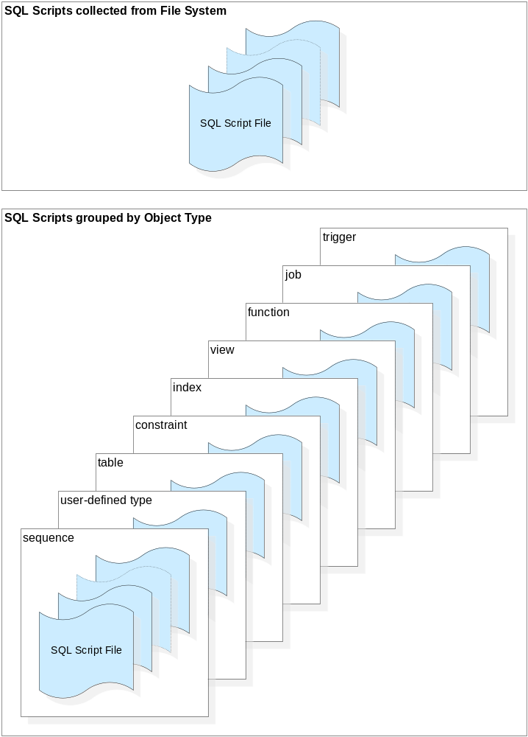
Figure 1 – SQL scripts collected and grouped by database object type

SQL Statements Processing

Constant Declaration and Usage
The Database Deployment Tool allows to declare literal constants in any SQL script file. Constants can be declared anywhere in a SQL script file. A constant is declared by the following expression:
--(defconstant +constant-name+ constant-value)
constant-name and constant-value correspond to alphabetical and numerical strings, which mustn’t include any space character; constant-name mustn’t include any + character.
/**
* Create chess game related stored functions.
*
* Copyright (C) 1998-2008 Majormode. All rights reserved.
*
* This software is the confidential and proprietary information of
* Majormode or one of its subsidiaries. You shall not disclose this
* confidential information and shall use it only in accordance with
* the terms of the license agreement or other applicable agreement
* you entered into with Majormode.
*
* MAJORMODE MAKES NO REPRESENTATIONS OR WARRANTIES ABOUT THE
* SUITABILITY OF THE SOFTWARE, EITHER EXPRESS OR IMPLIED, INCLUDING
* BUT NOT LIMITED TO THE IMPLIED WARRANTIES OF MERCHANTABILITY,
* FITNESS FOR A PARTICULAR PURPOSE, OR NON-INFRINGEMENT. MAJORMODE
* SHALL NOT BE LIABLE FOR ANY LOSSES OR DAMAGES SUFFERED BY LICENSEE
* AS A RESULT OF USING, MODIFYING OR DISTRIBUTING THIS SOFTWARE OR
* ITS DERIVATIVES.
*/

--(defconstant +western-chess-white-color+ 1)
--(defconstant +western-chess-black-color+ 0)

--(defconstant +western-chess-piece-none+ 0)
--(defconstant +western-chess-piece-bishop+ 1)
--(defconstant +western-chess-piece-king+ 2)
--(defconstant +western-chess-piece-knight+ 3)
--(defconstant +western-chess-piece-pawn+ 4)
--(defconstant +western-chess-piece-queen+ 5)
--(defconstant +western-chess-piece-rook+ 6)

/**
* Return the identification number of the chess piece, if any, of the
* given color that occupies the specified square, which would then
* occlude this square and avoid any other piece of the same color
* from moving to this specific square.
*
* @param p_match_id identification number of the match.
* @param p_square_index index of the square
* @param p_is_piece_white <code>true</code> to check whether there is
* a White piece that occupies the square, <code>false</code>
* to check whether there is a Black piece that occupies the
* square.
*
* @return the identification of the piece that occludes on the given
* square, if any, or <code>CHESS_PIECE_NONE</code> if there
* is is no piece on the given square or if there is a piece
* but of the opposite color on thi square.
*/
CREATE OR REPLACE FUNCTION get_western_chess_piece_id_occluding_on_square(
p_match_id IN bigint,
p_square_index IN smallint,
p_is_piece_white IN boolean)
RETURNS smallint
STABLE
AS $$
DECLARE
v_occluding_piece_id smallint;
BEGIN
v_occluding_piece_id =
get_western_chess_piece_id_on_square(p_match_id, p_square_index);
IF (v_occluding_piece_id <> +western-chess-piece-none+) AND
is_chess_piece_white_on_square(p_match_id,
p_square_index) = p_is_piece_white THEN
RETURN v_occluding_piece_id;
END IF;

RETURN +western-chess-piece-none+;
END;
$$ LANGUAGE PLPGSQL;
Code 1 – Example of constants declaration and usage
The Database Deployment Tool parses constant declarations from every SQL script files before executing any SQL statements defined in these scripts files. If a constant is defined more than once, the Database Deployment Tool checks whether the constant’s value stays the same; if so, the tool just warns the user, otherwise it raises an error and stops.
When executing an SQL statement, the Database Deployment Tool replaces in the SQL code constant names by their respective values.

PostgreSQL

