**Asdasd asdasdasdasd ASDASDASDASDASD ASDASD**

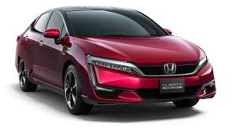

|  |  |  |  |  |
| --- | --- | --- | --- | --- |
| **sadasd** |  |  |  |  |
|  | **asdasd** |  |  |  |
|  |  | **12312312** |  |  |
|  |  |  | **sdfgsdf** | **sdfsdfsdf** |