HW 3

Dylan Campbell

1. Cloud computing and client-server computing are both a means to provide storage and processing power for a certain service that requires it. Though, cloud computing achieves all the performance of an in-house server, without actually having a physical server in the building. With that in mind, you can easily change how much storage and power you need flexibly, unlike the in-house server that you need to put the hardware together in advance.

2. There are a two kind of virtualization architectures. Bare-metal and hosted.
Bare-metal has the VMM, aka hypervisor, implemented on the hardware itself. This is different from Hosted where you must already have an OS installed on the hardware from which you install the hypervisor onto that.
Hosted architecture is useful for software development, OS support, and use on legacy systems. From there you can install multiple customizable virtual machines which can be used to be its own little sandboxed OS where you can easily destroy it and deploy it if needed without damaging the owner OS or hardware.
Bare-metal architecture has vm's installed just like the Hosted, but it better for providing real-time access or data processing.

3. There is currently no such thing as a purely distributed operating system at the moment. So we have to have individual OS's on machines communicate to one another. The role of the OS in a distributed system is to discern and organize the resources we are sharing/recieving. The issues that this gives us is synchronizaztion. We overcome it with message passing, like heartbeat.
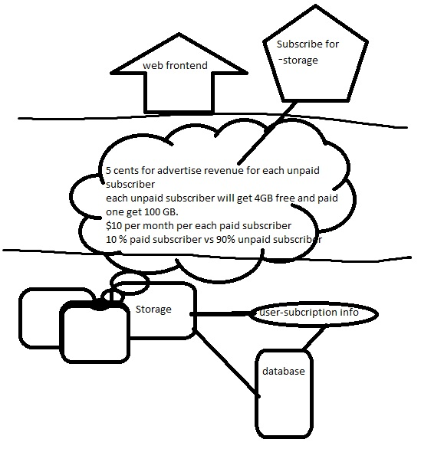
4.

