Dylan Campbell

Homework No.1
Due Date: Jan 12 2016
A late turn-in will not be accepted
1)List 5 system services/features and provide some examples (20%)
-kmode : used for managing Linux kernel modules
-acpid: designed to notify user-space programs of ACPI events.
-bluetooth: used to connect with bluetooth devices
-cups: Common Unix Print Server, used for printing
-sudo: program used to allow users to run programs with the priviledges of another user

2) Describe 2 ways to obtain system services. (10% each)
service –status-all (displays in CLI)
gnome-system-monitor (displays in GUI)

3) Write a command line that lists files in a current directory and if the output is
more than a page long as well as count how many files there are, it will
output a page at one time until you hit spacebar. (10%)
ls -R | more

4)Describe how Unix/Linux shell locates a given executable file when you don’t
specify full search path (10%)
It starts from wherever your $PATH is set and executes the first matching executable file it finds while searching down the path.

5) Describe how Unix/Linux shell command interpretation work (10%)
The command line usually takes the first token you input as an executable, any tokens after are passed as an argument to be run through the executable program. This can be altered by special characters, such as | . There are also specific commands that apply directly to the shell, such as cd.

6) Explain redirection in Linux and what are stdio, and stdout.. what different
between stdout and stderr (10%)
Stdio is standard input/output, which contains stdin, stdout, and stederr. The stdin refers to a stream of information that will be input into a file or program. Stdout refers to a stream of information that is output by a program. Stderr is a smarter stdio that will send errors to the cmdline instead of to the stream of info that is going to.

7) Start editor (vi or emacs), write number 1-30 hit return for each and save
them to a file “mynumber”. Then suspend the editor and show that it is
suspended or stopped but still active (in your job list). List the file. And
resume the editor. (you can either show screen capture or describe
commands). Check what is a process ID of editor and parent its process ID
(20%)

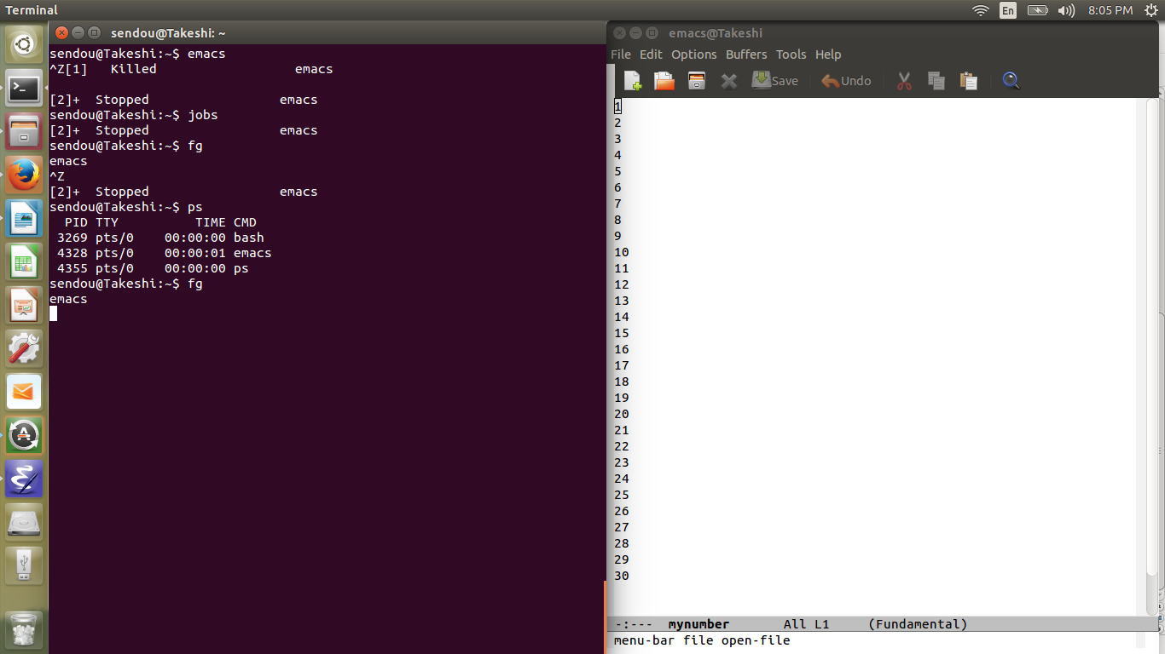
8) List your directory that contains mynumber file in a long format. Explain the
current file permission info. Change file permission mynumber so that your
group can read only (10%)

