AWS HW

Dylan Campbell

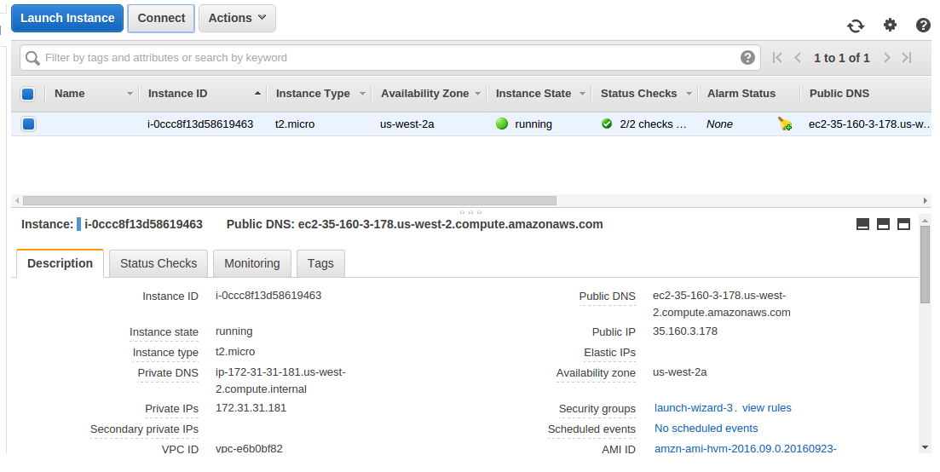
Launched an instance:

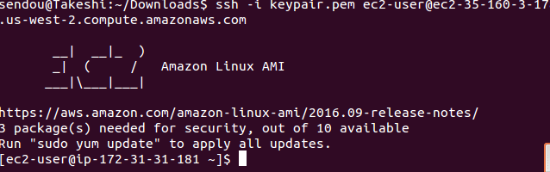
SSH Into Instance:

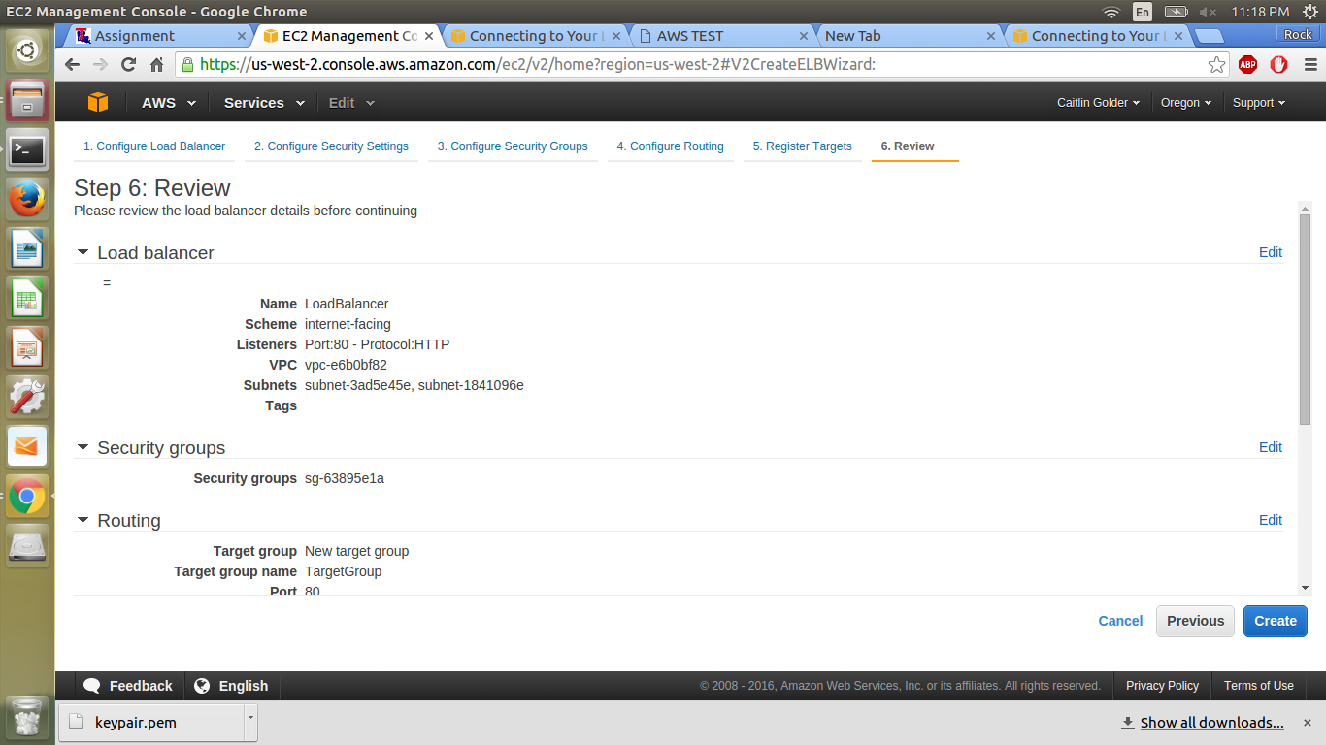
Create Load Balancer:

