Data Mining Report
by: Dylan Campbell

1-minute summary:
The level of income as a software developer is mostly dependent on the amount of time you have been programming.

5-minute summary:
Testing on many various prediction models, my best accuracy ended up being by the use of a decision tree model, cleaning, and discretization of income. I was able to deduce from this dataset that your level of income as a software developer is mostly dependent on the amount of time you have been programming.

FULL REPORT:
Looked around online for various datasets to use. I was having a hard time trying to figure out what would be a good dataset and what kind of discoveries I could even make. With my picky nature it took me a good bit to finally settle on a New York stocks dataset from Kaggle. I tried to do some testing on it, but I didnt really understand what I was seeing and most of the attributes were numbers. I decided I needed to find something else, since I wasnt about to doubley stress myself out. After looking again, I saw the 2016 New Coders Survey and was immediately inspired. I wanted to see if I could discover any sort of pattern to becoming a successful software developer without college. I wanted it to be very difficult to be successful without college so I would feel a little better about the money I have spent. The dataset was now chosen and the project proposal was coming up, so it was time to get to work.
I grabbed RapidMiner and was able to figure out the basics of it with the tutorial. Then first things first, I imported the data and did some initial readings on it. Tried to get a feel for what to expect as far as correlations are concerned. From my initial immpressions of the data, I could see a lot of dependent attributes, mainly due to these attributes being optional "follow up" questions. Noticed that I may need to do some binning on the income to get various levels of wealth, maybe to also judge the various levels of success. I also noticed that not everybody on the survey had a career in coding, some people just code for a hobby and have a different career. I was thinking I should not count their income unless they had a career in coding, otherwise it would skew my data. Selected only the attributes that I deemed would be useful. Filtered the rows to where I only got information for citizens who live in the United States. They could still be from a different country, but I want them to be employed in the US. I then decided to only gather the information of whether they do bootcamp/podcasts and not which specific ones they do. It seems like something I could delve into later, but for this project in this limited time, I thought just the basic knowledge would suffice.
I was having a lot of issues trying to bin my income from numerical into categorical. I want to split it into predetermined categories of success. Tried out the Correlation matrix and got a lot of values to look at with some obvious correlations, but I really needed to get my income binned. I then realized after many failed attempts messing with all the various discretization operators, that my issure started with my initial addition of the data to the repository. I just assumed that all of the attributes data types were correct by default, but it was setting a lot of them to polynomial since the csv used "NA" on the integer type fields, like income. I had to go through and change every integer attribute to actually be an integer so that the discretize functions will even recognize them. Managed to categorize the income based of 50k increments up to 200k. Nobody seemed to make more than 200k.
At this point I began testing the various predictive models. I split my data into an 80 training, 20 test using Performance(Classification) as my validator. I first tried out kNN to see how well we could predict the income level. It seemed like I was unable to make any sort of predictions towards anything higher than 100k. After viewing it, I was thinking I should add a specific level of success for people who made no income. I also needed to clear out the people who did not have a career in coding.
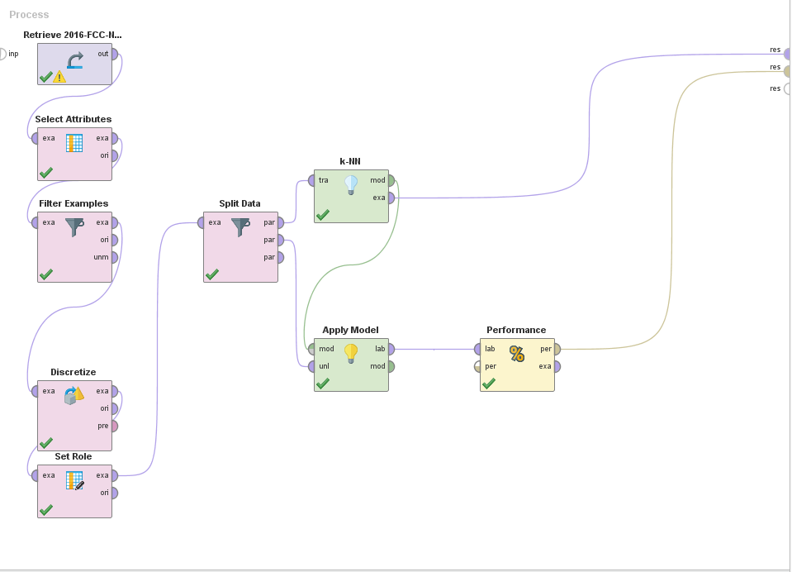
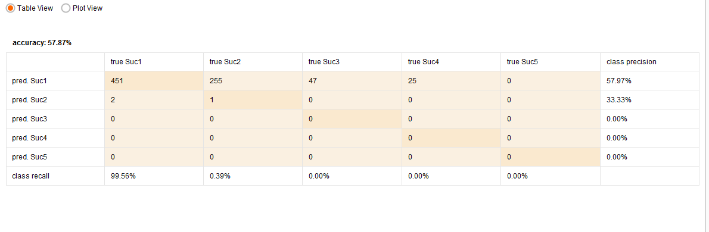
That run was using income as the class label, now just to see, I ran education level as the class label.
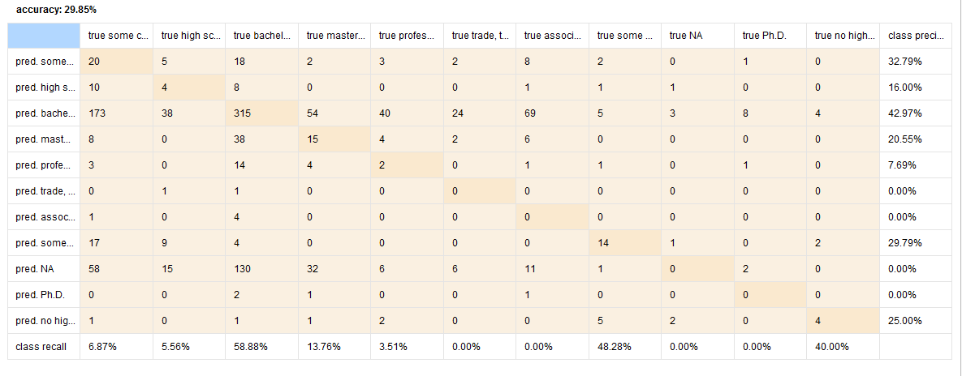
We seemed to be best at guessing bachelor's degree. I think that this was due to the sheer amount of bachelor degrees within the dataset. I realized at this point that I only had 5,010 examples to relate 96 attributes. Needed to reduce that dimensionality further. On a second glance, I noticed i had not taken care of all the missing values. So I ran kNN again after replacing the missing values with the averages and I got a better prediction.
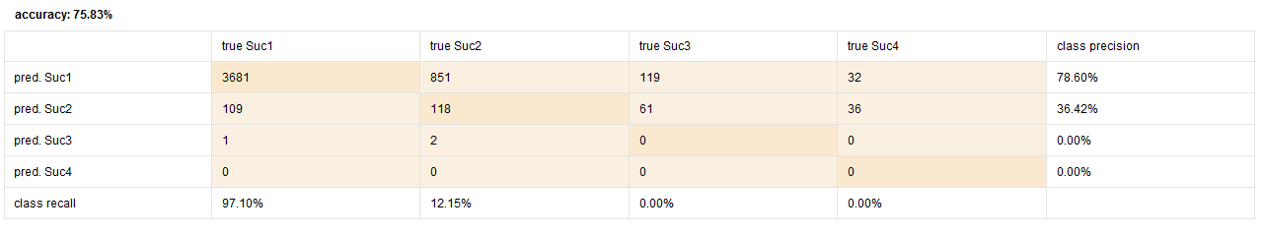
Percentage gain on education level as well.
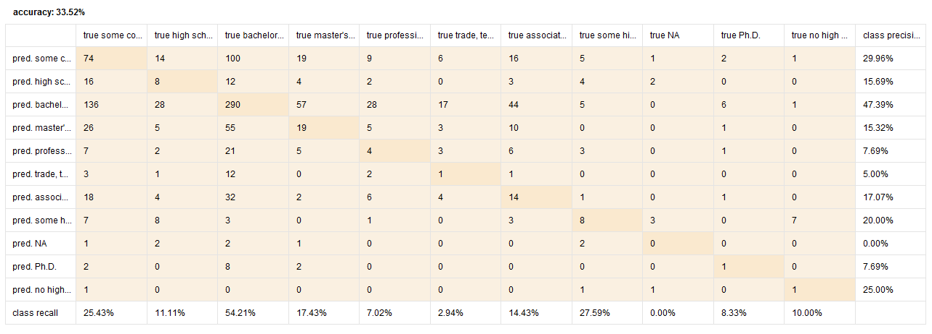
I was then trying to test using the decision tree model, but I seemed to be running into the issue where it is claiming that Income has missing values, even though I am ussing Replace Missing Values that would replace missing income with 0, but it was still running into errors.
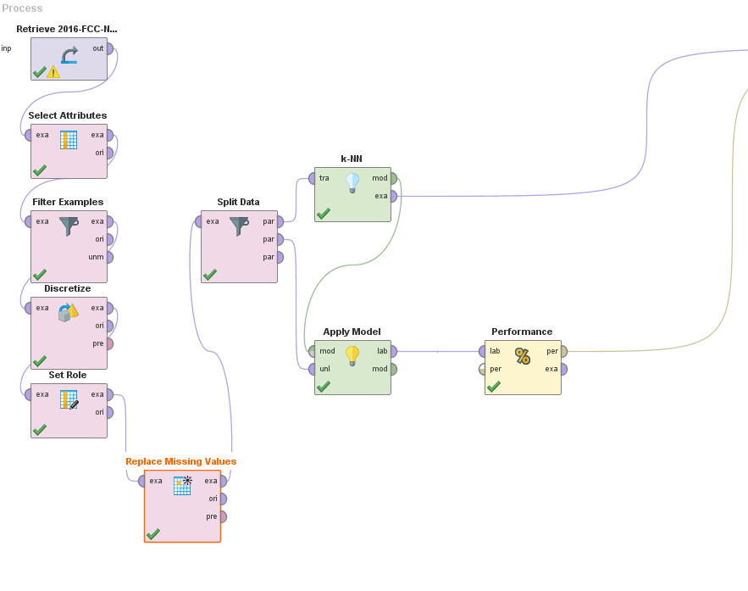
Changed course for a bit and tested out Naive Bayes.

It did not work as well as kNN. It gave back a lower accuracy.

I went back and tested out the decision tree again and discovered that I need to set role after I replace the missing values. It was causing issues the other way around.

After my first test on decision tree I managed to get a 75% accuracy!

From the classification matrix, I noticed that I was not predicting income from 150k to 200k. I also wanted to rid of Expected Earnings, as it seemed to be to obvious of a correlation.

Tested again, and now I see that people witha long commute time and who served in the military tend to be a Suc3, which is pretty successful.
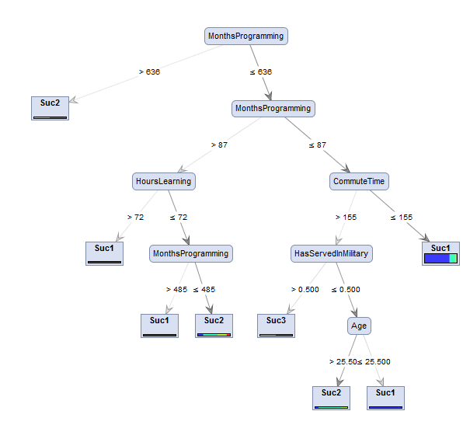
I then tested on purely the users who did not have a degree as well as being a software dev who did not leave their income "blank".

Accuracy was then at 66%, but I was still able to make some crazy connections using that decision tree.

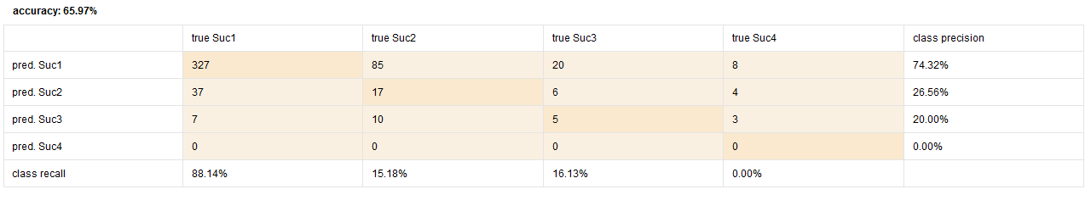
BIG MISTAKE!! I realized that I had the two port on my split data accidentally swapped, where I had been testing 80% of the data, whilst only using 20% to train..

I was getting a lot based on age, I then tried without age.
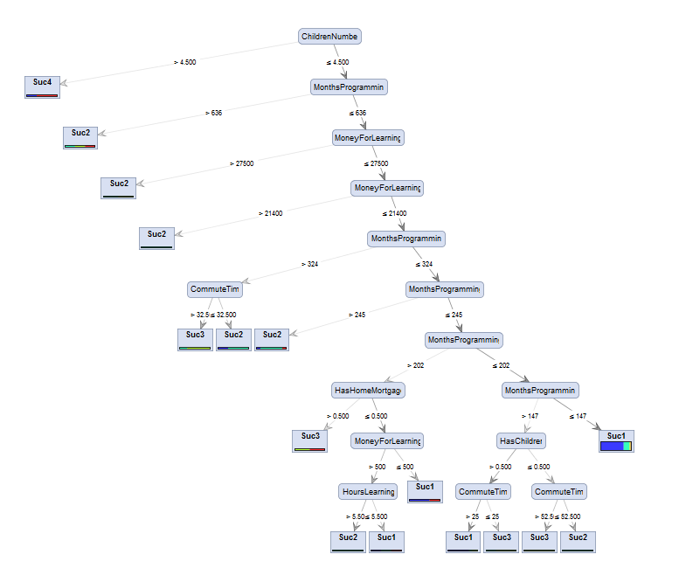
I could see that MonthsProgramming was playing heavily.
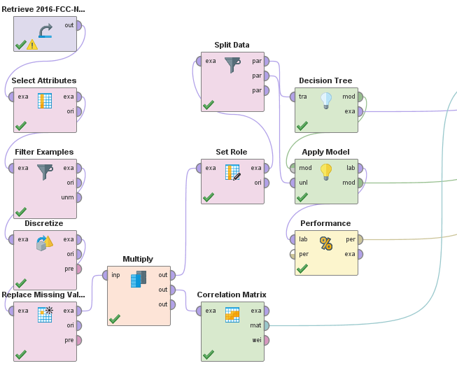

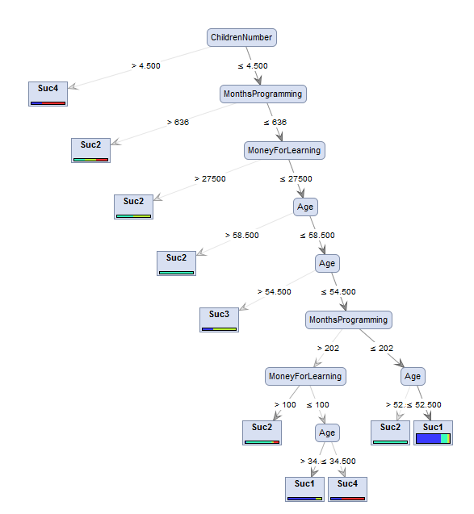
I then implemented a correlation matrix and noticed that MonthsProgramming had the greatest correlation to income(.356). With age at a close second with (.313).Financial Independents at (.194), may be that with more money come more people. Now I want to test with degrees included. Even with the addition of people who have college degrees, Months Programming still seems to be the strongest correlation to Income.(.328) Degree actually has a negative correlation (-.063) At this point, I think I am ready to start making some final inferences.
I then created my final presentation with my final thoughts.

