**Excel Challenge Report**

*Given the provided data, what are three conclusions we can draw about Kickstarter campaigns?*

1. Theater, music, and film & video have been the three most successful categories, where the number of successful campaigns is greater than the combined number of “live”, “canceled”, and “failed” campaigns. These three categories have over 300 kickstarts successful campaigns.

**Category statistics**

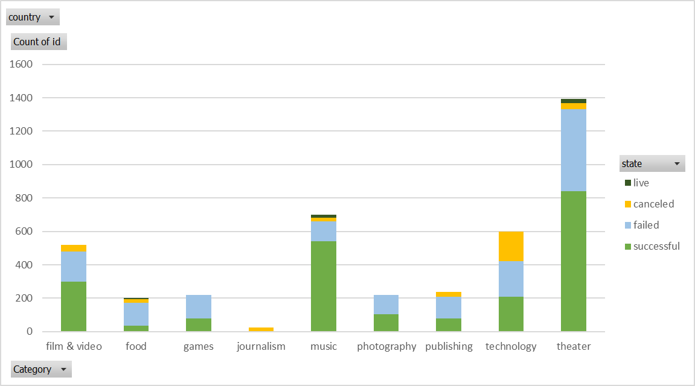

**Subcategory statistics**

1. “Plays” is a very popular subcategory with over a thousand Kickstarter campaigns. This subcategory has also been very succesful (65% success rate). However, the subcategories with a 100% success rate are “documentary”, “hardware”, and “rock”. These last three subcategories have 180, 140, and 260 succesful Kickstarter campains, respectively.

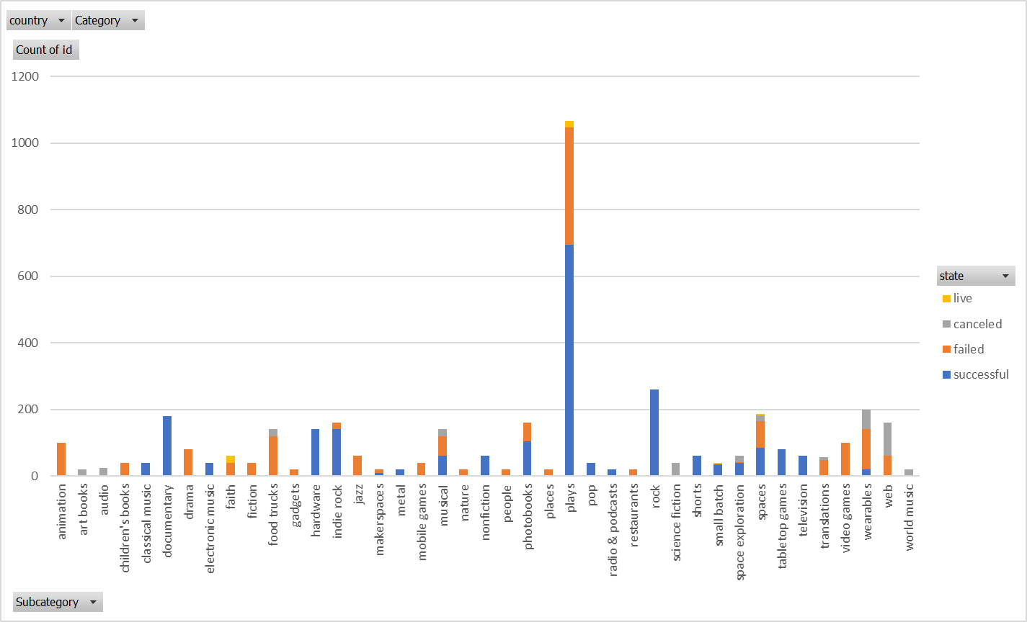

**Launch Date Outcomes**

1. Kickstarter projects launched in the month of May have a higher number of successful outcomes. However, projects launched after this month have a decreasing successful trend as the year progresses; the number of successful projects drops from 211 projects in June to 111 projects in December. Furthermore, projects launch in the month of December have higher chances of failing than succeeding.

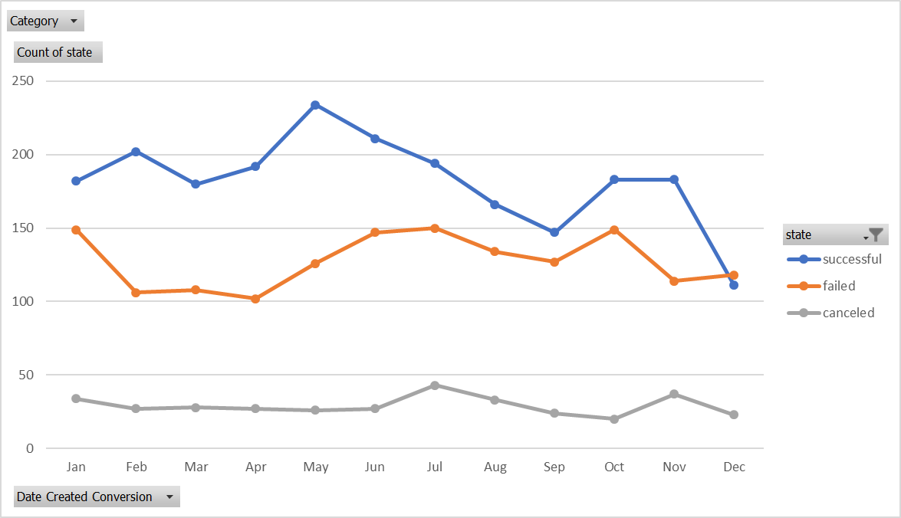

*What are some limitations of this dataset?*

* The dataset doesn’t provide other criteria that could make a Kickstarter successful. For example, the target audience, amount of research, innovation, etc. This type of information could provide relevant information that could uncover hidden trends for finding success.
* Data isn’t normalized, we have 13 currencies. If we want to analyze the goal, pledge, or average donation, we would have to standardize the currency.

*What are some other possible tables and/or graphs that we could create?*

* Graph to analyze the success by year and its relationship with the economy during that time.

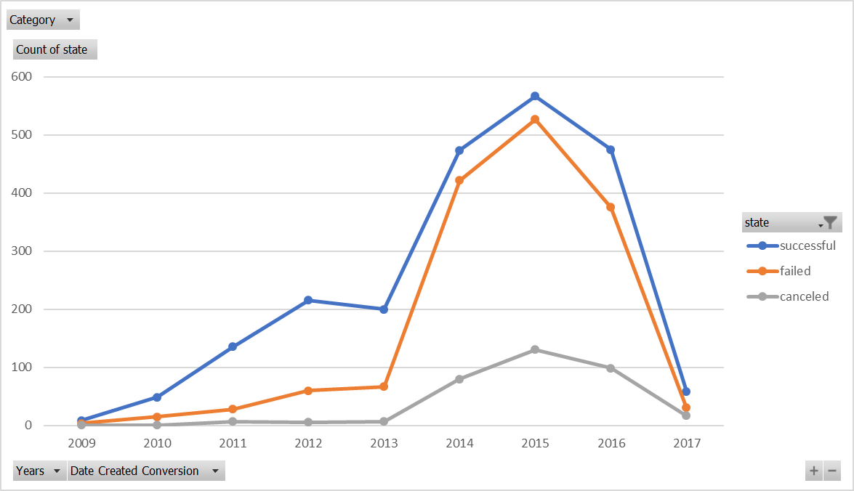

* Graph to analyze the theater category and subcategories by country. Plays are a popular Kickstarter in the US and United Kingdom (GB).

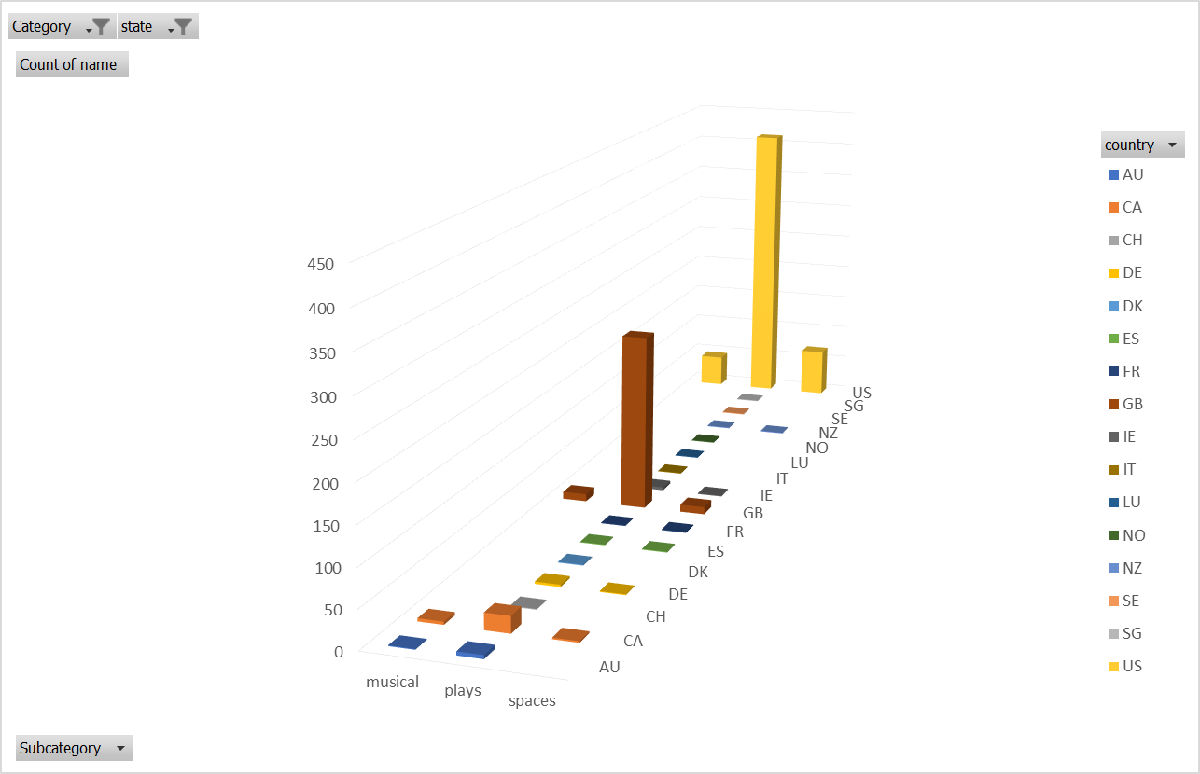

* Data distribution by Country

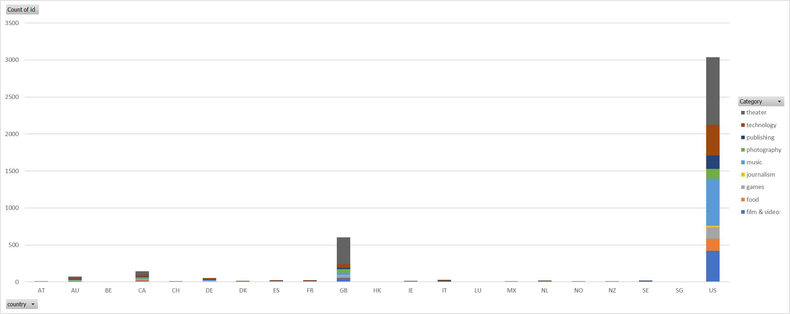

* Data table that summarizes the number of projects by country and state.



**Bonus**

