Payment details
To pay the registration fee for the DCCN-2026, please follow the RUDN offers website at https://offers.rudn.ru/ and enter DCCN in the search bar.
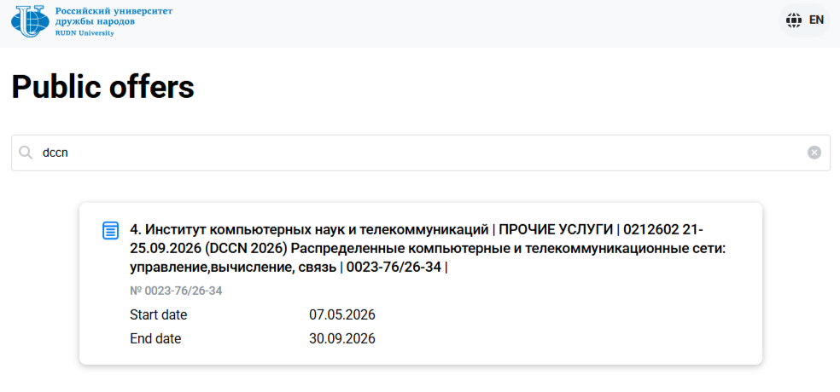
Participation in the DCCN-2026 requires acceptance of the public offer.
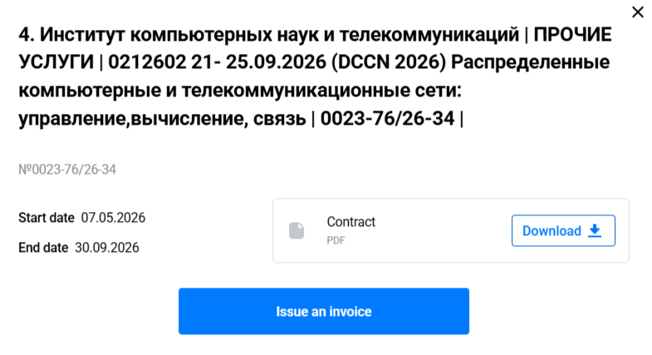
To access the offer, log in using the RUDN ID system — you can either use a corporate account in the RUDN domain or register with your personal email address.
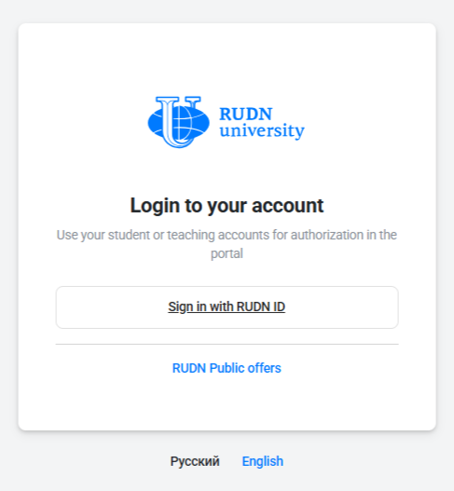
After logging in and confirming your agreement with the offer terms, an invoice will be sent to your email address.
Important: Please include your submission ID in the Uconfy system along with the payer's full name.
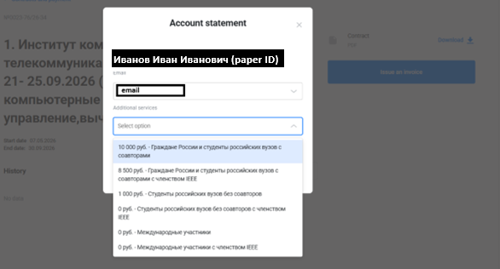
The registration fee can be paid by bank card via the link in the invoice or by QR code using your bank's mobile application.
After completing the payment, please send a confirmation of payment to the Organizing Committee org@dccn.ru, specifying the authors, the title of the paper, and its ID in the Uconfy system.
Important: when paying, please completely indicate the first name and the last name of the payer. Otherwise, we may not be able to identify the payer.

