The subject will be playing a game while they are shown notifications. Figure 1 shows the game they will be playing; a word counting game.

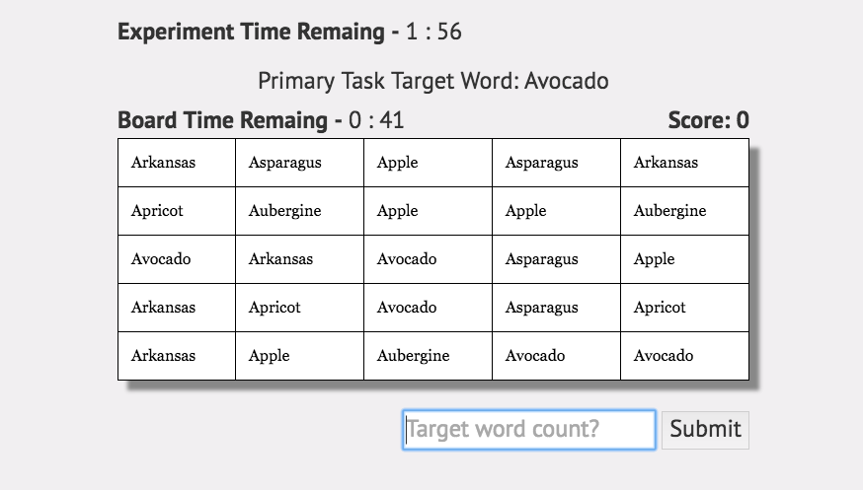

Figure 1. Word counting game. The user has to count how many times the word Avocado shows in the table, and submit it

The subject will then be shown multiple notifications, those notifications either relate to security or safety. We define Security Notifications to be notifications that relate to computer security, and Safety Notification to be notifications that relate to material and physical safety. The subject can respond however they please.

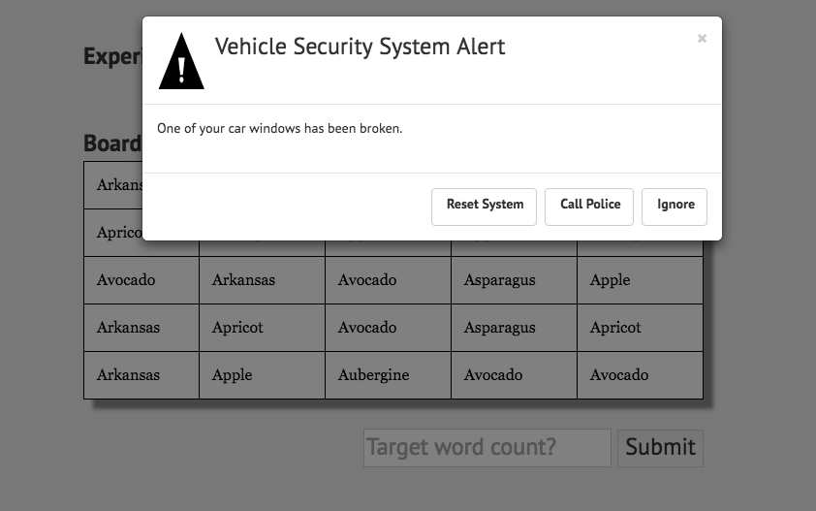

Figure 2. A Safety Notification

The subject will be shown multiple notifications, and asked which one they recall seeing.

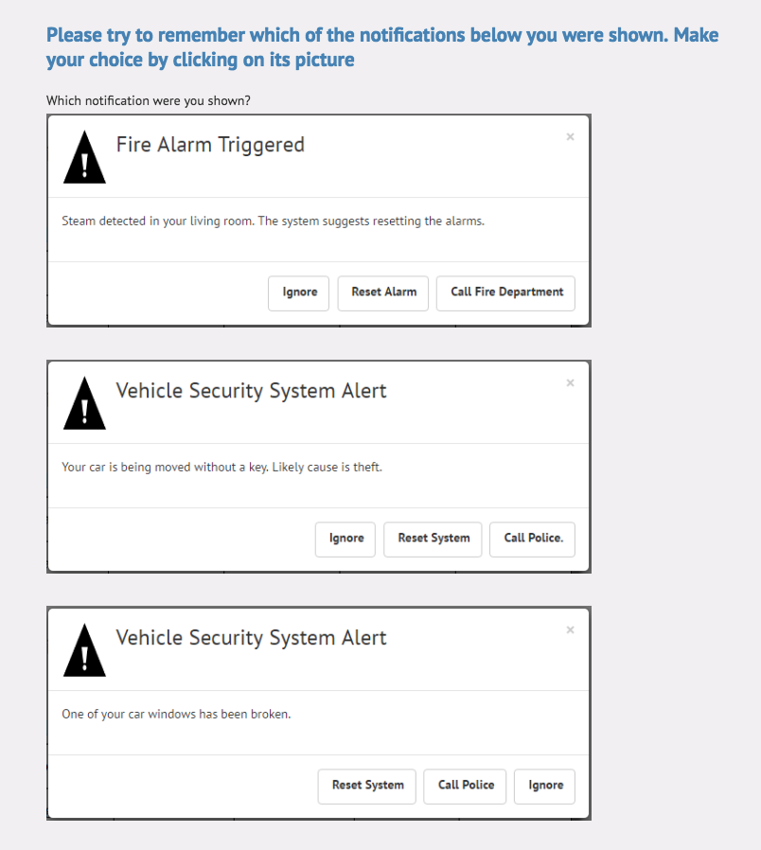

Figure 3. Recall survey

Finally the user will be asked basic demographics questions (Age, Gender, Country, and Highest Obtained Degree) to help us identify trends where people from different demographics respond differently to notifications.

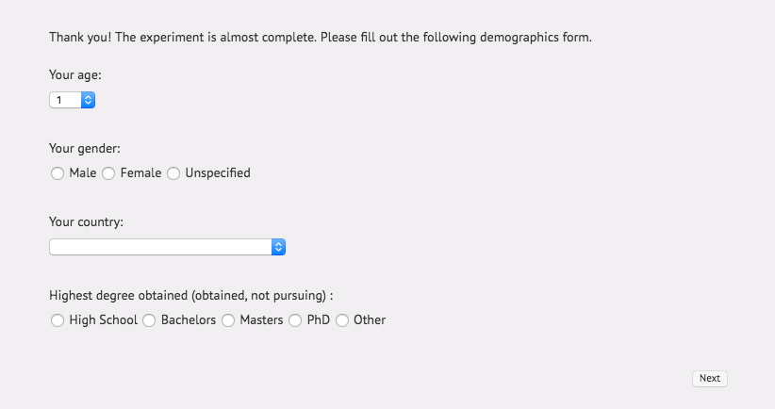

Figure 4. Demographics Survey