Derrick Du

Game Popularity

Intro to WebDev

24 October 2016

Website: <http://sites.bxmc.poly.edu/~derrickdu/midterm/index.html>

Github: <https://github.com/dcd310/HTML/tree/master/midterm>

**Project Goal**

I’ve always liked to play games ever since I was young but sometimes I get bored of the old ones and need newer games to play. In order to solve this dilemma, I created the game popularity website which lists the top 5 most popular games of three different genres: pc games, mmorpg games, and iphone games. By giving gamers who have run out of games to play new games, I hope to widen their library knowledge.

**Process**

The first step to completing this project is by researching the most popular games from each category. To do so, I looked at ranking charts from different sites, read player reviews, and compared statistics. Once I finalized the top five picks for each genre of gaming, I researched information about each game, including history, gameplay, and player base. Furthermore, I integrated links to easily access Twitch channels broadcasting each game as well as the games’ individual sites. Lastly, I selected my own personal favorites from each category and listed them on a separate page to share my own interest.

**Target Audience**

My website targets users between ages 8 and 25, both avid gamers and casuals alike. There are family-based games such as mobile application *The Game of Life* as well as R-rated games such as *Counter Strike: Global Offensive*. Because my site is organized and easy to navigate, younger users will have no problem accessing each page to explore different games. At the same time, the links are put in a manner so that users can avoid seeing graphic images or rated content if they are not of age by simply refraining from clicking links. The most important part is that users do not have to be familiar with gaming to use my website to explore different types of games.

**Competitive Analysis**

While there are many other game-reviewing sites, my website is different because of its user-friendliness. My website is organized very neatly and is easy to navigate; it also includes external links to each individual game, including Youtube trailer videos, Twitch channels, and download sites. In addition, my inclusion of my own favorites adds a unique, personal touch.

**Content**

The project is based off of one large css file that has content that is reused throughout the different html files.

The images are there to support and display an image to the text for the user to image what the games are like more easily. The videos are available for any user who is interested in the game and would like a preview/trailer to view after reading the overview.

**Technical Functionality**

My website is supported most browsers including:

* Firefox
* Chrome
* Safari
* IE

**Future Improvements**

For improvements, I would like to implement all game genres and have my top 5 lists always updated in order to stay with the ever-changing trends.

**Risks**

As of now, with user testing, the only error provided is that videos do not scale in percentage with height. This causes the video preview to look too skinny compared to its width.

**Site Map**

Every single webpage can access each other.

Home

Derrick’s Choices

PC Games

MMORPG Games

iPhone Games

About

**Wireframe**

**Home**

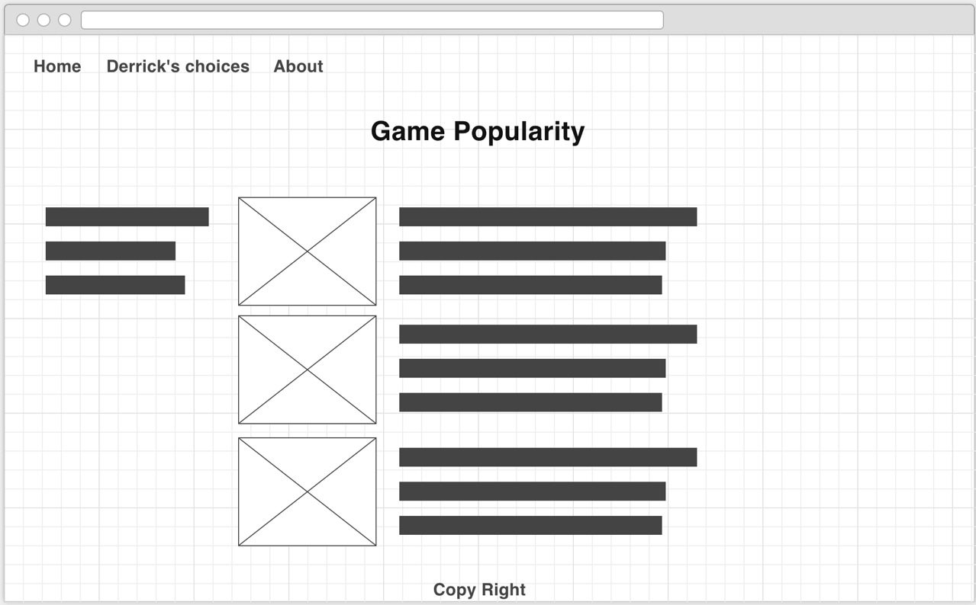

**Derrick’s Choices**

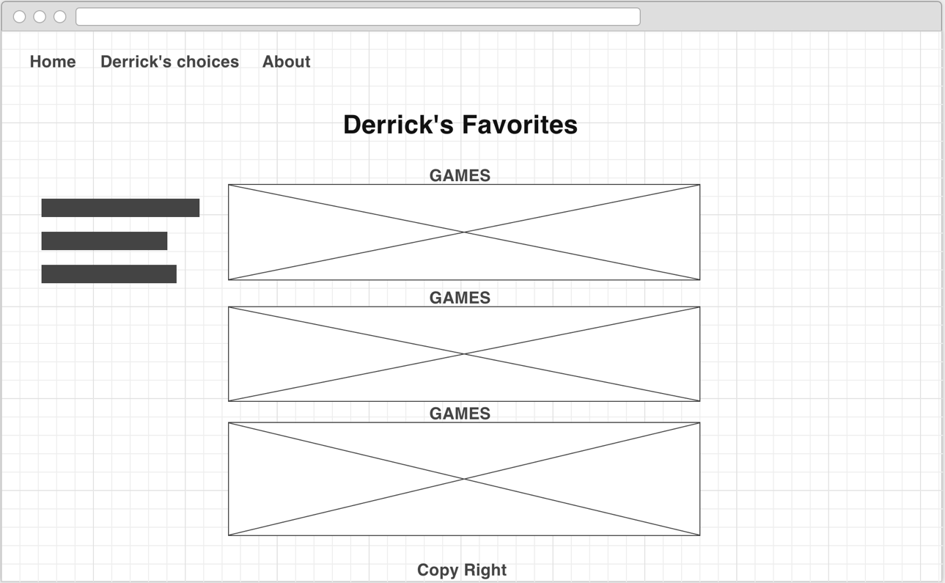

**About**

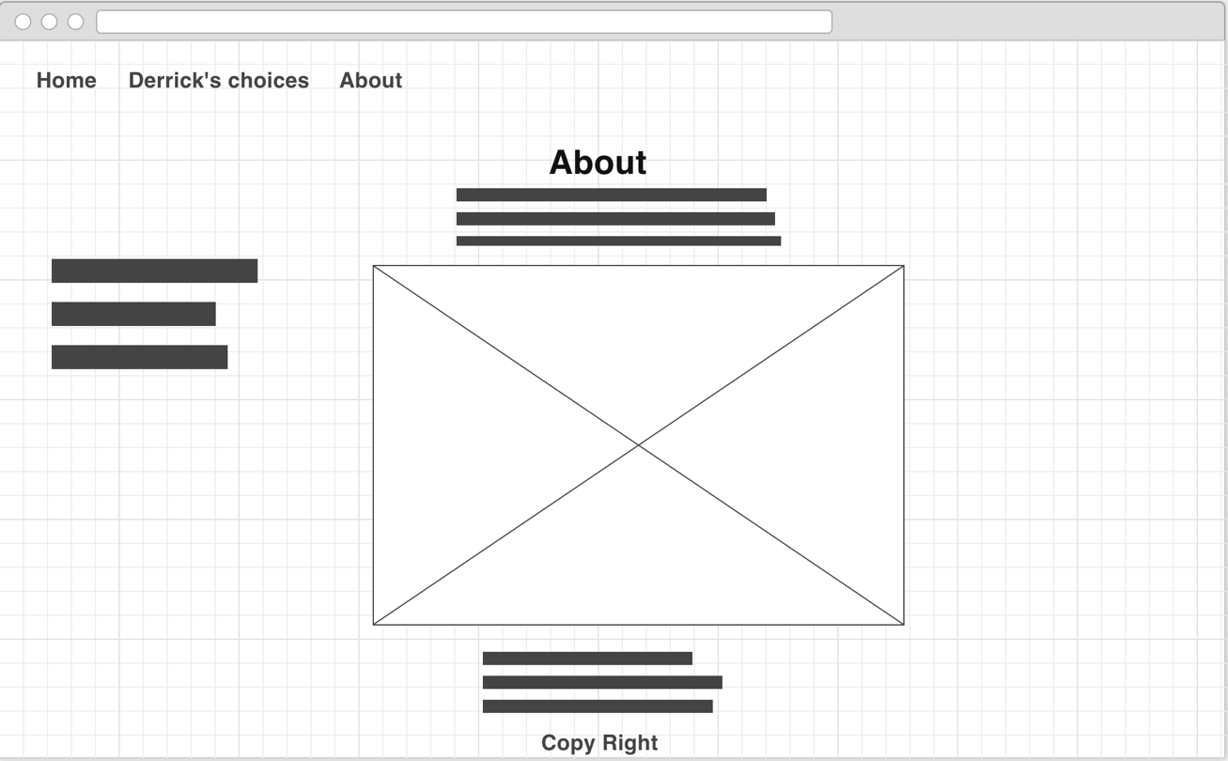

**PC Games**

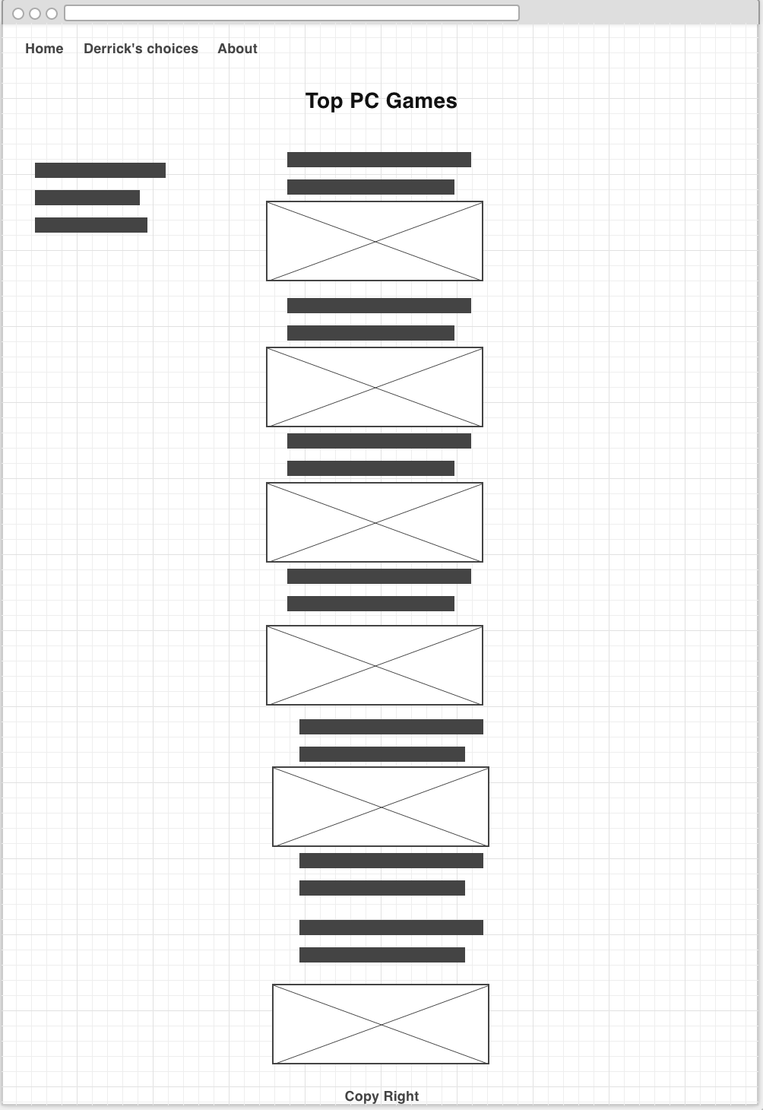

**MMORPG Games**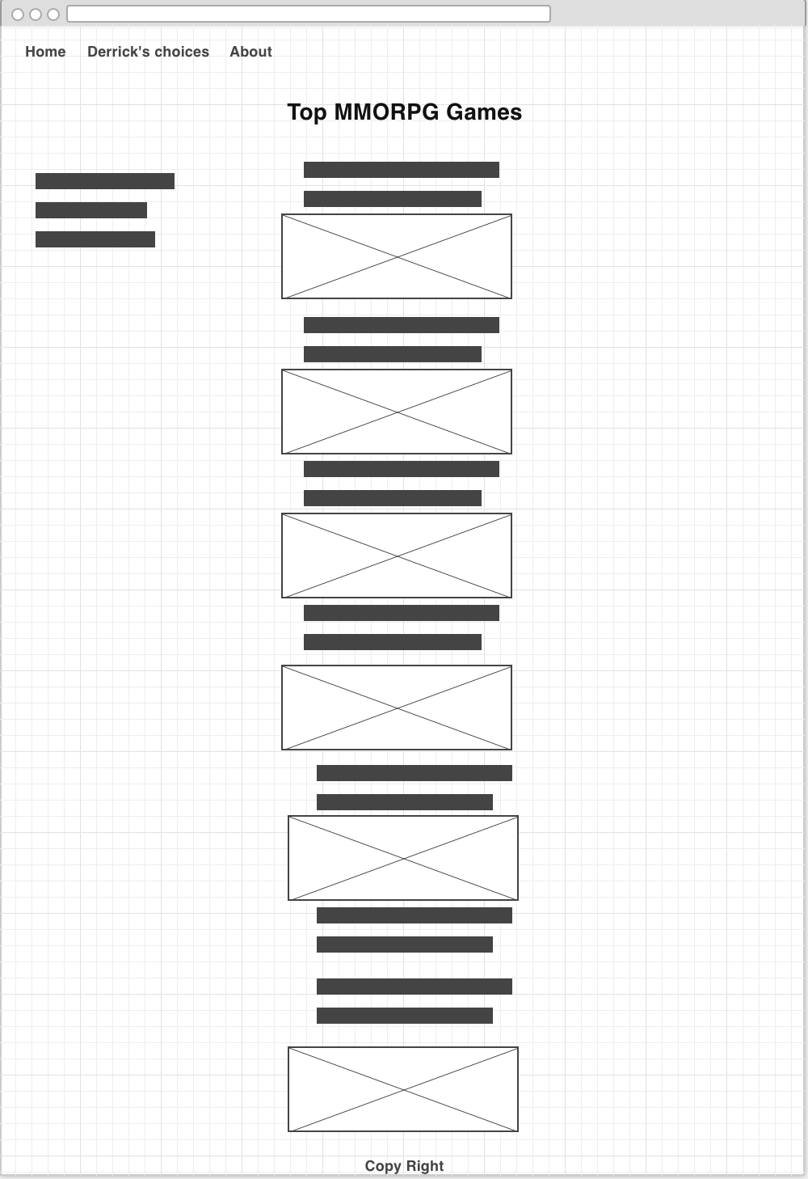

**iPhone Games**

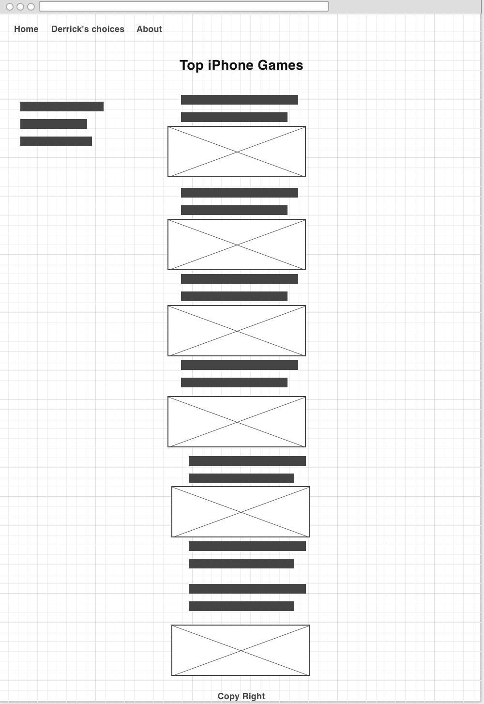

**Style Guide**

Body Text color: greyscale. Black: #000000 and White: #FFFFFF

Header text: color: Alice: #F0F8FF

Shadow: Blue: #0000FF

Border colors: Skyblue: #87CEEB

Font: Sans-serif