Microarray Analysis

Data: Gene expression data from 4 colitic mice at 7 timepoints (day 0, 1, 3, 6, 14, 21, 28)

Notes: Day 0 has expression data from an a fifth colitic mouse. Infection with Hh and Il10 at day 0. Colitis onset is at day 6 peaking at day 14.

Probes were mapped to genes and expression levels averaged. In total there were about 17,000 genes. From these 17,000 genes the 3,000 most varying were selected.

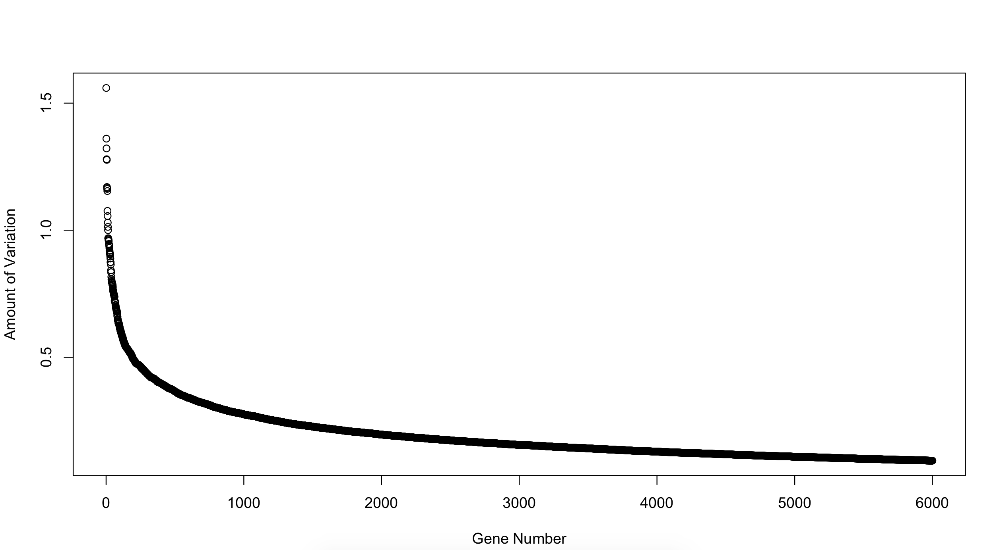
The most varying genes were chosen by the following process:

1. Expression levels were averaged across all 4 mice
2. Expression levels were divided by their value at day 0 and the log2 of the result was taken
3. The absolute sum of each row was taken as a measure of total change

Time-Series Plotting

Gene expression levels were plotted as a set of time series by:
1. Converting average expression to logfold
2. Imputing (21) missing days per gene by fitting a spline to the known days

These time-series were divided into three clusters using k-medoids and the Dynamic Time Warping metric. By inspection of results DTW provided a more natural clustering compared to l-n distance.

N.B. The time-series data was very continuous and did not truly cluster. Using a clustering provided a convenient shorthand to map genes into diminishing, neutral, and increasing over the course of the disease.
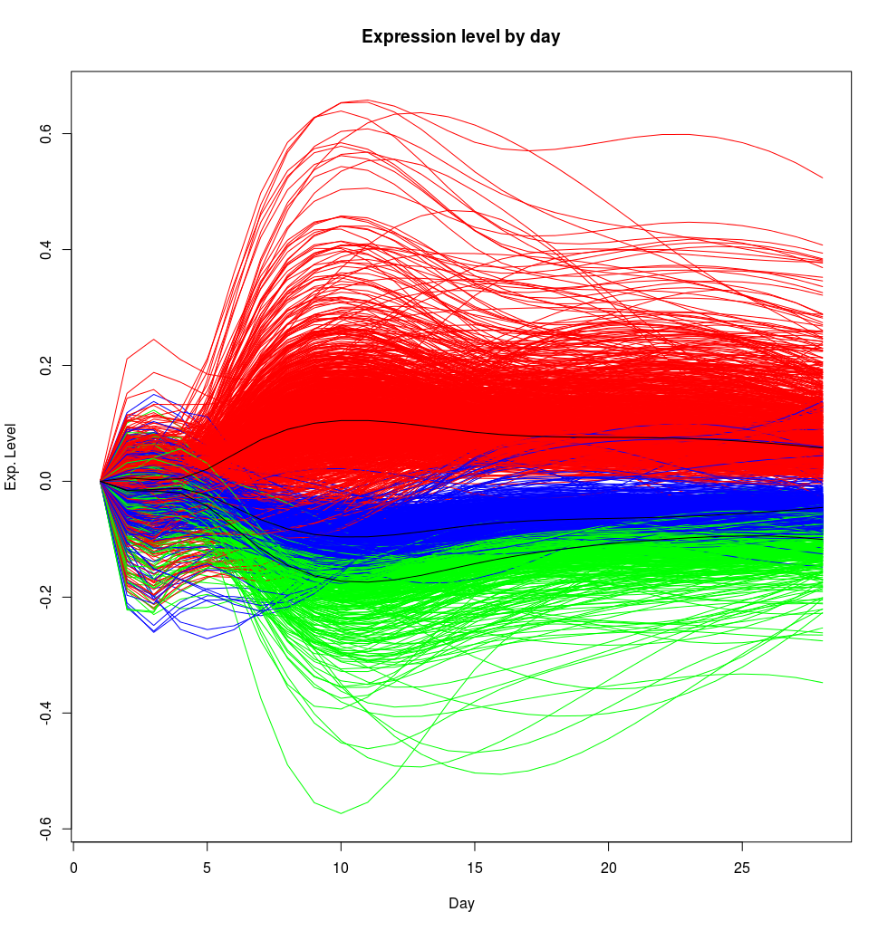

The time-series shows a notable throat at day 5 and a divergence at day 10 which is never fully resolved. This pattern is maintained even when more than 3,000 genes are included in the clustering

Gene Expression Correlation

Correlation analysis was used to find modules of genes which strongly interacted. The WGCNA R package was used for the bulk of this analysis.

WGCNA relies heavily on the Pearson coefficient and the Topological Overlap Index.

Pearson coefficient is a measure of the relationship between two variables; a high absolute value indicates a strongly linear relationship based on observed data. The sign of the coefficient indicates whether the relationship is positive or negative.

The TOI is a measure of how strongly two nodes in a graph interact based on their neighbours. If two nodes share most of their neighbours they will have a large TOI. Note that TOI is not the only reasonable metric of connection between nodes. TOI is easy to compute even for very large graphs.

In WGCNA Gene Correlation is assessed by:
1. Finding the Pearson coefficient between every pair of genes
2. Mapping gene interactions into a graph using a soft-threshold based on the Pearson coefficient
3. Finding the TOI of each pair of genes in the resulting graph

The resulting matrix of TOI is called the TOM for Topological Overlap Matrix. The TOM can be plotted as a heat map

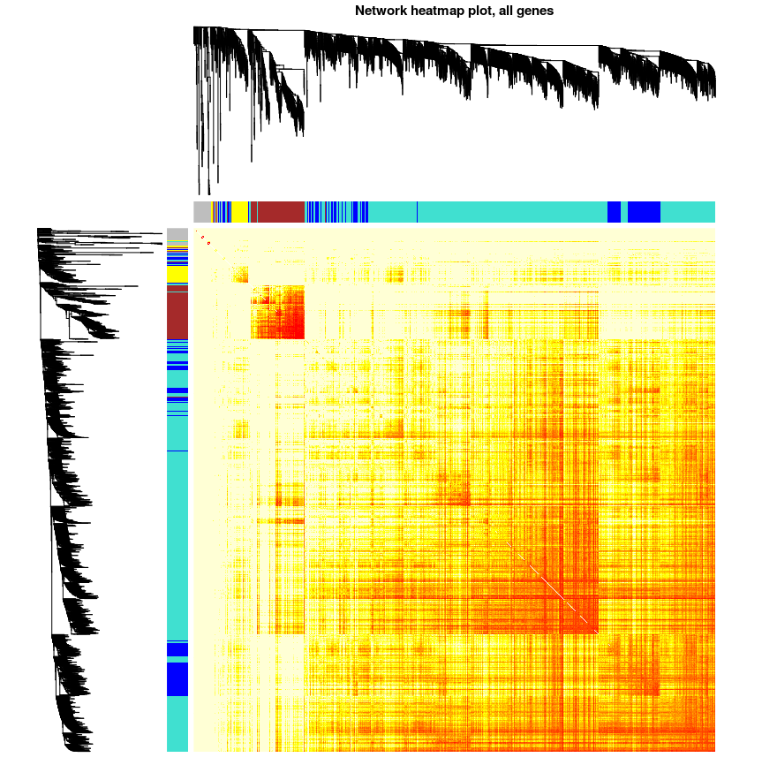
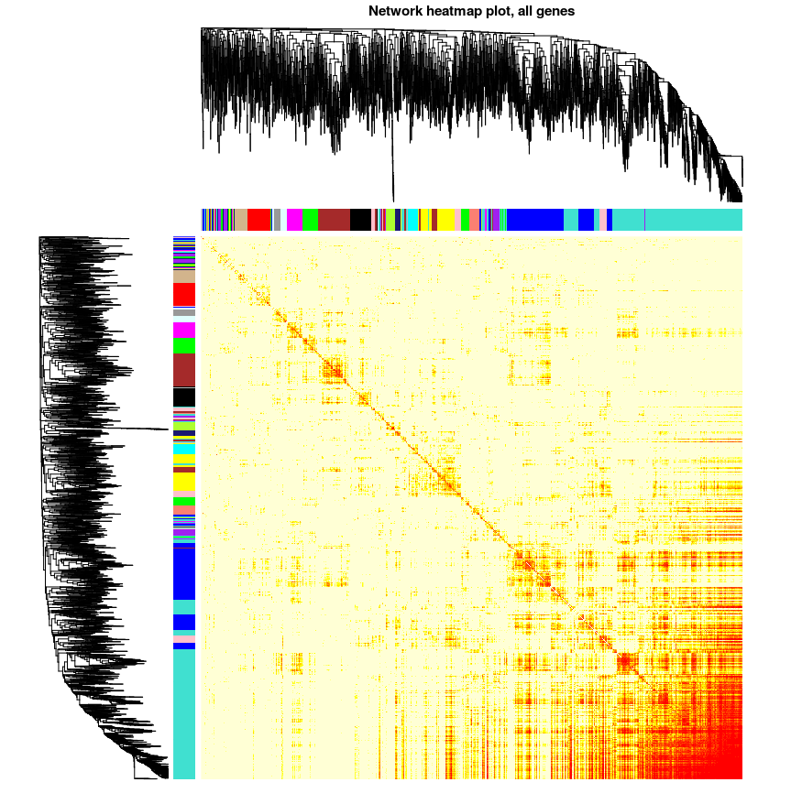
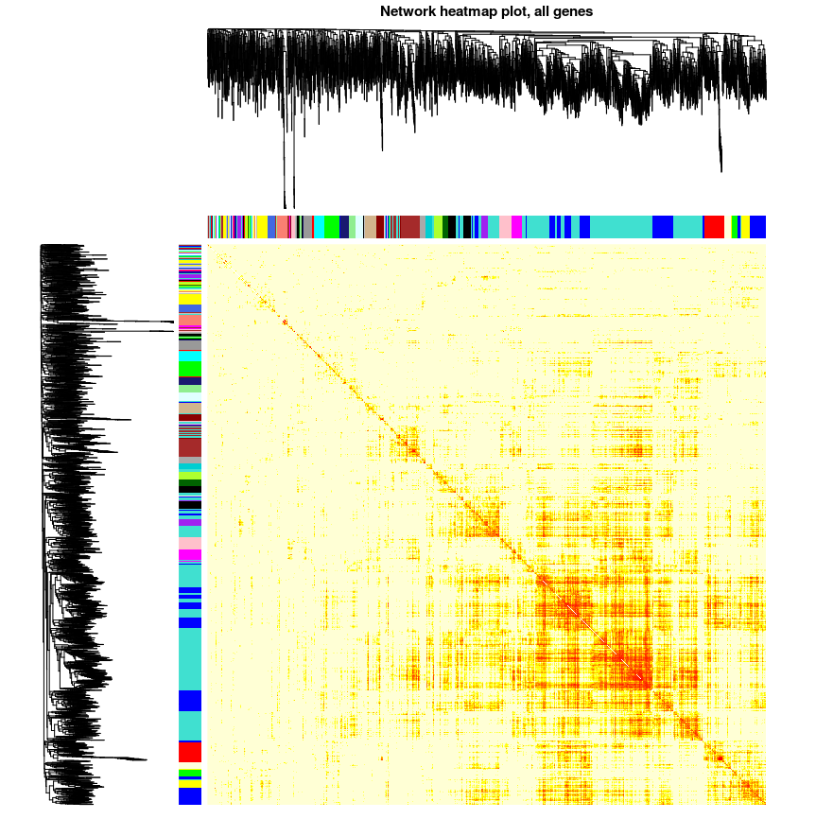

Unfortunately Pearson coefficient is an inaccurate metric with only 4 datums. To provide the test with more power the disease was assessed in three different stages using expression from different time-points for additional statistical power.

Upper left: All time points (29 in total)
Upper right: Disease peak, day 6 and 14 (8 points)
Lower left: Disease initiation, day 0 and 1 (9 points)

The strongest clusters from each TOM were chosen for further inspection.

All: turquoise, blue, brown (2,766 genes). Peak: yellow, brown, blue, turquoise (1,858 genes). Initiation: blue, brown, turquoise (1,515 genes).

Joint Analysis

Of these modules some proved to be heavily enriched for genes that rose significantly in time-series analysis. No cluster was signifigantly enriched for neutral or diminishing genes. Genes fell into time-series clusters in the following quantities:

Rising: 1,412
Neutral: 446
Diminishing: 1,142

Note that it is not surprising that overall proportions would be enriched for genes that vary more since the genes originally selected were the 3,000 most varying.

For a TOM module to be considered enriched for rising genes it had to have significantly more rising genes than would be expected in a random draw. 6 TOM modules met this criteria: all-blue (470), all-brown (326), peak-yellow (185), peak-brown (256), init-blue (431), and init-brown (161). This selected 1,627 unique genes in total.

Interestingly the chosen sets overlapped with each other very little. Pairwise Jaccard indices were quite low as were overlap coefficients. However 25 genes were conserved throughout every set:

21 rising:

"CIDEB" "AI326906" "PSME3" "LOC382092" "NUP85" "ABTB1" "APITD1" "RAB15" "USP39" "1200014P03RIK" "4921511I23RIK" "FOXM1" "BIRC1A" "PPM1G" "NCAPD2" "RUVBL2" "FBL" "OPTN" "2600005C20RIK" "MRPS18B" "SULT2B1" "H2AFX" "FARSB" "PTE2B"

4 diminishing:

"6720467C03RIK" "4921511I23RIK" "RAB15" "ABTB1"

