# Needfinding Assignment

Espiritu, Kinnirt Mill

DeGuzman, David

BSIT-MI182

UI/UX Design and Programming

# Activity:

**Having a private vehicle without a garage”**

Most of the Filipino citizens are having their own private vehicles in order to get to their desired destination in no time and to lessen the time that is being consumed in daily traffic encounters. We buy vehicle for our own convenience yet the problem that could arise is where are we going to park the car?

Many places in the Philippines implemented a policy wherein if you own a private vehicle, you also need to have your own garage to put your car into and not only to park your car outside the house or just in the street of your village, subdivision etc.

# Observations:

As we have observed to our respective places, we have witnessed and noticed that most of our neighbors who owns a vehicle does not have their own garage to park their car. They just parked their vehicles in the streets and they also do double parking on which is prohibited to our place, yet they still do it for their vehicle’s safe and convenient parking place.

On the other hand, some of them owns a car and does have a proper garage to put their cars into, which is way more well pleasing in the eyes and makes the pathway uncluttered.

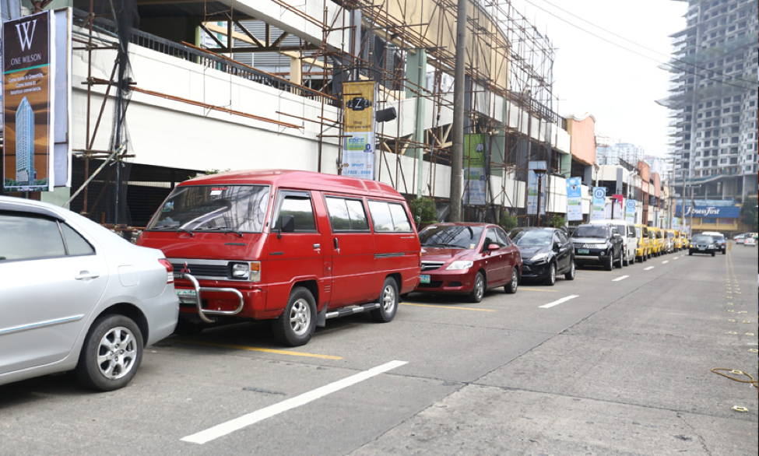

Figure - 1 Pasig City , Metro Manila

## **Problem**: Vehicles parked in the pathway and not in a garage.

## **Need**: If someone bought a car, they should provide a garage for the car’s parking.

In order to provide actual convenience, a policy should be implemented in every village, barangay, subdivision etc. wherein if a resident owns a car, they should also have their own garage. Also, prohibiting people who are parking exactly in the pathway and make them park somewhere just not in the street.

By this policy, it will lessen the vehicles that are occupying the streets or even the road that could possibly make other vehicles to pass through easily. It will also make less traffic mainly if the pathway is being used also by public utility vehicles like jeep, tricycle, UV Express and such.

Having your own garage will provide space for the pathway of the street that could be more convenient to the people who are walking or people who are driving on it,

# **Interviews:**

For our interviews, we asked for the help of 2 students who owns a car and 1 student who addresses the policy of “Kotse mo garahe mo”. All of the interviewee is all witnessed the illegal parking attitude of most people who owns a vehicle and asked them for their feedback and opinion about it.

Interviewee #1: Kristine Fabie Sanidad, STEM

Question #1: What can you say about to those who just park their cars exactly in the pathway?

- ***Streets are meant to be passageways for cars, not for parking. There are parking lots for a reason.***

Question #2: Do you believe that if you own a car, you should have your own garage as well?

- ***Yes. If you can afford a car, you might as well spend money for a garage. I believe that “no garage, no car” policy should be implemented since the Philippines is known for its congested streets.***

Question #3: What do you think they should do about to those who just parked their cars in the driveway?

- ***If owners were given a warning about parking cars in the streets beforehand and if there’s still no action made, towing the car may be a good resolution.***

Interviewee #2: Reign Mina, BSIT-MI student

Question #1: What can you say about to those who just park their cars exactly in the pathway?

**- I think that though it is an irresponsible thing to do, there is not much choice for anyone living in villages with limited spaces who owns a car. Most houses in populated metropolitan areas do not have sufficient spaces for parking cars.**

Question #2: Do you believe that if you own a car, you should have your own garage as well?

**- Yes, but there should be alternatives offered for the car owners without garages. For example, public overnight parking spaces.**

Question #3: What do you think they should do about to those who just parked their cars in the driveway?

**- As of now, there shouldn't be repercussions because the policies are barely implemented.**

# **Identified Needs:**

* *Smooth traffic flow:*
* Since there are no cars parked on the road, there would be no problem for the vehicles that are passing by to go through the road and make their way.
* *Safer and easy access:*
* People who are passing by will be safer to pass through since there no cars parked and only vehicles passing by are in sight. Thus, it would be easier for the person to avoid and see any danger that could occur.

# Conclusion

As we conduct our observations and interviews, we have concluded that the incident wherein private vehicles are being parked exactly on the main road are supposed to be illegal and prohibited for the pathway to be accessible and easier to pass through. We also gathered information wherein if people tend to buy their own car, they should invest as well on buying or making their own garage.

The most common issues that the people who are encountering this kind of problem on which somebody’s car are being parked in front of their house even though is not their car, they are saying that the way they park their car should be prohibited and be noticed by the officials and give them a warning of improper parking action.

Through the needs that we have gathered and observed about, we have noticed that they all agreed on the policy “no garage, no car” to lessen the parked vehicles that are being the source of traffic in the road on which it should be yielded and have a free flow traffic.

# Point of View:

## **Get your own garage**

* When you planned or you’re planning on getting a car, you should think about first where are you going to put your car or park your vehicle.
* Get the availability of space from your space if it doesn’t affect the pathway that the other vehicles are using.

## **Never park your car on others’ driveway**

* If you don’t have a spot to park your car, don’t just put it on someone’s parking or driveway
* Provide yourself with a space where other people wouldn’t be disturbed.

## **Think about the others**

* Do not only think about your own convenience.
* Consider others if they would be disturbed or bothered by your parking.
* Be patient enough to find a proper parking spot.