**Question 2:**

***ωC = 0.75*π***

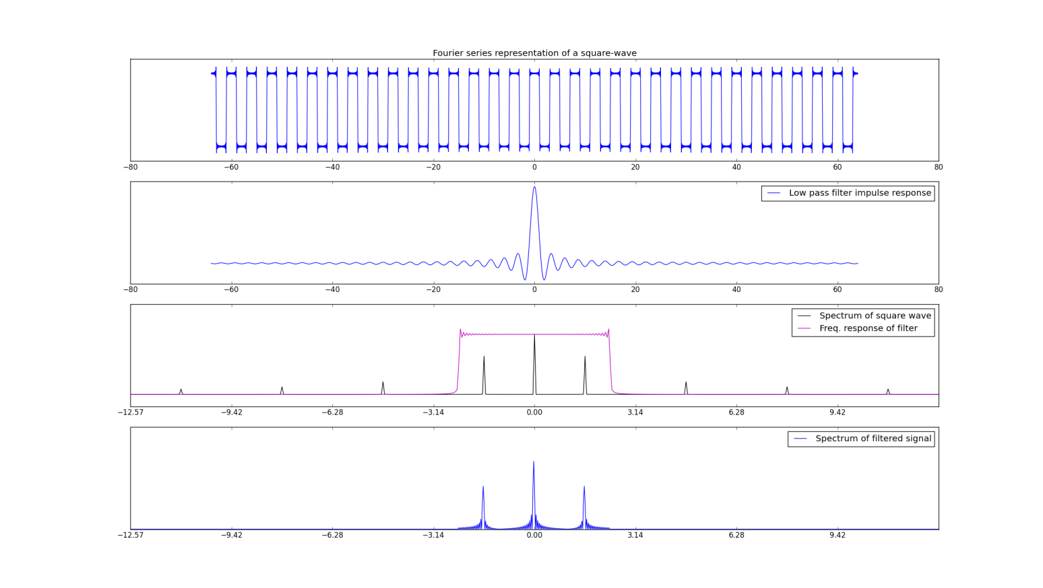 ***ωC = 1.75*π***

