RegexParser Guide

*This tool aim to draw the final state machine related to the regular expression given as input.*

HOW TO USE THE TOOL 1

HOW TO WRITE A REGULAR EXPRESSION 2

POSSIBLE ERRORS 3

USE EXAMPLE 5

CREDITS 7

# HOW TO USE THE TOOL

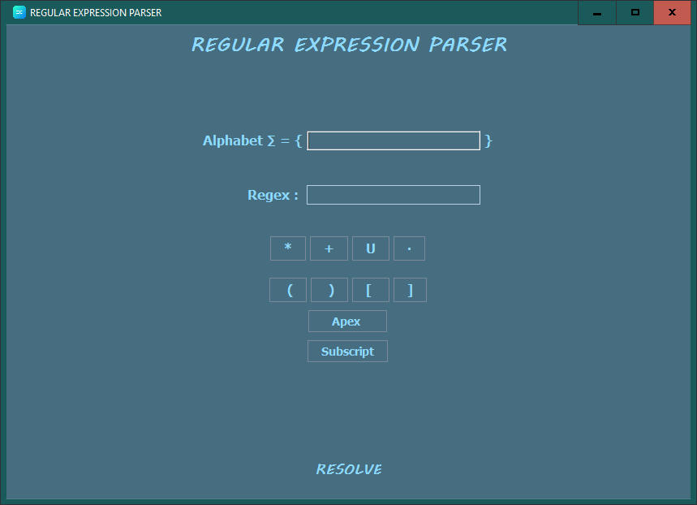The tool comes in the following form:

Figure - RegexParser application initial form

* **Alphabet $Σ$** : Textbox where write the alphabet symbols used to write the regex:
  + - Only ONE-char symbols are allowed.
    - Symbols like +, U, , $, %, &, |, are NOT allowed in this Textbox.
    - Symbols in the Textbox are not spaced. Insert these like the following example:

Figure 2 - example: insert symbol in the alphabet textbox

* **Regex**: Textbox where write the regular expression:
  + - View the chapter “how to write a Regular Expression” for more details.
    - Space between symbol are NOT allowed.
* **Symbols keyboard**: keyboard that allow to write a special symbol.
* **Apex button**: button that allow to write an apex to regular expression:
  + - One clicks on this button, show a textbox where insert the number you want.
    - The apex value MUST be greater than 0.
    - Only ONE-digit number are allowed.
* **Subscript button**: button that allow to write a subscript to regular expression:
  + - One clicks on this button, show a textbox where insert the number you want.
    - The subscript value MUST be smaller than the apex one. It can be equal to 0.
    - Only ONE-digit number are allowed.
    - You can insert a subscript ONLY IF there is an apex in the previous position.
* **Resolve button**: button that initiate the parsing process.

# HOW TO WRITE A REGULAR EXPRESSION

In this chapter, you can see how to avoid error when writing a regular expression.

An example is useful for this aim:

$$Σ=\left\{abc\right\}$$

$$Regex:{\left(ab\right)}^{*}U\left[c\right]Ua^{+}$$

* Make sure that between ( and ) or [ and ] there is at least one alphabet symbol.
* Make sure that *, +, ), ], ·, U and the apex are not the first symbol of the regular expression.
* Make sure that(, ·, [, U are not the last symbol of the regular expression.
* Make sure that the Apex value is greater than the Subscript one if this is present.
* Make sure that the number of ( or [ is equals to the number of ) or ] respectively.

In the next page, there are all errors you can see using this tool.

## POSSIBLE ERRORS

*The string “alphabet symbol” show the specific symbol of your use case.*

1. The Alphabet and the Regular Expression must not be empty.
2. Symbols not permitted in Regular Expression.
3. The Regular Expression must contain at least one alphabet symbol.
4. After a round bracket (, there could only be symbols: (, [, alphabet symbols.
5. The round bracket ( couldn't be the last symbol of the Regular Expression.
6. Before a round bracket ), there could only be symbols: ), ], *, +, one apex, one subscript, alphabet symbol.
7. The round bracket ) couldn't be the first symbol of the Regular Expression.
8. After a square bracket [, there could only be symbols: (, [, alphabet symbol.
9. The square bracket [ couldn't be the last symbol of the Regular Expression.
10. Before a square bracket ], there could only be symbols: ), ], *, +, one apex, one subscript, alphabet symbol.
11. After a square bracket ], there could only be symbols: (, ), [, ], one apex, U, ·, alphabet symbol.
12. The square bracket ] couldn't be the first symbol of the Regular Expression.
13. Before a star *, there could only be symbols: ), alphabet symbol.
14. After a star *, there could only be symbols: (, ), [, ], one apex, U, ·, alphabet symbol;
15. The star * couldn't be the first symbol of the Regular Expression.
16. Before a cross +, there could only be symbols: ), alphabet symbol.
17. After a cross +, there could only be symbols: (, ), [, ], one apex, U, ·, alphabet symbol.
18. The cross + couldn't be the first symbol of the Regular Expression.
19. Before a point ·, there could only be symbols: ), ], *, +, alphabet symbol.
20. After a point ·, there could only be symbols: (, [, alphabet symbol.
21. The point · couldn't be the first symbol of the Regular Expression.
22. The point · couldn't be the last symbol of the Regular Expression.
23. Before an Union U, there could only be symbols: ), ], *, +, alphabet symbol.
24. After an Union U, there could only be symbols: (, [, alphabet symbol.
25. The Union U couldn't be the first symbol of the Regular Expression.
26. The Union U couldn't be the last symbol of the Regular Expression.
27. Before an Apex, there could only be symbols: ), ], alphabet symbol.
28. After an Apex, there could only be symbols: (, ), [, ], one subscript, U, ·, alphabet symbol.
29. Before a Subscript, there could only be an apex.
30. Before an Apex-Subscript pair, there must be a square bracket ].
31. After a Subscript, there could only be symbols: (, ), [, ], U, ·, alphabet symbol.
32. Apex and Subscript couldn't be the first symbols of the Regular Expression.
33. The number of ( and [ must be the same of ), ], respectively.
34. The Apex must be a positive one-digit number.
35. There cannot be a Subscript if there's not an Apex.
36. The Subscript must be a positive one-digit number smaller than the Apex.
37. (, ), [, ], *, U, +, ·, ε are not allowed like alphabet symbols.

# USE EXAMPLE

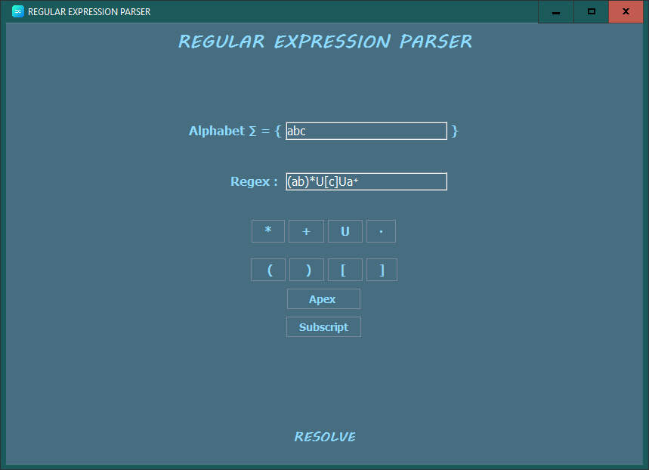

Figure 3- example: insert alphabet and regular expression

After one click on the RESOLVE button, you can see the result like in the next page.

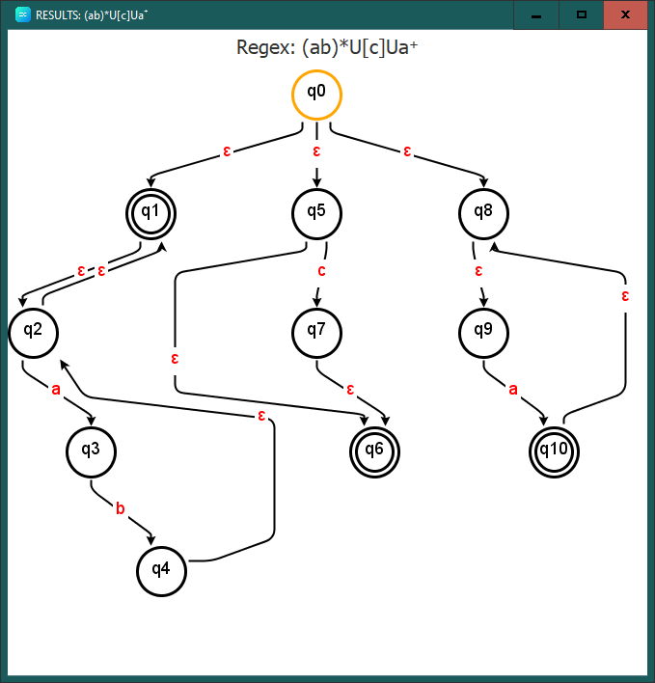

Figure - example: result

# CREDITS

Tool designed and developed by

Dott. Davide Cesani @ Università degli Studi di Bergamo

*d.cesani@studenti.unibg.it*

Dott. Federico Nespoli @ Università degli Studi di Bergamo

*f.nespoli1@studenti.unibg.it*

as end-of-class project.

Class:

Formal languages and Compilers

Prof. Giuseppe Psaila