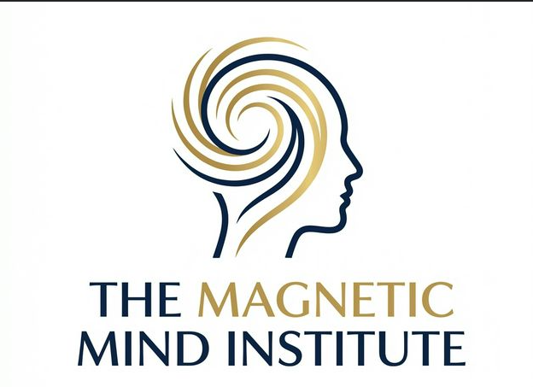

THE STICK PERSON

A Guide to Understanding Your Mind
Provided by The Magnetic Mind Institute
www.TheMagneticMind.institute

The Concept
To change your results, you must understand your mind. The problem is, the mind is not a physical thing—no one has ever seen it.
Dr. Thurman Fleet created a simple diagram in 1934 to eliminate confusion. It divides the mind into two parts: Conscious and Sub-Conscious

The Story
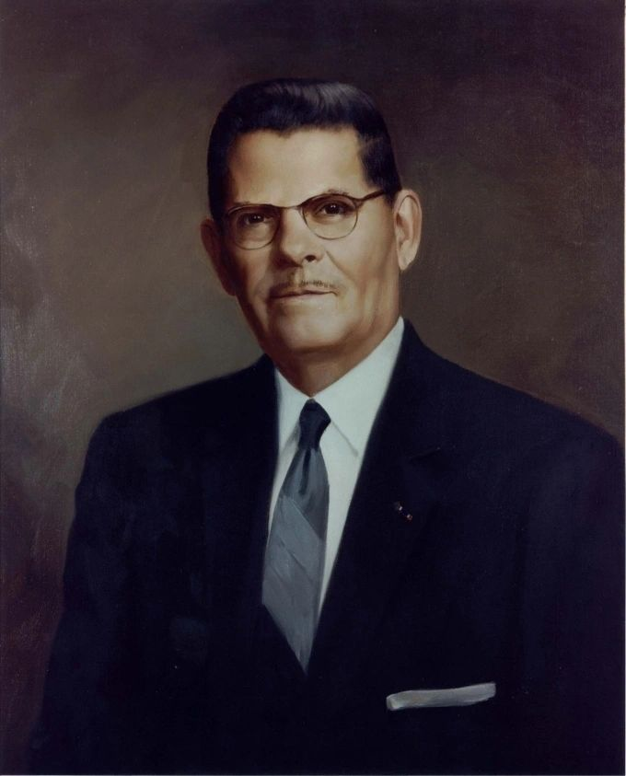
Dr. Thurman Fleet, was an incredible chiropractic healer and teacher a of metaphysics. He was born in 1895 and died in 1983. In 1931, Fleet founded Concept-Therapy in San Antonio, Texas.
While serving in the military in World War 1, he sustained injuries that “traditional medicine” could not heal. His service was one of distinction, he was awarded the Distinguished Service Cross and the Silver Star.
It was his quest to heal his own personal war injuries that eventually led him to study the connection between mind and body.
He believed that true healing required treating the "whole person” not just the body.

What is the Mind
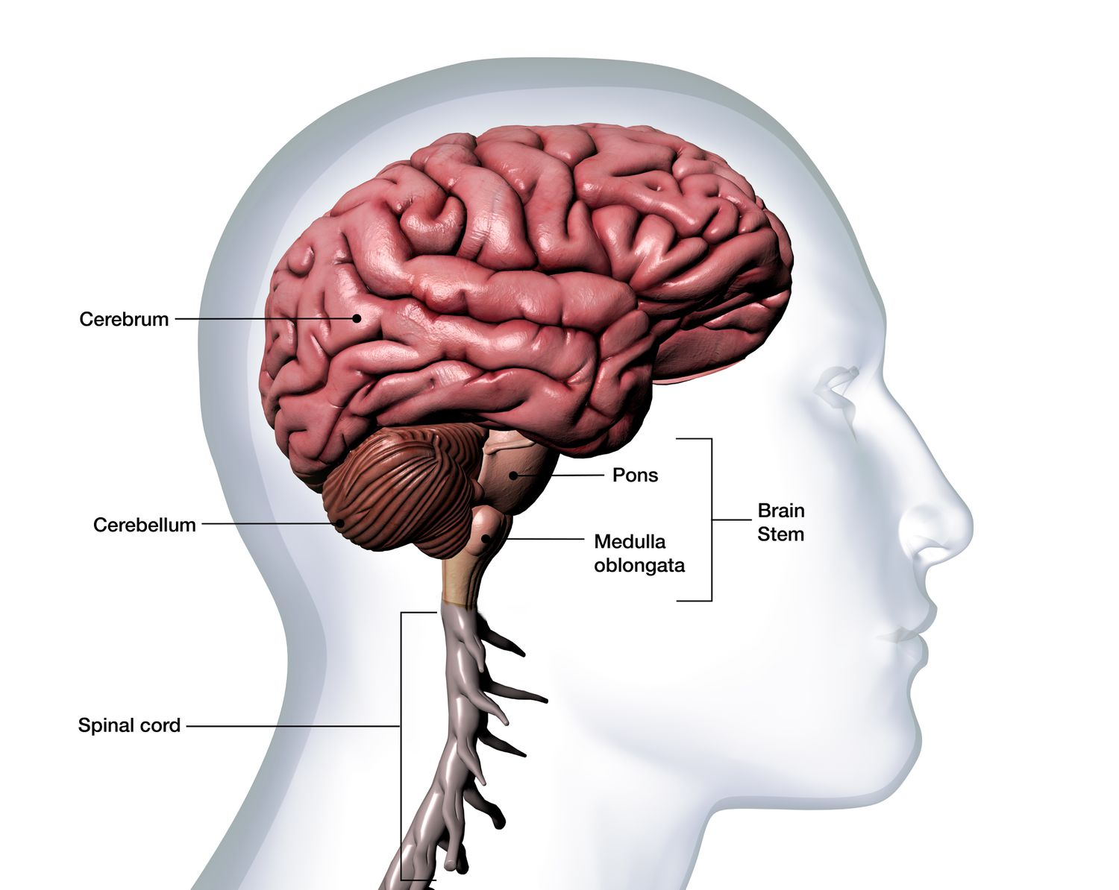

Most people confuse the “Mind” with the “Brain”, and some even use it interchangeable. This is incorrect. The brain is physical while the mind is mental.
As human beings we think in pictures. When we think of a red shoe, we do not see the words, RED SHOE in our head, but instead we see an image of a red shoe.


I am sure when you read the words, above “red shoes” no was saw a black shoe in their mind. This is because we think in pictures.
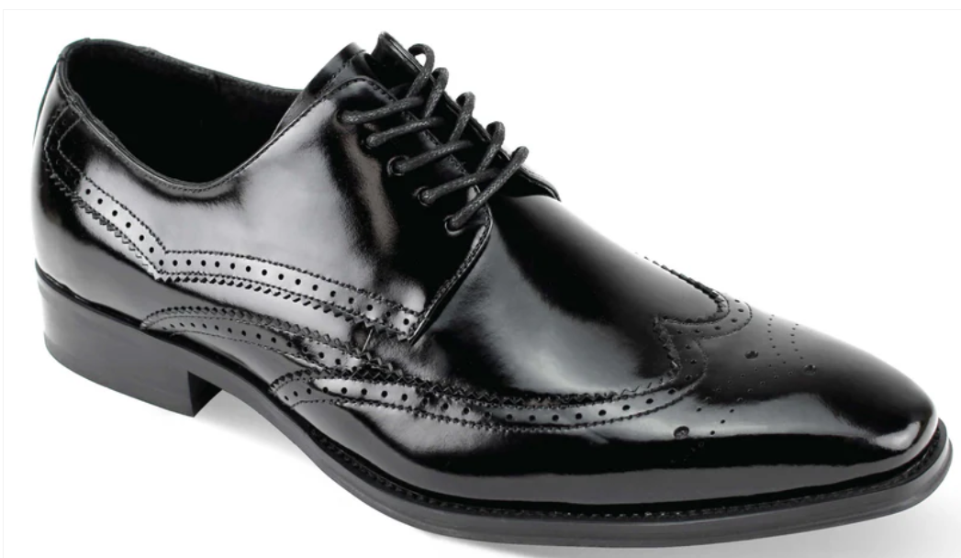
This was the concept that led Dr. Thurman fleet to invent the “Stickperson”. Dr Fleet understood that the human brain is wired for visual processing, because this is significantly faster than using words. Pictures are also better for long-term memory.
When he was seeing patients at his office in, the San Antonio, Texas the police department often had to re-route traffic patterns around and away from his office location, in order to accommodate the large numbers of patients.
He even had to move his office 3 times to comply with fire codes. What was it that what was it that Thurman had discovered.
He called his work “Concept Therapy”, Fleet’s teachings focus on the healing of the negative and limiting concepts in the subconscious mind. How did he achieve this? Why were people flocking to Dr. Thurman like this. What did he have, that no one else had. The short answer is, “it was the Stickperson”.

[Diagram Image Here]

1. The Conscious Mind (Top Half)
- • Thinking Mind, Educated Mind, Intellect
- • Can accept or reject any idea
- • Where you choose your thoughts

2. The Subconscious Mind (Bottom Half)
- • Emotional Mind, Feeling Mind
- • Cannot reject; must accept whatever is impressed upon it
- • Controls the vibration of your body and your actions

Applying Knowledge
- Your thoughts (Conscious Mind) create feelings (Subconscious Mind).
- Your feelings determine the vibration of your Body.
- Your vibration dictates your Action.
- Your Action produces your Results.
- If you want different results, you must change your programming (Paradigm).
- This requires repetition of new, empowering ideas until they sink into the Subconscious.

Start Your Paradigm Shift Today
Join The Magnetic Mind Institute for full lessons.
www.TheMagneticMind.institute

