**Minesweeper – The Extras – Part 3**

**Extra Credit :** You will be able to earn extra credit points on this project by completing one or all of the following tasks.

* 10pts – Make a more robust algorithm for randomly placing mines. For example your algorithm could fix the problem encountered when you get a lone mine.

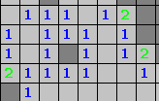 Finding the mine here is pretty easy

* 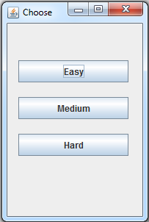10pts – Create a GUI that lets the user select the level of difficulty for the game. You should change the grid size and number of mines based on the user input.
* 5pts - Lock the cells so that once you lose you can’t continue playing.
* 10pts - Make and implement a reset button.
* 10pts – If the left mouse button is pressed a square is flagged if it is left clicked again the flag disappears
  + + 5 if you can’t open a flagged cell
  + + 5 if incorrectly flagged cells are shown when you loose
* ??pts - Any other improvements you want to make, subject to aproval