Daniel Goodnow
March 16, 2016
CS455
Homework 3

1. Irobot Create in Willow Garage

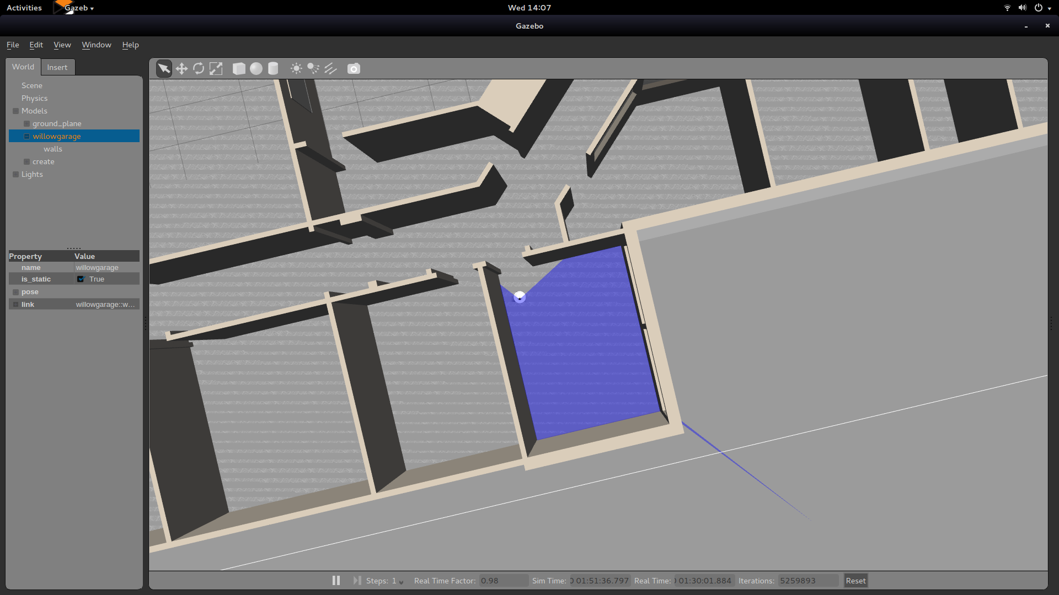
2. Map Generated by laser scanner on Irobot Create

