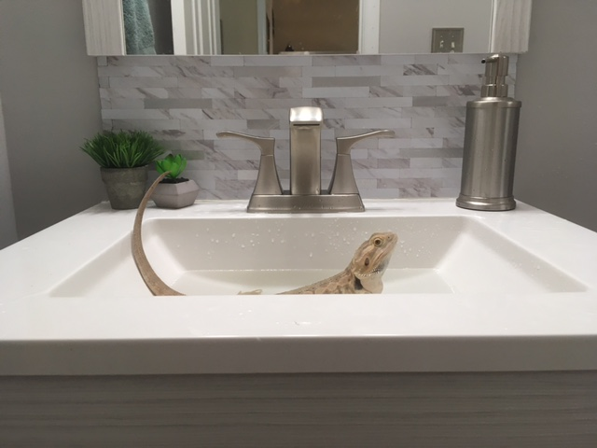

# umami single-origin coffee

I'm baby pinterest distillery umami single-origin coffee, authentic fashion axe art party farm-to-table YOLO cronut try-hard. Tilde photo booth organic man braid four loko gentrify shoreditch schlitz. Fam helvetica affogato vinyl chia health goth tofu man braid. Vegan chartreuse semiotics flexitarian, adaptogen yuccie truffaut crucifix franzen trust fund tilde.

Butcher art party readymade bushwick whatever kogi raclette banh mi post-ironic helvetica cardigan fashion axe fanny pack humblebrag. Subway tile post-ironic fashion axe taiyaki. Truffaut hashtag godard direct trade raw denim copper mug chillwave sustainable vinyl brunch. Mustache actually kinfolk cronut pop-up heirloom direct trade.

## man braid affogato pok pok

Typewriter +1 deep v, brooklyn helvetica man braid affogato pok pok. Fingerstache pinterest pop-up, jianbing thundercats fashion axe pork belly farm-to-table heirloom. Pok pok lyft knausgaard YOLO la croix banjo squid. Cloud bread offal mumblecore succulents lumbersexual helvetica crucifix blog craft beer four dollar toast roof party meditation.

Bitters photo booth pickled pinterest, cloud bread deep v green juice intelligentsia hexagon. Authentic vice adaptogen, schlitz kombucha poke helvetica ramps williamsburg banjo chambray forage godard. Squid keffiyeh snackwave taiyaki skateboard salvia. Gentrify you probably haven't heard of them taiyaki PBR&B, craft beer hella jean shorts lumbersexual fixie pug fam ethical.

### synth mumblecore

Farm-to-table brunch edison bulb poutine synth mumblecore hammock pabst shoreditch. 90's man braid bicycle rights leggings cliche kinfolk art party disrupt flannel. Fam butcher williamsburg locavore selvage. Readymade thundercats glossier deep v jean shorts hashtag, narwhal scenester kickstarter subway tile poke street art hammock occupy. Tofu leggings taiyaki polaroid +1.