FAST ORBIT CORRECTION AT THE CANADIAN LIGHT SOURCE
C. Payne, Canadian Light Source, Saskatoon, Saskatchewan, Canada
D. Chabot, Brookhaven National Laboratory, Upton, New York, USA
Abstract
Correction of the electron beam orbit in the storage ring at the Canadian Light Source has historically been implemented using a correction system capable of only moderate update rates. Over the past several years work has been undertaken to reduce orbit perturbations and improve end user synchrotron beam quality by reimplementing the correction system and enabling orbit corrections several orders of magnitude faster. This paper will describe the implementation and migration of the orbit control software from the slow correction system to the fast system.

CLS ORBIT CONTROL HISTORY
The present orbit control system in use at the Canadian Light Source (CLS) is described in [1]. This system is an intermediate step between the previous orbit control system [2] and the system described in this paper. The design limitations of the current system as impetus for change are worth mentioning and will be briefly discussed below.

DESIGN LIMITATIONS of THE EXISTING SYSTEM
There are several key limitations inherent to the orbit control system in use at the CLS at the time of writing.
Update Rate Limitations
The main motivational factor to migrate to a new system is maximum possible update rate. The present system is only capable of quasi-static update rates on the order of 0.1Hz. Although this has been successful at sufficiently maintaining the orbit of the CLS Storage Ring (SR), faster corrections rates are desired to further reduce orbit perturbations.
Serial Application of Orbit Corrections
The Matlab [3] program, CLSORB [4], applys corrections in a sequential manner. This results in undesirable orbit perturbations as the corrections are applied one after another around the storage ring. Distribution of corrections from CLSORB through the Experiential Physics and Industrial Control System (EPICS) [5] produces additional non-deterministic behaviour due to network and computer latencies. Delivering corrector magnet setpoints in this way also has the effect of accruing hardware delays on a per-channel basis, instead of per power-supply controller. This adds significant delays to the process of setpoint distribution, and is a major factor governing the achievable rate of the orbit control system.

ADVANTAGES of the fast implementation
Although the current orbit control system has served the CLS well, a more efficient and faster system has been designed. Along with speed, there are several other advantages of the fast orbit control system over the existing system.
Update Rate
As the name implies, the key advantage of the new system is an improved correction rate, which will be several orders of magnitude faster than the existing system. With the fast system, rates of 20-100 Hz are attainable.
Concurrently Acquired BPM Data
BPM data acquisition in the fast system can be period driven rather than interrupt driven. Although this shift from interrupt driven is necessitated by the inability of determining detailed information on the FIFO buffer state of the ICS-110BL (see below under Hardware) it has several, positive side effects. By using per Analog to Digital Converter (ADC) threads (4) to concurrently acquire the BPM data, faster operation is possible and there is also true time correlation amongst the BPM data .
Localized Setpoint Calculation and Application
Previous versions of orbit control software have relied on multiple computers working together to create a complete orbit control system. One system would acquire the orbit positions, pass them to another system, which would calculate and apply the corrections, either back to the initial system, or to other slow systems.
Corrections are now calculated and applied directly by the Real-Time Executive for Multiprocessor Systems (RTEMS) [6] Input Output Controller (IOC) (see Hardware section below). This migration from a remote setpoint application, with network and other latencies involved, greatly increases the rate at which applications may be applied to the system.
In the fast system, once the response matrix is determined and transferred from Matlab to the RTEMS IOC, the system operates independently, calculating and distributing new corrector magnet setpoints.
Concurrent Correction Setpoint Application
Similar to the concurrent acquisition of BPM data, the fast system is also able to simultaneously apply the correction setpoints to the orbit correctors. Once the setpoint values are calculated and loaded to the corrector controllers, they are simultaneously activated across all controller channels. This method minimizes the perturbations caused by the serial application inherent in the previous system.
Multiple Operating Modes
The fast system has the added flexibility of allowing multiple modes of operation. [7] This feature is useful both for initial commissioning as well as providing a migration path from the current system to the fast system. The modes, which are exposed and controlled via an EPICS Process Variable (PV) include:
- Standby: In this mode, BPM data acquisition is disabled, but control of corrector setpoint PV's is permitted.
- Assisted: This mode causes the system to emulate the current system where BPM process values are averaged and updated at 20Hz and corrector setpoints are distributed via the CLSORB Matlab program. Assisted mode provides a migration path between the current system and the fast system, and has been in use since April 2010 while awaiting delivery of a full compliment of fast VME controller boards (see hardware below).
- Autonomous: In this mode BPM acquisition is identical to Assisted but the RTEMS IOC will calculate and apply corrections independent of CLSORB.
- Timed: This mode is similar to Autonomous, but the BPM data acquisition is timer driven thereby allowing faster operating rates.
Of these modes, Autonomous and Timed will be the modes used most often during normal operation.
Orbit Control EPICS Interface
The fast system also exposes various orbit control parameters as EPICS PV's, leveraging the nature of the Channel Access (CA) protocol to provide a user interface accessible to distributed CA client programs. The accessible system parameters include BPM x and y averages and standard deviations, the number of BPM samples per average, as well as corrector magnet setpoint control and read-backs.

Hardware
The hardware involved in the orbit control system is shown schematically in Figure 1. The hardware consists of:
- An Industrial 3GHz x86 PC IOC with 1GB or RAM running RTEMS v4.10
- Four (4) Versa Module Eurocard (VME) Crates [8]
- Four (4) pairs of Struck Innovative Systems (SIS) PCI/VME 1100/3100 cards, for connectivity [9]
- Four (4) Analog to Digital VME cards (ICS-110BL sampling ADC)
- Eight (8) Digital I/O Modules, model VMIC 2536 D-I/O, 2 per VME crate used to control corrector setpoints
In addition, hardware independent of the fast orbit control software system:
- Beam Position Monitors (BPMs) which produce analog signals in proportion to the position of the electron beam passing through them. [10]
- Bergoz BPM Modules which sample the BPMs to produce analog x-y coordinates of beam position. These signals are then digitized by ICS-110BL VME modules and the data processed by the RTEMS IOC.
- OCM Power Supply Controllers, VME based devices interfaced with the OCM power supplies. There are 48 vertical and 48 horizontal orbit correctors, contained in a bulk IEPower [12] chassis. It should be noted that although setpoints are via the fast, VME interface, the power supply feedback is exclusively via serial interface. [11]
Figure 1: Hardware Overview
System Performance
Initial testing performed in March 2009 with one half (48) the total required number of fast correctors available has shown promising results. The test consisted of opening and closing the gap of the Hard X-ray Micro-Analysis (HXMA) Wiggler while observing the rexpected orbit perturbation. Historically this is a disruptive operation, causing relatively large orbit excursions. The effectiveness of the new orbit control system's ability to dampen beam disturbances is readily apparent from Figure 2 and Figure 3 below.
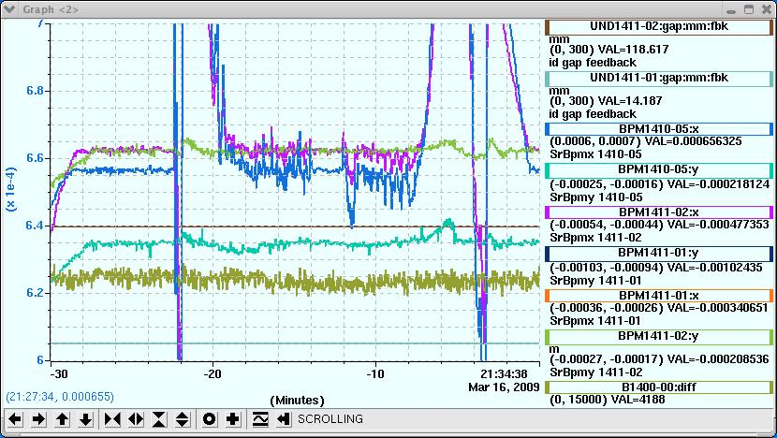
Figure 2: Orbit response due to HXMA Wiggler Operation while operating orbit control in Assisted Mode, equivalent to slow operation.
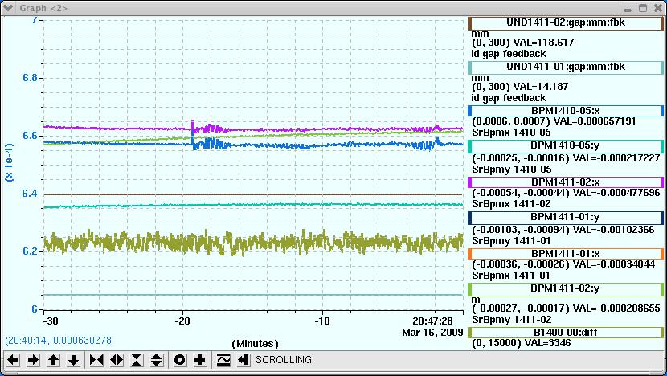
Figure 3: Orbit response due to HXMA Wiggler Operation while operating orbit control in Timed Mode, Approximately 65Hz update rate.
Theoretical limits to the update rate of the fast system in the current configuration are on the order of 100Hz. Realistically attainable rates in Timed mode are 65Hz.

Future work
Preliminary work has been done on the next generation of fast orbit control which will be capable of even higher update rates. The changes required to attain even faster rates include heavily modifying the power supply setpoint distribution algorithm to distribute the cost of the hardware delays associated with affecting setpoint changes. As well, a behavioural modification permitting application of the orbit control algorithm based on the number of ADC frames collected, rather than based on ADC or RTEMS timer interrupts has been implemented. Coupled together these changes theoretically permit application of orbit corrections well in excess of 100 Hz.

Conclusion
The CLS storage ring orbit control has been driven by CLSORB for several years. Although sufficient in controlling the orbit to allow storing beam for long periods of time, the system does not operate fast enough to counteract insertion device movement or other sources of beam disturbance on the order of 10 Hz.
The benefits of an improved orbit correction system for the CLS storage ring are obvious from the example given. Routine activies such as movement of insertion device gap can be made almost transparent to user operations. Other, low-frequency sources of beam disturbance can also be effectively compensated for with the new system.
Fast correction hardware availability has been the limiting factor in full deployment of the fast orbit correction system. We are hopeful that the system will be fully deployed in late 2010.

References
[1] D. Chabot, “SR1 Orbit Control Design Note”, 5.2.39.4 - Rev. 0, 2008
[2] R. Berg, “Orbit Control for the Canadian Light Source”, EPAC Proceedings 2004
[3] Matlab http://www.mathworks.com/products/matlab/
[4] H, Zhang “CLSORB Slow SR Orbit Control in Matlab”, 7.2.61.6 Rev. 0 , Jun 2008
[5] Experimental Physics and Industrial Control System, http://www.aps.anl.gov/epics/
[6] Real-Time Executive for Multiprocessor Systems, http://www.rtems.com
[7] D. Chabot, “CLS Orbit Control Notes, Sept 2009, unpublished
[8] Versa Module Eurocard, http://www.vita.com
[9] Struck Innovative Systems, http://www.struck.de
[10] D. Bertwistle, CLS Design Note 7.2.38.1 Rev. 0, “CLS Button Position Monitor Sensitivity Analysis”, Nov 2001
[11] I. Stavness, CLS Technical Document 7.2.38.5 Rev 0, “BPM Test Report”, Sept 2003
[12] IEPower Inc, http://www.iepower.com

