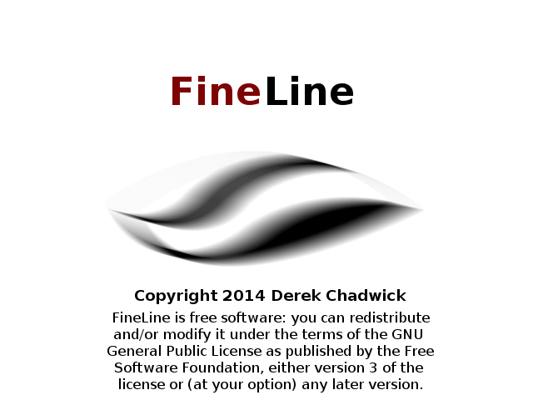

User Guide

Revision: 1.0

Date: 25 Feb 2014

Table of Contents
1. Introduction 3
2. Quick Start Guide 3
2.1 Download 3
2.2 Generate Event File 4
2.3 Event File Analysis 6
3. Project Management 8
4. Building From Source 9
4.1 Windows Build 9
4.2 Java GUI 9
4.3 Command Line Tools 9
4.4 Linux Build And Install 11
5. FineLine Event File Format 12
6. Command Reference 13
6.1 Command Line 13
6.2 GUI Functions 14
7. Acknowledgements and Copyright 19
8. References 19
9. Issues and Future Development 19

1. Introduction

Temporal analysis is crucial for accurate reconstruction of events relating to security incidents and crimes involving digital evidence (Microsoft, 2007). An accurate timeline of events is required to validate digital evidence, logical inferences, hypotheses and alternative hypotheses in order to determine the facts of a legal matter or security incident.

Manual timeline development is often a tedious and time consuming process even when a single computer is involved. The FineLine tools are an attempt to automate much of the operating system event log analysis and graphical timeline construction required to determine the sequence of events under investigation.

FineLine functions include:

- Processing and filtering of Microsoft Windows EVT and EVTX format event logs.
- Importing Linux Syslog and MACTIME/FLS event files.
- Filtering of event types.
- Keyword searching of event data.
- Cross-platform GUI.

2. Quick Start Guide

2.1 Download
Windows Binaries and Java GUI Package:

ZIP File: https://googledrive.com/host/0B6maxAp3j2akRnBvcGdSTThJbXM/fineline-windows-alpha-0.5.zip
SHA1: https://googledrive.com/host/0B6maxAp3j2akRnBvcGdSTThJbXM/fineline-windows-alpha-0.5.zip.sha1

7Z File: https://googledrive.com/host/0B6maxAp3j2akRnBvcGdSTThJbXM/fineline-windows-alpha-0.5.7z
SHA1: https://googledrive.com/host/0B6maxAp3j2akRnBvcGdSTThJbXM/fineline-windows-alpha-0.5.7z.sha1

Source Code Package:

GZIP File: https://googledrive.com/host/0B6maxAp3j2akRnBvcGdSTThJbXM/fineline-src-alpha-0.5.gz
SHA1: https://googledrive.com/host/0B6maxAp3j2akRnBvcGdSTThJbXM/fineline-src-alpha-0.5.gz.sha1

Unzip the binary package into any directory, no installation or system configuration is required.

2.2 Generate Event File

Copy the .evt/.evtx files you want to analyse to the FineLine directory. The recommended process is to analyse Security.evtx to obtain a basic computer usage timeline and use this as the starting point for the project/investigation. Windows event files are usually located in: C:\Windows\System32\winevt\Logs

Basic Usage:

Use the command line tools or the Java GUI to analyse the .evt/.evtx files, for example:

C:\fineline\fineline.exe -w -i Security.evtx

This will parse the Security.evtx event records and generate an output file called “fineline-events-YYYYMMDD-HHMMSS.fle”.

The .fle file extension is not mandatory, you can specify any file name for output using the "-o" option. For example:

C:\fineline\fineline.exe -w -i System.evtx -o my-system-events.txt

Using Filters:

An optional filter file can be used to remove extraneous events. The file "fl-filter-list.txt" is included in the download package or you can create your own custom filters using a text editor. For example:

C:\fineline\fineline.exe -w -i Security.evtx -f fl-filter-list.txt

Using a Network Connection:

Events can also be sent to the GUI via TCP/IP if the GUI is already running on the local machine or another host on the network. For example:

C:\fineline\fineline.exe -s -a 127.0.0.1 -i Security.evtx

Using the GUI:

To view a graphical timeline of events, start the Java GUI by double clicking on the jar file: FineLineGUIJava.jar

From the File menu select the Open menu item and use the file open dialogue to select the generated event file: fineline-events-YYYMMDD-HHMMSS.fle

When the event file has been imported you can add/delete or modify events on the timeline or manually add external events/evidence by right clicking on the timeline and selecting the appropriate command from the popup menu.

You can also import event files such as Syslog or MACTIME/FLS files using the Import menu item on the File menu.

The command line tools can also be run from the GUI in the filters tab.

2.3 Event File Analysis

From the forensics/security point of view most event records generated by an OS are irrelevant and attempting to analyse large volumes of these records is counter-productive. Therefore, the recommended method is to start the event analysis by focusing on a particular subset of security related events (Microsoft, 2014), (NSA/CSA, 2013).

For Microsoft Windows systems, these events include:

----------------------------------------------------------------------------------------
Account Activities 512, 513, 516, 517, 520, 521, 528, 529, 531, 540, 576, 624, 630, 642, 685, 4624, 4625, 4648, 4728, 4732, 4634, 4735, 4740, 4756
Application Crashes and Hangs 1000, 1002
Windows Error Reporting 1001
Blue Screen of Death (BSOD) 1001
Windows Defender Errors 1005, 1006, 1008, 1010, 2001, 2003, 2004, 3002, 5008
Windows Integrity Errors 3001, 3002, 3003, 3004, 3010 and 3023
Windows Firewall Logs 2004, 2005, 2006, 2009, 2033
MSI Packages Installed 1022 and 1033
Windows Update Installed 2 and 19
Windows Service Manager Errors 7022, 7023, 7024, 7026, 7031, 7032, 7034
Group Policy Errors 1125, 1127, 1129
AppLocker and SRP Logs 865, 866, 867, 868, 882, 8003, 8004, 8006, 8007
Windows Update Errors 20, 24, 25, 31, 34, 35
Hotpatching Error 1009
Kernel Driver and Kernel Driver Signing Errors 5038, 6281, 219
Log Clearing 104, 1102
Kernel Filter Driver 6
Windows Service Installed 7045
Program Inventory 800, 903, 904, 905, 906, 907, 908
Wireless Activities 8000, 8001, 8002, 8003, 8011, 10000, 10001, 11000, 11001, 11002, 11004, 11005, 11006, 11010, 12011, 12012, 12013
USB Activities 43, 400, 410
Printing Activities 307

Filtering:

The initial analysis should use aggressive filtering to remove extraneous events, for example:

C:\fineline\fineline.exe -s -a 192.168.1.100 -i Security.evtx -f fl-filter-list.txt

The file "fl-filter-list.txt" is included in the FineLine package and contains a list of 400 security related Windows event identifiers and filter flags, for example:

512 0
513 0
514 1
515 1
516 1
517 1
518 1
519 1
520 0
521 1
528 0
529 1
530 1
531 1
532 1
533 1
534 1
535 1
536 1
537 1
538 1
...

A flag value of 0 means include this event type and a flag value of 1 means filter out this event type. In this example almost all event types are filtered out as they are not relevant to the current stage of the investigation.

3. Project Management

TODO:

4. Building From Source

4.1 Windows Build

Requirements:

- libevt/libevtx by Joachim Metz (http://code.google.com/p/libevtx/)
- Oracle Java Development Kit (JDK) 1.7 to build the GUI.
- Microsoft Visual C++ 2010 to build the command line tools.

Download the FineLine source code package from (TODO:) and unzip into any directory.

4.2 Java GUI

Building the FineLine GUI requires version 1.7 of the Oracle Java Development Kit (JDK).
The GUI can be built using an IDE such as Netbeans or from the command line using the Java compiler.

4.3 Command Line Tools

The FineLine source package includes a Microsoft Visual C++ 2010 project file. You will need to download and build the libevt/libevtx libraries before building FineLine. The latest source code for libevt/libevtx can be obtained from: http://code.google.com/p/libevtx/

The easiest method of building libevt/libevtx on Windows is to use the Microsoft Visual C++ project file included with the libraries. Instructions are available on the libevtx Google Code page. After building libevt.dll and libevtx.dll you can install them using regsvr32.exe, if you get an error saying "Entry point not found" then just copy the DLL files to the FineLine build directory.

To build the FineLine tools open the MSVC project file, go to the project properties and change the include and linker search directories to the location of your libevt/libevtx build.

For example:

Header Files - C:\libevtx20130101\include;C:\libevt20130101\include;

Libraries - C:\libevtx20130101\msvcpp\Release;C:\libevt20130101\msvcpp\Release;

Now select the "Build Project" item from the build menu. When the build is complete you should have the following files in the various build directories:

- fineline.exe

- FineLineGUIJava.jar

- libevt.dll

- libevtx.dll

- fl-filter-list.txt

- fl-windows-security-event-list.txt

Copy all these files to a single directory then copy the .evt/.evtx files you want to analyse to the same directory for analysis.

4.4 Linux Build And Install

TODO.

5. FineLine Event File Format

FineLine event files are plain text files containing a project header section and a list of event records in time order sequence. The event files can be opened and edited with any text editor. Project header and event record fields are delimited by XML tags, if modifying events using a text editor do not change any of the XML tags.

6. Command Reference

6.1 Command Line

Fineline.exe – parses Windows EVT/EVTX event logs.

Command line options:

-w write events to file.
-s send events to the GUI
-i <filename> specify the input file to process
-o <filename> specify the name of the output file
-a <ip address> IP address of the GUI

Fineline-ie.exe – parses Internet Explorer 10+ WebCacheV01.dat files.

Command line options:

-w write URLs to a Fineline event file
-s send URLs to the GUI
-i <filename> specify the input file to process
-o <filename> specify the name of the output file
-a <ip address> IP address of the GUI

Fineline-iepre10.exe – parses Internet Explorer 1 – 9 index.dat files.

Command line options:

-w write URLs to a Fineline event file
-s send URLs to the GUI
-i <filename> specify the input file to process
-o <filename> specify the name of the output file
-a <ip address> IP address of the GUI

6.2 GUI Functions

File Menu:

New: Create a new FineLine project.
Open: Open an existing FineLine project file.
Close: Close the current project.
Import: Import an event file (FineLine, SysLog, MACTIME/FLS).
Save: Save the current project.
Save As: Save the current project to another file.
Print: Print the currently visible segment of the timeline.
Exit: Exit the GUI.

Edit Menu:

Copy: Copy the currently highlighted event to the clipboard.
Paste: Past the clipboard content as a new event in the timeline.
Cut: Remove the currently highlighted event and copy to the clipboard.
Project Settings: Open the project header dialogue for editing.

Help Menu:

About: Copyright notice.
Help: Open the user guide. (NOT IMPLEMENTED).

Timeline Graph View Panel:

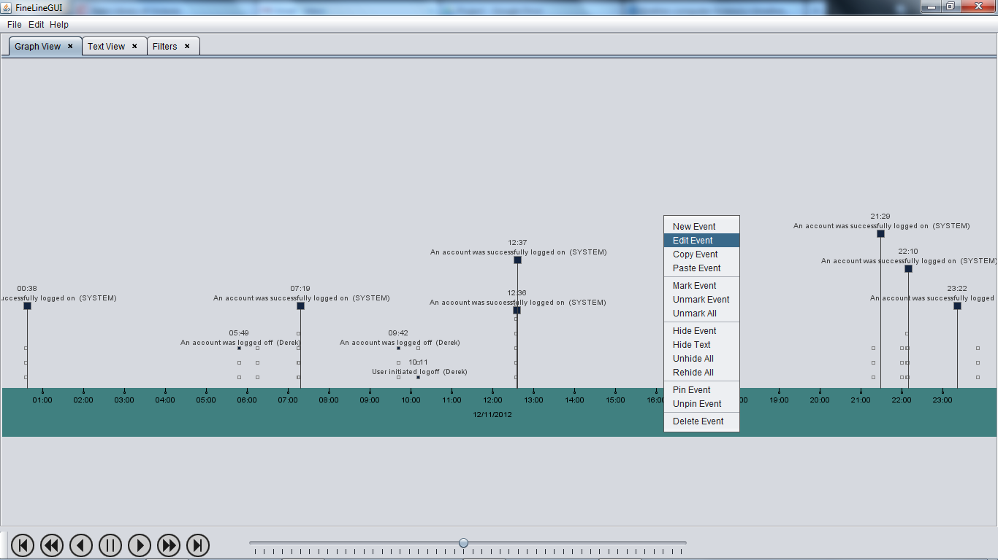

This panel displays the graphical timeline. The timeline can be scrolled by left clicking on the timeline ribbon and dragging it left or right. Events can be added, deleted or edited by right clicking on the event icon and selecting commands from the popup menu. The event height can be changed by left clicking on the event icon and dragging it up or down. To highlight an event hover the mouse cursor over the event icon.

Popup Menu:

New: Open the event editor to create a new event or evidence item.
Edit: Open the event editor for the currently highlighted event.
Copy: Copy the currently highlighted event to the clipboard.
Paste: Past the clipboard content as a new event in the timeline.
Cut: Remove the currently highlighted event and copy to the clipboard.
Mark: Mark the currently highlighted event.
Unmark: Unmark the currently highlighted event.
Unmark All: Remove marks from all events.
Hide Event: Hide the currently highlighted event.
Hide Event Text: Hide the summary text of the currently highlighted event.
Unhide All: Display all currently hidden events.
Pin Event: Keep current event highlighted.
Unpin Event: Remove highlight from current event.
Delete: Delete the currently highlighted event.

Timeline Text View Panel:

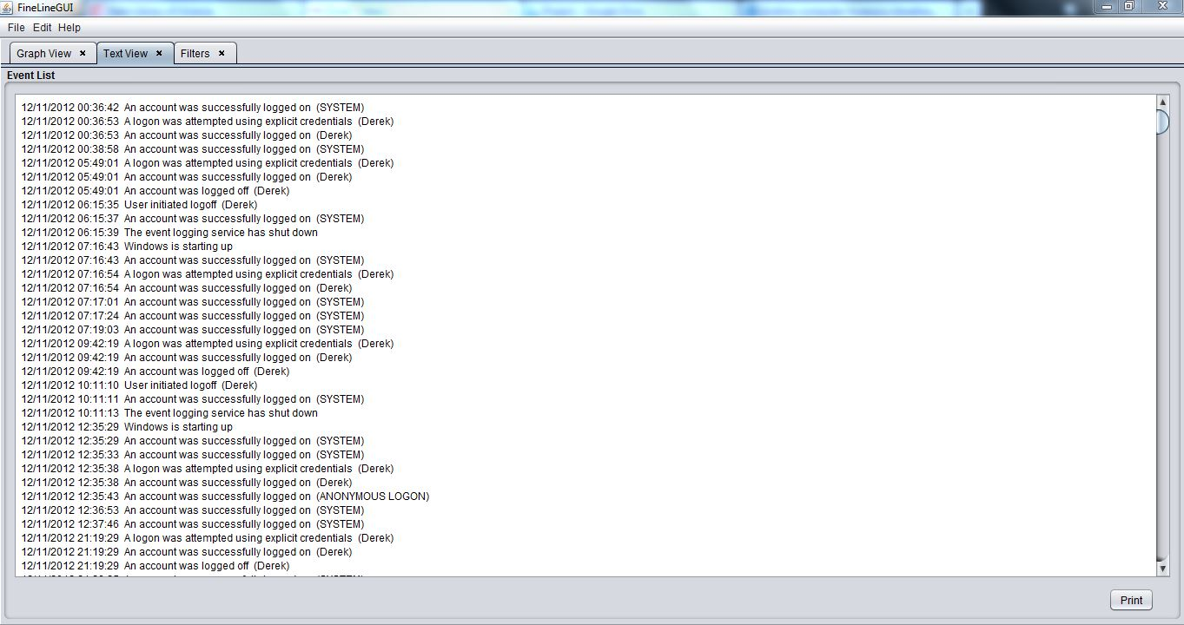

This panel displays a list of the event records.

Print: Print the event list records.

Timeline Filter Panel:

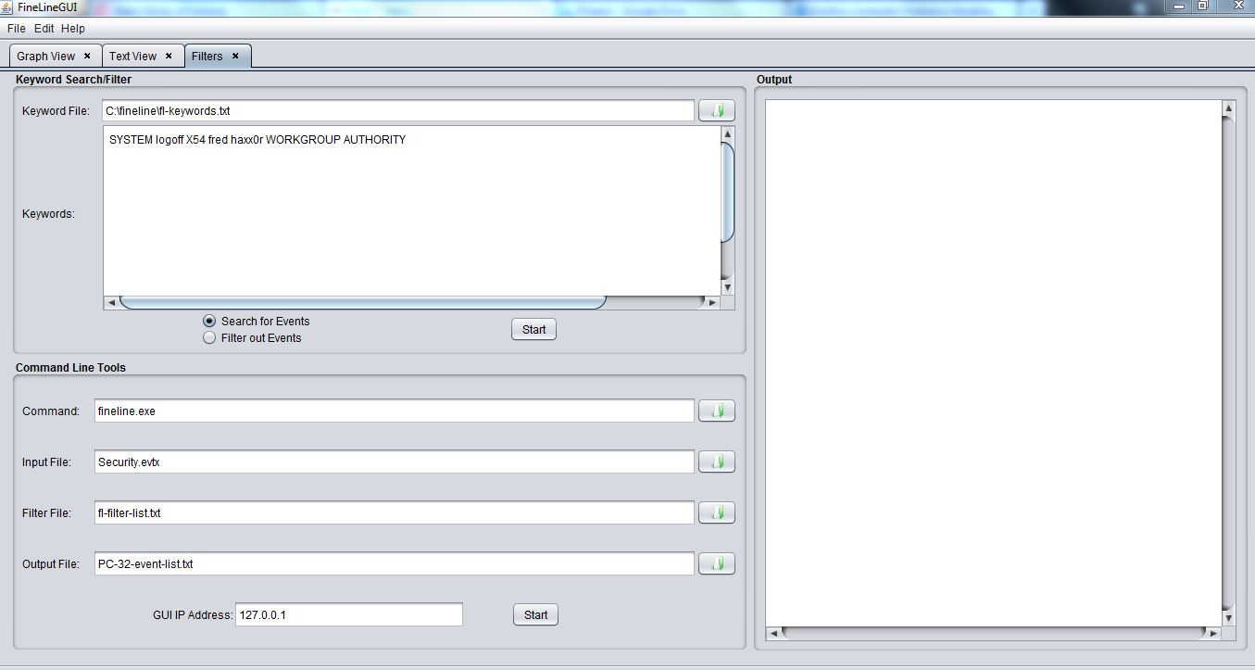

Keyword Search/Filter:

This panel implements event searching and filtering. Keywords can be entered into the text area and/or a keyword file can used. The keyword file should be a plain text file with keywords separated by one or more spaces. When the search function is selected all matching events will be retained on the timeline and non-matching events will be hidden. When the filter function is used all matching events will be hidden and non-matching events will be retained. To undo a search/filter operation, right click on the timeline ribbon and select “Unhide All” from the popup menu.

1. Open a keyword file (Optional).
2. Edit the keyword list.
3. Select Search or Filter.
4. Start the search or filter process.

Command Line Tools:

This panel is used to run the command line tools. Enter the required commands and options into the relevant fields and click on the start button to run the process.

1. Command line programme.
2. Input event file.
3. Output event file name (Optional).
4. GUI IP address (Optional).

Toolbar:

These buttons are used to control the timeline display with scrolling and zooming functions:

1. Go to the beginning of the timeline.
2. Got to previous day/time period.
3. Scroll timeline backward.
4. Pause scrolling.
5. Scroll timeline forward.
6. Go to next day/time period.
7. Go to end of timeline.
8. Zoom timeline in/out.

7. Acknowledgements and Copyright

FineLine was created using the following free development tools:

1. Libevt/libevtx by Joachim Metz (http://code.google.com/p/libevtx/).
2. Uthash by Troy D. Hanson (http://troydhanson.github.io/uthash/).
3. Oracle Java Development Kit 1.7
4. Netbeans IDE 7.4
5. Microsoft Visual C++ 2010 Express
6. LibreOffice 4.1.2.3
7. GNU/Linux Development Toolchain.

8. References

Microsoft. (2007). Fundamental Computer Investigation Guide for Windows. Online at: http://technet.microsoft.com/en-us/library/cc162846.aspx

Microsoft. (2014). Monitoring and Auditing for End systems. Online at: http://technet.microsoft.com/en-us/library/cc750908.aspx

National Security Agency/Central Security Agency. (2013). Spotting the Adversary with Windows Event Log Monitoring. Online at http://www.nsa.gov/ia/_files/app/Spotting_the_Adversary_with_Windows_Event_Log_Monitoring.pdf

9. Issues and Future Development

1. Printing functions not fully implemented and tested.

2. GUI improvements: graph view panel, filter panel and text view panel.

3. Implement log2timeline file import function.

4. Email and web analysis tools.

5. Scripting and automation functions.

