iitgn cdf (caa)
PG Diploma in AI-ML and Agentic AI Engineering, Cohort 2
Major Examination 1
sample paper
Python, pandas and SQL, statistics and analyst technique, with a first look at the ML core
Maximum marks: 70 Week 5 Time allowed: 3 hours
Name Roll number
Signature Invigilator’s signature

Before you begin
1. This booklet holds 40 questions in five sections, an answer sheet for Sections A to D, and a rough-work page. Check that all 20 pages are printed before you begin.
2. Mark your answers to Sections A to D on the answer sheet at the back of the booklet. It is the only page the evaluator reads for those sections, so a mark left only on a question page earns nothing. Write your Section E answers on the lines under each question.
3. There is no negative marking, so answer every question. To change an answer on the answer sheet, shade the old box completely and tick the new one; a row with two ticks scores zero.
4. Read code as Python 3, pandas and PostgreSQL. Question 40 asks for steps in plain words, pseudo-code or code, and syntax is never marked: a slip costs nothing when the logic is right.
5. Every number a question needs is printed with it, and every calculation can be done by hand.
6. Kalpa is fictional. The people named are Meera Raghavan, CEO of Kalpa Retail; Anand Iyer, its finance controller; Kavya Nair, its senior analyst; and Ananya Bose, COO of Kalpa Connect.
7. Pen and this booklet only: no laptop, phone, calculator, notes or AI assistant.
8. Write your roll number at the top of every page.

Section | What you do | Questions | Marks | Suggested minutes | Marks awarded
A | Judge statements about four exhibits | 1 to 15 | 15 | 22
B | Choose the one correct option | 16 to 25 | 20 | 28
C | Order the steps, or find the step that does not belong | 26 to 29 | 8 | 10
D | Read one case, answer six questions on it | 30 to 35 | 12 | 18
E | Justify a stance, or write the steps | 36 to 40 | 15 | 40
 | Total | 1 to 40 | 70 | 118
The suggested minutes add up to 118, about two hours, which leaves an hour of the three-hour sitting for reading and checking.
Section A True or false 15 marks
Decide whether each statement is true or false for the exhibit it refers to, and mark T or F on the answer sheet. Each statement carries 1 mark.
Statements 1 to 4 refer to Exhibit 1, a Python 3 snippet that compares Kalpa Retail’s customers across two quarters.
Exhibit 1. Each list holds the customer on each order, so a customer who ordered twice appears twice.
q1 = ["C-1", "C-2", "C-3", "C-2", "C-4"] # customer on each Q1 order
q2 = ["C-2", "C-5", "C-2", "C-6"] # customer on each Q2 order
q2_amounts = [1200, 800, 400, 600] # amount of each Q2 order, Rs

kept = set(q1) & set(q2)
lost = set(q1) - set(q2)

spend = {}
for cust, amt in zip(q2, q2_amounts):
spend[cust] = spend.get(cust, 0) + amt

ranking = sorted(spend, key=spend.get, reverse=True)
1. | lost holds three customers: C-1, C-3 and C-4.
2. | len(q1) + len(q2) - len(kept) is 8, the number of different customers across the two quarters.
3. | After the loop, spend has three entries, and C-2’s is 1600, since its two Q2 orders are added together.
4. | ranking is [1600, 800, 600], the Q2 spends from largest to smallest.

Statements 5 to 8 refer to Exhibit 2: in October Kalpa Retail ran a new app checkout beside the old one in two cities.
Exhibit 2. Sessions and orders by city and checkout; conversion is orders divided by sessions.
City | Checkout | Sessions | Orders | Conversion
Pune | Old | 800 | 240 | 30%
Pune | New | 200 | 64 | 32%
Patna | Old | 200 | 20 | 10%
Patna | New | 800 | 96 | 12%
Both cities | Old | 1,000 | 260 | 26%
Both cities | New | 1,000 | 160 | 16%

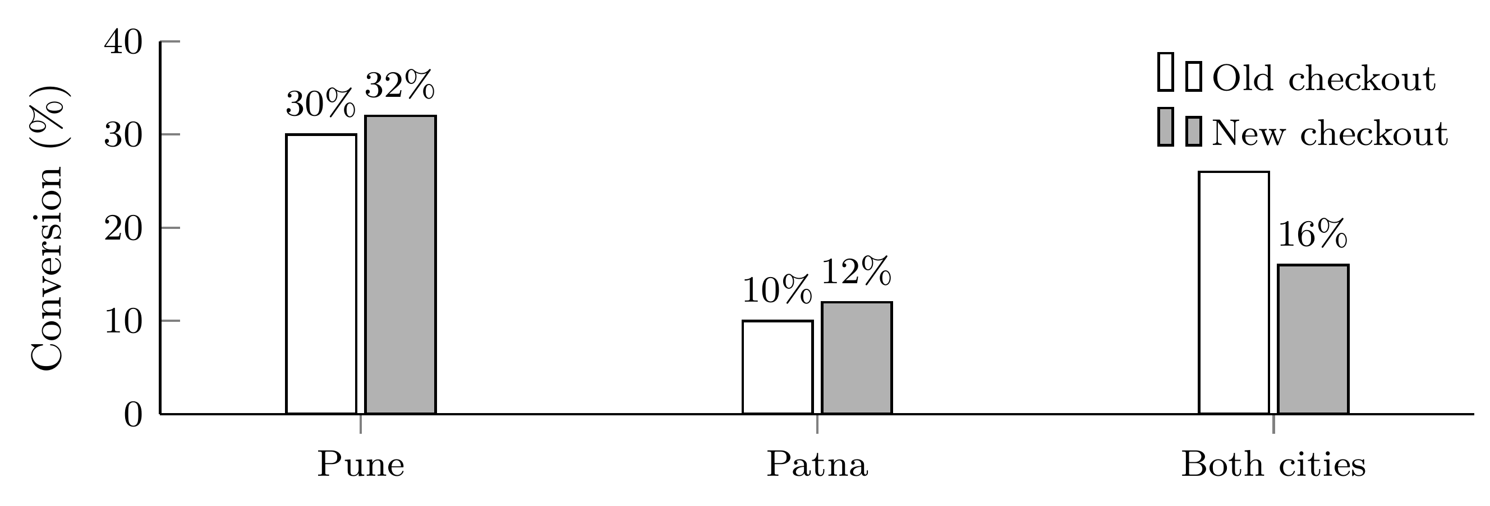
5. | In each city, the new checkout converted 2 points better than the old one.
6. | Since the new checkout won in both cities, it must also win when the two cities are added together.
7. | The combined figures favour the old checkout because 800 of the new checkout’s 1,000 sessions came from Patna, where every checkout converts poorly.
8. | Kavya should report the combined 26 against 16 percent, since it uses all 2,000 sessions.

Statements 9 to 12 refer to Exhibit 3, the checkout funnel of the Kalpa Retail app in two months, counted in sessions.
Exhibit 3. Sessions reaching each step of the app checkout.
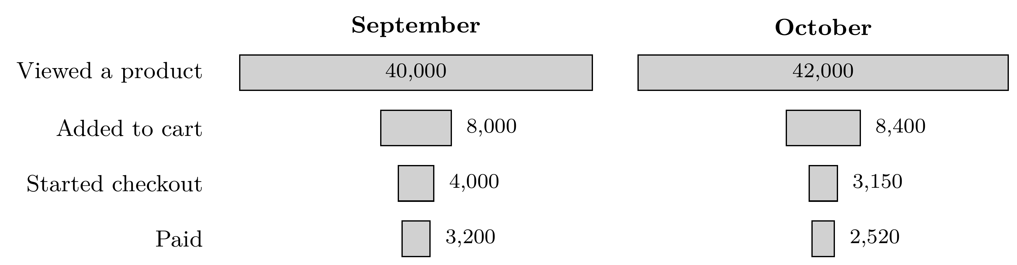
9. | The step that moved between the two months is the one from adding to cart to starting checkout.
10. | In October, 7.5 percent of the sessions that viewed a product went on to pay.
11. | Viewing to adding is the lowest step in both months, so it is the first place to look for the cause of October’s fall.
12. | From September to October, conversion from viewing a product to paying fell by 2 percentage points, which is a fall of one quarter.

Statements 13 to 15 refer to Exhibit 4: a model that flags Retail-Plus members for a festive offer, scored on 2,000 validation members, 80 of whom bought within the offer window.
Exhibit 4. The model’s four boxes on the 2,000 validation members.
 | Bought | Did not buy
Flagged by the model | 30 | 30
Not flagged | 50 | 1,890

13. | The model’s accuracy, 0.96, is the same as the accuracy of flagging nobody.
14. | Half of the flagged members bought, and the model found fewer than half of all the members who bought.
15. | If an offer to a member who does not buy wastes Rs 150 and a missed buyer costs Rs 1,350, the model’s flagging threshold, now 0.5, should rise so that fewer members get the offer.

Section B One correct option 20 marks
Each question has exactly one right answer: mark its letter on the answer sheet. Where a question asks for the incorrect statement, the right answer is the one statement that is false. Each question carries 2 marks.
16. Kavya Nair fitted a straight line to 40 Retail-Plus members, relating each member’s app visits in a month, between 1 and 10, to their spend that month.
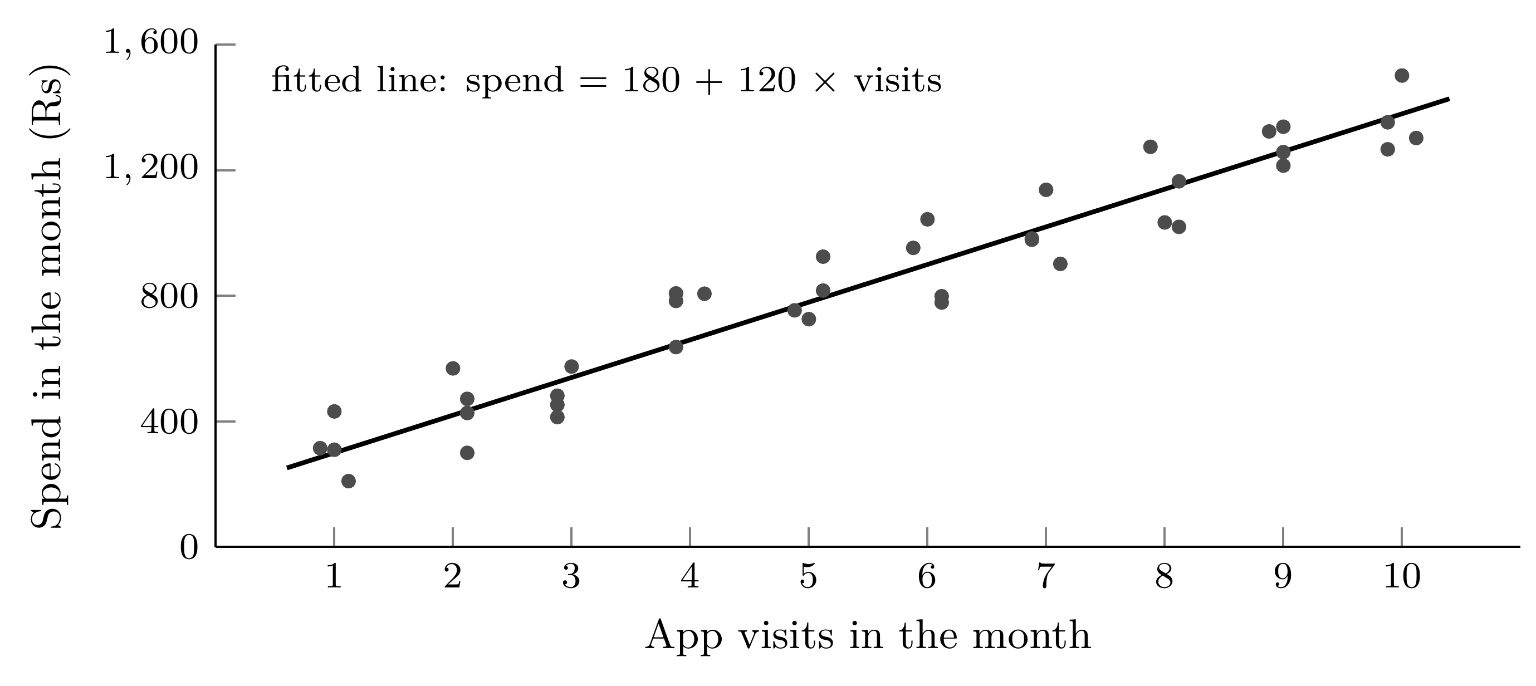
key facts
Fitted line | spend = Rs 180 + Rs 120 × visits
Members | 40, each with 1 to 10 visits in the month

Which reading of the line holds?
(A) With 5 visits the line predicts Rs 600 of spend: 5 visits at Rs 120 each.
(B) With 30 visits the line predicts Rs 3,780, as safely as at any other point.
(C) With 5 visits it predicts Rs 780, and each extra visit goes with Rs 120 more.
(D) Getting any member to visit once more will raise that member’s spend by Rs 120.

17. Kavya Nair wants to know whether the same 300 Retail-Plus members spent more in Q2 than in Q1. She has each member’s spend in both quarters.
key facts
Members | the same 300 in both quarters
Data | each member’s Q1 spend and Q2 spend
Question | did spend rise from Q1 to Q2?

Which comparison matches how the data was collected?
(A) A paired test on each member’s Q2 less Q1, asking whether the average change is above zero.
(B) A two-sample test that treats Q1 and Q2 as two separate groups of 300 and compares their means.
(C) No test at all: if the Q2 average is higher than the Q1 average, spend has risen.
(D) A test of the 300 Q2 figures alone against Kalpa’s spend target of Rs 2,000.

18. Kalpa Retail took twelve Business orders in October, plotted below in Rs lakh. Kavya Nair flags any order more than two standard deviations above the mean for checking, then reports a typical order. Finance has confirmed that the Rs 30 lakh bulk order is genuine.
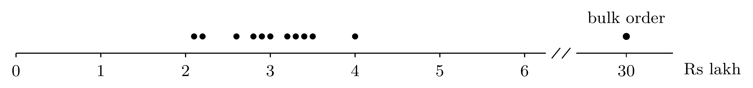
key facts
The twelve orders, in Rs lakh | 2.1, 2.2, 2.6, 2.8, 2.9, 3.0, 3.2, 3.3, 3.4, 3.5, 4.0 and 30.0
Mean; standard deviation | Rs 5.25 lakh; Rs 7.5 lakh
The bulk order | Rs 30 lakh, confirmed genuine by Finance

What should her note say?
(A) Bulk order flagged and removed; typical order Rs 3.0 lakh, the mean of the other eleven.
(B) Bulk order flagged and kept; typical order Rs 5.25 lakh, the mean of all twelve.
(C) Bulk order flagged and kept; typical order Rs 3.0 lakh, the sixth order, counted upward.
(D) Bulk order flagged and kept; typical order Rs 3.1 lakh, the median of the twelve.

19. The head of Retail-Plus wants the three members who spent the most in October, counting delivered orders only. Kavya Nair pulls the month’s orders, one row per order:
Order | Member | Amount (Rs) | Status
KR-21 | M-01 | 9,000 | Delivered
KR-22 | M-02 | 4,000 | Delivered
KR-23 | M-03 | 8,500 | Delivered
KR-24 | M-05 | 4,500 | Cancelled
KR-25 | M-02 | 4,500 | Delivered
KR-26 | M-04 | 7,000 | Delivered
KR-27 | M-05 | 6,000 | Delivered
KR-28 | M-01 | 1,000 | Delivered
KR-29 | M-02 | 3,500 | Delivered
KR-30 | M-04 | 2,000 | Delivered

key facts
One row is | one order
Spend counts | delivered orders only
Wanted | the three members with the highest spend

Which three members should the list name?
(A) M-01, M-03 and M-04
(B) M-01, M-02 and M-04
(C) M-01, M-03 and M-05
(D) M-01, M-02 and M-05

20. Meera Raghavan’s Monday front page carries one line for each customer segment. For Retail-Plus, Kavya Nair has Q1 revenue (April to June) of Rs 5.86 lakh and Q2 revenue (July to September) of Rs 4.14 lakh. Company revenue in Q2 was Rs 9.84 crore.
key facts
Retail-Plus, Q1 (April to June) | Rs 5.86 lakh
Retail-Plus, Q2 (July to September) | Rs 4.14 lakh
Company revenue, Q2 | Rs 9.84 crore

Which line should go on the front page?
(A) Retail-Plus, Q2: Rs 4.14 lakh, down 41.5 percent on Q1’s Rs 5.86 lakh; 0.4 percent of company revenue.
(B) Retail-Plus, Q2: Rs 4.14 lakh, down 70.6 percent on Q1’s Rs 5.86 lakh; 0.4 percent of company revenue.
(C) Retail-Plus, Q2: Rs 4.14 lakh, down 29.4 percent on Q1’s Rs 5.86 lakh; 0.4 percent of company revenue.
(D) Retail-Plus, Q2: Rs 4.14 lakh, down 29.4 percent on Q1’s Rs 5.86 lakh; 4.2 percent of company revenue.

21. In early December, Kavya Nair is asked whether demand at Kalpa Retail is growing. Diwali fell in the third week of October last year and in the second week of November this year.
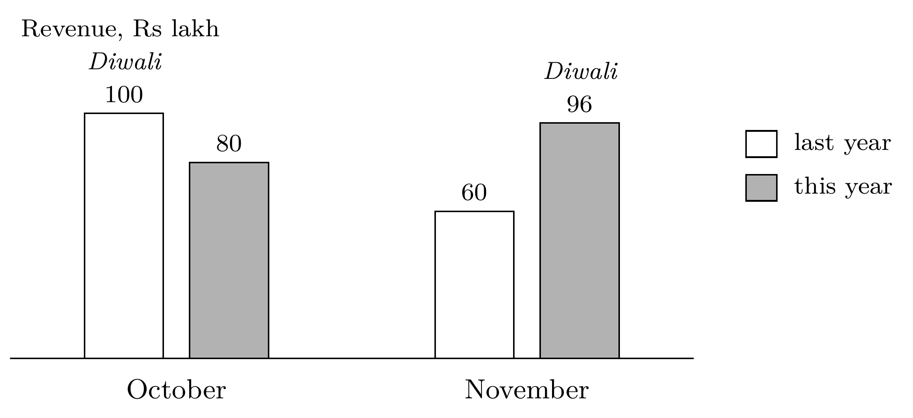
key facts
October revenue | Rs 1 crore last year; Rs 80 lakh this year
November revenue | Rs 60 lakh last year; Rs 96 lakh this year
Diwali | third week of October last year; second week of November this year

Which reading should she report?
(A) Up 10 percent: October and November, year on year.
(B) Down 20 percent: October alone, year on year.
(C) Up 60 percent: November alone, year on year.
(D) Up 20 percent: this November against this October.

22. Kalpa Retail gave a festive coupon to 400 of its 800 Retail-Core customers, picked at random. Over the next month the coupon group spent Rs 210 more per customer than the rest. Kavya Nair shuffled the coupon labels 2,000 times: in 30 shuffles the coupon group came out ahead by Rs 210 or more, and in 58 the gap was Rs 210 or more in either direction.
key facts
Coupon | 400 of 800 customers, picked at random
Gap in spend | Rs 210 per customer, coupon group ahead
Label shuffles | 2,000
Coupon group ahead by Rs 210 or more | 30 shuffles
Gap of Rs 210 or more, either way | 58 shuffles

Which sentence belongs in the note?
(A) There is a 1.5 percent chance that the coupon made no difference to spend.
(B) The coupon beat chance, so its extra spend more than covers the cost of the discount.
(C) In 1.5 percent of chance-only worlds, the gap was Rs 210 or more in either direction.
(D) In 1.5 percent of chance-only worlds, the coupon group led by Rs 210 or more.

23. Of 2,000 Kalpa Retail baskets, 200 hold an A5 notebook, 400 hold a pen set, and 120 hold both. The head of merchandising notes that 60 percent of notebook buyers take a pen set, while only 30 percent of pen-set buyers take a notebook, and concludes that the pull runs one way.
key facts
Baskets | 2,000
With an A5 notebook | 200
With a pen set | 400
With both | 120

Which statement is correct?
(A) Lift is 0.6 one way and 0.3 the other, so the pull runs only from notebook to pen set.
(B) Lift is 3.0 both ways, so offering a pen set to notebook buyers is a sound cross-sell.
(C) Lift is 3.0 from notebook to pen set and 1.5 back, since pen sets are more common.
(D) Lift is 3.0 both ways, so offering notebook buyers a pricier notebook is a sound upsell.

24. An analyst builds a spend table for four Retail-Plus members in pandas:
members = pd.DataFrame({"member": ["M-1", "M-2", "M-3", "M-4"]})
orders = pd.DataFrame({"member": ["M-1", "M-1", "M-3"],
"amount": [500, 300, 400]})

spend = orders.groupby("member", as_index=False)["amount"].sum()
table = members.merge(spend, on="member", how="left")
print(len(table), table["amount"].mean())
What does the last line print, and why?
(A) 4 600.0: all four members stay, and the mean skips the two blanks.
(B) 4 300.0: all four members stay, and the two blanks count as zero.
(C) 2 600.0: only the two members with orders survive the merge.
(D) 3 400.0: the merged table holds one row for each of the three orders.

25. Three Kalpa Retail orders and the payments against them sit in two PostgreSQL tables. KR-1 was paid in two instalments, and KR-2 has not been paid. An analyst runs the query below.
orders |  |  | payments
order_id | amount |  | payment_id | order_id | amount
KR-1 | 1,000 |  | P-1 | KR-1 | 600
KR-2 | 500 |  | P-2 | KR-1 | 400
KR-3 | 2,000 |  | P-3 | KR-3 | 2,000

SELECT COUNT(*) AS rows_out, SUM(o.amount) AS booked
FROM orders o
LEFT JOIN payments p ON p.order_id = o.order_id;
What does the query return?
(A) rows_out is 3 and booked 3,500: a LEFT JOIN gives one row per order.
(B) rows_out is 3 and booked 4,000: KR-2 drops out, having no payment.
(C) rows_out is 4 and booked 4,500: KR-1 appears once per payment.
(D) rows_out is 4 and booked 3,500: SUM counts each order only once.

Section C Ordering 8 marks
Questions 26 and 27: write the letters of the steps in the order the steps must happen. Questions 28 and 29: write the letter of the one step that does not belong. Each question carries 2 marks, and an order with a single pair of neighbouring steps swapped earns 1.
26. Meera wants the customer with the fifth-highest delivered revenue in 2025. The pseudo-code below solves it, one line per step. Put the lines in the order they must run.
(P) ordered = totals sorted by revenue, highest first
(Q) delivered = orders in 2025 with status "delivered"
(R) answer = the customer in ranked with rank 5
(S) totals = revenue summed per customer in delivered
(T) ranked = ordered with ranks 1, 2, 3, ... (ties share)

27. The head of Retail-Plus asks whether newer members keep ordering as well as older ones. Put the steps of the cohort table in the order they must happen.
(P) Divide each count by the number of members who joined in that cohort’s month.
(Q) Give each member a cohort: the calendar month in which they joined.
(R) Read the cohorts side by side at the same age, never down one calendar month.
(S) Work out each order’s age in months, counting the cohort month as age zero.
(T) For each cohort and each age, count the members who ordered at that age.

28. Of Kalpa’s customers, 300 ordered only in 2024, 500 in both years and 200 only in 2025. A trainee writes the steps below to list the customers who ordered in 2025 but not in 2024. Which step does not belong?
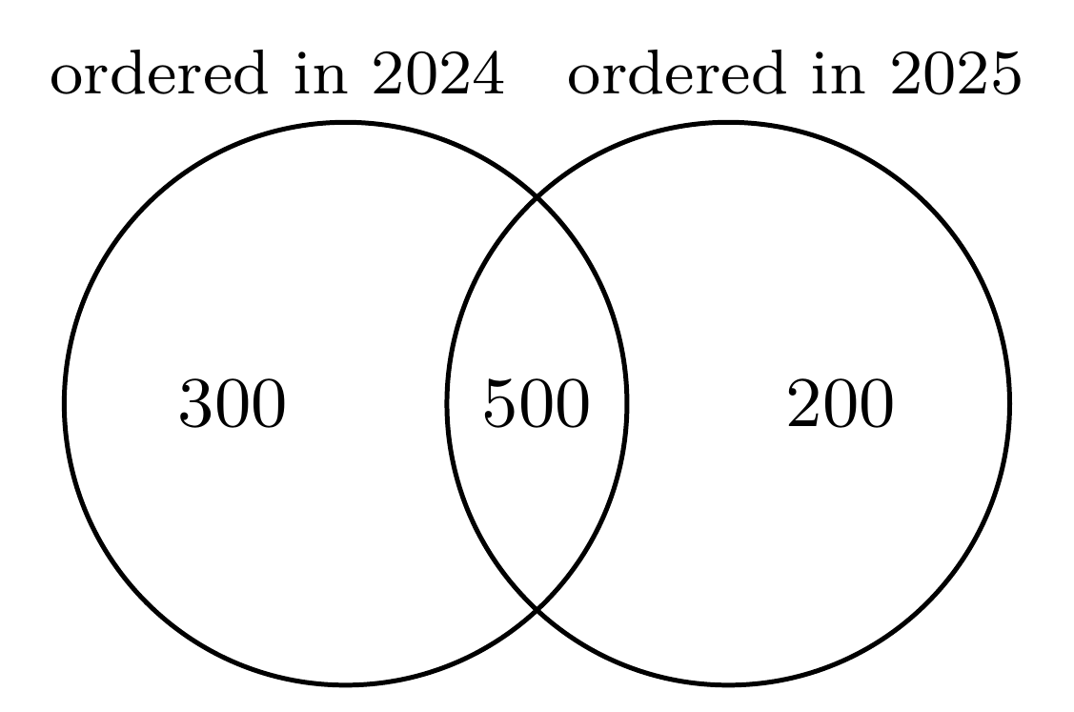
(P) List the distinct customer ids with an order in 2025.
(Q) List the distinct customer ids with an order in 2024.
(R) Keep only the customers with exactly one order in 2025.
(S) Take the 2025 ids that do not appear in the 2024 list.
(T) Check that the result holds 200 customers, the count in the diagram.
(U) Report the list, with its count beside it.

29. A trainee’s plan for a model that flags Retail-Plus members likely to buy again within ninety days runs in the order below. Which step does not belong?
(P) Seal a test slice before anything else is built, and put it away.
(Q) Split the rest into training and validation, each with the same buyer share.
(R) Fit the model on the training rows only.
(S) Compare the model with flagging nobody, on the validation rows.
(T) Tune the threshold on the test slice until its score peaks.
(U) Open the test slice once, at the end, for the committee.

Section D Scenario set 12 marks
Read the case and its exhibits once, then answer questions 30 to 35 from them. Each question has one correct option and carries 2 marks.
Case: is broadband retention slipping at Kalpa Connect?
[1] Kalpa Connect sells home broadband through two channels: its stores, and an online offer that gives a new subscriber the first month free. On 5 October Ananya Bose, the COO, saw a dashboard tile showing that month-one retention, the share of a month’s new subscribers who are paying one month after they joined, was lower for the July cohort than for the June cohort. The head of retention blames the new customer-care script that went live in July and wants it withdrawn before Friday’s review.
[2] Exhibit 5 breaks the two cohorts down by channel. A cohort is everyone who joined in one calendar month, and age is counted from that month, as Exhibit 6 shows. The August cohort is also live. A third channel, a partner kiosk in one mall, signed 8 subscribers in June and kept 6, and signed 12 in July and kept 11.
[3] Ananya wants a note from the analytics team before Friday, and a single retention number that the team will be measured on from next quarter.
key facts
Data pulled | 5 October
Channels | stores; an online offer with the first month free; a partner kiosk
Month-one retention | joiners still paying one month after joining, over all who joined that month
Age | counted in calendar months, the joining month being age zero
Care script | live from July
Partner kiosk | kept 6 of 8 in June and 11 of 12 in July

Exhibit 5. Month-one retention by cohort and channel, as pulled on 5 October.
Cohort | Channel | Joined | Paying at month one
June | Stores | 800 | 720
June | Online offer | 200 | 140
July | Stores | 800 | 720
July | Online offer | 1,200 | 840

Exhibit 6. How age is counted, shown for the June and July cohorts: each age is one whole calendar month.
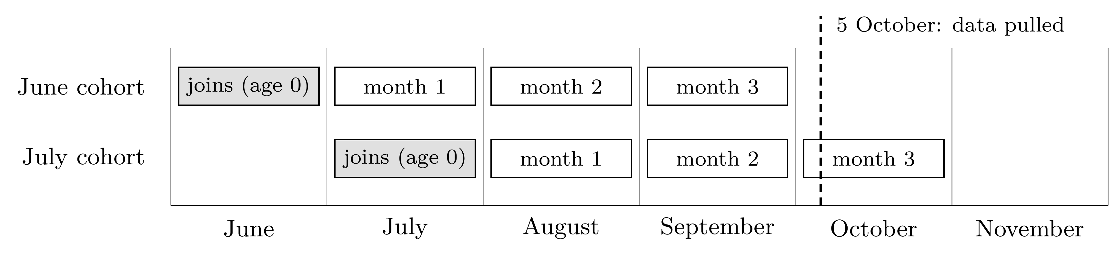

30. Which reading of Exhibit 5 holds?
(A) Both channels kept a smaller share of their July joiners than of their June joiners.
(B) The stores kept fewer of their July joiners, which places the script’s failure in stores.
(C) The online offer’s month-one retention fell from 90 percent in June to 70 percent in July.
(D) Each channel kept its June rate in July, and more July joiners took the online offer.

31. What is July’s month-one retention across both channels?
(A) 80 percent, the mean of the two channels’ month-one rates.
(B) 78 percent: 1,560 still paying out of the 2,000 who joined in July.
(C) 81 percent: 2,420 still paying out of the 3,000 who joined in June and July.
(D) 70 percent, the rate of the channel that signed most of July’s subscribers.

32. Ananya asks when the August cohort’s month-two retention can first be read in full.
(A) Already, on 5 October, from the days of October so far.
(B) On 1 October, once September had closed.
(C) On 1 November, once October has closed.
(D) On 1 December, once November has closed.

33. How should the note treat the partner kiosk, which kept 6 of 8 June subscribers and 11 of 12 in July?
(A) As a lead: on 8 and 12 subscribers, one person moves the rate by about 8 to 13 points.
(B) As a finding: a rise from 75 to 92 percent is the largest move anywhere in the case.
(C) As noise: the move is two or three people, so the note should leave the kiosk out.
(D) As proof that kiosks retain best, since 92 percent beats the stores and the online offer.

34. Ananya wants one retention number that the team will be measured on from next quarter. Which row defines it soundly?
 | Numerator | Denominator | Window | Exclusions
(A) | Subscribers paying at month three | Those still paying at month one | Whenever the tile is refreshed | Staff and test accounts
(B) | Subscribers paying at month three | Everyone who joined in the month | Month three of each cohort | Staff and test accounts
(C) | Subscribers paying at month three | Everyone who joined in the month | Whenever the tile is refreshed | Cancellations in the free month
(D) | Subscribers paying at month three | Everyone who joined in the month | Month three of each cohort | Cancellations in the free month

35. Which action should the note to Ananya recommend?
(A) Withdraw the script, report retention by channel, and price the online offer.
(B) Keep the script, report retention by channel, and stop the online offer.
(C) Keep the script, report the blended tile alone, and price the online offer.
(D) Keep the script, report retention by channel, and price the online offer.

Section E Justify, or write the steps 15 marks
Questions 36 to 39: each claim was made by a Kalpa colleague. Circle agree or disagree, then justify your stance in three to five sentences, naming the idea that decides it and applying it to the numbers given; 1 mark is for the stance and 2 for the justification. Question 40: write the steps in plain words, pseudo-code, SQL or pandas; it is marked on the logic, and syntax is not marked. Each question carries 3 marks.
36. Kalpa Retail’s October file holds 1,000 Business orders, with a mean of Rs 5.25 lakh and a standard deviation of Rs 7.5 lakh. Fourteen orders lie more than two standard deviations above the mean, beyond Rs 20.25 lakh. Finance has confirmed 11 of them as genuine bulk orders; the other 3 carry an extra zero typed by mistake. A trainee writes:
key facts
Orders; mean; standard deviation | 1,000; Rs 5.25 lakh; Rs 7.5 lakh
Beyond mean + 2 standard deviations | 14 orders, above Rs 20.25 lakh
Finance’s check of the 14 | 11 genuine bulk orders; 3 with an extra zero

“Orders beyond two standard deviations are errors, so delete all 14 before we report the average order value.”
Circle one: agree disagree

37. Of the 600 orders in Kalpa Retail’s October export, 450 carry a discount amount, averaging Rs 120, and 200 of those 450 show a discount of Rs 0. The other 150 have the discount field blank. A trainee writes:
key facts
Orders | 600
Discount recorded | 450 orders, averaging Rs 120; 200 of them show Rs 0
Discount field blank | 150 orders

“Blank means no discount was given, so fill the blanks with 0 and report the average discount as Rs 90 across all 600 orders.”
Circle one: agree disagree

38. Members who opened Kalpa Retail’s loyalty email spent Rs 260 more over the next month than members who did not open it. Kavya Nair shuffled the opened and not-opened labels 2,000 times, and in 4 shuffled worlds the openers came out ahead by Rs 260 or more. She writes:
key facts
Gap in spend | openers ahead by Rs 260 a member, over the next month
Label shuffles | 2,000
Shuffles with openers ahead by Rs 260 or more | 4

“The gap is real, but we cannot yet say that the email caused it.”
Circle one: agree disagree

39. For one month Kalpa Retail gave phone buyers Rs 100 off a screen guard. Phone sales matched the month before, when 2,400 phone buyers took a screen guard at full price; with the offer, 3,000 did. A screen guard earns Rs 150 of margin at full price, and setting up the offer cost Rs 20,000. The marketing lead writes:
key facts
Offer | Rs 100 off a screen guard, for phone buyers, one month
Phone sales | the same as the month before
Guards sold the month before, at full price | 2,400
Guards sold with the offer | 3,000
Margin on a guard at full price | Rs 150
Cost of setting up the offer | Rs 20,000

“The offer sold 3,000 screen guards, Rs 4,50,000 of margin, so it paid for itself many times over.”
Circle one: agree disagree

40. Kalpa Retail’s orders table has one row per order, with the order id, customer id, city, order date, amount and status. Meera wants each city’s October revenue growth on September, counting delivered orders only, and a list of the cities where revenue fell by more than 10 percent.
key facts
One row is | one order
Revenue counts | delivered orders only
Growth | October on September, for each city
Flag | cities where revenue fell by more than 10 percent

Write the steps. Plain words, pseudo-code, SQL or pandas are all accepted, and syntax is not marked.

Answer sheet for Sections A to D
Tick one box in each row. To change an answer, shade the old box completely and tick the new one. For questions 26 and 27, write one step letter in each box, first step on the left; for questions 28 and 29, write one letter.
Section A. True or false, questions 1 to 15: tick T or F.
1 | t |  | f |  | 6 | t |  | f |  | 11 | t |  | f
2 | t |  | f |  | 7 | t |  | f |  | 12 | t |  | f
3 | t |  | f |  | 8 | t |  | f |  | 13 | t |  | f
4 | t |  | f |  | 9 | t |  | f |  | 14 | t |  | f
5 | t |  | f |  | 10 | t |  | f |  | 15 | t |  | f
Section B. One correct option, questions 16 to 25: tick one letter.
16 | a |  | b |  | c |  | d |  | 21 | a |  | b |  | c |  | d
17 | a |  | b |  | c |  | d |  | 22 | a |  | b |  | c |  | d
18 | a |  | b |  | c |  | d |  | 23 | a |  | b |  | c |  | d
19 | a |  | b |  | c |  | d |  | 24 | a |  | b |  | c |  | d
20 | a |  | b |  | c |  | d |  | 25 | a |  | b |  | c |  | d
Section C. Ordering, questions 26 to 29: write the letters.
26 | the steps in order, first on the left

27 | the steps in order, first on the left

28 | the step that does not belong

29 | the step that does not belong

Section D. Scenario set, questions 30 to 35: tick one letter.
30 | a |  | b |  | c |  | d |  | 33 | a |  | b |  | c |  | d
31 | a |  | b |  | c |  | d |  | 34 | a |  | b |  | c |  | d
32 | a |  | b |  | c |  | d |  | 35 | a |  | b |  | c |  | d

For the evaluator | Section A | Section B | Section C | Section D | A to D
Marks | / 15 | / 20 | / 8 | / 12 | / 55

Rough work. Nothing on this page is marked.

