iitgn cdf (caa)
PG Diploma in AI-ML and Agentic AI Engineering, Cohort 2
Major Examination 1: Answer Key and Marking Scheme
sample paper
For evaluators. This document is not shared with learners.
Answers at a glance
Sections A to D in order. Section A: True or False. Sections B and D: the option letter. Section C: the letters of the steps.
Q | Key |  | Q | Key |  | Q | Key |  | Q | Key
1 | True |  | 16 | C |  | 26 | Q S P T R |  | 30 | D
2 | False |  | 17 | A |  | 27 | Q S T P R |  | 31 | B
3 | True |  | 18 | D |  | 28 | R |  | 32 | C
4 | False |  | 19 | B |  | 29 | T |  | 33 | A
5 | True |  | 20 | C |  |  |  |  | 34 | B
6 | False |  | 21 | A |  |  |  |  | 35 | D
7 | True |  | 22 | D
8 | False |  | 23 | B
9 | True |  | 24 | A
10 | False |  | 25 | C
11 | False
12 | True
13 | True
14 | True
15 | False
Section E is marked against its anchors (pages that follow). The stance the evidence supports: 36 disagree, 37 disagree, 38 agree, 39 disagree. Question 40 is marked on the steps alone.
How to mark this paper
1. Mark Sections A to D from the answer sheet only, against the answers at a glance: 1 mark for each Section A statement judged correctly, and 2 marks for each correct answer in Sections B, C and D.
2. A shaded box counts as withdrawn. A row with two ticks, or with none, scores zero, and no marks are deducted for a wrong answer.
3. Questions 26 and 27 earn 2 marks for the exact order and 1 mark when a single pair of neighbouring steps is swapped; any other order scores 0. Questions 28 and 29 earn 2 marks for the right letter and 0 otherwise.
4. Mark Section E against the anchors on its pages, one question across all scripts before moving to the next, so that the anchors stay fixed.
5. Enter the section totals on the answer sheet’s evaluator strip and on the cover’s marks table, and total out of 70.
6. A second evaluator re-marks Section E on one script in five and on every script within two marks of a grade floor. A difference of more than one mark on a question goes to the paper setter.
7. After marking, flag any question that fewer than one learner in five answered correctly, or that the bottom third of the room answered correctly more often than the top third, and send it to the paper setter with its rates: the fault may sit in the question.
The blueprint
Area | A | B | C | D | E | Marks | Share
Python, pandas and SQL | 4 | 6 | 4 |  | 3 | 17 | 24 percent
Data quality and reporting |  | 2 |  | 2 | 6 | 10 | 14 percent
Statistics: summaries, tests and cause | 4 | 6 |  | 6 | 3 | 19 | 27 percent
Analyst technique | 4 | 4 | 2 | 4 | 3 | 17 | 24 percent
ML core | 3 | 2 | 2 |  |  | 7 | 10 percent
Total | 15 | 20 | 8 | 12 | 15 | 70
Marks by level: easy 23 (33 percent), medium 37 (53 percent), hard 10 (14 percent). Marks by week: W1 29, W2 15, W4 19, W5 7.
What guessing alone would score
A learner who marked every objective question at random would average about 16.3 marks of 70 (23 percent), and Section E cannot be guessed. Scores in that region say little about what a learner knows.
Section A. True or false (15 marks)
Statements 1 to 4: the Python snippet in Exhibit 1
Exhibit 1. Each list holds the customer on each order, so a customer who ordered twice appears twice.
q1 = ["C-1", "C-2", "C-3", "C-2", "C-4"] # customer on each Q1 order
q2 = ["C-2", "C-5", "C-2", "C-6"] # customer on each Q2 order
q2_amounts = [1200, 800, 400, 600] # amount of each Q2 order, Rs

kept = set(q1) & set(q2)
lost = set(q1) - set(q2)

spend = {}
for cust, amt in zip(q2, q2_amounts):
spend[cust] = spend.get(cust, 0) + amt

ranking = sorted(spend, key=spend.get, reverse=True)
the working kept is {C-2} and lost is {C-1, C-3, C-4}. spend is {"C-2": 1600, "C-5": 800, "C-6": 600}, and ranking is ["C-2", "C-5", "C-6"]. The lists hold 5 and 4 orders from 4 and 3 different customers, 6 across both quarters.
Q | Statement | Key | Why
1 | lost holds three customers: C-1, C-3 and C-4. | True | set(q1) is {C-1, C-2, C-3, C-4} and set(q2) is {C-2, C-5, C-6}; taking away the Q2 customers leaves C-1, C-3 and C-4, who ordered in Q1 and not in Q2.
2 | len(q1) + len(q2) - len(kept) is 8, the number of different customers across the two quarters. | False | The expression is 5 + 4 - 1 = 8, but the lists count orders, and C-2 appears twice in each. Different customers are len(set(q1) | set(q2)) = 4 + 3 - 1 = 6. Misstep: orders counted as customers.
3 | After the loop, spend has three entries, and C-2’s is 1600, since its two Q2 orders are added together. | True | .get(cust, 0) starts each new customer at 0 and the loop adds every order: C-2 gets 1,200 + 400 = 1,600, C-5 800 and C-6 600.
4 | ranking is [1600, 800, 600], the Q2 spends from largest to smallest. | False | Sorting a dictionary sorts its keys, and key=spend.get only decides their order, so ranking is ["C-2", "C-5", "C-6"], the customers from the biggest spender down.
Statements 5 to 8: the checkout test in Exhibit 2
Exhibit 2. Sessions and orders by city and checkout; conversion is orders divided by sessions.
City | Checkout | Sessions | Orders | Conversion
Pune | Old | 800 | 240 | 30%
Pune | New | 200 | 64 | 32%
Patna | Old | 200 | 20 | 10%
Patna | New | 800 | 96 | 12%
Both cities | Old | 1,000 | 260 | 26%
Both cities | New | 1,000 | 160 | 16%

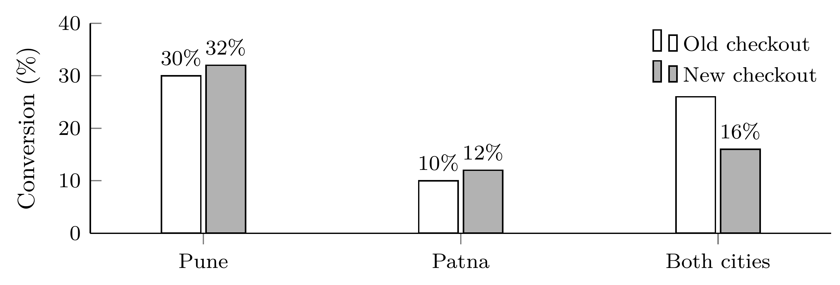
the working Inside each city the new checkout leads by 2 points; in total it trails, 16 against 26 percent, because 800 of its 1,000 sessions came from Patna against 200 of the old checkout’s. City decides both conversion and which checkout a session saw, so it confounds the total.
Q | Statement | Key | Why
5 | In each city, the new checkout converted 2 points better than the old one. | True | Pune: 64 / 200 = 32 percent against 240 / 800 = 30 percent. Patna: 96 / 800 = 12 percent against 20 / 200 = 10 percent.
6 | Since the new checkout won in both cities, it must also win when the two cities are added together. | False | Added together it converts 160 / 1,000 = 16 percent against the old checkout’s 260 / 1,000 = 26 percent. Winning inside every group does not guarantee winning in the total: this reversal is Simpson’s paradox.
7 | The combined figures favour the old checkout because 800 of the new checkout’s 1,000 sessions came from Patna, where every checkout converts poorly. | True | City drives conversion and also decided which checkout a session saw, so it confounds the total: the new checkout’s total is weighed down by Patna’s low base, while the old checkout’s sessions sit mostly in Pune.
8 | Kavya should report the combined 26 against 16 percent, since it uses all 2,000 sessions. | False | The fair comparison holds city fixed: compare inside each city, or give both checkouts the same city mix. Using every session does not help when the mix differs. Misstep: a confounded total read as the answer.
Statements 9 to 12: the funnel in Exhibit 3
Exhibit 3. Sessions reaching each step of the app checkout.
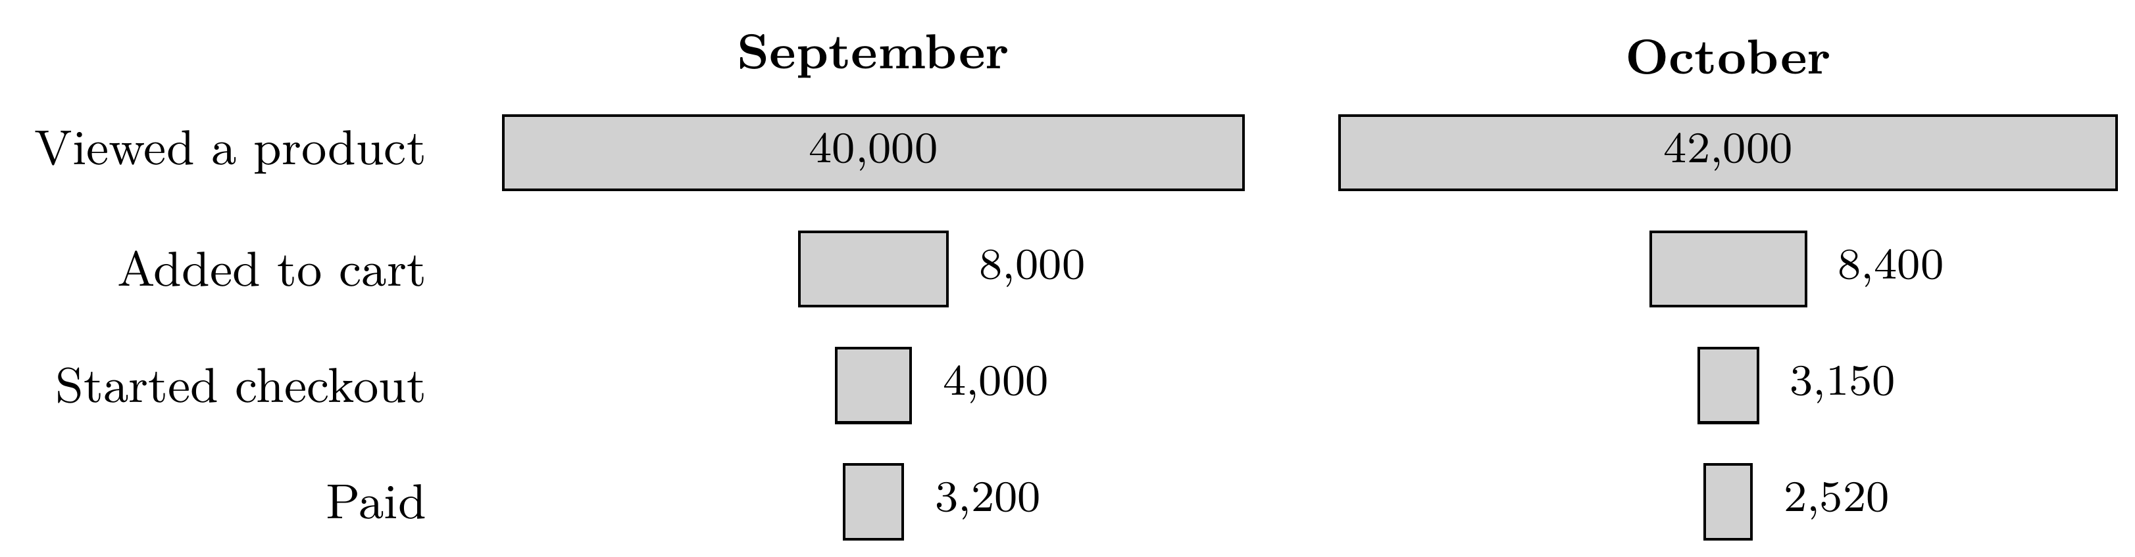
the working Step rates, September then October: view to cart 20 and 20 percent; cart to checkout 50 and 37.5 percent; checkout to pay 80 and 80 percent. End to end: 8 percent and 6 percent, a fall of 2 points, which is a quarter of 8.
Q | Statement | Key | Why
9 | The step that moved between the two months is the one from adding to cart to starting checkout. | True | View to cart is 20 percent in both months and checkout to pay 80 percent in both; cart to checkout fell from 50 to 37.5 percent.
10 | In October, 7.5 percent of the sessions that viewed a product went on to pay. | False | 2,520 of 42,000 is 6 percent; 7.5 percent is 3,150 of 42,000, the share that started checkout, one step short of paying.
11 | Viewing to adding is the lowest step in both months, so it is the first place to look for the cause of October’s fall. | False | A step that was just as low in September cannot explain a fall that happened in October; look first where a rate changed, cart to checkout, once tracking and definition changes are ruled out.
12 | From September to October, conversion from viewing a product to paying fell by 2 percentage points, which is a fall of one quarter. | True | End to end, September converted 3,200 / 40,000 = 8 percent and October 2,520 / 42,000 = 6 percent: 2 points, and 2 of 8 is a fall of 25 percent. Points and percent describe the same change in two ways.
Statements 13 to 15: the model in Exhibit 4
Exhibit 4. The model’s four boxes on the 2,000 validation members.
 | Bought | Did not buy
Flagged by the model | 30 | 30
Not flagged | 50 | 1,890

the working Accuracy (30 + 1,890) / 2,000 = 0.96; flagging nobody also scores 1,920 / 2,000 = 0.96. Precision 30 / 60 = 0.50; recall 30 / 80 = 0.375.
Q | Statement | Key | Why
13 | The model’s accuracy, 0.96, is the same as the accuracy of flagging nobody. | True | (30 + 1,890) / 2,000 = 0.96; flagging nobody gets all 1,920 non-buyers right, also 0.96. On a lopsided outcome accuracy says little, so read the buyers’ boxes.
14 | Half of the flagged members bought, and the model found fewer than half of all the members who bought. | True | Precision is 30 / 60 = 0.50; recall is 30 / 80 = 0.375, below half.
15 | If an offer to a member who does not buy wastes Rs 150 and a missed buyer costs Rs 1,350, the model’s flagging threshold, now 0.5, should rise so that fewer members get the offer. | False | Act when the chance of a buyer exceeds 150 / (150 + 1,350) = 0.10, so the threshold moves down from 0.5 and more members get the offer; 0.5 is the threshold only when the two mistakes cost the same.
Section B. One correct option (20 marks)
16. Key C One correct option · Medium · ML core · W5 Mon
Kavya Nair fitted a straight line to 40 Retail-Plus members, relating each member’s app visits in a month, between 1 and 10, to their spend that month.
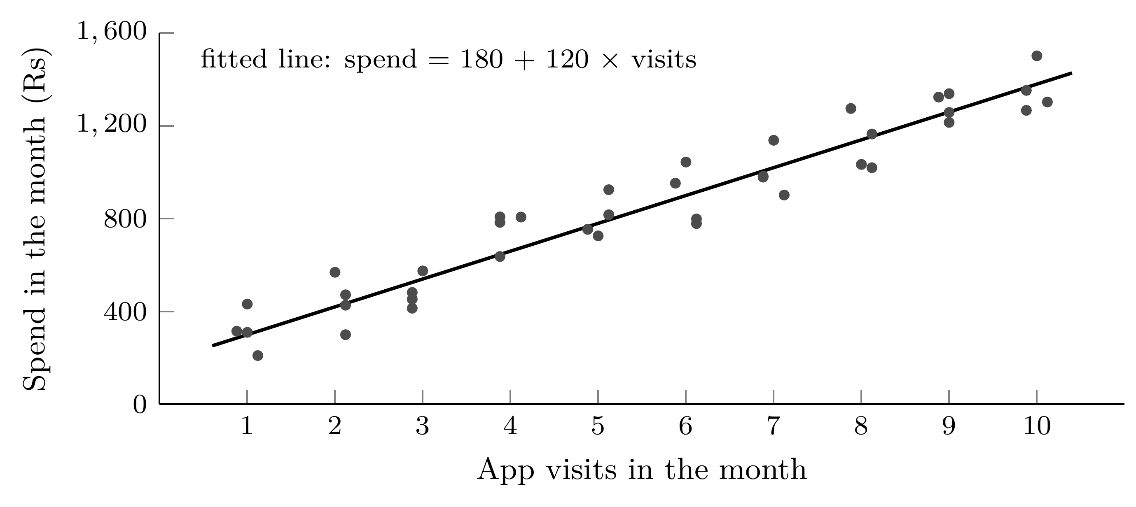
key facts
Fitted line | spend = Rs 180 + Rs 120 × visits
Members | 40, each with 1 to 10 visits in the month

Which reading of the line holds?
(A) With 5 visits the line predicts Rs 600 of spend: 5 visits at Rs 120 each.
(B) With 30 visits the line predicts Rs 3,780, as safely as at any other point.
(C) With 5 visits it predicts Rs 780, and each extra visit goes with Rs 120 more. (answer)
(D) Getting any member to visit once more will raise that member’s spend by Rs 120.

 | Why it is right or wrong, and the misstep behind a wrong choice
A | The line has an intercept: 180 + 120 × 5 = 780, and dropping the Rs 180 gives 600. Misstep: reading the slope as the whole line.
B | Thirty visits lies far outside the 1 to 10 visits the line was fitted on, so nothing says the straight line still holds there. Misstep: extrapolating past the data.
C | 180 + 120 × 5 = 780, and the slope says members with one more visit spend about Rs 120 more on average: a pattern across members, read inside the 1 to 10 range.
D | The slope compares members who already differ in visits, and engaged members both visit more and spend more, so pushing visits may not move spend at all. Misstep: an association read as a cause.
most likely confusion (D) The slope is often described as the effect of one more visit, so the causal reading sounds like the textbook one; the data compare different members and cannot show what pushing visits would do.
17. Key A One correct option · Easy · Statistics: summaries, tests and cause · W1 Thu
Kavya Nair wants to know whether the same 300 Retail-Plus members spent more in Q2 than in Q1. She has each member’s spend in both quarters.
key facts
Members | the same 300 in both quarters
Data | each member’s Q1 spend and Q2 spend
Question | did spend rise from Q1 to Q2?

Which comparison matches how the data was collected?
(A) A paired test on each member’s Q2 less Q1, asking whether the average change is above zero. (answer)
(B) A two-sample test that treats Q1 and Q2 as two separate groups of 300 and compares their means.
(C) No test at all: if the Q2 average is higher than the Q1 average, spend has risen.
(D) A test of the 300 Q2 figures alone against Kalpa’s spend target of Rs 2,000.

 | Why it is right or wrong, and the misstep behind a wrong choice
A | The same members appear in both quarters, so each member is their own comparison, and the change per member removes the large differences between members. This is the flip test from class, or a paired t-test.
B | Treating the quarters as unrelated groups throws away the pairing, so the spend gap between members buries the change. It fits two different sets of customers, as in a coupon test. Misstep: a two-sample test on paired data.
C | A higher average can come from chance alone; the test asks how often chance gives a rise this large. Misstep: reading a difference without testing it.
D | The question compares each member with themselves across quarters, and a target answers a different question. Misstep: testing against the wrong benchmark.
most likely confusion (B) Comparing two means is the test most learners reach for first; it fits two different groups of customers, while here each member appears in both quarters.
18. Key D One correct option · Easy · Statistics: summaries, tests and cause · W1 Mon, Wed
Kalpa Retail took twelve Business orders in October, plotted below in Rs lakh. Kavya Nair flags any order more than two standard deviations above the mean for checking, then reports a typical order. Finance has confirmed that the Rs 30 lakh bulk order is genuine.
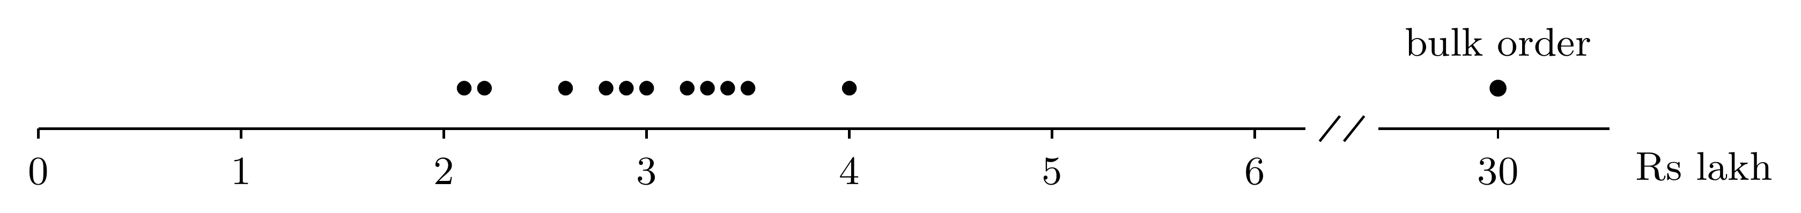
key facts
The twelve orders, in Rs lakh | 2.1, 2.2, 2.6, 2.8, 2.9, 3.0, 3.2, 3.3, 3.4, 3.5, 4.0 and 30.0
Mean; standard deviation | Rs 5.25 lakh; Rs 7.5 lakh
The bulk order | Rs 30 lakh, confirmed genuine by Finance

What should her note say?
(A) Bulk order flagged and removed; typical order Rs 3.0 lakh, the mean of the other eleven.
(B) Bulk order flagged and kept; typical order Rs 5.25 lakh, the mean of all twelve.
(C) Bulk order flagged and kept; typical order Rs 3.0 lakh, the sixth order, counted upward.
(D) Bulk order flagged and kept; typical order Rs 3.1 lakh, the median of the twelve. (answer)

 | Why it is right or wrong, and the misstep behind a wrong choice
A | The line, 5.25 + 2 × 7.5 = Rs 20.25 lakh, marks the order for checking, and Finance’s check says it is genuine, so it stays. Misstep: treating a flag as a verdict of error.
B | Keeping the order is right, but the mean, pulled up by it, sits above eleven of the twelve orders and describes almost none of them. Misstep: the mean read as typical.
C | With an even count the middle falls between the sixth and seventh orders, 3.0 and 3.2. Misstep: taking the sixth value alone.
D | Rs 30 lakh lies beyond the Rs 20.25 lakh line, so it is flagged; Finance has confirmed it, so it stays. The median, (3.0 + 3.2) / 2 = 3.1, does not move with it and describes a typical order.
most likely confusion (A) Crossing the two-standard-deviation line feels like proof of an error; the line only says the order is unusual enough to check, and the check found it genuine.
19. Key B One correct option · Hard · Python, pandas and SQL · W2 Wed, W1 Mon
The head of Retail-Plus wants the three members who spent the most in October, counting delivered orders only. Kavya Nair pulls the month’s orders, one row per order:
Order | Member | Amount (Rs) | Status
KR-21 | M-01 | 9,000 | Delivered
KR-22 | M-02 | 4,000 | Delivered
KR-23 | M-03 | 8,500 | Delivered
KR-24 | M-05 | 4,500 | Cancelled
KR-25 | M-02 | 4,500 | Delivered
KR-26 | M-04 | 7,000 | Delivered
KR-27 | M-05 | 6,000 | Delivered
KR-28 | M-01 | 1,000 | Delivered
KR-29 | M-02 | 3,500 | Delivered
KR-30 | M-04 | 2,000 | Delivered

key facts
One row is | one order
Spend counts | delivered orders only
Wanted | the three members with the highest spend

Which three members should the list name?
(A) M-01, M-03 and M-04
(B) M-01, M-02 and M-04 (answer)
(C) M-01, M-03 and M-05
(D) M-01, M-02 and M-05

 | Why it is right or wrong, and the misstep behind a wrong choice
A | These members hold the three largest single orders, Rs 9,000, Rs 8,500 and Rs 7,000: the list ranks orders when the request ranks members. Misstep: the wrong grain.
B | Total each member’s delivered orders first: M-02 Rs 12,000, M-01 Rs 10,000, M-04 Rs 9,000, M-03 Rs 8,500 and M-05 Rs 6,000. One row is an order, so the members are built from the rows before they are ranked.
C | These have the highest average order: M-03 Rs 8,500, M-05 Rs 6,000 and M-01 Rs 5,000. M-02 orders often at a modest size and spends the most. Misstep: an average in place of a total.
D | Counting the cancelled KR-24 lifts M-05 to Rs 10,500, past M-04’s Rs 9,000; a cancelled order is not spend. Misstep: the booked reading where delivered was asked for.
most likely confusion (A) Scanning for the biggest amounts is the quickest move, and it names three real big spenders; M-02 never places a large order and still spends the most.
20. Key C One correct option · Medium · Data quality and reporting · W2 Fri, W1 Mon
Meera Raghavan’s Monday front page carries one line for each customer segment. For Retail-Plus, Kavya Nair has Q1 revenue (April to June) of Rs 5.86 lakh and Q2 revenue (July to September) of Rs 4.14 lakh. Company revenue in Q2 was Rs 9.84 crore.
key facts
Retail-Plus, Q1 (April to June) | Rs 5.86 lakh
Retail-Plus, Q2 (July to September) | Rs 4.14 lakh
Company revenue, Q2 | Rs 9.84 crore

Which line should go on the front page?
(A) Retail-Plus, Q2: Rs 4.14 lakh, down 41.5 percent on Q1’s Rs 5.86 lakh; 0.4 percent of company revenue.
(B) Retail-Plus, Q2: Rs 4.14 lakh, down 70.6 percent on Q1’s Rs 5.86 lakh; 0.4 percent of company revenue.
(C) Retail-Plus, Q2: Rs 4.14 lakh, down 29.4 percent on Q1’s Rs 5.86 lakh; 0.4 percent of company revenue. (answer)
(D) Retail-Plus, Q2: Rs 4.14 lakh, down 29.4 percent on Q1’s Rs 5.86 lakh; 4.2 percent of company revenue.

 | Why it is right or wrong, and the misstep behind a wrong choice
A | Rs 1.72 lakh divided by Q2’s Rs 4.14 lakh gives 41.5; a change from Q1 is measured on Q1, so the fall is 29.4 percent. Misstep: the wrong base for a percentage change.
B | 4.14 / 5.86 = 0.706 is Q2 as a share of Q1, a ratio; the growth rate is (4.14 less 5.86) / 5.86, a fall of 29.4 percent. Misstep: a ratio read as a rate of change.
C | Every part holds: Q2 alone, its rupees, the fall of 1.72 / 5.86 = 29.4 percent on Q1’s base, and the segment’s scale, Rs 4.14 lakh of Rs 9.84 crore, which is 0.4 percent.
D | Rs 9.84 crore is 984 lakh, so Rs 4.14 lakh is 0.4 percent of company revenue; 4.2 percent divides by 98.4 lakh, as if a crore were ten lakh. Misstep: a slip between lakh and crore.
most likely confusion (A) Its line has every part a front page needs, and only the percentage is wrong: dividing the fall by Q2 in place of Q1 inflates it from 29.4 to 41.5 percent.
21. Key A One correct option · Medium · Analyst technique · W4 Fri
In early December, Kavya Nair is asked whether demand at Kalpa Retail is growing. Diwali fell in the third week of October last year and in the second week of November this year.
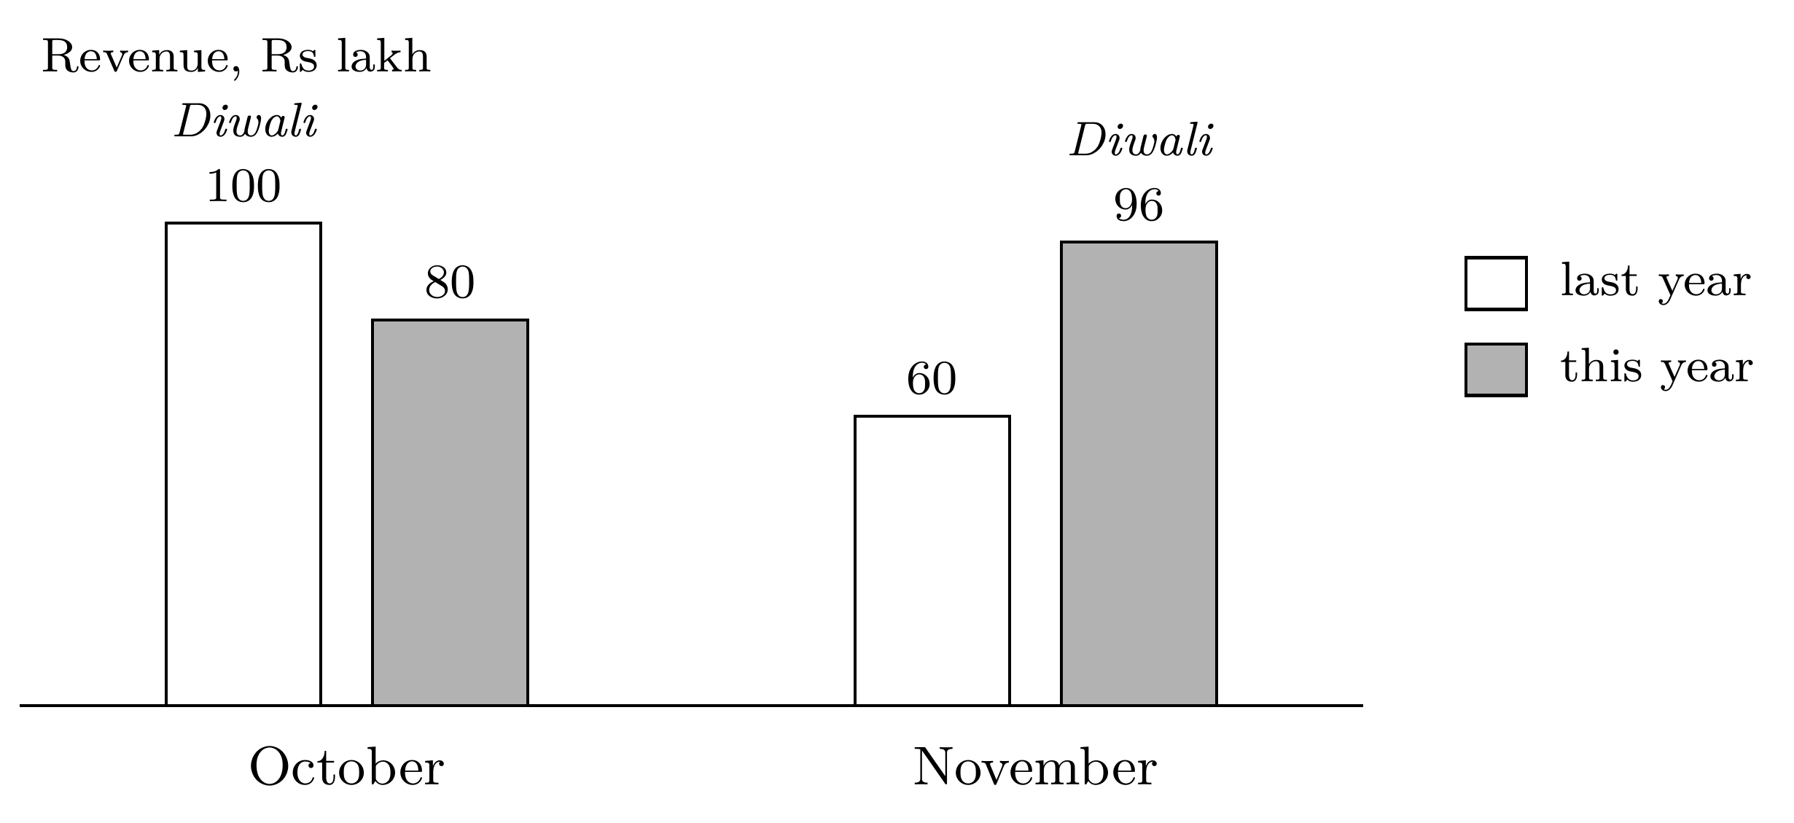
key facts
October revenue | Rs 1 crore last year; Rs 80 lakh this year
November revenue | Rs 60 lakh last year; Rs 96 lakh this year
Diwali | third week of October last year; second week of November this year

Which reading should she report?
(A) Up 10 percent: October and November, year on year. (answer)
(B) Down 20 percent: October alone, year on year.
(C) Up 60 percent: November alone, year on year.
(D) Up 20 percent: this November against this October.

 | Why it is right or wrong, and the misstep behind a wrong choice
A | Diwali moved from October to November, so each month alone sets a festival month against an ordinary one. Both two-month windows hold one Diwali: Rs 1.76 crore against Rs 1.60 crore is up 10 percent.
B | Last October held Diwali and this October did not, so the year-apart comparison no longer cancels the season. Misstep: a season-apart comparison used without checking the festival.
C | The same fault the other way: this November holds Diwali and last November did not. Misstep: a festival month set against an ordinary one.
D | Neighbouring months differ in season, and this November holds the festival. Misstep: a month-on-month reading across a festival.
most likely confusion (B) Comparing a month with the same month last year is the usual way to remove the season, so a fall of 20 percent looks safe; it fails when the festival changes month.
22. Key D One correct option · Medium · Statistics: summaries, tests and cause · W1 Thu
Kalpa Retail gave a festive coupon to 400 of its 800 Retail-Core customers, picked at random. Over the next month the coupon group spent Rs 210 more per customer than the rest. Kavya Nair shuffled the coupon labels 2,000 times: in 30 shuffles the coupon group came out ahead by Rs 210 or more, and in 58 the gap was Rs 210 or more in either direction.
key facts
Coupon | 400 of 800 customers, picked at random
Gap in spend | Rs 210 per customer, coupon group ahead
Label shuffles | 2,000
Coupon group ahead by Rs 210 or more | 30 shuffles
Gap of Rs 210 or more, either way | 58 shuffles

Which sentence belongs in the note?
(A) There is a 1.5 percent chance that the coupon made no difference to spend.
(B) The coupon beat chance, so its extra spend more than covers the cost of the discount.
(C) In 1.5 percent of chance-only worlds, the gap was Rs 210 or more in either direction.
(D) In 1.5 percent of chance-only worlds, the coupon group led by Rs 210 or more. (answer)

 | Why it is right or wrong, and the misstep behind a wrong choice
A | The shuffle assumes the coupon did nothing and asks how often chance alone gives this gap; its answer is a share of chance-only worlds, which is a different thing from the chance that the coupon did nothing. Misstep: the most common misreading of a p-value.
B | Beating chance says the gap is real; whether Rs 210 a customer pays for the coupon is a separate sum. Misstep: significance read as worth.
C | Either way the share is 58 / 2,000 = 2.9 percent; 1.5 percent is the one-way share. Misstep: mixing the two counts.
D | 30 / 2,000 = 0.015 is the share of worlds in which the labels mean nothing and the coupon group still leads by Rs 210 or more. The coupon was planned to raise spend, so one direction is the question.
most likely confusion (A) It reads like the plain-English version of the result, and it is the sentence the room was warned about: the p-value is a share of chance-only worlds, never the chance that the effect is absent.
23. Key B One correct option · Medium · Analyst technique · W4 Wed
Of 2,000 Kalpa Retail baskets, 200 hold an A5 notebook, 400 hold a pen set, and 120 hold both. The head of merchandising notes that 60 percent of notebook buyers take a pen set, while only 30 percent of pen-set buyers take a notebook, and concludes that the pull runs one way.
key facts
Baskets | 2,000
With an A5 notebook | 200
With a pen set | 400
With both | 120

Which statement is correct?
(A) Lift is 0.6 one way and 0.3 the other, so the pull runs only from notebook to pen set.
(B) Lift is 3.0 both ways, so offering a pen set to notebook buyers is a sound cross-sell. (answer)
(C) Lift is 3.0 from notebook to pen set and 1.5 back, since pen sets are more common.
(D) Lift is 3.0 both ways, so offering notebook buyers a pricier notebook is a sound upsell.

 | Why it is right or wrong, and the misstep behind a wrong choice
A | 0.6 and 0.3 are the two confidences, 120 / 200 and 120 / 400; lift divides a confidence by the other item’s share of baskets. Misstep: confidence read as lift.
B | Lift = 120 × 2,000 / (200 × 400) = 3.0 whichever item comes first, so the two sell together three times as often as chance would give, and offering the second to buyers of the first is a cross-sell. Confidence differs only because pen sets are twice as common.
C | Pen set to notebook is 0.3 divided by the notebook’s share, 0.1, which is 3.0; 1.5 divides by the pen set’s own share. Misstep: dividing by the wrong item.
D | The lift is right, but it describes two different products bought together, which supports a cross-sell; an upsell moves a buyer to a pricier version of the same product, and nothing here measures that. Misstep: cross-sell and upsell swapped.
most likely confusion (D) It gets the lift right and then names the wrong kind of offer: a pricier notebook is an upsell, and pen-set baskets say nothing about it.
24. Key A One correct option · Medium · Python, pandas and SQL · W2 Thu
An analyst builds a spend table for four Retail-Plus members in pandas:
members = pd.DataFrame({"member": ["M-1", "M-2", "M-3", "M-4"]})
orders = pd.DataFrame({"member": ["M-1", "M-1", "M-3"],
"amount": [500, 300, 400]})

spend = orders.groupby("member", as_index=False)["amount"].sum()
table = members.merge(spend, on="member", how="left")
print(len(table), table["amount"].mean())
What does the last line print, and why?
(A) 4 600.0: all four members stay, and the mean skips the two blanks. (answer)
(B) 4 300.0: all four members stay, and the two blanks count as zero.
(C) 2 600.0: only the two members with orders survive the merge.
(D) 3 400.0: the merged table holds one row for each of the three orders.

 | Why it is right or wrong, and the misstep behind a wrong choice
A | groupby gives M-1 800 and M-3 400; the left merge keeps all four members, with blanks for M-2 and M-4, and .mean() skips blanks: (800 + 400) / 2 = 600.0. For the average over every member, fill the blanks with 0 first, since a member with no orders spent Rs 0.
B | .mean() skips missing values, so the two blanks never enter the average; 300.0 would need fillna(0) first. Misstep: assuming pandas treats a blank as zero.
C | A left merge keeps every row of the left table, members, so the table has four rows. Misstep: a left merge read as an inner one.
D | The groupby already turned three orders into two members, so the merge sees one row per member. Misstep: losing track of what one row is.
most likely confusion (B) Members with no orders did spend Rs 0, so 300 is the right business answer; the code does not compute it, because .mean() skips the blanks the merge creates.
25. Key C One correct option · Medium · Python, pandas and SQL · W2 Tue
Three Kalpa Retail orders and the payments against them sit in two PostgreSQL tables. KR-1 was paid in two instalments, and KR-2 has not been paid. An analyst runs the query below.
orders |  |  | payments
order_id | amount |  | payment_id | order_id | amount
KR-1 | 1,000 |  | P-1 | KR-1 | 600
KR-2 | 500 |  | P-2 | KR-1 | 400
KR-3 | 2,000 |  | P-3 | KR-3 | 2,000

SELECT COUNT(*) AS rows_out, SUM(o.amount) AS booked
FROM orders o
LEFT JOIN payments p ON p.order_id = o.order_id;
What does the query return?
(A) rows_out is 3 and booked 3,500: a LEFT JOIN gives one row per order.
(B) rows_out is 3 and booked 4,000: KR-2 drops out, having no payment.
(C) rows_out is 4 and booked 4,500: KR-1 appears once per payment. (answer)
(D) rows_out is 4 and booked 3,500: SUM counts each order only once.

 | Why it is right or wrong, and the misstep behind a wrong choice
A | A LEFT JOIN keeps every order and repeats an order for every payment that matches it, so KR-1 takes two rows. Misstep: a LEFT JOIN read as one row per left row.
B | KR-2 has no payment, and a LEFT JOIN keeps it with blank payment columns; dropping it is what an inner join does. Misstep: LEFT read as INNER.
C | KR-1 matches P-1 and P-2, so it fills two rows; KR-2 keeps one row with blanks, and KR-3 one. Four rows, and SUM adds KR-1’s Rs 1,000 twice: 1,000 + 1,000 + 500 + 2,000 = 4,500 against Rs 3,500 booked. Total the payments per order first, then join.
D | SUM adds every row it is given and cannot tell that two rows are the same order. Misstep: expecting SUM to remove repeats.
most likely confusion (A) A LEFT JOIN is taught as the join that keeps every order, which is true, so one row per order feels safe; it keeps every order and also repeats it for each matching payment.
Section C. Ordering (8 marks)
26. Key Q S P T R Put in order · Medium · Python, pandas and SQL · W2 Wed
Meera wants the customer with the fifth-highest delivered revenue in 2025. The pseudo-code below solves it, one line per step. Put the lines in the order they must run.
Order | Step | Why it must come here
1. Q | delivered = orders in 2025 with status "delivered" | Every later line works on the delivered 2025 orders, so the filter comes first.
2. S | totals = revenue summed per customer in delivered | Revenue is summed per customer, so one row becomes one customer before anything is sorted.
3. P | ordered = totals sorted by revenue, highest first | Sorting needs the totals.
4. T | ranked = ordered with ranks 1, 2, 3, ... (ties share) | A rank is a position in the sorted list, so it needs the sort; equal totals share a rank.
5. R | answer = the customer in ranked with rank 5 | The answer reads rank 5, so it comes last.
partial credit Award 1 mark for an order with one pair of neighbouring steps swapped, such as Q S T P R; any other wrong order scores 0.
27. Key Q S T P R Put in order · Medium · Analyst technique · W4 Thu
The head of Retail-Plus asks whether newer members keep ordering as well as older ones. Put the steps of the cohort table in the order they must happen.
Order | Step | Why it must come here
1. Q | Give each member a cohort: the calendar month in which they joined. | Every later step needs the cohort, and it is fixed once for each member.
2. S | Work out each order’s age in months, counting the cohort month as age zero. | Age is counted from the joining month, so it needs the cohort first.
3. T | For each cohort and each age, count the members who ordered at that age. | The counts sit by cohort and age, so both must exist.
4. P | Divide each count by the number of members who joined in that cohort’s month. | A rate needs the count above it and the cohort’s size below it.
5. R | Read the cohorts side by side at the same age, never down one calendar month. | Only rates compare across cohorts of different sizes, and only at the same age.
partial credit Award 1 mark for an order with one pair of neighbouring steps swapped, such as Q S P T R; any other wrong order scores 0.
28. Key R Find the step that does not belong · Easy · Python, pandas and SQL · W1 Tue, W2 Tue
Of Kalpa’s customers, 300 ordered only in 2024, 500 in both years and 200 only in 2025. A trainee writes the steps below to list the customers who ordered in 2025 but not in 2024. Which step does not belong?
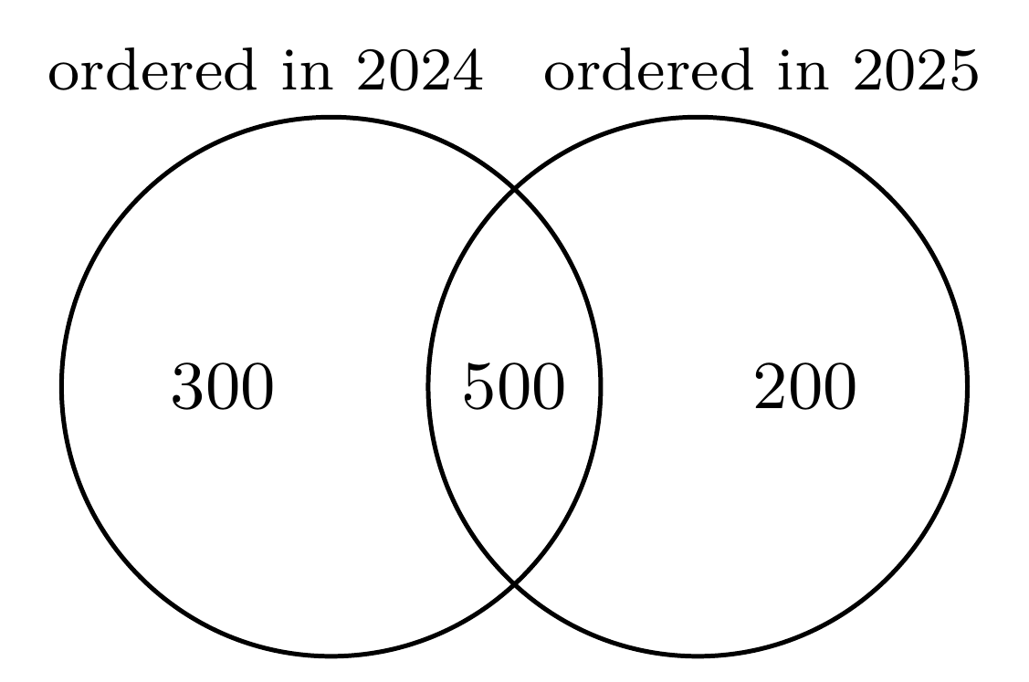
(P) List the distinct customer ids with an order in 2025.
(Q) List the distinct customer ids with an order in 2024.
(R) Keep only the customers with exactly one order in 2025. (answer)
(S) Take the 2025 ids that do not appear in the 2024 list.
(T) Check that the result holds 200 customers, the count in the diagram.
(U) Report the list, with its count beside it.

 | Why it is right or wrong, and the misstep behind a wrong choice
P | Belongs: the 2025 customers, each counted once.
Q | Belongs: the list to take away.
R | Does not belong: a customer new in 2025 may order many times, and a one-order customer may have bought in 2024 too, so order counts do not decide who is new.
S | Belongs: the set difference, 2025 less 2024, is the answer.
T | Belongs: a check against a known count catches a wrong filter or a duplicate.
U | Belongs: the count gives the list its scale.
most likely confusion (T) A check can look like an extra step; tying the result to a count already known is how a wrong filter gets caught.
29. Key T Find the step that does not belong · Easy · ML core · W5 Mon
A trainee’s plan for a model that flags Retail-Plus members likely to buy again within ninety days runs in the order below. Which step does not belong?
(P) Seal a test slice before anything else is built, and put it away.
(Q) Split the rest into training and validation, each with the same buyer share.
(R) Fit the model on the training rows only.
(S) Compare the model with flagging nobody, on the validation rows.
(T) Tune the threshold on the test slice until its score peaks. (answer)
(U) Open the test slice once, at the end, for the committee.

 | Why it is right or wrong, and the misstep behind a wrong choice
P | Belongs: the test slice is cut first and sealed, so nothing that follows can lean on it.
Q | Belongs: training learns, validation chooses, and the buyer share stays the same in both.
R | Belongs: the model learns only from training rows.
S | Belongs: a model earns its place only by beating the baseline on rows it never saw.
T | Does not belong: a test slice used to choose anything becomes validation, and its score stops being an honest estimate. Choose the threshold on validation.
U | Belongs: the sealed test is spent once, for the final number.
most likely confusion (S) Comparing a model with doing nothing can look like a wasted step; it is the baseline every model must beat.
Section D. Scenario set (12 marks)
The case runs on invented Kalpa Connect numbers, and every item answers from the case alone. The channel rates are fixed by construction: stores keep 90 percent and the online offer 70 percent in both months, so the blend’s fall is pure mix.
Case: is broadband retention slipping at Kalpa Connect?
[1] Kalpa Connect sells home broadband through two channels: its stores, and an online offer that gives a new subscriber the first month free. On 5 October Ananya Bose, the COO, saw a dashboard tile showing that month-one retention, the share of a month’s new subscribers who are paying one month after they joined, was lower for the July cohort than for the June cohort. The head of retention blames the new customer-care script that went live in July and wants it withdrawn before Friday’s review.
[2] Exhibit 5 breaks the two cohorts down by channel. A cohort is everyone who joined in one calendar month, and age is counted from that month, as Exhibit 6 shows. The August cohort is also live. A third channel, a partner kiosk in one mall, signed 8 subscribers in June and kept 6, and signed 12 in July and kept 11.
[3] Ananya wants a note from the analytics team before Friday, and a single retention number that the team will be measured on from next quarter.
key facts
Data pulled | 5 October
Channels | stores; an online offer with the first month free; a partner kiosk
Month-one retention | joiners still paying one month after joining, over all who joined that month
Age | counted in calendar months, the joining month being age zero
Care script | live from July
Partner kiosk | kept 6 of 8 in June and 11 of 12 in July

Exhibit 5. Month-one retention by cohort and channel, as pulled on 5 October.
Cohort | Channel | Joined | Paying at month one
June | Stores | 800 | 720
June | Online offer | 200 | 140
July | Stores | 800 | 720
July | Online offer | 1,200 | 840

Exhibit 6. How age is counted, shown for the June and July cohorts: each age is one whole calendar month.
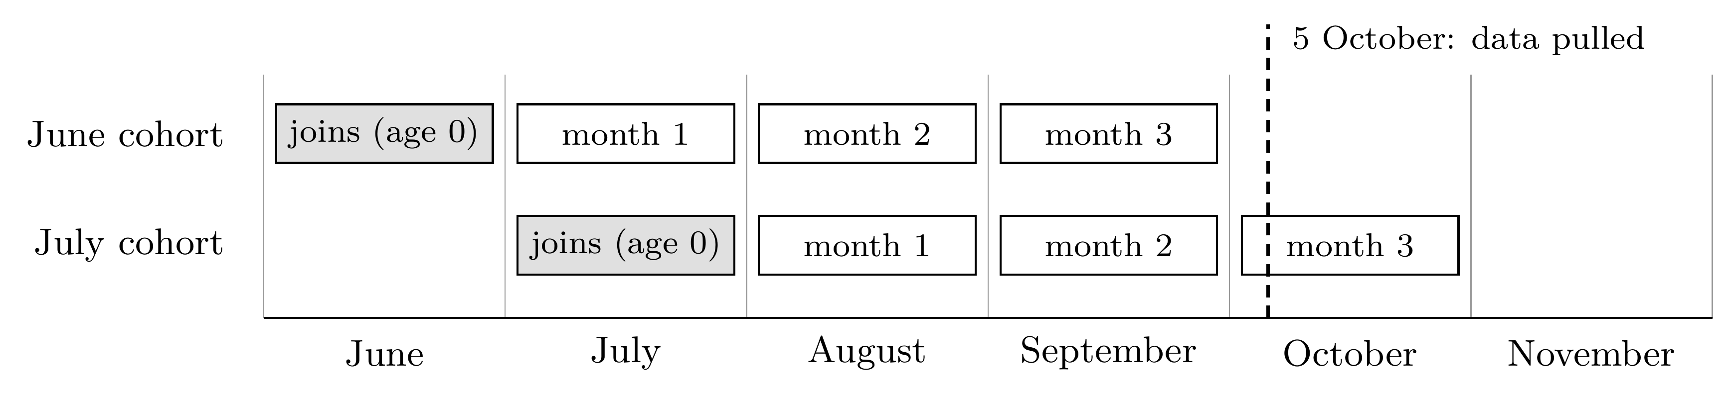
30. Key D Scenario set · Medium · Statistics: summaries, tests and cause · W1 Tue, W4 Thu
Which reading of Exhibit 5 holds?
(A) Both channels kept a smaller share of their July joiners than of their June joiners.
(B) The stores kept fewer of their July joiners, which places the script’s failure in stores.
(C) The online offer’s month-one retention fell from 90 percent in June to 70 percent in July.
(D) Each channel kept its June rate in July, and more July joiners took the online offer. (answer)

 | Why it is right or wrong, and the misstep behind a wrong choice
A | Neither channel’s rate moved; only the blend did. Misstep: reading the blend’s fall into each channel.
B | The stores kept 720 of 800 in both months, the same 90 percent. Misstep: blaming the channel nearest to the script.
C | 90 percent is the stores’ rate and 70 percent the online offer’s, in both months. Misstep: comparing one channel’s June with the other’s July.
D | Stores kept 720 of 800 (90 percent) and the online offer 140 of 200 and 840 of 1,200 (70 percent) in both months; the offer’s share of joiners rose from 20 percent to 60.
most likely confusion (A) The dashboard showed a fall, so a fall inside each channel is the natural guess; the exhibit shows each rate unchanged and the mix moving.
31. Key B Scenario set · Medium · Statistics: summaries, tests and cause · W4 Thu, W1 Tue
What is July’s month-one retention across both channels?
(A) 80 percent, the mean of the two channels’ month-one rates.
(B) 78 percent: 1,560 still paying out of the 2,000 who joined in July. (answer)
(C) 81 percent: 2,420 still paying out of the 3,000 who joined in June and July.
(D) 70 percent, the rate of the channel that signed most of July’s subscribers.

 | Why it is right or wrong, and the misstep behind a wrong choice
A | A plain mean gives the 800 store joiners the same vote as the 1,200 online joiners. Misstep: averaging rates instead of weighting by size.
B | (720 + 840) / (800 + 1,200) = 1,560 / 2,000 = 0.78. June’s was 860 / 1,000 = 0.86, so the blend fell 8 points while each channel held.
C | Pooling June with July answers a different question: the stem asks about the July cohort, and each cohort is read on its own. Misstep: two cohorts mixed into one rate.
D | The online offer’s 70 percent is one part of the blend, and the stores’ 720 count too. Misstep: taking the largest group for the whole.
most likely confusion (A) Averaging the two rates feels fair, but it gives a channel with 800 joiners the same weight as one with 1,200.
32. Key C Scenario set · Easy · Data quality and reporting · W1 Mon, W4 Thu
Ananya asks when the August cohort’s month-two retention can first be read in full.
(A) Already, on 5 October, from the days of October so far.
(B) On 1 October, once September had closed.
(C) On 1 November, once October has closed. (answer)
(D) On 1 December, once November has closed.

 | Why it is right or wrong, and the misstep behind a wrong choice
A | Month two is October, and on 5 October most of it has not happened, so any reading now is partial. Misstep: reading a window before it closes.
B | August is age zero, so September is month one and October month two. Misstep: counting the joining month as month one.
C | Age counts from the joining month: August is age zero, September month one and October month two. The month-two reading is complete once October closes, on 1 November.
D | This treats September, the first full month after joining, as age zero. Misstep: starting the count one month late.
most likely confusion (B) “Month two” sounds like the second month of the cohort’s life, which is September; Exhibit 6 counts the joining month as age zero, so month two is October.
33. Key A Scenario set · Easy · Statistics: summaries, tests and cause · W1 Thu
How should the note treat the partner kiosk, which kept 6 of 8 June subscribers and 11 of 12 in July?
(A) As a lead: on 8 and 12 subscribers, one person moves the rate by about 8 to 13 points. (answer)
(B) As a finding: a rise from 75 to 92 percent is the largest move anywhere in the case.
(C) As noise: the move is two or three people, so the note should leave the kiosk out.
(D) As proof that kiosks retain best, since 92 percent beats the stores and the online offer.

 | Why it is right or wrong, and the misstep behind a wrong choice
A | One subscriber is 1 / 12, about 8 points, in July and 1 / 8, about 13, in June. Under about thirty customers a rate is a lead, worth one line and a date to look again.
B | The largest percentage on a page most often sits on the smallest base, and this move is two or three people. Misstep: a headline rate on a tiny base.
C | The move is only two or three people, which is why it earns a caveat and a date to look again; leaving it out hides a possible lead. Misstep: discarding where the note should qualify.
D | Twelve subscribers cannot carry a comparison with channels of 800 and 1,200. Misstep: ranking channels on unequal counts.
most likely confusion (C) It rightly sees that the move is two or three people and then overcorrects by dropping the kiosk; the taught move is to keep it as a lead with its count beside it.
34. Key B Scenario set · Medium · Analyst technique · W4 Mon
Ananya wants one retention number that the team will be measured on from next quarter. Which row defines it soundly?
 | Numerator | Denominator | Window | Exclusions
(A) | Subscribers paying at month three | Those still paying at month one | Whenever the tile is refreshed | Staff and test accounts
(B) | Subscribers paying at month three | Everyone who joined in the month | Month three of each cohort | Staff and test accounts
(C) | Subscribers paying at month three | Everyone who joined in the month | Whenever the tile is refreshed | Cancellations in the free month
(D) | Subscribers paying at month three | Everyone who joined in the month | Month three of each cohort | Cancellations in the free month

 | Why it is right or wrong, and the misstep behind a wrong choice
A | Two lines fail. Dividing by those still paying at month one drops the early leavers from the base, so the rate improves as early churn rises, and a window tied to the refresh reads each cohort at a different age. Misstep: survivors as the denominator.
B | Every line is fixed: a numerator the team moves only by keeping subscribers, the whole cohort beneath it, one age for every cohort, and exclusions for accounts that are not customers.
C | Two lines fail. A window tied to the refresh date reads each cohort at a different age, so the number moves with the calendar, and the exclusion removes the free-month losses the team exists to prevent. Misstep: an unfixed window.
D | The case calls an online joiner a new subscriber from the first day, so leaving out cancellations in the free month removes the very losses the team exists to prevent and invites churn to be moved into that month. Misstep: an exclusion that rewards the failure.
most likely confusion (D) Its only flaw sounds like cleaning, since free-month cancellers never paid; they are new subscribers in the case’s own terms, and dropping them hides the losses the number exists to show.
35. Key D Scenario set · Hard · Analyst technique · W4 Tue, Thu
Which action should the note to Ananya recommend?
(A) Withdraw the script, report retention by channel, and price the online offer.
(B) Keep the script, report retention by channel, and stop the online offer.
(C) Keep the script, report the blended tile alone, and price the online offer.
(D) Keep the script, report retention by channel, and price the online offer. (answer)

 | Why it is right or wrong, and the misstep behind a wrong choice
A | Both channels kept their June rates in July, so the fall comes from the mix and the evidence does not touch the script. Misstep: crediting a blend’s move to a change that happened at the same time.
B | Stopping the offer would give up 840 paying subscribers to avoid 360 early leavers; its rate is lower and its count far higher, so it is priced before it is cut. Misstep: judging a channel on its rate alone.
C | The blend moves with the channel mix, which the retention team does not control, so reporting it alone repeats this week’s false alarm. Misstep: one number when the mix moves.
D | Neither channel fell, so the script stays; reporting by channel stops the mix from posing as a fall, and pricing the offer settles whether its extra subscribers are worth the free month and the lower retention.
most likely confusion (B) The online offer’s rate is genuinely lower, so cutting it feels decisive; the count it brings in, and its price, decide the question.
Section E. Justify, or write the steps (15 marks)
1. Each answer earns 1 mark for the stance the evidence supports and up to 2 marks for the justification, judged against the anchors for that question.
2. Marks follow the mechanism named and its application to the numbers in the claim; length, polish and repetition earn nothing.
3. An answer with the wrong stance scores 0 for the stance, and its justification can still earn 1 mark if it names the correct mechanism. Check such answers against the anchors and the model answer.
36. Key Disagree Argue and justify · Medium · Data quality and reporting · W1 Wed, Thu
“Orders beyond two standard deviations are errors, so delete all 14 before we report the average order value.”
the stance Disagree. The two-standard-deviation line flags orders for checking and proves nothing wrong, and the check has already shown 11 of the 14 to be genuine.
Marks | What the answer shows
3 | Disagrees; says the line flags orders for checking and is no proof of error; uses Finance’s check (the 11 genuine orders stay, the 3 typos are corrected from source or set aside with a logged reason); and reports a typical order that the bulk orders do not distort, such as the median, or the mean with and without them.
2 | Disagrees and says the line only flags, without using the 11 and 3 split or without the reporting fix.
1 | Disagrees with a general reason, such as that outliers can be real, applied to nothing in the case.
0 | Agrees, or gives no reason.
A full-mark answer. Disagree. Two standard deviations is a line for checking, not a verdict of error, and the checking is done: 11 of the 14 orders are genuine bulk orders, so they stay, flagged. The 3 with an extra zero are real orders with a wrong amount, so they should be corrected from the source or set aside with a logged reason. Since a few very large orders pull the mean up, the note should give the median as the typical order and report the bulk orders separately.
37. Key Disagree Argue and justify · Easy · Data quality and reporting · W1 Tue, Wed
“Blank means no discount was given, so fill the blanks with 0 and report the average discount as Rs 90 across all 600 orders.”
the stance Disagree. A blank means the discount was not recorded; orders with no discount already show Rs 0, so the blanks are unknown, and filling them with 0 invents 150 zero discounts.
Marks | What the answer shows
3 | Disagrees; explains that blank means unrecorded, which differs from zero, using the 200 recorded zeros as evidence; shows the effect (Rs 54,000 over 600 orders gives Rs 90 against Rs 120 over the 450 recorded); and says to report Rs 120 on the 450 with the 150 blanks stated, and to find which source left them blank.
2 | Disagrees and says missing is not zero, without the numbers or without the reporting fix.
1 | Disagrees with a general doubt, such as that the data may be incomplete, naming no mechanism.
0 | Agrees, or gives no reason.
A full-mark answer. Disagree. A blank discount means nobody recorded one, which is different from a discount of zero: the 200 orders with no discount already show Rs 0. Filling the 150 blanks with 0 spreads the same Rs 54,000 over 600 orders and pulls the average from Rs 120 to Rs 90 by inventing 150 zero discounts. Report Rs 120 across the 450 recorded orders, state that 150 orders, a quarter, have no discount on record, and find out which source left them blank.
38. Key Agree Argue and justify · Medium · Statistics: summaries, tests and cause · W1 Thu
“The gap is real, but we cannot yet say that the email caused it.”
the stance Agree. The shuffle rules out chance as the likely explanation, and the members chose whether to open, so the openers may differ from the rest in ways that drive spend.
Marks | What the answer shows
3 | Agrees; says why the gap is real (4 in 2,000 shuffled worlds), why the cause is open (members chose to open, so openers, likely the more engaged buyers, differ from non-openers), and proposes a random hold-back that compares spend per member.
2 | Agrees and explains one half, that chance is unlikely or that opening was self-selected, with the other half or the fair test missing.
1 | Agrees with a general remark, such as that correlation is not causation, applied to nothing specific.
0 | Disagrees with no correct mechanism, or gives no reason.
A full-mark answer. Agree. Only 4 of 2,000 shuffled worlds produced a gap of Rs 260, so chance alone is an unlikely explanation and the gap is real. Opening the email was each member’s choice, and members who open loyalty emails are likely the ones who already buy more, so they would out-spend the rest with no email at all. To credit the email, send it to a random four-fifths of members next month, hold back the rest, and compare spend per member between the two groups.
39. Key Disagree Argue and justify · Hard · Analyst technique · W4 Wed
“The offer sold 3,000 screen guards, Rs 4,50,000 of margin, so it paid for itself many times over.”
the stance Disagree. Only the 600 extra guards are the offer’s gain, while its discount went to all 3,000 buyers.
Marks | What the answer shows
3 | Disagrees; counts only the 600 extra guards as the gain (600 × Rs 150 = Rs 90,000) and sets against it the discount on all 3,000 buyers (Rs 3,00,000) and the set-up cost (Rs 20,000), reaching a loss of about Rs 2,30,000.
2 | Disagrees and names the method, that only the extra guards count and the discount is paid on every taker, with the arithmetic missing or wrong.
1 | Disagrees on the ground that some guards would have sold anyway, without the costs.
0 | Agrees with no correct mechanism, or gives no reason.
A full-mark answer. Disagree. With phone sales flat, 2,400 buyers would have taken a guard anyway, so only 600 guards are the offer’s doing, worth 600 × Rs 150 = Rs 90,000 of margin. The Rs 100 discount went to all 3,000 buyers, which is Rs 3,00,000, and the set-up cost Rs 20,000, so the offer lost about Rs 2,30,000. Counting every guard as the gain credits the offer with sales it did not cause.
40. Key Steps Write the steps · Hard · Python, pandas and SQL · W2 Mon, Thu
Kalpa Retail’s orders table has one row per order, with the order id, customer id, city, order date, amount and status. Meera wants each city’s October revenue growth on September, counting delivered orders only, and a list of the cities where revenue fell by more than 10 percent.
how it is marked Marked on the logic alone: the grain before the comparison, September as the base of the growth rate, the flag, and the city with no September revenue. Syntax earns and loses nothing.
Marks | What the answer shows
3 | Brings the data to one row per city and month before comparing (delivered orders in September and October, summed by city and month); computes growth on September’s base, (October less September) / September; flags growth below minus 10 percent; and deals with a city that has no September revenue, which cannot have a growth rate.
2 | Gets the grain and the growth formula right, but misses the delivered filter or the city with no September revenue.
1 | Steps head the right way but compare orders before totalling them, divide by October, or flag on the change in rupees.
0 | No workable steps.
A full-mark answer. (1) Keep the delivered orders dated in September or October. (2) Sum the amount for each city and month, so that one row is one city in one month. (3) Put each city’s September and October totals side by side; a city with no September orders gets a blank, not a zero. (4) For each city with September revenue, growth = (October less September) / September. (5) Flag the cities where growth is below minus 0.10, and list the cities with no September revenue separately, since their growth cannot be computed. (6) Check that the city totals for each month add back to that month’s delivered revenue.
Also accept. SQL that sums amount by city and month with GROUP BY, or pandas with groupby(["city", "month"]) and a pivot, earns the same marks when it follows these steps; slips in syntax cost nothing.

