In prj-prod-dataplatform.audit_balance.ml_model_run_details we have these columns:
customerId digitalLoanAccountId crifApplicationId prediction errorDetail deployedModelId model modelDisplayName modelVersionId calcFeature start_time end_time subscription_name message_id publish_time attributes
The table schema is like:
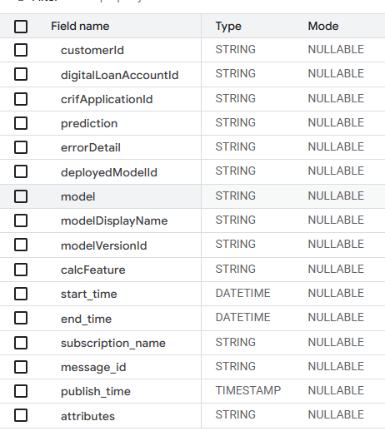

Prediction – might have single value like 26567.77685575922 or 0.0430482589 or might have a json value like {'cb_score': 0.5170787059841818, 'dl_score': 0.7206695675849915, 'combined_score': 0.6188741367845867}.
calcFeature column have json value like {"inc_beta_ln_loan_type":"BNPL","inc_beta_ln_education_level":"High School Graduate","inc_beta_ln_employment_type_new":"Self-Employed\/Private Practice","inc_beta_ln_industry_new":"Delivery Rider \/ Driver","inc_beta_ln_age":29,"inc_beta_ln_brand":"OPPO","inc_beta_ln_city":"CF0741","inc_beta_ln_purpose":"missing","inc_beta_ln_osversion_bin":"1-Nomad","inc_beta_ln_postal_code":"4217","inc_beta_ln_gender":"M","inc_beta_ln_doc_type_rolled":"Other","inc_beta_ln_cnt_dependents":"2","inc_beta_ln_source_of_funds_new":"2","inc_beta_ln_marital_status_new":"Married","inc_beta_encoded_company_name_grouped":327826.3827764811}
The data in this table we flatten to create our data suitable for PSI, CSI, Gini calculation etc.
I can see you have created various functions to calculate Gini, PSI, CSI, Log-Loss Calculation, MAE and MAPE, Month-over-Month Analysis, Periodic Metrics Calculation.
However, we would like you to create few more functions to transform the data suitable for the above function from prj-prod-dataplatform.audit_balance.ml_model_run_details. (We will share the sample data with you)
Idea is the create a function where we pass the table name, in function it will first run the big query to flatten the data

Further to this the function for PSI, CSI, GINI plots are missing.
Please create supporting functions to the above functions to create respective Industry standard plots.
PSI Chart

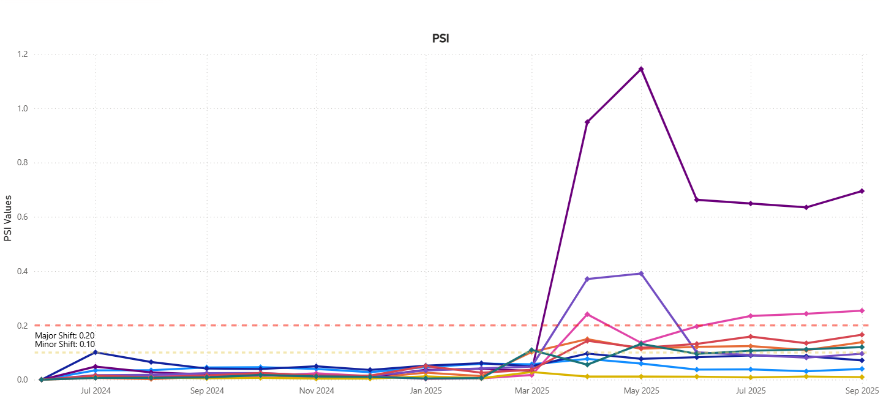

PSI Heatmap by Feature and Month
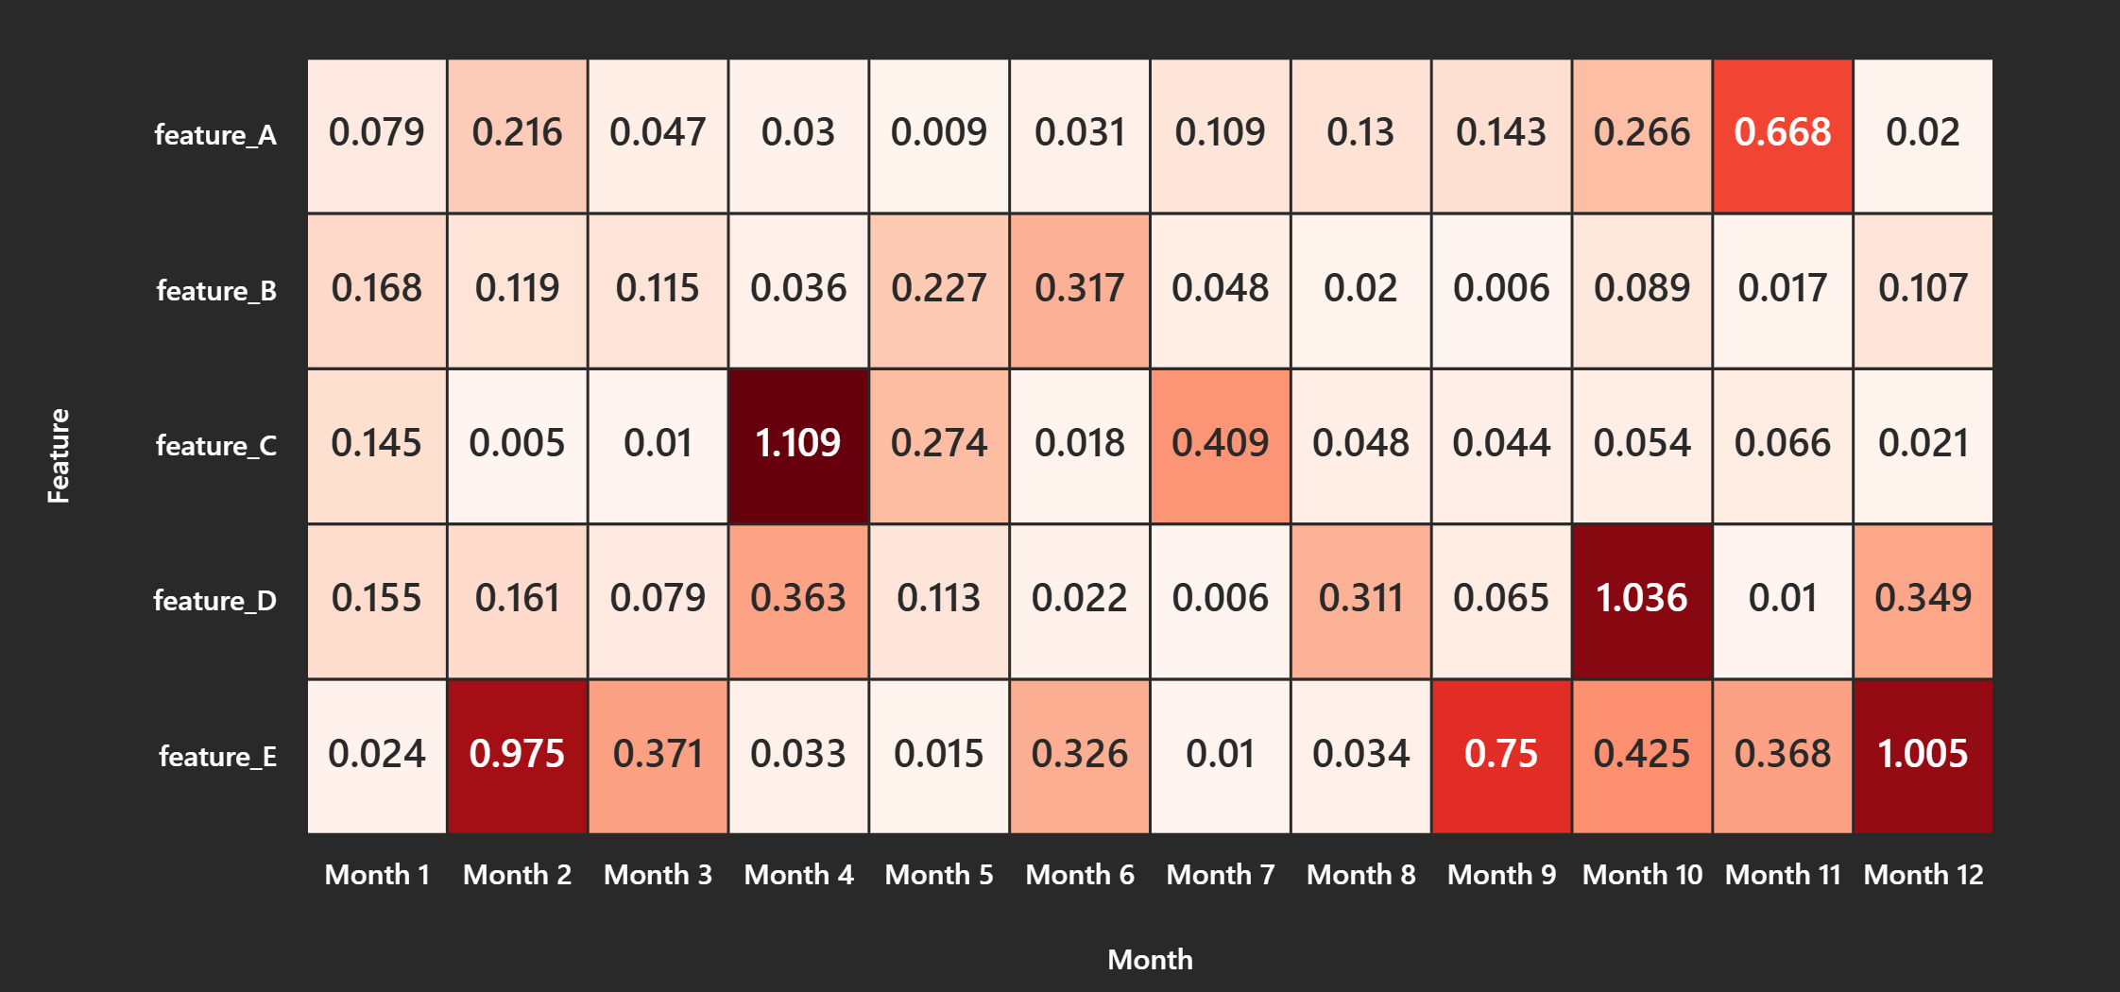

Basically, the idea is to have a sequence of functions which will transform the tabular data with json strings to flatten table, calculate the PSI for the score, calculate the CSI for the features give an output as dataframe with same structure (same column names)
Month,
feature,
bin_value,
DateCategory(Training, Test),
train_pct,
test_pct,
bin_csi,
feature_csi,
account_count
segment_type 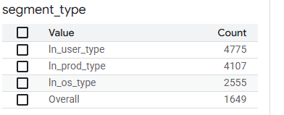
Modelname

