Technical Specification: Model Monitoring & Data Transformation for Innofyre
Version: 1.0
Date: 10 Oct 2025
Prepared by: Dwaipayan (Data Science Analyst)

1. Overview
This document specifies the technical requirements and design for Innofyre to implement data transformation, model monitoring metrics, and industry-standard visualizations based on the BigQuery table prj-prod-dataplatform.audit_balance.ml_model_run_details. The outcome will enable reliable PSI, CSI, and Gini analyses, plots, and standardized outputs.

2. Current Situation (As-Is)
- Only basic PSI/CSI/Gini functions exist. No production-grade transformation layer.
- Flattening of prediction/calcFeature JSON and segmentation into Training/Test are missing.
- Standard binning utilities and plotting functions are not yet implemented.

3. Scope
- Flatten JSON fields (prediction, calcFeature, attributes) into a structured, analysis-ready table.
- Compute and report PSI (Population Stability Index), CSI (Characteristic Stability Index), and Gini for model scores.
- Generate industry-standard visualizations: PSI chart, PSI heatmap by feature/month, and Gini (Lorenz) plot.
- Produce standardized output DataFrames for PSI/CSI with the exact column schema required by downstream consumers.
- Package functions with clear APIs, documentation, and sample usage notebooks/scripts.

4. Objectives
- Automate data flattening from prj-prod-dataplatform.audit_balance.ml_model_run_details.
- Standardize score extraction and feature handling.
- Provide robust, tested implementations of PSI, CSI, and Gini with configurable binning and segment definitions.
- Deliver high-quality plots that adhere to industry practices and are suitable for reports and dashboards.

5. Data Source & Schema
Source Table (BigQuery): prj-prod-dataplatform.audit_balance.ml_model_run_details
- customerId
- digitalLoanAccountId
- crifApplicationId
- prediction (numeric or JSON)
- errorDetail
- deployedModelId
- model
- modelDisplayName
- modelVersionId
- calcFeature (JSON with multiple attributes)
- start_time, end_time
- subscription_name, message_id, publish_time
- attributes (JSON)

6. Score Definitions
The model outputs may present scores either as a single numeric prediction or as a JSON object containing multiple scores. The implementation must standardize the following:
- If prediction is a single numeric value: treat as combined_score unless otherwise specified.
- If prediction is JSON: extract keys when present: cb_score, dl_score, combined_score.
- Score range normalization (optional): ensure scores are within [0,1] when required by plots or metrics; otherwise preserve native range.
- Segment association: each score must be tagged with DateCategory (Training/Test) based on configured time windows or flags.
- Model identity: attach model, modelDisplayName, modelVersionId to each score record.

7. Assumptions
- The source table is append-only; historical rows are immutable once ingested.
- Timestamps (start_time/end_time/publish_time) are in UTC and will be converted to reporting timezone when needed.
- Training vs Test segmentation will be defined by a date cutoff or an explicit attribute in attributes.
- calcFeature JSON keys are stable; new keys may appear and should be handled gracefully (ignored unless whitelisted).
- Missing/NULL values: impute to an "Unknown" bin for categorical features; exclude from PSI/CSI numerator and track counts.
- Low-volume bins: merge bins with account_count below a configurable threshold (default: 50) into an "Other" bin to stabilize metrics.
- Binning: use quantile-based bins for scores (default: 10) and frequency-based or domain-specific bins for categorical features.
- PSI/CSI computation uses proportions; zero proportions are clipped to a small epsilon (e.g., 1e-6) to avoid division by zero.
- Gini for binary outcomes is computed as Gini = 2*AUC - 1 where AUC is ROC area; for continuous targets, use Lorenz-based formulation.

8. Functional Requirements

8.1 Data Flattening Function
Implement function to flatten JSON fields and return an analysis-ready DataFrame:
def flatten_ml_model_run_details(table_name: str, feature_keys: list[str] | None = None, prediction_keys: list[str] | None = None) -> 'pd.DataFrame':
"""
- Executes BigQuery to select and flatten columns from `table_name`.
- Parses `prediction` (numeric or JSON) into standardized columns (combined_score, cb_score, dl_score).
- Flattens `calcFeature` into separate columns for each requested `feature_keys`.
- Returns a DataFrame with timestamps, model identifiers, scores, and features.
"""
In prj-prod-dataplatform.audit_balance.ml_model_run_details we have these columns:
customerId digitalLoanAccountId crifApplicationId prediction errorDetail deployedModelId model modelDisplayName modelVersionId calcFeature start_time end_time subscription_name message_id publish_time attributes
The table schema is like:
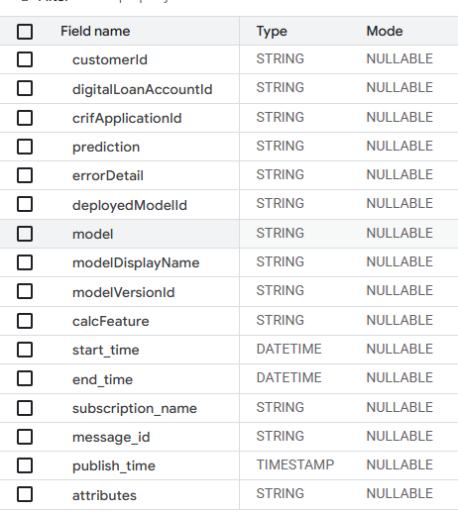
Prediction – might have single value like 26567.77685575922 or 0.0430482589 or might have a json value like {'cb_score': 0.5170787059841818, 'dl_score': 0.7206695675849915, 'combined_score': 0.6188741367845867}.
calcFeature column have json value like {"inc_beta_ln_loan_type":"BNPL","inc_beta_ln_education_level":"High School Graduate","inc_beta_ln_employment_type_new":"Self-Employed\/Private Practice","inc_beta_ln_industry_new":"Delivery Rider \/ Driver","inc_beta_ln_age":29,"inc_beta_ln_brand":"OPPO","inc_beta_ln_city":"CF0741","inc_beta_ln_purpose":"missing","inc_beta_ln_osversion_bin":"1-Nomad","inc_beta_ln_postal_code":"4217","inc_beta_ln_gender":"M","inc_beta_ln_doc_type_rolled":"Other","inc_beta_ln_cnt_dependents":"2","inc_beta_ln_source_of_funds_new":"2","inc_beta_ln_marital_status_new":"Married","inc_beta_encoded_company_name_grouped":327826.3827764811}

8.2 Metric Calculation Functions
Provide functions to compute PSI, CSI, Gini, Log-Loss, MAE, MAPE, and Month-over-Month metrics.
def compute_psi(train_df, test_df, score_col: str, bins: int = 10) -> 'pd.DataFrame':
"""Compute PSI for the specified score using quantile bins and return bin-level and overall PSI."""
def compute_csi(train_df, test_df, feature_cols: list[str], bins: int | dict = 10) -> 'pd.DataFrame':
"""Compute CSI per feature and return standardized output schema."""
def compute_gini(y_true, y_score) -> dict:
"""Return gini_value and plotting data (Lorenz curve)."""

8.3 Visualization Functions
- PSI Chart: bar plot of bin_csi/psi values across bins for a given month/segment.
- PSI Heatmap: matrix heatmap by feature (rows) and month (columns) showing feature_csi.
- Gini Plot: Lorenz curve and Gini annotation.

8.4 Standardized Output Schema
CSI/PSI outputs must conform to the following column names and semantics:
- Month
- feature
- bin_value
- DateCategory (Training, Test)
- train_pct
- test_pct
- bin_csi
- feature_csi
- account_count
- segment_type
- Modelname

9. Non-Functional Requirements
- Performance: end-to-end flatten + metrics for one month should complete within 5 minutes for up to 5M records.
- Reliability: functions are idempotent and retriable; transient BigQuery failures handled via exponential backoff.
- Observability: structured logging at INFO/DEBUG levels; metric summaries emitted as JSON.
- Configurability: bin counts, epsilon, thresholds, and segmentation windows externalized via config.
- Compatibility: Python 3.10+, Pandas/NumPy/Matplotlib/Seaborn; BigQuery SQL Standard.

10. Technical Design

10.1 Processing Flow
1) Extract & flatten from BigQuery → 2) Segment into Training/Test → 3) Bin scores/features → 4) Compute PSI/CSI → 5) Compute Gini → 6) Generate plots → 7) Persist outputs.

10.2 BigQuery Flattening Approach (Example SQL)
SELECT
customerId,
digitalLoanAccountId,
crifApplicationId,
SAFE_CAST(JSON_VALUE(prediction, '$.combined_score') AS FLOAT64) AS combined_score,
SAFE_CAST(JSON_VALUE(prediction, '$.cb_score') AS FLOAT64) AS cb_score,
SAFE_CAST(JSON_VALUE(prediction, '$.dl_score') AS FLOAT64) AS dl_score,
CASE WHEN SAFE_CAST(prediction AS FLOAT64) IS NOT NULL THEN SAFE_CAST(prediction AS FLOAT64) END AS prediction_numeric,
JSON_VALUE(calcFeature, '$.inc_beta_ln_loan_type') AS inc_beta_ln_loan_type,
SAFE_CAST(JSON_VALUE(calcFeature, '$.inc_beta_ln_age') AS INT64) AS inc_beta_ln_age,
JSON_VALUE(calcFeature, '$.inc_beta_ln_brand') AS inc_beta_ln_brand,
model, modelDisplayName, modelVersionId, start_time, end_time, publish_time
FROM `prj-prod-dataplatform.audit_balance.ml_model_run_details`
WHERE publish_time BETWEEN @start AND @end;

10.3 Metric Formulas
Population Stability Index (PSI) per bin i: PSI_i = (p_i - q_i) * ln(p_i / q_i); Overall PSI = Σ PSI_i, where p_i is Test proportion and q_i is Training proportion.
Characteristic Stability Index (CSI) uses the same formulation applied to feature distributions across bins.
Gini (binary classification): Gini = 2 * AUC - 1; alternatively via Lorenz curve: Gini = 1 - 2 * area_under_lorenz.
- Typical PSI interpretation: < 0.10 (stable), 0.10–0.25 (moderate shift), > 0.25 (significant shift).
- Clip proportions to epsilon to avoid division by zero; ensure Σ proportions per segment equals 1.

10.4 Binning Strategy
- Scores: quantile bins (default: 10); support custom edges.
- Numeric features: quantile or equal-width bins based on config.
- Categorical features: frequency-based top-k categories with an "Other" bucket.
- Minimum bin volume threshold to avoid sparse bins and unstable metrics.

11. API Signatures & Outputs

Use a wrapper to input the data, flatten it and create a suitable dataset for PSI, CSI and gini calculation.
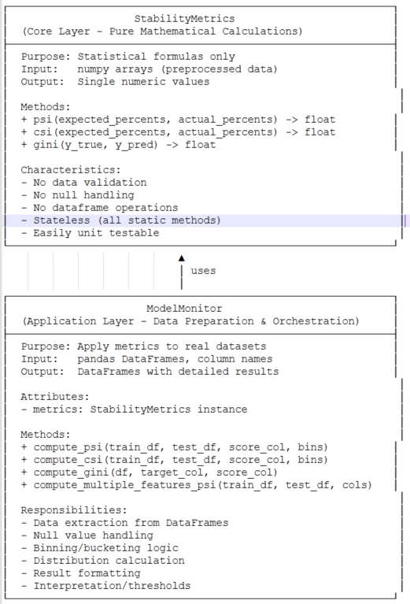

class ModelMonitoringManager:
def __init__(self):
self.api = MonitoringAPI()

def monitor_model(self, train_df, test_df, score_col, feature_cols, bins=10):
psi_df = self.api.compute_psi(train_df, test_df, score_col, bins)
csi_df = self.api.compute_csi(train_df, test_df, feature_cols, bins)
psi_plot = self.api.plot_psi(psi_df, month="2025-10", score_col=score_col)
csi_heatmap = self.api.plot_psi_heatmap(csi_df)
return {
"psi": psi_df,
"csi": csi_df,
"psi_plot": psi_plot,
"csi_heatmap": csi_heatmap

class MonitoringAPI:

def flatten_ml_model_run_details(self, table_name: str, feature_keys: list[str], prediction_keys: list[str]) -> pd.DataFrame:

# Placeholder for actual implementation

pass

def compute_psi(self, train_df, test_df, score_col: str, bins: int = 10) -> pd.DataFrame:

# Placeholder for actual implementation

pass

def compute_csi(self, train_df, test_df, feature_cols: list[str], bins: int | dict = 10) -> pd.DataFrame:

# Placeholder for actual implementation

pass

def plot_psi(self, psi_df, month: str, score_col: str) -> plt.Figure:

# Placeholder for actual implementation

pass

def plot_psi_heatmap(self, csi_df) -> plt.Figure:

# Placeholder for actual implementation

pass

def plot_gini(self, y_true, y_score) -> plt.Figure:

gini_score = self.gini(y_true, y_score)

fig, ax = plt.subplots()

ax.bar(['Gini'], [gini_score], color='skyblue')

ax.set_title('Gini Coefficient')

ax.set_ylim(0, 1)

return fig

def gini(self, y_true, y_score) -> float:

"""Calculate Gini coefficient from true labels and predicted scores."""

auc = roc_auc_score(y_true, y_score)

return 2 * auc – 1

You can create something like this based on your expertise and experience. For example – I am sharing a code from where I am mostly referencing the monitoring. PSI_CSI_GINI.py

12. Standard Output Data Model
CSI/PSI DataFrame must contain:
- Month (YYYY-MM)
- feature
- bin_value
- DateCategory (Training or Test)
- train_pct
- test_pct
- bin_csi (or bin_psi for scores)
- feature_csi (aggregated per feature per month)
- account_count
- segment_type
- Modelname

12. Acceptance Criteria
- Data flattening returns a DataFrame with parsed scores (combined_score/cb_score/dl_score) and selected calcFeature keys.
- PSI/CSI computations match reference calculations within tolerance (±1e-6) on sample datasets.
- Visualizations render without errors and adhere to specified aesthetics.
- Output DataFrame columns exactly match the required schema and pass validation checks.
- Documentation includes examples and clear instructions; unit tests cover edge cases (missing values, zero bins, sparse categories).

14. Deliverables
- Python module with functions and docstrings.
- Plot generation utilities (Matplotlib/Seaborn).
- Example notebook/script demonstrating end-to-end workflow.
- Technical documentation (this specification).
- Sample dataset and expected outputs for validation.

15. Deliverables
1) Load config (binning_config.yaml)
2) Extract sample_ml_model_run_details.csv (or BigQuery)
3) flatten_runs → segment_data → bin_scores/bin_features
4) build_psi_dataset/build_csi_dataset/build_gini_datasetd
5) Feed outputs into existing PSI/CSI/Gini functions and plotting utilities

16. Plot Ideas:

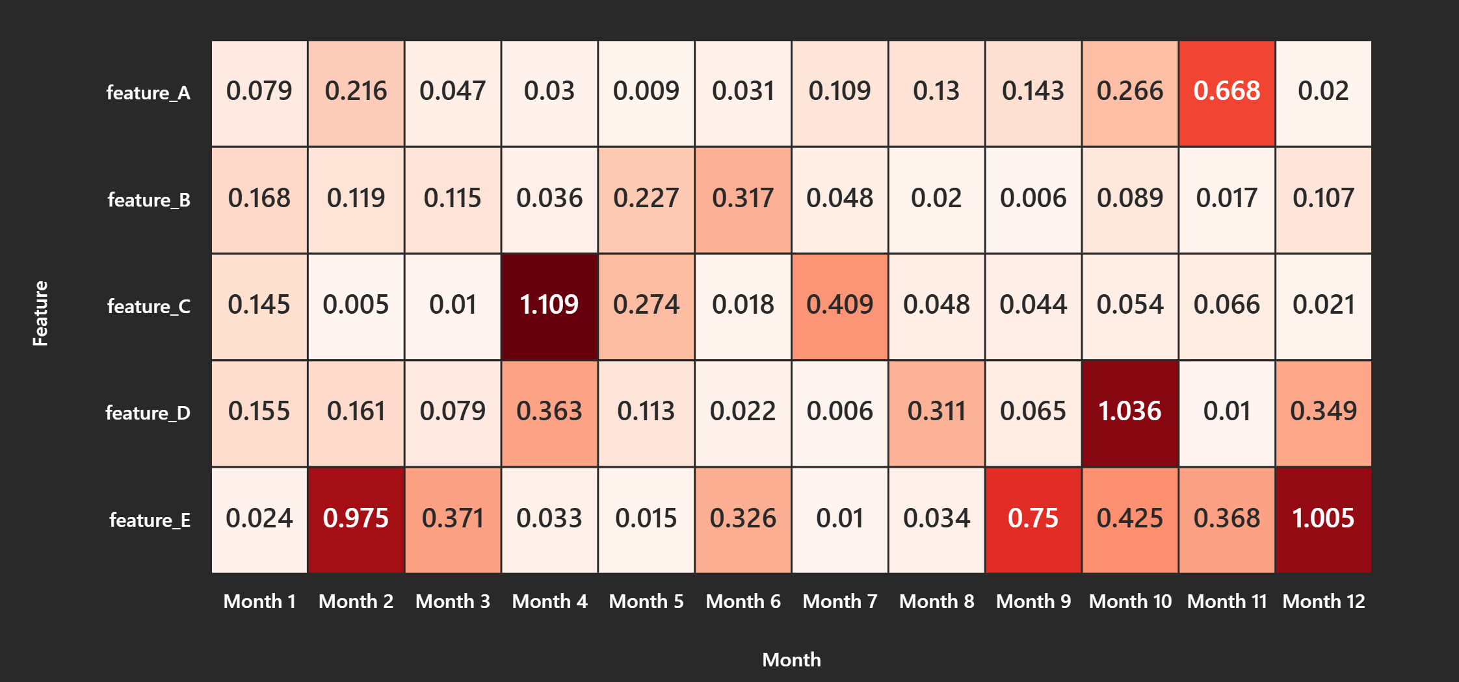

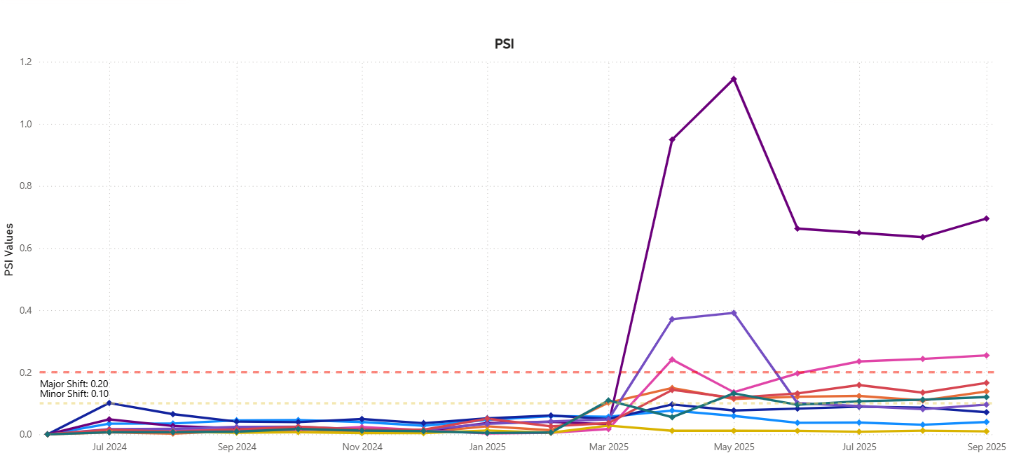

Basically, the idea is to have a sequence of functions which will transform the tabular data with json strings to flatten table, calculate the PSI for the score, calculate the CSI for the features give an output as dataframe with same structure (same column names)

