CS 255 System Design Document
Donald Champagne // 08-16-2026

UML Diagrams

UML Use Case Diagram
The use case diagram below shows the four types of users who interact with DriverPass (Customer, Secretary, IT Officer, and Owner) and the actions each of them can perform within the system.
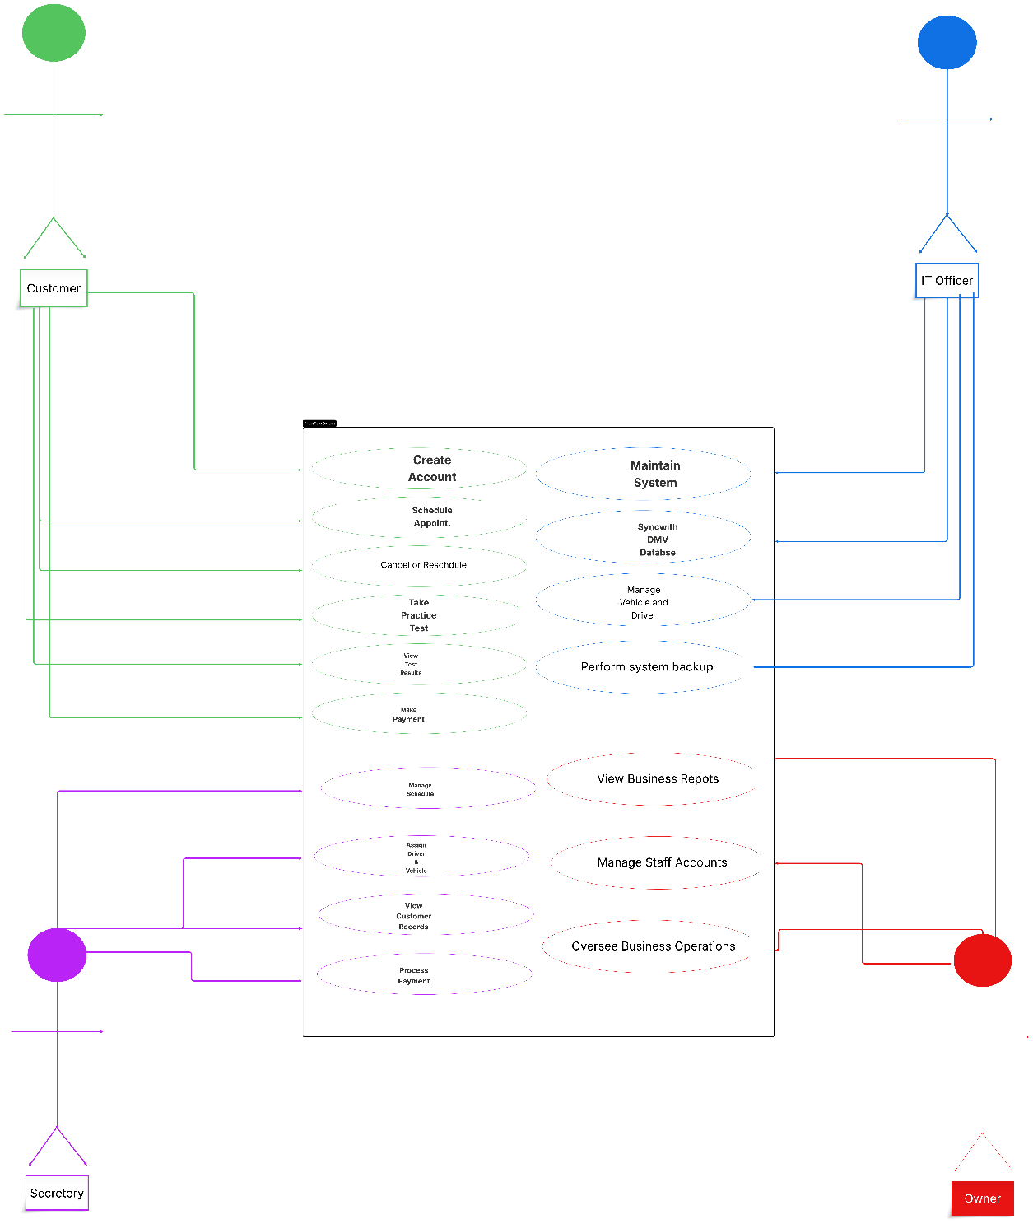

UML Activity Diagrams
The two activity diagrams below break down the Schedule Appointment process and the Take Practice Test process, showing the steps the system follows and the decision points along the way.
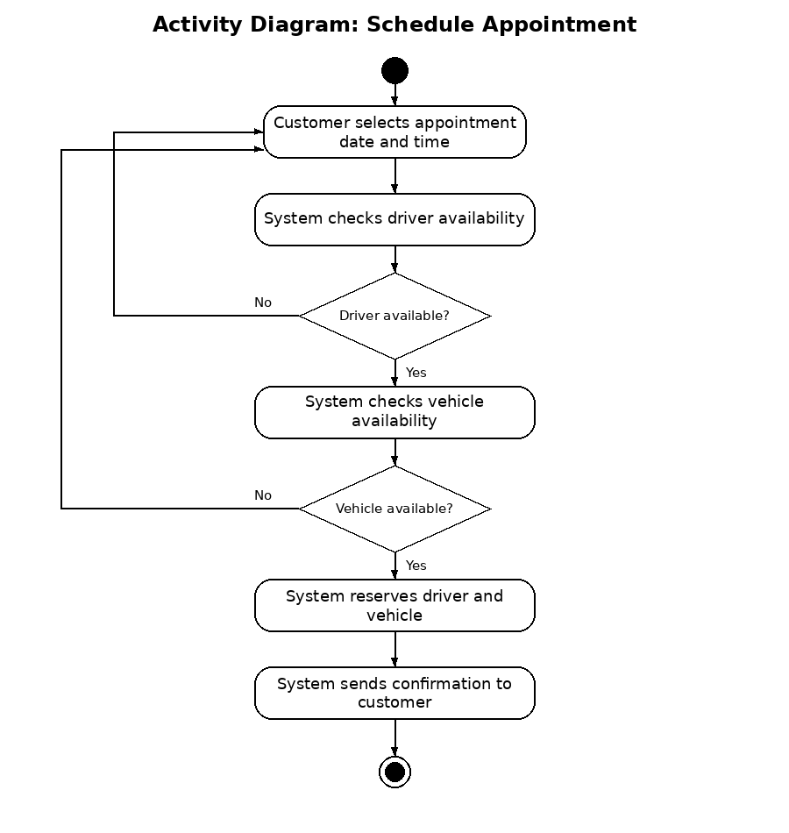
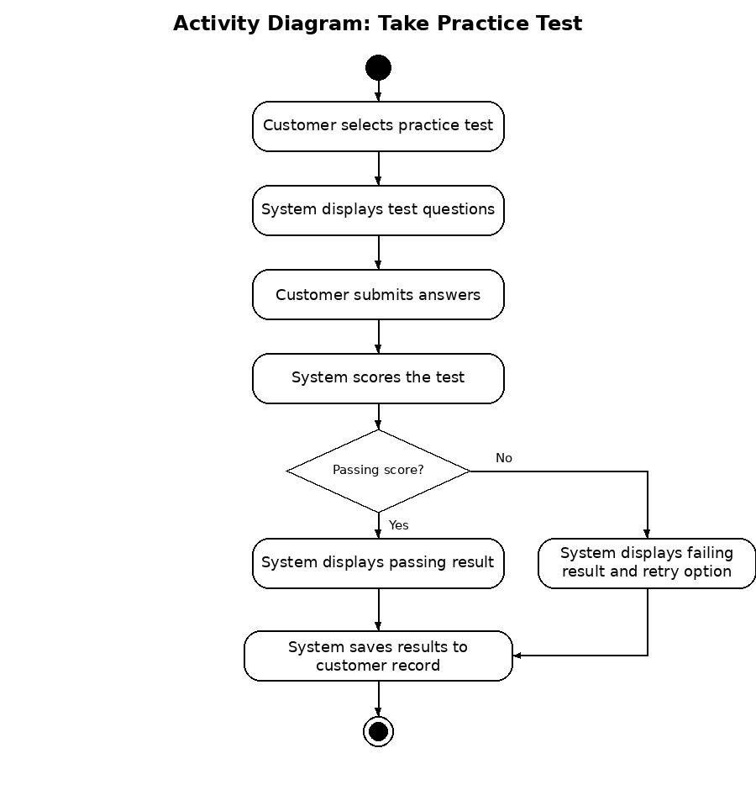

UML Sequence Diagram
The sequence diagram below shows how the Customer, System, Driver, and Vehicle objects communicate with one another when a customer schedules an appointment.
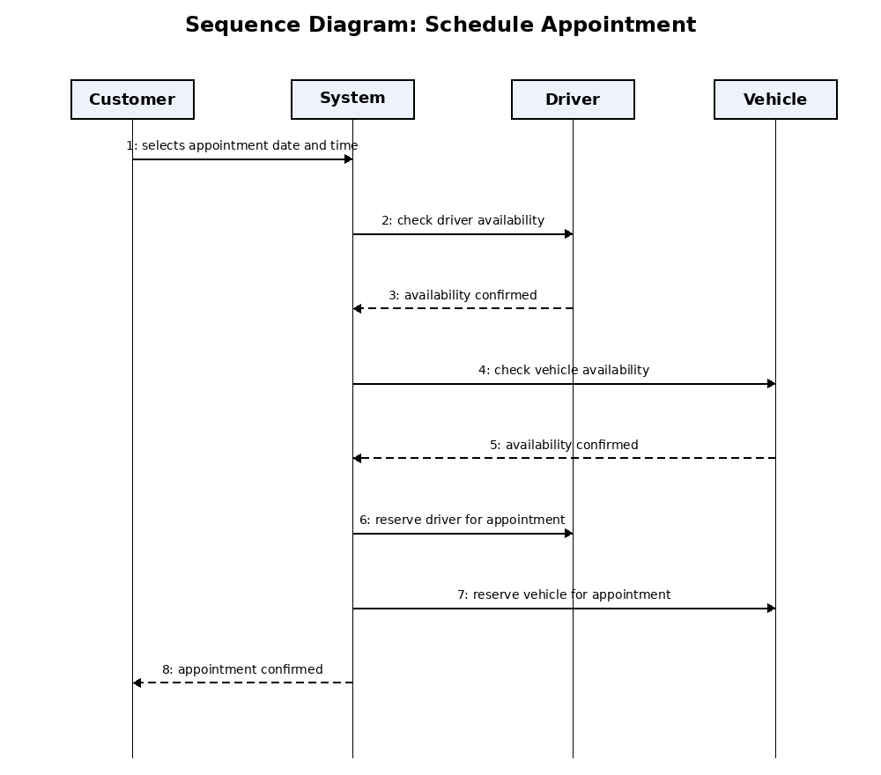

UML Class Diagram
The class diagram below shows the main classes in the DriverPass system, including Customer, Appointment, Driver, Vehicle, PracticeTest, Payment, and Employee, along with the attributes each class holds and how the classes relate to one another.
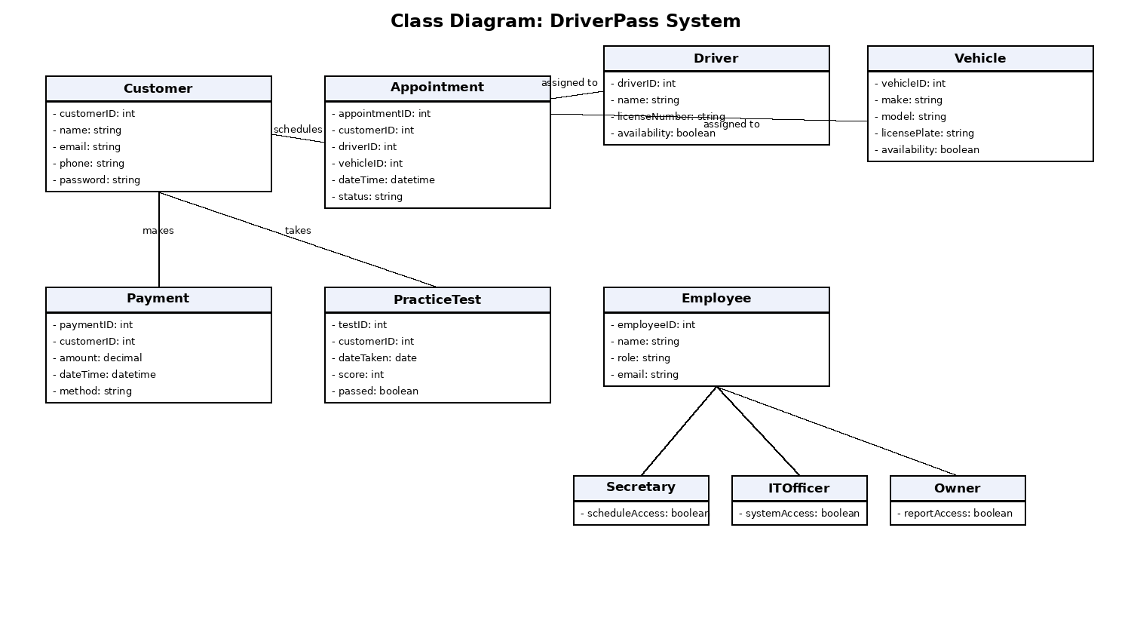

Technical Requirements
The DriverPass system will be built as a cloud based, web accessible application so that customers, secretaries, the IT officer, and the owner can all reach the system from a browser without needing to install anything locally.
Hardware: The system does not require DriverPass to purchase or maintain physical servers. It will run on cloud hosted infrastructure through a provider such as AWS or Microsoft Azure. Staff and customers only need a device capable of running a modern web browser, such as a desktop, laptop, tablet, or smartphone.
Software: The system needs a cloud hosted relational database to store customer accounts, appointments, driver and vehicle records, practice test results, and payment history. The backend will be built using a modern web application framework connected to that database, and the frontend will be a responsive web interface that works across both desktop and mobile browsers. The system also needs to integrate with the DMV database through a secure API connection so that scheduling and licensing information can stay synced automatically. Payments are processed through a secure third party payment processor rather than storing raw card information directly.
Tools and Infrastructure: Because DriverPass has no in house IT department beyond a single IT officer, the system relies on the cloud provider to handle physical infrastructure, automatic backups, and uptime monitoring. The IT officer will need administrative access to manage system settings, user accounts, and system wide updates. Automated daily backups of the database are needed so appointment, payment, and customer data can be restored quickly in the event of an outage or data loss. All data transmitted between the customer's browser and the system, including login credentials and payment information, needs to be encrypted using HTTPS and TLS to protect sensitive information in transit.
Scalability and Availability: Since DriverPass plans to grow and the system needs to stay available for scheduling at all hours, the cloud hosted infrastructure needs to support automatic scaling during high traffic periods and needs to maintain high availability so customers can schedule appointments or take practice tests at any time.

