|  |  |
| --- | --- |
| **Microsoft Azure LUIS**  Microsoft vs Google chatBOTs  1)simpler to configure and easier to understand for the user.  (no coding needed other than ability to interpret and use the returned JSON,in application.)  2)has ***slot filling*** feature.  If the user does not provide all the information then a prompt can be made to sent automatically for the required information.  (achieved by marking some entities as REQUIRED)  3)*UNIQUE FEATURES*:(has the **composite entity** feature)  It involves the grouping of entities into a single predefined entity.  Example: The utterance : ”2 adult first class tickets from Kolkata to New Delhi” specifies the following entities:  Number of tickets(2)  Ticket type(adult)  Ticket class(1st)  3)less languages are supported in the multilingual feature.  4)Good for cortana functionality and IOT applications.  URL:  https://azure.microsoft.com/en-in/services/cognitive-services/language-understanding-intelligent-service/ | **Google Cloud (Dialog Flow)**  1)difficult to configure and understand,more suited for complicated projects where advanced features are required.  2)has ***slot filling*** feature.  If the user does not provide all the information then a prompt can be made to sent automatically for the required information.  (achieved by marking some entities as REQUIRED)  3)*UNIQUE FEATURES:* has **follow up intents** and context parameterization,connecting one intent to another.  For example if the user needs a reminder for a booking :  A Booking intent will lead to a Reminder intent in succession with the requisite entities.  #)**AUTOMATED EXPANSION** feature:recognize new undefined entities as time goes on,with practice and experience.  Here,Dialog flow brings in AI.  #)can link with commonly used Facebook messenger app and the chatbot can also take the help of the **Google Assistant**.  #)can handle multiple intents in the same chat and ignore unnecessary entities which may not be required.(**ignore distractions**)  3)more languages are supported in the multilingual feature.  4)Good for middle level B2C(business to consumer) bots,virtual assistants,MVPs(minimum viable product).  URL:  <https://dialogflow.com>  (also helpful:: video on website leading to 3 subsequent videos on basics of dialog flow) |

CONCLUSION::

Dialog flow may seem very attractive and tempting,but taking into account the simplicity of our problem statement(a bot for leave application),it is advisable to go for Microsoft Azure for the sheer simple mechanism of its functionality.

Also an important additional point,the use of C# language is better suited to the Microsoft Azure than the Google Cloud.

**Q:)How to store conversation history between chatbots and employee?**

[**https://stackoverflow.com/questions/49665510/how-to-store-and-retrieve-the-chat-history-of-the-dialogflow**](https://stackoverflow.com/questions/49665510/how-to-store-and-retrieve-the-chat-history-of-the-dialogflow)

**(This data can be stored to the database and used to learn and improve responses for future use)**

OTHER BOT SERVICES

*(1)Amazon Lex:*

*PROS::*

1)automated speech recognition,speech into text conversion.

2)natural language processing

3)SDKs for multiple programming languages.

4)Mobile Hub Integration(important for user authentication and behavior anaylsis).

5)Backend infrastructure of Lex is supported by AWS Lamda.(most advanced serverless computing platform).

Hence,user can focus completely on building the application.

*CONS:*

1)**not** multilingual(can understand only English)

2)Preparation of data set is complicated compared to Microsoft Azure and Dialog flow.

[**URL:**https://aws.amazon.com/lex/](URL:https://aws.amazon.com/lex/)

*(2)IBM Watson:*

*PROS::*

1)360 degree speech to text,text to speech question and answer facility.

2)multilingual.

3)posseses a language translater.

4**)visual recognition security**

5)expansive SDK for multiple programming languages (Java,Python,Node)….acceptable and compatible.

*CONS:*

1)**expensive** compared to Dialog flow and Amazon Lex.

2)Tutorials not upto the mark.

**URL:**

1)<https://www.ibm.com/watson/>

2)<https://en.wikipedia.org/wiki/Watson_(Computer)>

[(a)software,(b)comparision with human players]

**SUCCESS TILL NOW**

All these 4 chatbot building platforms have been successful but the order of popularity is ::

[1]IBM Watson

[2]Microsoft Bot Framework

[3]Dialog Flow

[4]Amazon Lex

But considering the task at hand,[2] (here,**LUIS**)comes out to be the best for our problem statement(leave applications).

**UPCOMING DEVELOPMENTS IN AI FROM MICROSOFT**

1)***Face recognition::***

Uses Face API to even give the approximate age,gender and emotion from the picture of a person’s face.

**URLs:**

a)https://azure.microsoft.com/en-in/services/cognitive-services/face/

b)*Uses of face recognition::*

[https://www.facefirst.com/blog/amazing-uses-for-face-recognition-facial- recognition-use-cases/](https://www.facefirst.com/blog/amazing-uses-for-face-recognition-facial-%20%20%20%20%20%20%20%20%20recognition-use-cases/)

2) ***Speech recognition::***

A detailed list of features of voice recognition off all the leading providers can be found under::

##) https://medium.com/swlh/the-past-present-and-future-of-speech-recognition-technology-cf13c179aaf

((users saying Alexa to “boil the kettle”:is not far away from us))

URL exclusively for microsoft’s speech recognition::

\*\*)<https://azure.microsoft.com/en-in/services/cognitive-services/speech-services/>

3) ***Ambient computing(from* Ambient intelligence*)::***

In **computing**, **ambient** intelligence (AmI) refers to electronic environments that are sensitive and responsive to the presence of people.

A typical context of ambient intelligence environment is home, but may also be extended to work spaces (offices, coworking), public spaces (based on technologies such as [smart street lights](https://en.wikipedia.org/wiki/Intelligent_street_lighting)), and hospital environments

\*\*) <https://en.wikipedia.org/wiki/Ambient_intelligence>

This area will be **dominated by Amazon** due to the unstoppable developments in Alexa.

**4)Cortana additions::**

{A}With Microsoft about to launch Redstone 4 (after Windows 10).It will see advancement in Cortana feature also.

In the new development,we will be able to create a Cortana profile which will provide updates without even asking.The profile will be modifiable from the start menu.

It will allow us to set our home,places of work and Cortana itself,will automatically update us regarding weather and traffic in those locations.

**URL::** <https://www.techradar.com/news/the-next-windows-10-update-will-make-cortana-more-helpful-than-ever>

{B}Last summer, [Amazon and Microsoft announced that their respective personal assistants would be able to talk to one another](https://www.zdnet.com/article/microsoft-and-amazon-agree-to-enable-cortana-alexa-communication/) so customers could opt to use the assistant most suited to a particular task. Amazon and Microsoft officials said last year that they'd make Cortana-Alexa integration available before the end of calendar 2017. Since then, there's been no word on when this might actually arrive.

**URL::** <https://www.zdnet.com/article/microsoft-quietly-adds-cortana-features-still-testing-alexa-integration/>

{C}Cortana for a long time specially has become stagnant in the digital assistant market,way behind Google Assistant and Amazon Alexa.

But Microsoft has been taking steep steps to get back and reposition Cortana.Here are the developments::

**URL**:: <https://www.windowscentral.com/microsoft-repositioning-cortana>

If all these are carried out to perfection then Microsoft will be in a dangerous position lethal for other companies since

**Microsoft will be the only company that can truly make your PC and smartphone work better together.**

**Explanation:**Google assistant will not be able to help you on your PC,will not be able to send notifications and other things to your PC either**,Cortana can.**

**Some more developments**: <https://news.microsoft.com/ai/>

**USE OF AI in RECRUITMENT AUTOMATION**

3 components of Recruitment automation::

1)*Resume screening*::Powered by AI,intelligent screening software **uses employee data** on performance and tenure,the software figures out which candidates went on to become successful and unsuccessful candidates.

**Advantages::**

{a}Reduces time to hire because it automates a low value,repitive task that most recruiters hate to do anyway.

{b}allows recruiters to **focus their time** on high value priorities like talking to candidates to assess their personalities.

*2)Recruitment automation for pre-qualification*:: In form of chatbots,AI aids in improving candidate experience. 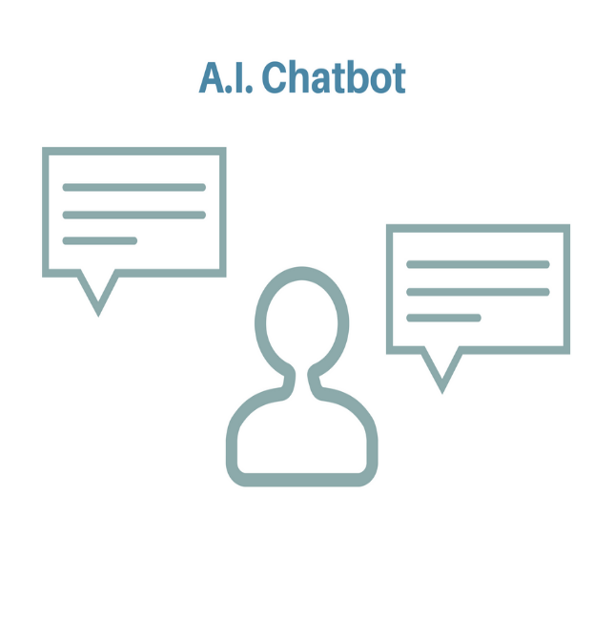

**Advantage::**

Allows human recruiters to provide these consistent updates in real time by asking pre-defined questions,related to job requirements and providing feedback updates and next step suggestions.

*3)For interviews::*

(\*1)record candidate interviewing and

(\*2)asses factors like ->word choices

->speech pattern

->facial expression

And judge if candidate fits the role or not.

We can also add additional data points

**URL::** <https://ideal.com/3-ways-recruitment-automation-will-change-recruiting-forever/>

<https://www.entelo.com/recruiting-automation/>

**The best automation tools for building recruitment softwares powered by AI::** <https://medium.com/@DDI_Development/the-6-best-recruiting-automation-tools-for-2018-fb50dd116cc6>

<https://ideal.com/recruiting-automation-tools/> (include chatbots)

Recruiting automation solutions are most commonly implemented in HR departments and are often integrated with [applicant tracking system (ATS) software](https://www.g2crowd.com/categories/applicant-tracking-system-ats) and [CRM software](https://www.g2crowd.com/categories/crm) to streamline the entire job hiring process from candidate sourcing through employee management.

**Comparative study of automation software::** <https://www.g2crowd.com/categories/recruiting-automation>

ESSENTIAL METRICS FOR CHATBOTS

Some key points for chatbot metrics::

* **Active rates and engaged rates**::Active implies user is online but has not responded,engaged implies user has responded.

Active rate : defined as no. of active sessions of a user/total number of sessions of that user.

Engaged rate;defined as no. of engaged sessions of that user/total number of sessions of that user.

* Average number of conversations per user.
* Time required by user for a response(Retention rate)
* Confusion rate
* Goal/Task completion rate
* **URL::**
* **1)**[**https://venturebeat.com/2016/10/04/5-metrics-every-chatbot- developer-needs-to-track/**](https://venturebeat.com/2016/10/04/5-metrics-every-chatbot-%20developer-needs-to-track/)
* **2)**[**https://appinventiv.com/blog/key-metrics-to-evaluate-your-chatbots-performance**](https://appinventiv.com/blog/key-metrics-to-evaluate-your-chatbots-performance)
* **3)**[**https://www.entrepreneur.com/article/295447**](https://www.entrepreneur.com/article/295447)

**(**10 metrics to optimize chatbots**)**

AI powered cameras::

Google has released Google clips and Microsoft is expected to act on similar lines.

The AI powered cameras **automatically click** if they detect common traits of good photos.Using machine learning,it takes a 15 second burst photograph(moment is fully captured).

The camera also responds to lighting and facial expressions.

**Uses:: ->1)**can capture unique family memories.

**->2)Security:** a)can take a 24 hour video feed of the

area(example::your home)

b)can ping the user if it sees an unfamiliar face or if

anyone enters the house at odd hours.

**->3)Abuse prevention:** AI camera can transmit video if abuser begins acting in an aggressive manner.

**Example:** Alexa calls 911 in response to a violent physical attack.

**It can also serve as an evidence in murder case.**

**URLs:: (a)**[**https://futurism.com/ai-cameras-use**](https://futurism.com/ai-cameras-use)

**(b)**[**https://digitalcameraworld.com/features/what-is-an-ai-powered-camera**](https://digitalcameraworld.com/features/what-is-an-ai-powered-camera)

**(\*#)AI powered cameras to record ATTENDANCE::**

It uses **Face Recognition Based Time Attendance System**::can be used to calculate working hours/number of leaves.

**Q:)How does it work?**

* Uses 2D/3D images to capture images of employee in the computer.
* This information is used when same employee uses system for the entry/exit in the working place.
* Matches identity.Informs entry and exit of both *employee and outsiders.*
* Being automated,not required to be observed the whole day.

**Advantages:**

* Saves time
* High accuracy,error-free.
* Noise resistant model
* Avoid spreading of contagious diseases like flu,virus,bacterial disease since no touch is involved.
* Easier and reliable time records for PAYROLL.
* 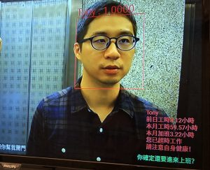
* If the employee is over-worked, our system will gently reminds him/her to care more for the health. The above figure shows the daily and monthly working hour of the employer.

**URLs::**

[**https://www.iinaindia.com/time-attendance-system/face-recognition-based/**](https://www.iinaindia.com/time-attendance-system/face-recognition-based/)

**<2>**[**https://www.wifiattendance.com/blog/ai-changing-workplace/**](https://www.wifiattendance.com/blog/ai-changing-workplace/)

**#>AI frontdesk improve office security and working conditions::**

[**https://ailabs.tw/smart-city/ai-frontdesk/**](https://ailabs.tw/smart-city/ai-frontdesk/)

**Development of Facial Recognition Algorithm for marking attendance::**

This technique is used in a school in Tokyo to inform the parents if student is not present in the school.

<https://tokyotechies.com/using-facial-recognition-technology-smart-attendance-application/>

### Artificial Intelligence in HR

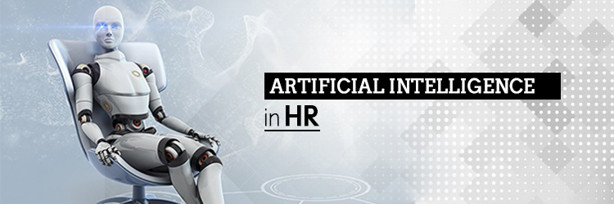

For example, **Textio uses augmented writing** (application of AI on writing) to give HRs a fitting job description to attract right talent. It does this my analyzing data on similar job postings and the kind of candidates it attracted. Companies such as Apple and Twitter are using the technology to attract the best in class employees.

Another software, [Veriato](http://www.veriato.com/" \t "_blank), analyses employee mails and messages for words that reflect employee emotions and feelings. It then scores each employee on positive and negative sentiments. This score can have application in measuring employee engagement, productivity or detecting company fraud and cyber attacks.

Similarly there are specialized software for HR processes like [MontageTalent](https://www.montagetalent.com/" \t "_blank) for interviewing, [Talla](https://talla.com/" \t "_blank) for on-boarding and [growBot](https://www.growbot.io/" \t "_blank) for social recognition.

**Upcoming Technologies in ALEXA**

* Amazon releases Alexa powered devices: a)Microwave

b)Amplifier

c)In car gadget

-> Amazon hance,wants to expand voice assistant-Alexa to people’s homes and cars where people spend most of their times.

-> **URL::**

<https://www.cnbc.com/2018/09/17/amazon-planning-8-new-alexa-devices-microwave-amplifier.html>

* Microsoft can be expected to react to stay alive in the market.

**FUTURE Of Voice Assistants::**

* We will be able to control our homes with voice commands.
* Example: While driving we will be able to send messages without causing an accident.
* The assistants will gain memory and converse more naturally.
* For Example, In online searching,the best answer to a question will be provided and not 10 different answers to choose from.

**WHAT GOOGLE ASSISTANT can do?**

Here are some activities that Google Assistant can do?

* Can open G-mail by saying “OK Google,open Gmail.”
* Weather forecast
* Sports feed
* News feed
* Can also give pleasant news if user asks for “*Give good news*” or show me something good.
* Book movie tickets.
* Play tunes
* Set reminders
* Plan a route
* Wake up via alarm
* Send a text message
* Send a voice message(eg: to contact kids at home,we can broadcast a voice message directly to Google Home speakers.) [can also transcribe if you want message in readable form].

**THUS,**hardly anything is left which the Google Assistant cannot do.